Capital stops

Paula Owens

Geography Teaching Resource

Primary

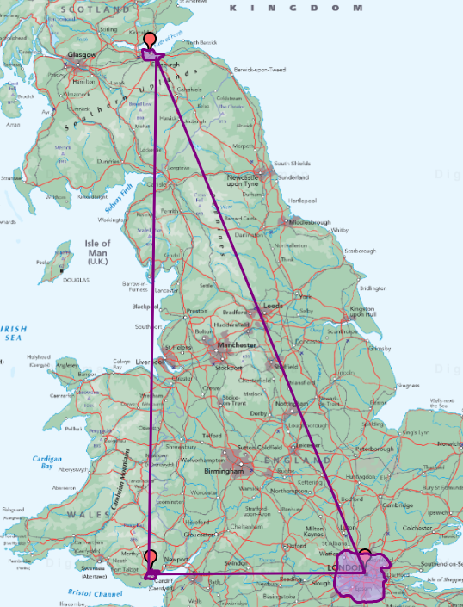

Contents
Contents 2
Digimap for Schools Geography Resources 3
Content and curriculum links 3
Activity 4
Introduction 4
Main activity 5
Discuss the capital cities of Great Britain 5
Ask the pupils some questions about capital cities. 5
Locate and mark the capitals London, Cardiff and Edinburgh: 5
Shade the urban areas 6
Connect the cities 8
Discuss the results with the pupils 9
Taking it further 10
Web links 10
Copyright 11
Acknowledgements 11

Digimap for Schools Geography Resources
These resources are a guide for teachers to demonstrate to the whole class or direct individual students as appropriate. Each activity has several ideas within it that you can tailor to suit your class and pupils. Some resources contain worksheets for direct distribution to pupils.
https://digimapforschools.edina.ac.uk/

Content and curriculum links
Level | Context | Location
Primary | Capital cities of Great Britain | London, Cardiff, Edinburgh

Knowledge/Skills | Use the zoom function on map/locate places on a map/draw an area on a map/add labels
Curriculum links (England) | Locating and naming capital cities in GB using appropriate geographical vocabulary, using and making maps
Curriculum links (Wales) | Knowledge and Understanding of the World:  Use and make simple maps to find where places are and how they relate to other places.
Scottish Curriculum for Excellence | Social Studies Outcomes: People, Place and Environment: 2-08a, 2-13a, 2-14a

Activity
Pupils locate the capital cities of Great Britain and approximately mark their urban boundaries using the ‘Area’ tool. Once located they describe the location of these places and some of the features you might find there. They also search for given locations and identify which city they belong to.

Introduction
Great Britain is the political entity made up of England, Scotland, Wales and their offshore islands. It does not include the Isle of Man, the Channel Islands or Northern Ireland.
A capital city is usually the centre of government and administration and often the largest city in the country. Digimap for Schools gives coverage of Great Britain at different scales so that pupils can appreciate the location of cities and towns and also zoom into find particular named, landmarks such as the Houses of Parliament.
Capital city landmarks like these can also be explained using aerial images

Main activity

Discuss the capital cities of Great Britain

• England, London (also the capital of the UK)
• Wales, Cardiff
• Scotland, Edinburgh

Ask the pupils some questions about capital cities.

For example:
- What is a capital city?
- Which of these places have they been to?
- What do they know about these places?

Locate and mark the capitals London, Cardiff and Edinburgh:
- Login to Digimap for Schools.
- Ask pupils to zoom in 2 or 3 times and look for the 3 cities.
- Pupils can move around with the arrow keys on a keyboard or by click/touch and drag the map in any direction.
- Add a marker to each capital.
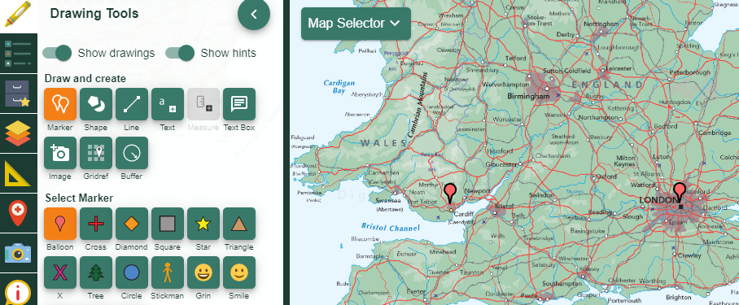

Shade the urban areas
For each capital city they are going to shade the urban area around it.
- Open the Drawing Tools.
- Select Shape.
- Select Freehand.
- Choose the line and fill colours.
- Now draw a shape around the urban area. Pupils may wish to zoom in on a city to make this easier.
- Click and hold the mouse, dragging around the darker shading showing the area of the city. Release the mouse to finish.
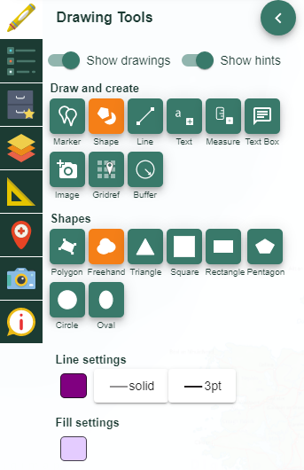

While the City of London is the heart of London, the area called London includes the built-up busy area around the city heart where lots of people live and work.

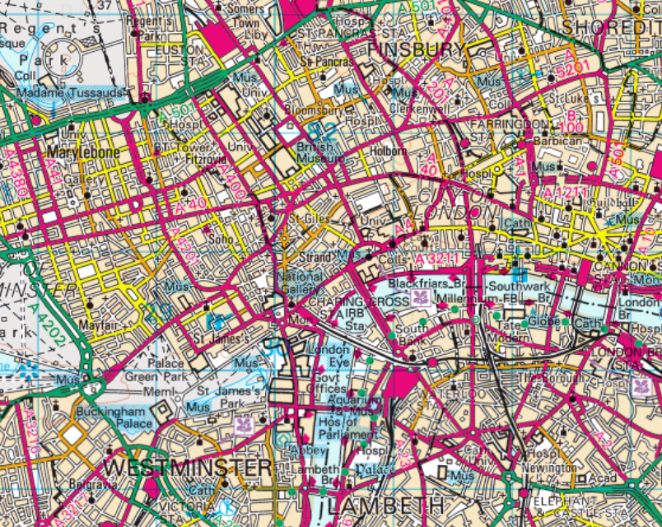

Connect the cities
- Zoom out to the smallest scale where all three cities are shown.
- Use the draw a line tool to connect the three capitals in a triangle. This provides an easy way to remember their relative positions.
- Print it out.

Discuss the results with the pupils
• What did they notice about the position of these cities?
• Which is furthest North/South/East/West?
• Which has the largest urban area?
• Which is nearest the coastline of Europe?
• Are there any cities bigger than any of the capitals within each country?

Taking it further
- Hand out the worksheet ‘City Search’ for pupils to search for some given places; find out which capital they belong to and see what they can find out about them.
- Add the school location to the capitals map by adding a marker and a label. Which capital is nearest? How far away is it?
- Zoom into the map so that you can see the school location and the nearest capital city. Select the Measuring tool from the toolbar and click on the school location and then drag it to the city to find out the distance in kilometres.
- Plan a day out to a city. How will you get there? What will you see? Research places you might go to and mark them on a large-scale (detailed) map of the city using a postcode search.
- Find out what rivers these cities are built on. Gather other information and make some ‘Capital Fact Files’.

Web links
https://www.parliament.scot/
https://senedd.wales/
https://www.parliament.uk/visiting/
https://www.cardiffbay.co.uk/
https://www.visitlondon.com/things-to-do/whats-on/special-events
https://edinburgh.org/
https://www.visitcardiff.com/

Copyright
©EDINA at the University of Edinburgh 2016
This work is licensed under a Creative Commons Attribution-Non Commercial Licence

Acknowledgements
© CollinsBartholomew Ltd (2019) FOR SCHOOLS USE ONLY
© Crown copyright and database rights 2020 Ordnance Survey (100025252). FOR SCHOOLS USE ONLY.
Aerial photography © Getmapping plc. Contains OS data. FOR SCHOOLS USE ONLY.
Historic mapping courtesy of the National Library of Scotland. FOR SCHOOLS USE ONLY.

