Capital Stops: City Search
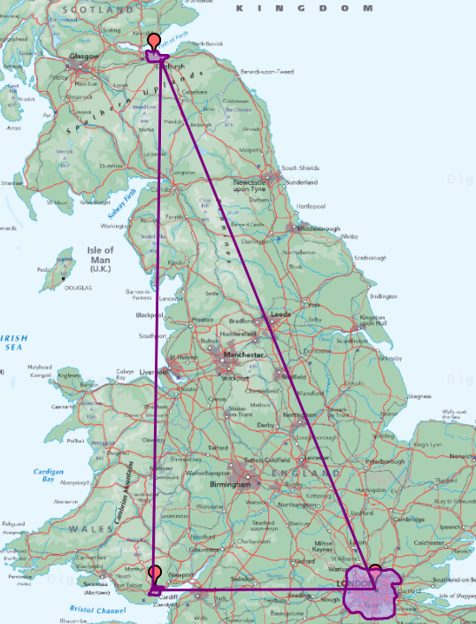

Worksheet

Primary

Activity Sheet
Use Digimap for Schools to explore the capital cities of Great Britain: London, Cardiff and Edinburgh.

Your mission:
You are a capital city explorer.
Use the map to search for places, solve clues and plan an adventure.
You will use:
- the search box
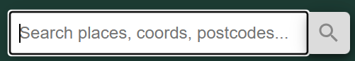
- zoom in and zoom out
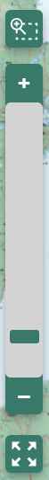
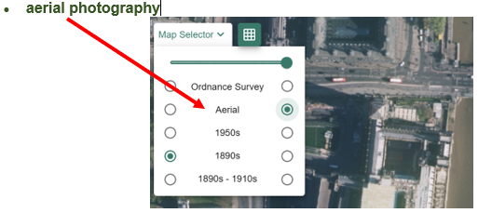
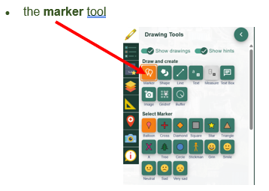
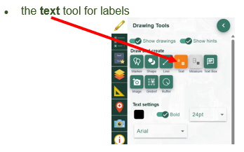
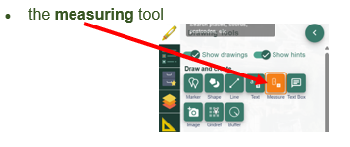
- postcode search

1. Find the capitals
Search for the three capital cities and add a marker to each one.
Which capital is furthest north?

Which capital is furthest south?

Which capital is furthest west?

Which capital has the largest urban area?

2. City Search
Search for each place and write which capital city it belongs to.
Place to find |  | Capital city
Houses of Parliament
Cardiff Bay
Edinburgh Castle
Senedd
Princes Street
Buckingham Palace
Houses of Parliament

Pick two places you found and write one thing you noticed.
Place 1:
I noticed:
Place 2:
I noticed:

3. Add your school
Find your school and add:
a marker
a label
Which capital is nearest to your school?

4. Measure the distance
Zoom in so that you can see your school and the nearest capital city.
Use the measuring tool to find the distance in kilometres.
Nearest capital city:
Distance from school: _______________________________________ km

5. Plan a day out
Choose one capital city to visit.
I want to visit:
How will you get there?

What will you see? Write down three places you would like to visit.

Use postcode search to find one place you would like to visit and mark it on a large-scale map.
Place found by postcode:

What is it?

6. River detectives
Find out what river each capital city is built on or near.
Capital city |  | River
London
Cardiff
Edinburgh

7. Capital fact file
Choose one capital city and complete the fact file.
Capital city:

Country:

River:

One famous place:

Something I noticed on the map:

Something I noticed on the aerial photography:

I would like to visit because:

8. My capital explorer checklist
☐ I found London
☐ I found Cardiff
☐ I found Edinburgh
☐ I searched for places
☐ I added my school
☐ I found the nearest capital
☐ I measured the distance in kilometres
☐ I planned a day out
☐ I found the rivers
☐ I completed a capital fact file

Well done, capital explorer!

Copyright
©EDINA at the University of Edinburgh 2016
This work is licensed under a Creative Commons Attribution-Non Commercial Licence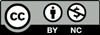

Acknowledgements
© CollinsBartholomew Ltd (2019) FOR SCHOOLS USE ONLY
© Crown copyright and database rights 2020 Ordnance Survey (100025252). FOR SCHOOLS USE ONLY.
Aerial photography © Getmapping plc. Contains OS data. FOR SCHOOLS USE ONLY.
Historic mapping courtesy of the National Library of Scotland. FOR SCHOOLS USE ONLY.

