digimapforschools.edina.ac.uk

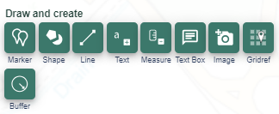
Here are some ideas to bring The Daily Mile back into the classroom with Digimap for Schools.

How to Digimap your Daily Mile !
Activity Idea 1

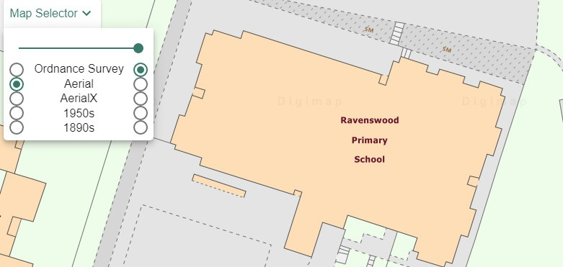
Find your school playground/playing field using the postcode or placename search, then zoom in for amazing detail. The map will show your school building footprint. You’ll probably even be able to make out where your classrooms/doors out to the playground are positioned.
You’ll see paths/tracks in your playing fields.

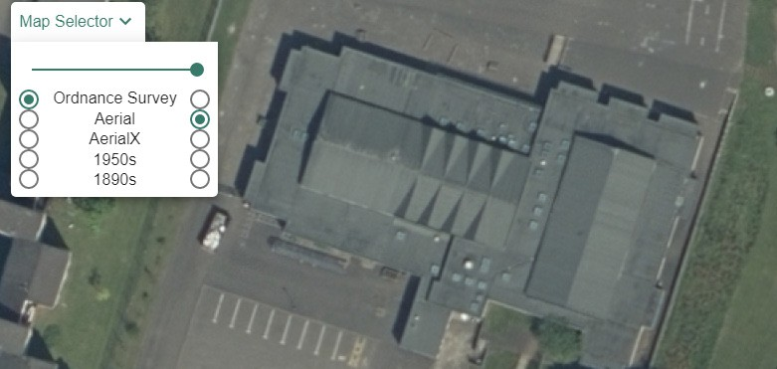
Use the line tool in our Drawing Tools to draw the route of your Daily Mile. Use the Add Measurement label tool to click on the line you’ve drawn and find out the distance your pupils have run!

To annotate your map a little more why not use the standalone label and text box tools to add information o the map. Why not label where there is a lovely tree, a piece of wildlife or a warning where there is too much
litter. You could even tie this up with your EcoSchool tidy up!

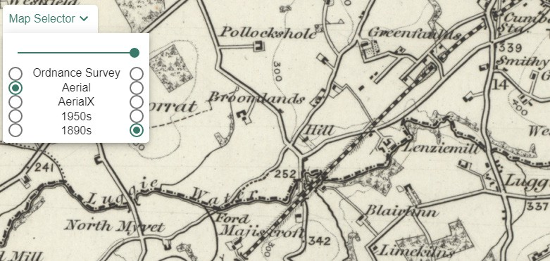
If you’d like a different perspective of what you’re
looking at then use the Map Selector to select the Aerial photography - just select the button to the right of Aerial to display it - you will see your school roof!

If you zoom out a little, you can use the Map Selector tool to find out what the local area around your school looked like in the 1890s (bottom) or 1950s, a great discussion with your pupils!

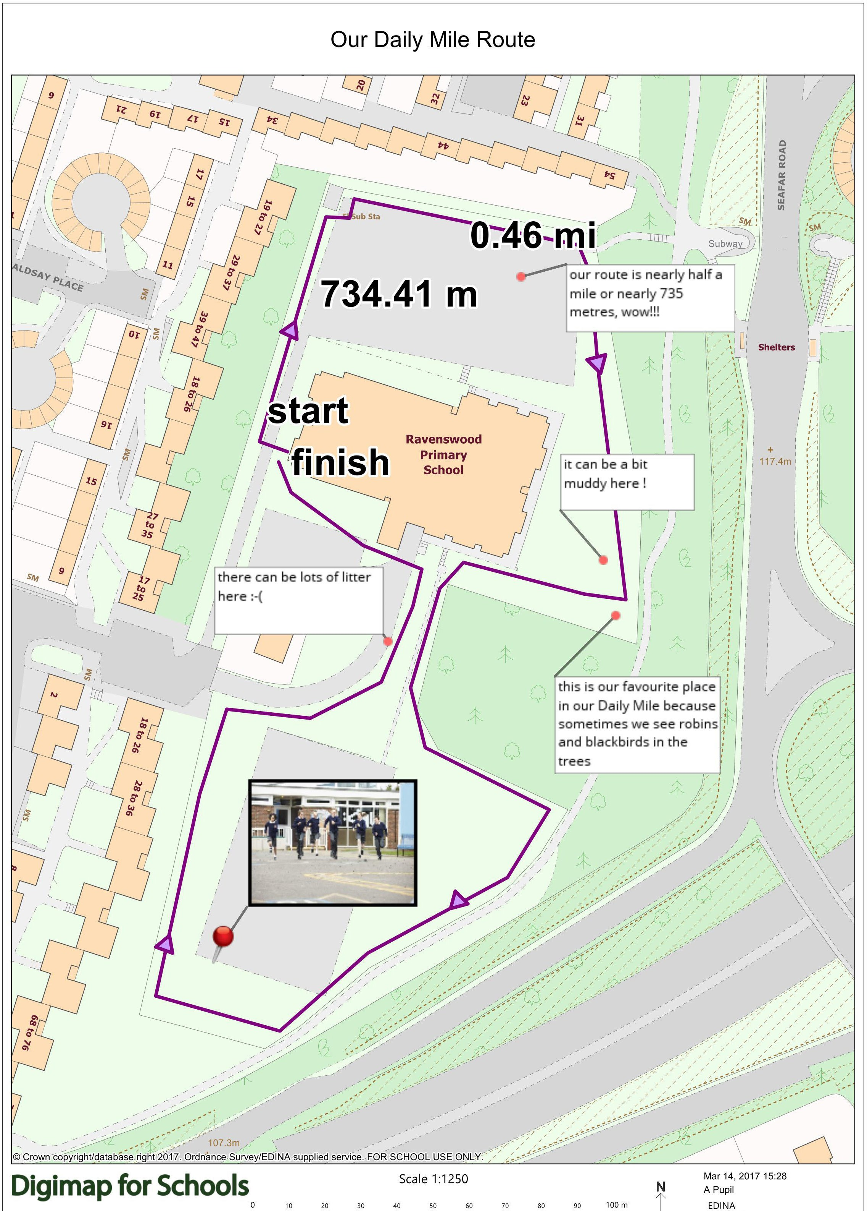

digimapforschools.edina.ac.uk

