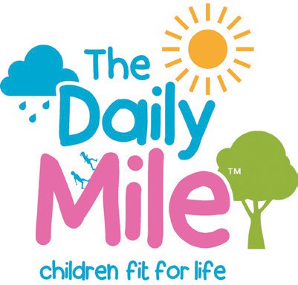
In this exercise we use the cumulative running total your pupils have run (in a week, month, year!) to find out where your pupils could have reached if they had ran this cumulative distance from your school to all the points on the compass.

How to Digimap your Daily Mile!
Activity 2

You can stick with the four cardinal points of North, South, East and West but you could expand to include the addition of the four ordinal directions of North East, South East, South West and North West. This exercise also introduces the concept of the radius of a circle and scale.

- Enter your school postcode in the search box.
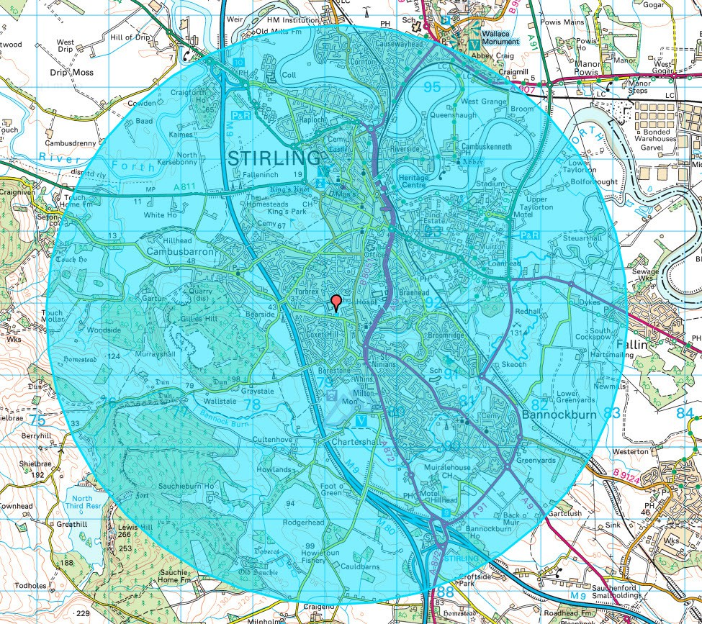
- Select the buffer tool from the Drawing Tools.
- Select point buffer.
- Enter a radius of 2.5 miles.
- Select your line and fill colours.
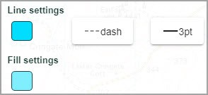

- Click on the centre of your school.

The shaded circle identifies how far ‘as the crow flies’ 2.5 miles is from your school. Tip: you might need to zoom out to see the full extent of your circle!

digimapforschools.edina.ac.uk
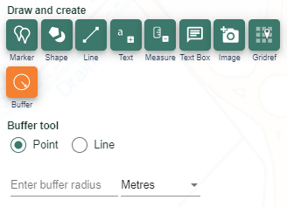

- Zoom in and move around the perimeter of your circle – zoom in and out. Ask your pupils if they recognise places.

- Use the Map Selector to view what places you could have run to in the 1890s and 1950s too! Zoom back out so that you can see the entire circle.
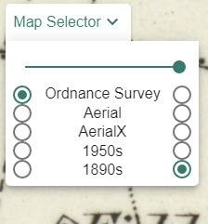

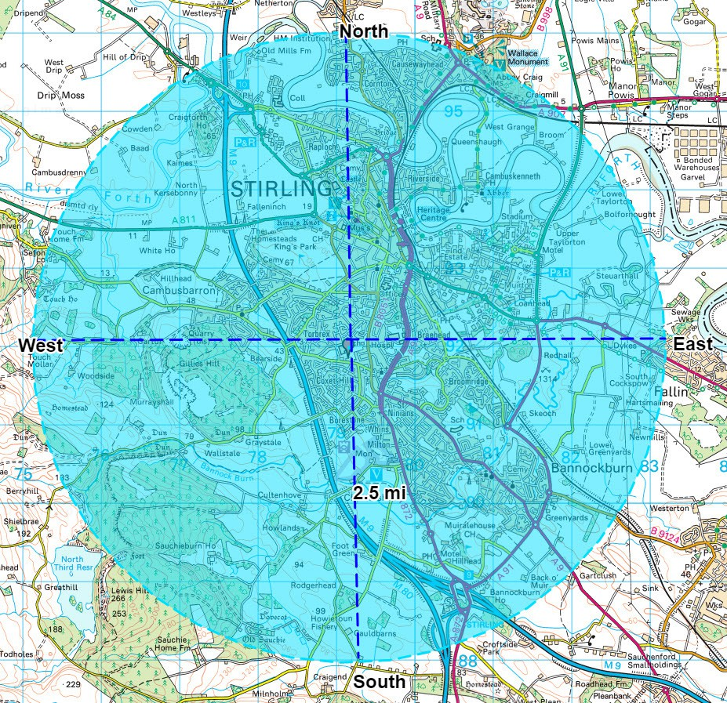
- Select the draw line tool and draw straight lines North South East and West from the centre point. Click once to start drawing and double click to finish on the circle edge. Remember you can select different colours and line styles.
- Add North, East, South, West labels with the add standalone label tool.

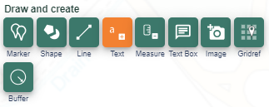

- Zoom out to a smaller scale. The circle is smaller at the smaller scale. Use the Add Measurement Label tool to confirm the radius of the circle has remained 2.5miles! Use the measurement tool to convert the distance to kilometres.
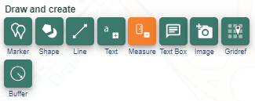

digimapforschools.edina.ac.uk

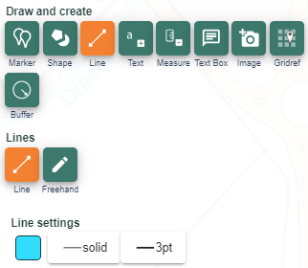

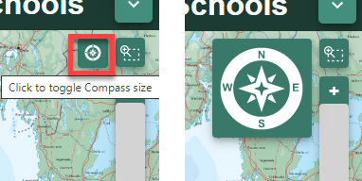
Extensions:
- Repeat the entire exercise with a circle of a larger radius representing further distances your pupils could have run in a month or even a year!

- Talk about the points of the compass. Give it a real life context by perhaps identifying where on the map your school Ecoflag is positioned in the playground and talk about what is the predominant direction it blows in. Display the compass on the map window (find this beside the scale bar). Ask your pupils to draw an arrow to show which direction they think the wind is
coming from – help them realise a ‘west wind’ means a wind that blows from the west so the flag will position itself to the east of the pole!

