How far would your pupils get along famous routes in Great Britain if they ran them as part of their Daily Mile?

How to Digimap your Daily Mile!
Activity 3

You could look at:
- Cotswold Way
- John Muir Way
- West Highland Way
- Fife Coastal Path
- Jarrow March
- Mary Queen of Scot’s life
- Hadrian’s and Antonine’s Walls

This exercise focuses upon Antonine’s Wall which runs from Old Kirkpatrick on the Firth of Clyde to Carriden on the Firth of Forth. Ordnance Survey mapping contains fabulous detail of Roman sites including the courses of the Antonine Wall, Hadrian’s Wall, the location of Roman forts and even Roman Baths!
This exercise encourages you to use the distance that your pupils have run on their Daily Mile to estimate how long it would take them to run the length of the Antonine Wall.

- You’ll need to know the distance your pupils run each day, in miles and kilometres.
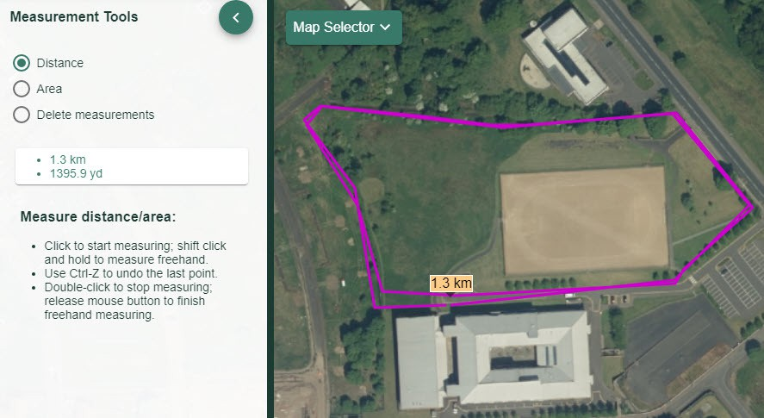
- Try our measurement tools and drawing tools to measure your route. Check Our Daily Mile Activity 2 to see how it’s done!

digimapforschools.edina.ac.uk
CARRIDEN
KINNEIL
INVERAVON
MUMRILLS
FALKIRK
WATLING LODGE
ROUGH CASTLE
SEABEGS
CASTLECARY
WESTERWOOD
CROY HILL
BAR HILL
AUCHENDAVY
KIRKINTILLOCH
GLASGOW BRIDGE
CADDER
WILDERNESS PLANTATION
BALMUILDY
SUMMERSTON
BEARSDEN
CASTLEHILL
CLEDDANS
DUNTOCHER
OLD KIRKPATRICK
BISHOPTON

Roman Forts on the Antonine Wall

- Got your route distance?

- Select a Roman Fort from the list above. We chose Duntocher.
- Search for the place name and identify the Roman Fort on the map.
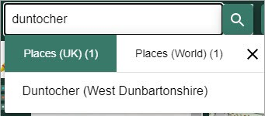

- Display the Key and to discuss with your pupils the symbols used to represent historic detail on maps.

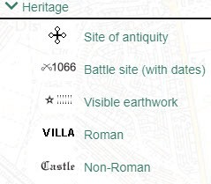

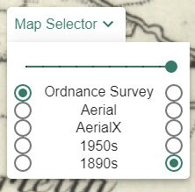
- Using the Map Selector, display an 1890s or 1950s map.
- Is there any evidence on maps from the 1890s or 1950s of the Roman forts? Do you think people in the 1890s were aware of archaeological finds? Discuss with your pupils.
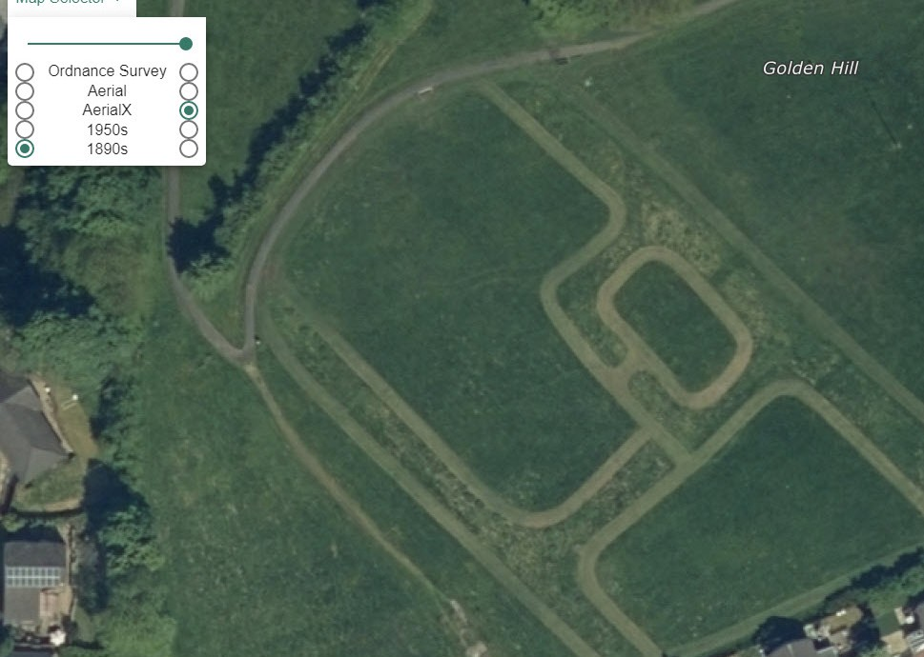
- Select Aerial from the Map Selector and zoom in as far as you can. Do you see any visible evidence of Roman habitation? Do you think aerial photography existed in the 1890s and if so, would maps from the 1890s look different?

- Return to the OS map.

- Using the measurement tools click once on the Roman fort then move along the route of the wall clicking every time you need to change direction. TIP: Use the arrow keys to move the map if you need to keep measuring and you have reached the edge of the map window.
- When you reach the distance your pupils have run over a week, double click to finish. Your distance will be displayed on the map and in the measurement tools menu.
- Talk about where they have reached. Do your pupils know the local area? What would it have looked like in Roman times?

digimapforschools.edina.ac.uk
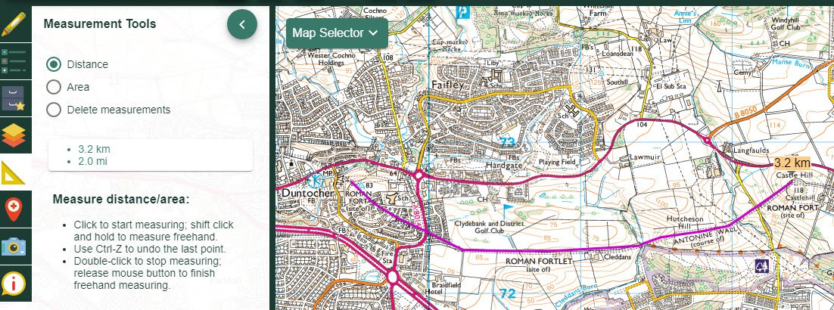
Extension:
If the full distance of Antonine’s Wall is 39 miles (63 kilometres) how many Daily Miles would
it take your pupils to travel the entire length of the wall??

