digimapforschools.edina.ac.uk

Exploring new areas

How to Digimap your Daily Mile!
Activity 5
Here are a range of ideas designed to enable teachers to use The Daily Mile and Digimap for Schools to encourage pupils to research and learn about areas beyond their own locality.

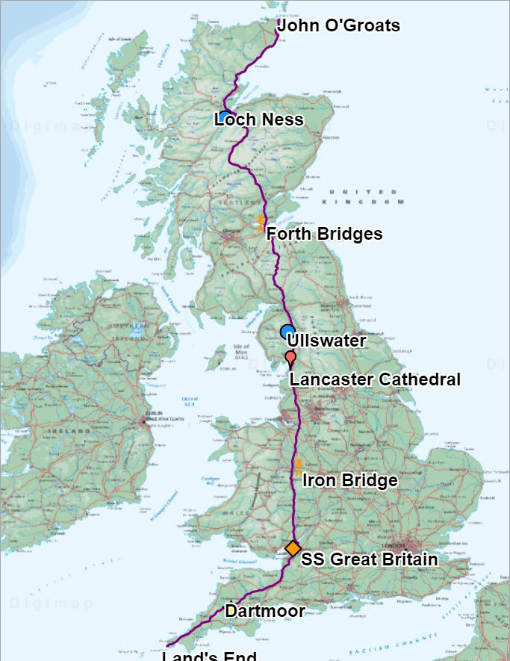
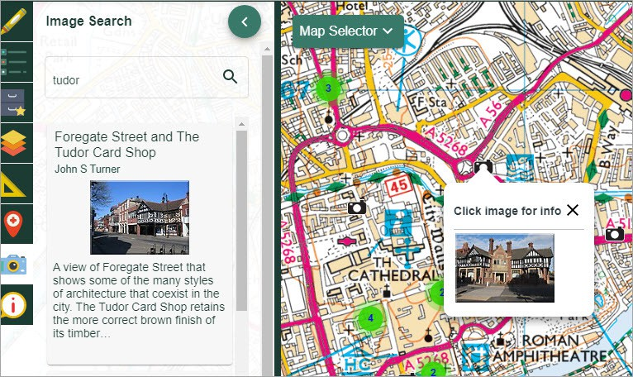
Example 1
You have decided to run from Land’s End to John O’ Groats. On the way, you will be
calling in at different landmarks. Can you plot your route via the landmarks on the map?
Remember to use the Search box if you don’t
know where Land’s End or John O’Groats are!
Example 2
You are studying the Tudors and have been looking at some of the amazing buildings they built. You would like to run to some favourites. To find examples of Tudor buildings, open Image Search, type Tudor and search. You’ll find examples all over Great Britain.
EXAMPLE 2
EXAMPLE 1

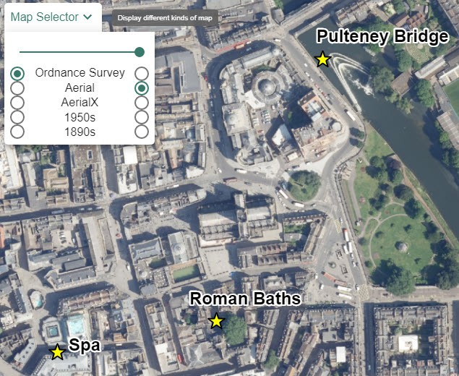
Example 3
EXAMPLE 3
digimapforschools.edina.ac.uk
You are going to run a historic site and then make a presentation about it. Use the Map Selector to view different types of mapping - aerial photography, historical and contemporary mapping
- to assist with your presentation.

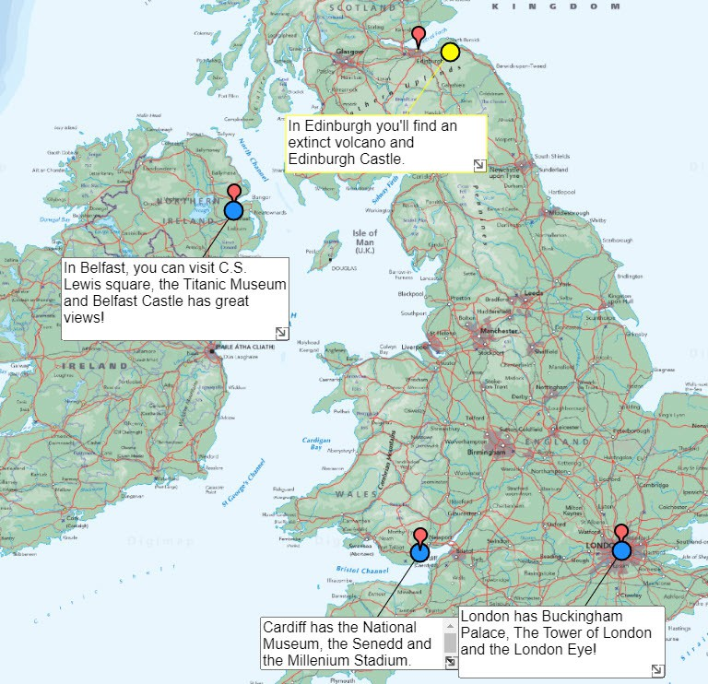
Example 4
EXAMPLE 4
You think it would be interesting to run to each of the capitals of England, Scotland and Wales.
Record the routes and use the Place text box tool to wriite some information about each capital.

