Flooding and other hazards

Paula Owens

Geography Teaching Resource

Primary
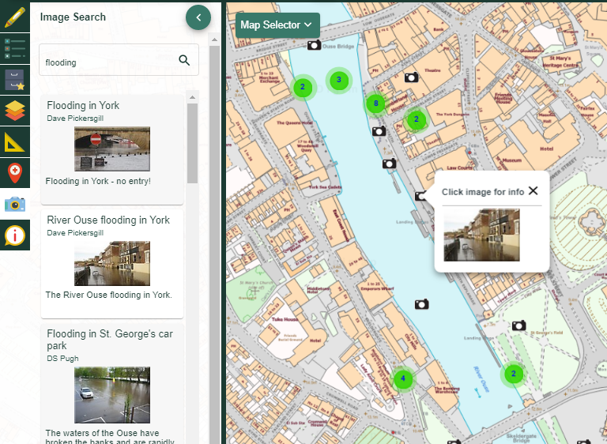

Contents
Contents 2
Digimap for Schools Geography Resources 3
Content and curriculum links 3
Flooding 5
Local Area 5
Image Search 5
Flooding Report 7
Sketch Maps 7
Fieldwork 7
In the News 8
Literacy Links 8
Numeracy Links 8
Taking it further 8
Copyright 10
Acknowledgements 10

Digimap for Schools Geography Resources
These resources are a guide for teachers to demonstrate to the whole class or direct individual students as appropriate. Each activity has several ideas within it that you can tailor to suit your class and pupils. Some resources contain worksheets for direct distribution to pupils.
https://digimapforschools.edina.ac.uk/

Content and curriculum links
Level | Context | Location
Primary, 7-11 years | Using Geograph images | Various throughout Great Britain

Knowledge/Skills | Using Geograph with maps
Curriculum links (England) | - Name and locate counties and cities of the United Kingdom, geographical regions and their identifying human and physical characteristics, key topographical features (including hills, mountains, coasts and rivers), and land-use patterns; and understand how some of these aspects have changed over time.  - Describe and understand key aspects of: physical geography, including: climate zones, biomes and vegetation belts, rivers, mountains, volcanoes and earthquakes, and the water cycle; human geography, including: types of settlement and land use...and the distribution of natural resources including energy, food, minerals and water  - Use fieldwork to observe, measure, record and present the human and physical features in the local area using a range of methods, including sketch maps, plans and graphs, and digital technologies.
Curriculum links (Wales) | - Use maps, imagery and ICT to find and present locational information. Interpret maps, and photographs.  - Describe the causes and consequences of how places and environments change, e.g. by season; from past to present; the need for sustainability.  - Carry out investigations of ‘geography in the news’, topical events and issues in the local area.
Scottish Curriculum for Excellence | - I can describe the major characteristic features of Scotland’s landscape SOC 2-07a  - I can describe the physical processes of a natural disaster and discuss its impact on people and the landscape. SOC 2-07b  - To extend my mental map and sense of place, I can interpret information from different types of maps and am beginning to locate key features within Scotland, UK, Europe or the wider world. SOC 2-14a

Flooding
Digimap for Schools can help children document, describe and explain incidences of flooding and other hazards, aided by a library of images from Geograph in the Image Search menu.
Every year, incidences of flooding in Great Britain appear on the news, sometimes causing people to be evacuated from their homes and often causing travel disruptions. Coastal as well as inland areas can be identified as being within a flood hazard area while weather services advise us when adverse weather is imminent and which rivers are on flood alert. Flooding is part of our everyday lives and vocabulary and one of several environmental hazards that we live with, although some people are affected more than others.
Do you live in an area that has been affected by flooding? Have you heard or read about a major flooding event in Great Britain that has caused severe disruption? Have you ever experienced any flooding at first-hand? Ask children what their experience of flooding is and find out what they know. There may be a topical news story and / or there may be some local incidences of flooding in the past that will make this issue relevant to children.

Local Area
- Brainstorm what children already know about local flooding and create a list of places where flooding is thought or known to have occurred.
- Using Digimap for Schools bring up a large-scale map of the local area and identify places where this flooding is thought to have occurred.
- Add markers and use two colours to identify places where children are certain flooding has occurred, and which are well documented, and where they think it may have occurred but where there is no immediate evidence available.

Image Search
Open the Image Search menu.
- Type in ‘flooding’ into the search bar.
- Investigate what the available images tell you.
  - Are there lots of images of flooding in your locality?
  - Do the available images match the places you have already identified with markers?
  - How well do children’s perceptions of flooding match the available images?
  - Are there image ‘hotspots’? Where are these and how can they be explained?
  - When were the images taken? Is there one year where a lot of flooding images were taken indicating a severe weather event that year? What time of year features most?
  - Can you find any images which show some impacts of a flooding event? What does this tell you about the effect on people?
- Select a flooding hotspot and choose three images that best explain what has happened. Using information from the images, add some text boxes to points on the map to explain a) what has happened and b) the impact of a flooding event.

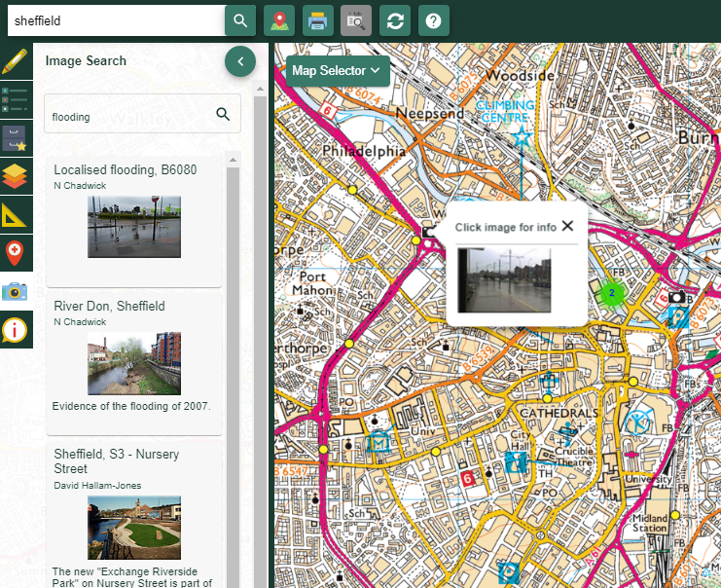

Children could research in groups to create their own report about flooding in the local area and identify areas which are particularly at risk. Having identified areas of risk, these could be highlighted using the Area Tool with the ‘Fill Area’ set to 50% transparency.

Flooding Report
Older children could write a more detailed report, adding suitable images from Geograph to illustrate this. They might investigate map features such as slope, river channelization, height above sea level and urbanisation to help them explain in more depth why some areas are high flood risk.
Children could work in groups with a given area and year to compare changes in the environment over time. The historical layer maps on Digimap for Schools could add a further layer of understanding as they may help explain how places have changed in ways that influence the degree of flood risk. For example, increased urban development may be a negative factor in some places whilst increased sea defences may alleviate flooding from the sea in others.

Sketch Maps
Ideally, annotated sketch maps are best done in situ during fieldwork. If this is not possible, photographs can be used to annotate the view of the landscape. Print a chosen Geograph image of a flooded area in greyscale and ask children to use coloured felts to draw on and annotate features. Or use the full and original chosen image on the Interactive Whiteboard and ask children to draw their own annotated sketch map based on what they can see. Identify where on the map the image is from and add a marker and a text box. Children could then take a photograph of their sketch map and upload it to the marker location on the Digimap for Schools’ © map using the Photo Tool.

Fieldwork
Investigating local flood hazard areas is a good opportunity for fieldwork. It may be that children use images from Geograph to first practise their annotated sketch maps in the classroom before doing them in the field. Children could take their own images out in the field identifying risk factors and impacts and add them to maps of the local area when back in school.

In the News
Use topical links to a flooding event somewhere else in the country and use the above ideas to describe and explain the flooding and why it happened where it did. Available television clips and newspaper stories can be used to add details to maps. Use appropriate search terms to find Geograph images that will help illustrate before and after scenarios.

Literacy Links
- Create a short spoken or written report about flooding events in your area. Use maps and images to back up your explanation.
- Create a dramatic story about a flooding event and how it affected one family. Or, through the eyes of a member of the Emergency Services called to respond.
- Write a newspaper front page based on a local flood event and select images from Geograph to illustrate. Use maps to show in detail where and how the drama unfolded.
- Read newspaper stories and listen to news stories about flooding events.

Numeracy Links
- Create an infographic poster about flooding in your own (or another) area with graphs, tables, images and number statistics. Include Grid References, percentages and / or measurement statistics. Be creative and produce something eye catching.
- Create a ‘Living Graph’ based on weather data during the flooding event to identify how the flooding event developed and what the impacts were during that time scale, adding in precise location data.
- Identify and measure lengths of a river course or coastline where flooding is particularly likely to happen.

Taking it further
We live with many hazards in Great Britain as well as flooding which can occur causing changes in our physical landscape and impact on our everyday life. Here are some other examples that could be used as search terms and investigated in much the same way.
- Landslip
- Coastal erosion
- Other severe weather events such as snow and blizzards, storms and tornadoes, heatwaves.
- Sinkholes
What other terms and hazards could children come up with?
Using their knowledge of local hazard events, ask children to think of sustainable scenarios for the future. They would need to think about improving the quality of the environment, people’s quality of life and how this might contribute to financial wellbeing too e.g. by providing jobs.

Copyright
©EDINA at the University of Edinburgh 2017
This work is licensed under a Creative Commons Attribution-Non Commercial Licence

Acknowledgements
© CollinsBartholomew Ltd (2019) FOR SCHOOLS USE ONLY
© Crown copyright and database rights 2020 Ordnance Survey (100025252). FOR SCHOOLS USE ONLY.
Aerial photography © Getmapping plc. Contains OS data. FOR SCHOOLS USE ONLY.
Historic mapping courtesy of the National Library of Scotland. FOR SCHOOLS USE ONLY.

