**Using Image Search**

Paula Owens

**Geography Teaching Resource**

Primary

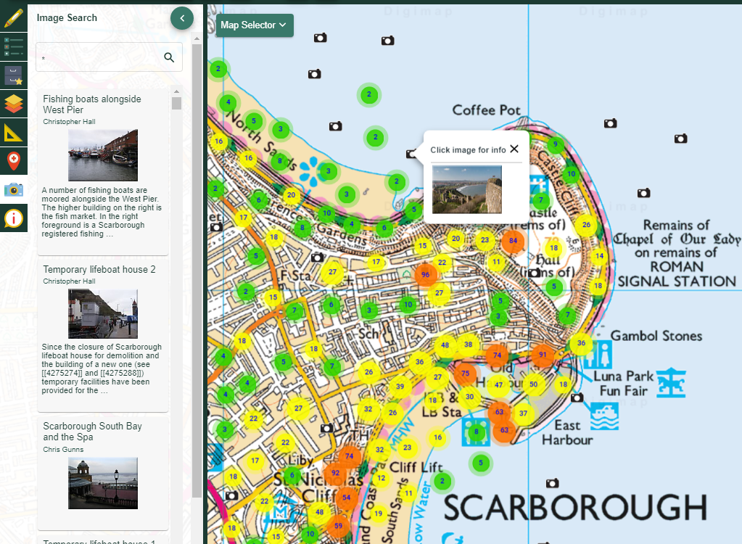

# Contents

Contents 2

Digimap for Schools Geography Resources 3

Content and curriculum links 3

Introducing Image Search 4

Investigating with Geograph 4

Using Image Search 4

Search terms 5

Searching images 5

Using Image Search to enhance existing resources 6

Who goes to School by Boat 6

Landscape Fingerprints 6

Aerial Images: Landmarks 7

Transport, travel and trade 7

Literacy Links 7

Numeracy Links 7

Fieldwork Links 8

Copyright 9

Acknowledgements 9

# Digimap for Schools Geography Resources

These resources are a guide for teachers to demonstrate to the whole class or direct individual students as appropriate. Each activity has several ideas within it that you can tailor to suit your class and pupils. Some resources contain worksheets for direct distribution to pupils.

<https://digimapforschools.edina.ac.uk/>

# Content and curriculum links

|  |  |  |
| --- | --- | --- |
| **Level** | **Context** | **Location** |
| All | Using Image Search to find Geograph images | Can be applied anywhere in the UK |

|  |  |
| --- | --- |
| Knowledge/Skills | Using Image Search for Geograph images |
| Curriculum links (England) | * Name and locate counties and cities of the United Kingdom, geographical regions and their identifying human and physical characteristics, key topographical features (including hills, mountains, coasts and rivers), and land-use patterns * Use fieldwork to observe, measure, record and present the human and physical features in the local area using a range of methods, including sketch maps, plans and graphs, and digital technologies. |
| Curriculum links (Wales) | * Use maps, imagery and ICT to find and present locational information. Interpret maps, and photographs. * identify and describe the spatial patterns of places and environments and how they are connected. Identify and describe natural and human features, e.g. weather conditions, types of buildings. |
| Scottish Curriculum for Excellence | * I can describe the major characteristic features of Scotland’s landscape SOC 2-07a * To extend my mental map and sense of place, I can interpret information from different types of maps and am beginning to locate key features within Scotland, UK, Europe or the wider world. SOC 2-14a |

# Introducing Image Search

The Image Search menu in Digimap for Schools offers access to the [Geograph image library.](https://m.geograph.org.uk/)

Users can search and view geo-referenced photographic imagery to complement the existing, mapping and aerial imagery tools. Using the image Search on the toolbar, you can now browse and search thousands of geo-referenced photographs across Great Britain and investigate places, landscapes and regions in even greater depth.

These resources provide some ideas to get started using Image Search with different age groups and across different subject areas including links to literacy and numeracy. In addition to this overview there are some separate activities for ages 5–7 and 7–11 years.

# Investigating with Geograph

Maps help us notice, name, describe and locate the features of a landscape by using a combination of symbols, patterns, colours, numbers and text. Geograph images add another layer of meaning by giving us photographic evidence of what can be seen at various locations. As all images are crowd-sourced and covered by the Creative Commons Licence, they not only provide a diverse view of Great Britain but can be used to aid and illustrate further work and investigation.

# Using Image Search

* Click on the Image Search camera icon on the toolbar and a search bar appears that allows you to search for photographs on the map using specific words or terms.
* You could also browse the alphabetically organised elastic search facility which, will suggest options based on the initial letters that you type.
* You can then zoom in and out of the map to see the mapped photographs that meet your search enquiry.
* The location and number of photographs in an area is shown through a series of markers which become thumbnails as you zoom in further.
* Each thumbnail can be clicked to view as a larger photograph and has a title, a description, the photographer’s name and date when it was taken.
* Note: you can type an asterisk (*) to see all available images at a location – ONLY in the 5 most zoomed in map views.

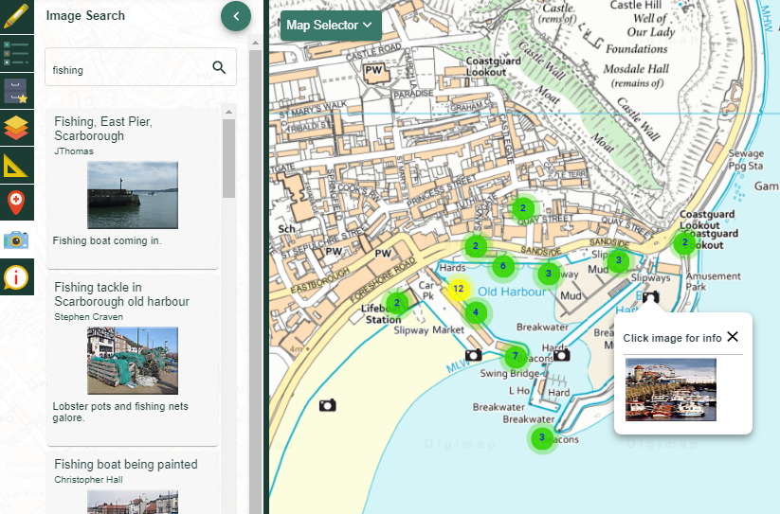

# Search terms

You can search using a specific or a generic feature term. For example, Lake Windermere, Edinburgh Castle, Mount Snowdon, Buckfast Abbey, and The Smalls Lighthouse are all examples of specifically named features with singular identities whilst lake, castle, mountain, abbey, wood and lighthouse are terms used to denote generic features. Ask children to try out different words and explore both the range of what they can find out and the most useful search terms. From glacial deposits to spider’s webs to mosques – you will be surprised what you can discover. Pool ideas and strategies to increase children’s skill as a landscape researchers and detectives.

# Searching images

General questions you might ask when using the search feature (you might think about differentiation here in general terms e.g. Early, developing, extending and consolidating understanding).

* What feature name do I want to search for? (Early)
* What is the best term to use? (Developing)
* How can I explain the distribution of a feature? (Extending)
* What predictions can I make about feature type and location (Consolidating)

You can also interrogate each image more carefully, for example by using some of the questions given below.

* What can you see in the image? Can you recognise and name features? (Early)
* Can you describe what you see using appropriate adjectives? (Early)
* Can you compare images noticing changes such as weather, time of year etc? (Developing)
* Can you identify and explain what is happening in the image (For example, human processes such as settlement, traffic, farming, quarrying and natural processes such as erosion, landslip, accretion and deposition? (Developing)
* Whereabouts on the map do you think the image was taken? Can you give a precise Grid Reference? (Extended)
* Can you explain why a feature shown in the photograph is found in that location? (Extended)
* Can you suggest where similar images might be found and explain why? (Consolidating).

# Using Image Search to enhance existing resources

There is a wide suite of resources available for different age groups on the Digimap for Schools website and these have been written for use with the current maps, the historical maps and the aerial imagery layers in mind. Geograph images can enhance these existing resources. Here are some examples:

## Who goes to School by Boat

This resource for younger children investigates how and why children travel to school by boat in the Scilly Isles. Using the term Scilly Isles and browsing this location for Geograph images will give useful background information about the appearance of the landscape in this area, whilst using the search term ‘school’ and limiting this search to the Scilly Isles may provide a photograph of the school in the activity.

## Landscape Fingerprints

A resource for children aged 7 – 11 to help them investigate contours in the context of significant mountains in Great Britain. You could use Geograph images to help you further explore and understand the patterns and meaning of the contours on the map. Here you might use locational search terms such as e.g. ‘Brecon Beacons’, generic terms such as ‘mountain’ or more specific terms such as e.g. ‘Pen Y Fan’. Encourage children to discuss which kind of term best suits the purpose.

## Aerial Images: Landmarks

This resource has some activity ideas for children aged 5 – 7 and involves exploring some notable landmarks in England, Scotland and Wales using aerial imagery as well as maps. At each location, use the appropriate search term to explore available photographs that reveal the landmark in more detail.

## Transport, travel and trade

A resource for children aged 7 – 11 that investigates aerial imagery of key transport links and facilities. Using Geograph would enable you to add location appropriate images of different forms of transport and the road, rail and water networks that connect them. This activity would also help children consolidate their knowledge of transport vocabulary and is one of many examples of potential literacy links to be made.

# Literacy Links

Geograph images provide many opportunities to develop literacy skills and deepen understanding about features and processes in the wider world.

* develops oracy, by encouraging children to listen and talk about what can be seen, name features and use descriptive and comparative terminology.
* develops writing skills by creating visual prompts that children can use for story settings and provides a wealth of background information and illustration for non – fiction texts.
* develops reading skills by promoting interest in, and research of, relevant content.

# Numeracy Links

Geograph images provide opportunities for exploring mathematical and numeracy links in real life contexts.

* develops number skills by providing opportunities for counting, sorting, ranking and classifying images at various locations.
* allows children to measure the size or area of features such as the size of a lake or the distance between features such as two farms in the same village using Digimap Tools.
* develops awareness of time through investigating the season and year when an image was taken.
* provides opportunities for data handling skills by organising and categorising information by type, location and date.
* Develops spatial awareness by encouraging and supporting the use of locational referencing codes such as Grid References.

# Fieldwork Links

* Visit places in your locality to find the location of Geograph photographs and replicate the image. How do they compare?
* Take and upload your own photographs with their Grid Reference to Geograph. Write an accompanying description.

# Copyright

©EDINA at the University of Edinburgh 2016

This work is licensed under a Creative Commons Attribution-Non Commercial LicenceCreative commons licence, CC BY NC

# Acknowledgements

© CollinsBartholomew Ltd (2019) FOR SCHOOLS USE ONLY

© Crown copyright and database rights 2020 Ordnance Survey (100025252). FOR SCHOOLS USE ONLY.

Aerial photography © Getmapping plc. Contains OS data. FOR SCHOOLS USE ONLY.

Historic mapping courtesy of the National Library of Scotland. FOR SCHOOLS USE ONLY.