Getting here

Comparing routes to schools

Alan Parkinson

Geography Teaching Resource

Secondary

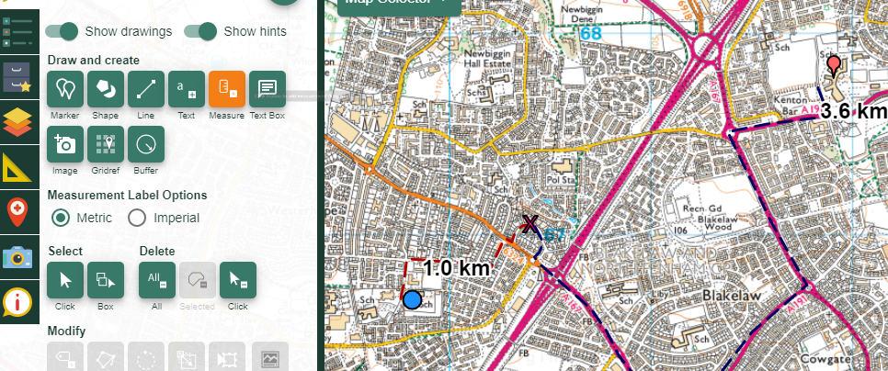

Contents
Digimap for Schools Geography Resources 3
Content and Curriculum Links 3
Introduction 4
Activity 4
Example map 4
Tasks 5
Task 1 Find your locations 5
Task 2 Mark your locations 8
Task 3 Draw primary route 9
Task 4 Draw secondary route 10
Task 5 Add labels and print 11
Task 6 Compare journeys 12
Taking it further 13
Copyright 13
Acknowledgements 13

Digimap for Schools Geography Resources
These resources are a guide for teachers to demonstrate to the whole class or direct individual students as appropriate. Each activity has several ideas within it that you can tailor to suit your class and pupils. Some resources contain worksheets for direct distribution to pupils.

Content and Curriculum Links
Level | Context | Location
Secondary. | Comparing routes to primary and secondary school | Any schools.

Knowledge | Introduction to Digimap for Schools. Zoom levels.
Curriculum links (England) | Map skills/local geography.
Curriculum links (Wales) | Locating places using maps and using maps of different types and scales to interpret and present locational information.
Scottish Curriculum for Excellence | Social studies outcomes: people, place and environment: 0-07a, 1–14a, 2–09a.

Introduction
This activity is suitable both for beginners and as a refresher for students who are already familiar with the software from use at primary.

Activity
This activity can be run by handing out the student activity sheet, or you may prefer to ‘model’ the process on an interactive white board as the students work with you on screens in front of them.

Example map
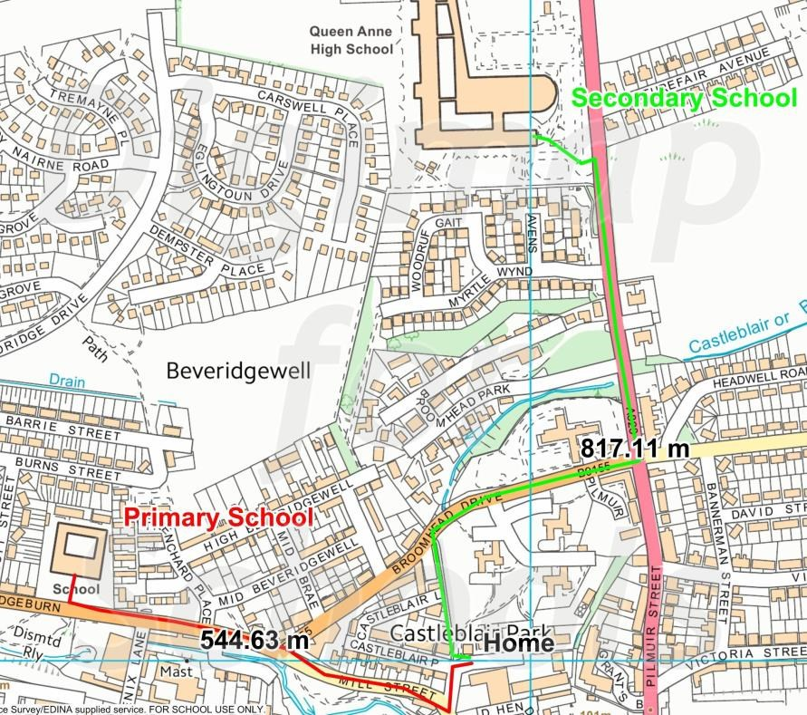

Tasks
You are going to compare the journey that you used to make to your primary school with the journey that you now make to come to this school.

Task 1 Find your locations
- Login to Digimap for Schools.
- Find a suitable map that shows both the primary/middle school that you attended, and where you live.
- Enter a postcode (or place name) to find the map you want and zoom so that both your primary school and home are on the screen.
- Make your map bigger if that will help.
- Which one of these types of map are you looking at?

OS Landranger scale mapping (individual buildings are not often shown):
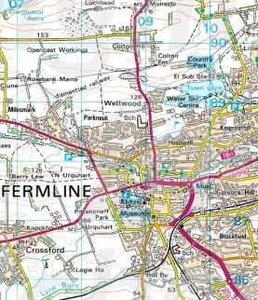

OS Explorer mapping (bigger buildings are shown, but smaller ones are grouped):
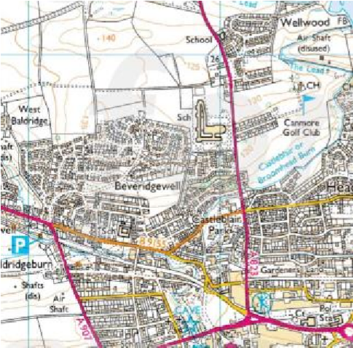

OS VectorMap Local scale mapping (most buildings and street names are shown).
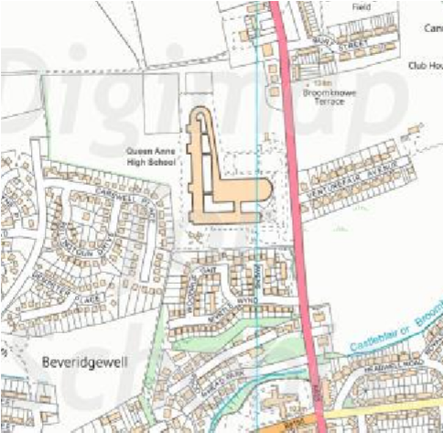

OS MasterMap (buildings are shown in a lot of detail):
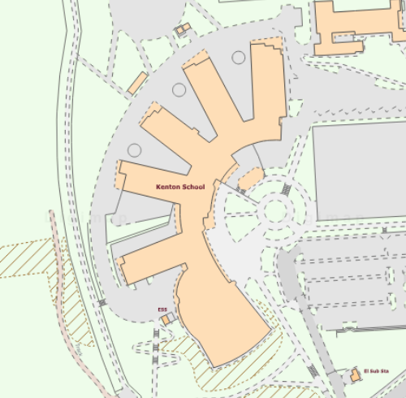

Task 2 Mark your locations
- Mark your primary school and home.
- Open the Drawing Tools.
- Click on the Marker button.
- Select a marker.
- Click on the map to mark your school.
- Also add a marker to mark your home. Pan and zoom the map if you need to.

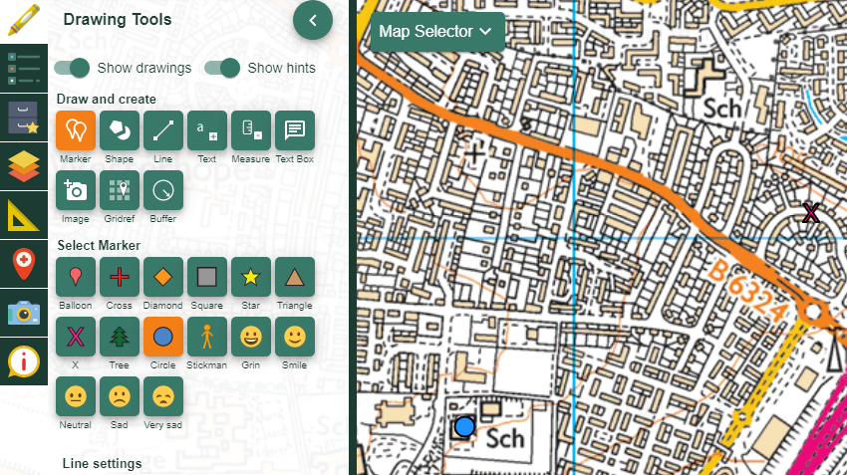

Task 3 Draw primary route
Draw the route from school to home.

- Select the line tool.
- Change the style and colour of the line if you wish.
- Click once on the map at either of your markers to start drawing your route. Every time you want to change direction you need to click. Double click to finish drawing your line.
- If you need to delete your line and start again select Delete Click button and click on the line.
- Now click on the measure tool and click on to your line to find its total length.

Write your answer here.

My journey to primary school was …………………………km/miles

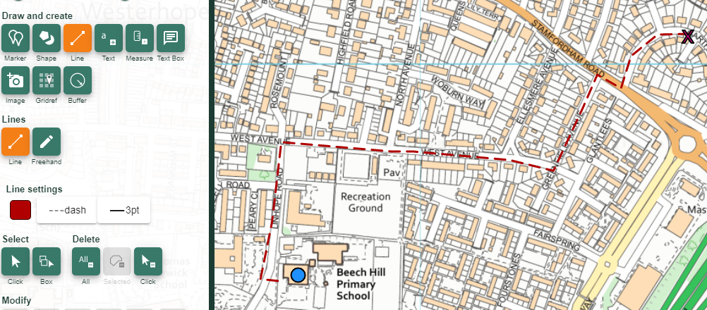

Task 4 Draw secondary route
Add your secondary school journey.

- Repeat the above from step 2 for your journey to the school you attend now.
- Choose a different colour and style of line to show this journey.
- Write your answer here:

My journey to secondary school is……………………km/miles.

Task 5 Add labels and print
Add labels to each place.

- Select the Text tool.
- Then choose the colour and size of text using the Text settings.
- Then select the location on the map and type your text.
- If you want to change the text afterwards you can click on it to select it. You can change the words, text colour and size.
- To reposition the label (or any feature) just click and drag it to a new position. N.B. Make sure the select button is orange before you click and drag.
- Once you are happy with your map close the Drawing Tools.
- Save your map to a folder as instructed by your teacher.
- If you are printing your map select a scale that shows both of your journeys. Check the Layout to make sure the print will cover the right area.

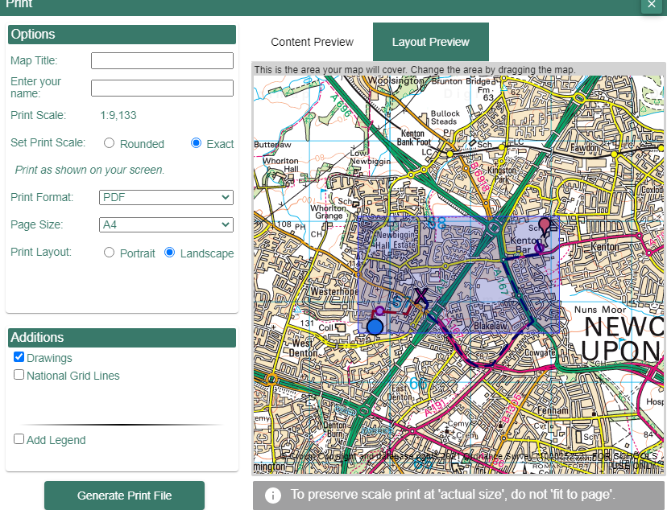

Task 6 Compare journeys
- Write a comparison of the two journeys which includes the distance travelled, the time involved and the method of travel.
- Write some simple route instructions for one of these routes:

  - Mention any important landmarks that are shown on the map.
  - Show someone else the starting point and give them the instructions.
  - Can they find their way to the right place?

Taking it further
- Does your school have a website which shows the location of your school? Why not check out these maps, and maybe create a better one.
- Ask students to create a similar task sheet as if they were the teacher, to explain how to add some other feature to the map.
- This activity could be linked with school travel planning and identifying safer routes to school.

Copyright
©EDINA at the University of Edinburgh 2016
This work is licensed under a Creative Commons Attribution-Non Commercial Licence

Acknowledgements
© CollinsBartholomew Ltd (2019) FOR SCHOOLS USE ONLY
© Crown copyright and database rights 2020 Ordnance Survey (100025252). FOR SCHOOLS USE ONLY.
Aerial photography © Getmapping plc. Contains OS data. FOR SCHOOLS USE ONLY.
Historic mapping courtesy of the National Library of Scotland. FOR SCHOOLS USE ONLY.

