Taste of Scotland

Paula Owens

Geography Teaching Resource

Primary
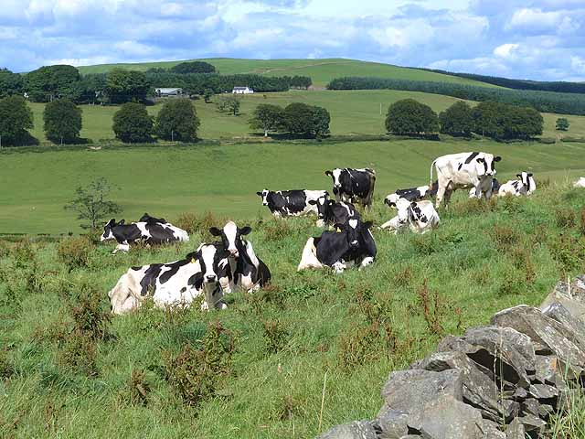
Cows above the valley of the Corrie Water
cc-by-sa/2.0 - © Oliver Dixon - geograph.org.uk/p/3579374

Contents
Contents 2
Digimap for Schools Geography Resources 3
Content and curriculum links 3
Activity 4
Introduction 4
Main activity 4
Part 1 – What a farmer needs to make ice cream 5
Part 2 – What can you find out about the farm from the map? 5
Locate and label the farm 5
Hand out notes 5
Explore the farm – hand out 6
Part 3 – how far does the ice cream travel from the farm? 8
Taking it further 9
Web links 9
Copyright 10
Acknowledgements 10

Digimap for Schools Geography Resources
These resources are a guide for teachers to demonstrate to the whole class or direct individual students as appropriate. Each activity has several ideas within it that you can tailor to suit your class and pupils. Some resources contain worksheets for direct distribution to pupils.
https://digimapforschools.edina.ac.uk/

Content and curriculum links
Level | Context | Location
Primary | Organic ice cream production in Galloway | Galloway, Scotland

Knowledge/Skills | Locating places using given directions/using a key/adding markers and labels
Curriculum links (England) | Describe and understand key aspects of human geography, including: land use; economic activity, and the distribution of natural resources including food
Curriculum links (Wales) | Social Studies Outcomes: People, Place and Environment 1-09a, 2-08a, 2-14a
Scottish Curriculum for Excellence | Use maps, imagery and ICT to find and present locational information; measure, collect and record data through carrying out practical investigations using secondary sources

Activity
Investigating the features of a dairy farm producing ice cream and how lots of different factors are important for this to be a successful industry.

Introduction
Food production is a very important industry in Scotland. One in five people in Scotland working in manufacturing are in the food industry (Scottish Government 2013). The ‘Cream o’ Galloway’ is a 340 hectare farm on the edge of a National Scenic Area in south-west Scotland, with 90 Ayrshire cows, a small Angus suckler herd and 500 ewes. The business includes ice cream production and tourism, with a family visitor centre and woodland (with nature trails) which welcomes over 70,000 visitors a year. Cream o’ Galloway ice cream is sold across Great Britain. Using Digimap for Schools, pupils can investigate features of the setting and location of this farm and how far the product travels.

Main activity
There are three parts to this activity which can be spread out over more than one session.

Introduce the farm you are going to be talking about and the ice cream it produces using either their website or the short film about what they do. (See web links).
There is also a background information sheet.

Part 1 – What a farmer needs to make ice cream
- Discuss with your class what the most important things are that a farmer needs to make good ice cream. Use the card sorting activity provided and the worksheet to record ideas about what a farmer might need and how these things are connected. Pupils could work in groups to sort the cards, decide which things are more important and how they might be connected.
- Cows are kept indoors during the winter months then are let outside into the fields again in the spring. Why is this? Do the pupils think the cows get excited about going outside again? Watch the video clip ‘Cows out to grass’ (see web link). Do they think happy, content cows produce better quality milk?

Part 2 – What can you find out about the farm from the map?

Locate and label the farm
- Ask the pupils to open Digimap for Schools and find the farm by using the postcode of the farm: DG7 2DR
- When pupils find ‘Rainton’ ask them to add a marker.
- Ask them to open the Drawing Tools and select the Marker button.
- Choose a marker and click on the farm.
- Select Text button.
- Select font type, size (18) and colour and then click on the farm and type ‘Cream o’ Galloway’.

Hand out notes
Encourage pupils explore the farm by zooming in as far as possible to the OS MasterMap® level (highest detail) and finding all the items on the following hand-out and label them on the map.

Explore the farm – hand out

The map extract below shows tracks. What activity do you think takes place here?
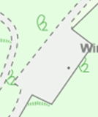
What is this feature on the map? Clue 1: look at the black dot on the grey and use the map Key to find out what this means. Clue 2: it can be found approximately 300m SW of Rainton farm buildings.

Paths – the picture below is the nature trail map from the website, why (and in what ways) does it look different to the real map in Digimap for Schools?

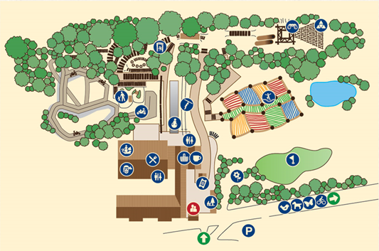

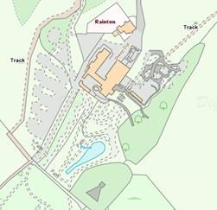

Find this view and label where you think the following are:

- Visitor car park
- Pond
- Cras’ nest viewing tower
- Grass and pasture
- Outdoor adventure playground
- Tube slide
- Indoor play barn

Ask them to describe the farm using what they have found out from the map. They could also choose the best map view of the farm and save it with a title and/or print it out.

Here are some things you might discover at Cream o’ Galloway Label on your map as you find them:
What is this feature on the map, left? Clue 1: look at the black dot on the grey and use the map Key to find out what this means. Clue 2: it can be found approximately 300m SW of Rainton farm buildings.

Part 3 – how far does the ice cream travel from the farm?
‘Local’ food is usually defined as that supplied within a 30–50 mile radius of the source.

- Pupils can find this link from the website www.creamogalloway.co.uk/stockists and investigate where the ice cream is sold.
- Ask pupils to enter the first part of the farm’s own postcode, DG7 and search within a 50 mile radius for stockists.
- Are there many outlets?
- What do the results tell you?
- How far does the ice cream travel and what kinds of shops stock it?
- Do pupils think they sell it in a shop near them?
- Ask them to enter the first part of the school postcode to find the nearest supplier. If there is nothing within two miles of the school postcode, gradually try a wider area using the search tool.
- Where can we buy it? When you find the nearest shop or stockist, make a note of the postcode. Using this postcode and that of your school and the farm at DG7 2DR add three markers to the map and label ‘Our nearest shop’, ‘Cream o’ Galloway’ and ‘Our School’.
- Measure the distance from the farm to the shop by using the Measuring tool ‘Measure distance’. Click on the farm and drag the mouse to your nearest supplier in a straight line (measuring ‘as the crow flies’). See the measurement in kilometres or miles.
- Ask pupils to explain why people would want to buy this ice cream and how good the location of the farm is for producing dairy products, hosting a visitor centre and distributing its goods.

Taking it further
- Find out what other foods come from Scotland. Create a map with locations and labels to show the different kinds of food and drink and where they are located.
- Investigate ‘organic’ farming and whether you think this is a good idea or not for farmers, customers and the environment.

Web links
- Ice cream outlet www.creamogalloway.co.uk/
- Cows out to Grass video https://safeshare.tv/x/GiVdbZRFkH
5. Soil Association https://www.soilassociation.org/
6. Scottish Government information about the food and drink industry https://www.gov.scot/policies/food-and-drink/
7. Cream o’ Galloway Flickr images https://www.flickr.com/photos/creamogalloway/

Copyright
©EDINA at the University of Edinburgh 2016
This work is licensed under a Creative Commons Attribution-Non Commercial Licence

Acknowledgements
© CollinsBartholomew Ltd (2019) FOR SCHOOLS USE ONLY
© Crown copyright and database rights 2020 Ordnance Survey (100025252). FOR SCHOOLS USE ONLY.
Aerial photography © Getmapping plc. Contains OS data. FOR SCHOOLS USE ONLY.
Historic mapping courtesy of the National Library of Scotland. FOR SCHOOLS USE ONLY.

