**Aerial Landmarks**

Paula Owens

Geography Teaching Resource

5-7 years

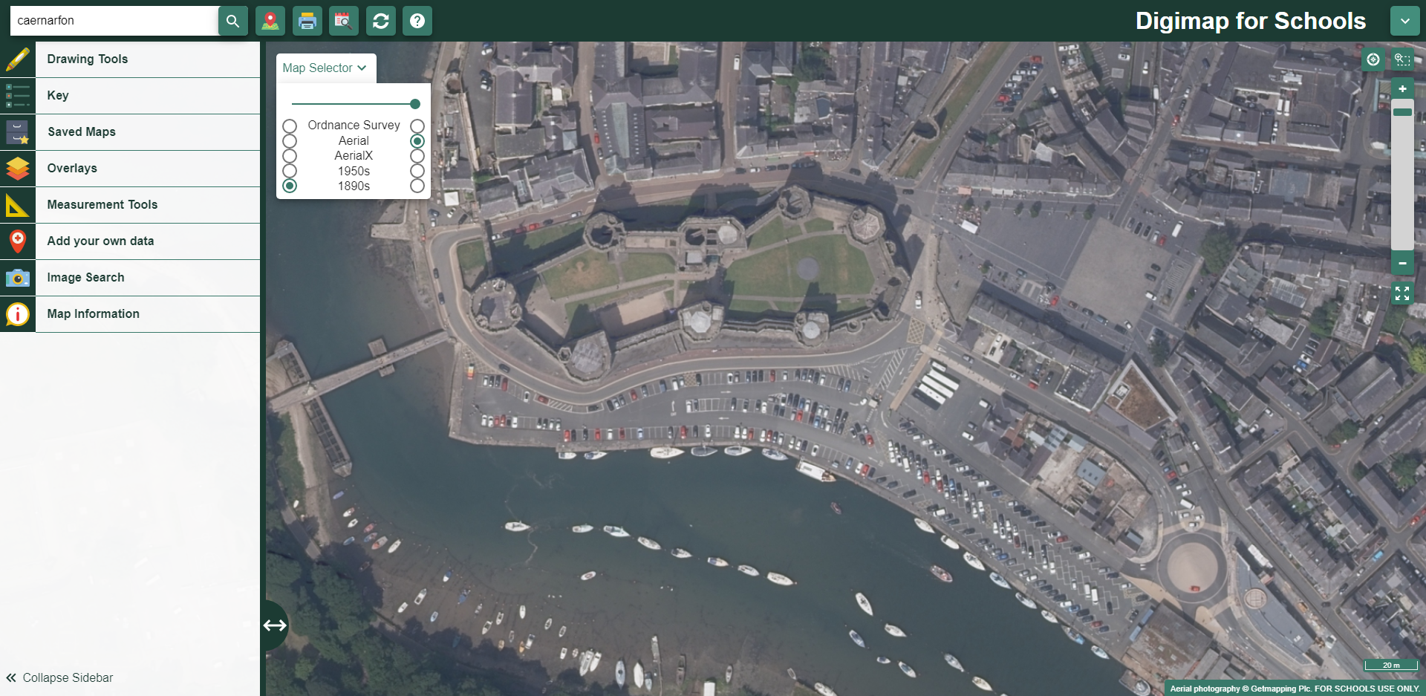

Contents

Digimap for Schools Geography Resources 3

Content and Curriculum Links 3

Introduction 5

Main activity 5

1 Buckingham Palace, London 6

2 Arthur’s Seat, Edinburgh 8

3 Caernarfon Castle 10

Taking it further 12

Copyright 13

Acknowledgements 13

# Digimap for Schools Geography Resources

These resources are a guide for teachers to demonstrate to the whole class or direct individual students as appropriate. Each activity has several ideas within it that you can tailor to suit your class and pupils. Some resources contain worksheets for direct distribution to pupils.

<https://digimapforschools.edina.ac.uk/>

# Content and Curriculum Links

|  |  |  |
| --- | --- | --- |
| **Level** | **Context** | **Location** |
| 5-7 years | Landmarks in Great Britain | Various |

|  |  |
| --- | --- |
| **Knowledge** | Using aerial imagery with maps |
| Curriculum links (England)  Geography KS1 | Use basic geographical vocabulary to refer to:   * key physical features, including: beach, cliff, coast, forest, hill, mountain, sea, ocean, river, soil, valley, vegetation, season and weather * key human features, including: city, town, village, factory, farm, house, office, port, harbour and shop * Use aerial photographs and plan perspectives to recognise landmarks and basic human and physical features. |
| Curriculum links (Wales)  Communication, Language and Literacy (CLL) Reading  Knowledge and Understanding of the World | * (Y1) understand the meaning of visual features and link to written text, e.g. illustrations, photographs, diagrams and charts * (Y2) use the different features of texts to make meaning, e.g. pictures, charts and layout. * Identify natural features, e.g. rivers, hills, beaches, and the human features, e.g. buildings, roads, bridges, of their own locality * Begin to recognise differences between their own locality, localities in other parts of Wales and in different parts of the world |
| Scottish Curriculum for Excellence  Social studies  Experiences and outcomes | Learn how to locate, explore and link features and places locally and further afield.   1. I can describe and recreate the characteristics of my local environment by exploring the features of the landscape.   SOC 1-07a |
| All: Literacy opportunities  All: Numeracy opportunities | Activities have identified opportunities for literacy and numeracy |

# 

# Introduction

Landmarks are significant features in the landscape. They might be nationally and internationally significant such as for example, London’s Buckingham Palace, Edinburgh’s Arthur’s Seat or Caernarvon’s Castle, or a landmark might just have regional or local significance. A landmark might be a built feature such as the ‘Angel of the North’ sculpture or a physical feature such as a peak, lake or ridge. No matter where you live in the country, there will be landmarks near you with either national and / or local significance. Recognising and describing national and local landmarks is a good activity for young children to engage with when learning to interpret aerial images and maps: they can provide a common frame of reference when moving away from the familiar school grounds and local area.

# Main activity

Three landmarks with national significance for Great Britain and also more particularly, to England, Wales and Scotland have been chosen here. You might select to do one of the activities or all three. You could also develop your own enquiry for your own selected landmarks, some of which might be chosen because of their special significance to children in their own locality.

# 1 Buckingham Palace, London

1. Enter ‘Buckingham Palace’ into the search box.
2. Zoom in as far as you can.
3. Then, with the landmark at the centre of the map, expand the view by zooming out until you can see the outline of the Palace, the Quadrangle within it, the road curving around it (Constitution Hill) and the Queen Victoria memorial.

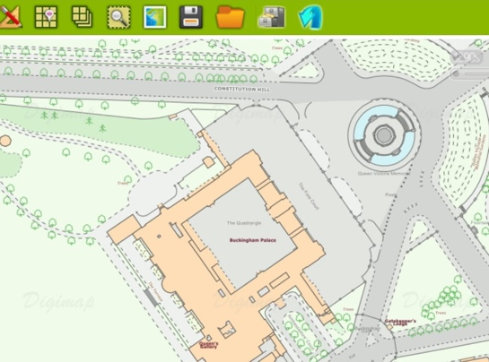

1. Open the Map Selector, select Aerial to show the aerial view of Buckingham Palace.

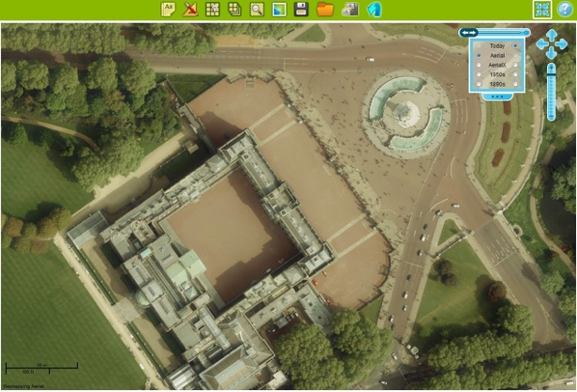

1. Discuss what you can see. For example, you might ask:

* How many cars are parked in the Palace grounds? Can you count them?
* How many people do you think are outside the Palace? Can you estimate this?
* What time of year do you think it is? How can you tell?
* Do you think it’s morning or afternoon? How can you tell?
* What surprises you about the view of the Palace from above? For example, the quadrangle inside the palace with vehicles in it might be an unexpected feature.
* Can you map the cars and the people on a blank map? Using the Drawing Tools, select an marker to represent cars or people and mark these. These will then be on the map when you select an OS map again.

1. Now zoom in further. What do you notice?
2. What patterns can you find on the roof of Buckingham Palace? Draw around the ones you like the best using one of the shapes from the Drawing tools.
3. Where do you think the garden boundary is? Zoom out a little and explore this.
4. What are the gardens like? Are there any unusual features?

**Useful Vocabulary**:

capital, grounds, landmark, memorial, palace, quadrangle, tourists, trees, woods.

# 2 Arthur’s Seat, Edinburgh

1. Enter ‘Arthur’s Seat’ into the search box and select the one in ‘Edinburgh’.
2. Zoom in as far as you can then zoom out four times to 200m view (visible in the bottom right of the map window). Arthur’s Seat is marked with its name and the Viewpoint symbol.

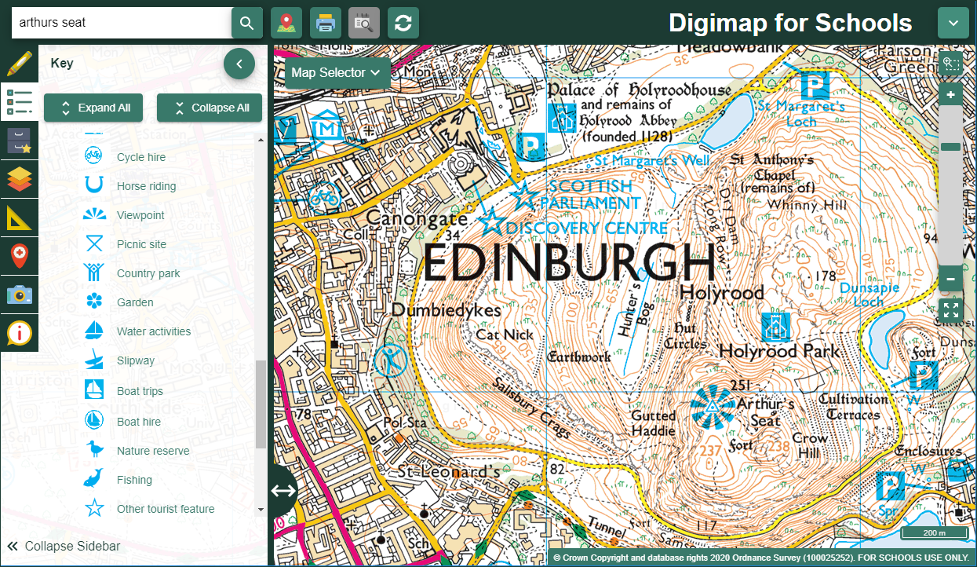

Image of viewpoint symbol from OS 1:25000 scale colour raster map.

1. Select the Drawing Tools and add a marker to the spot where ‘Arthur’s Seat is.
2. Open the Map Selector and select Aerial.

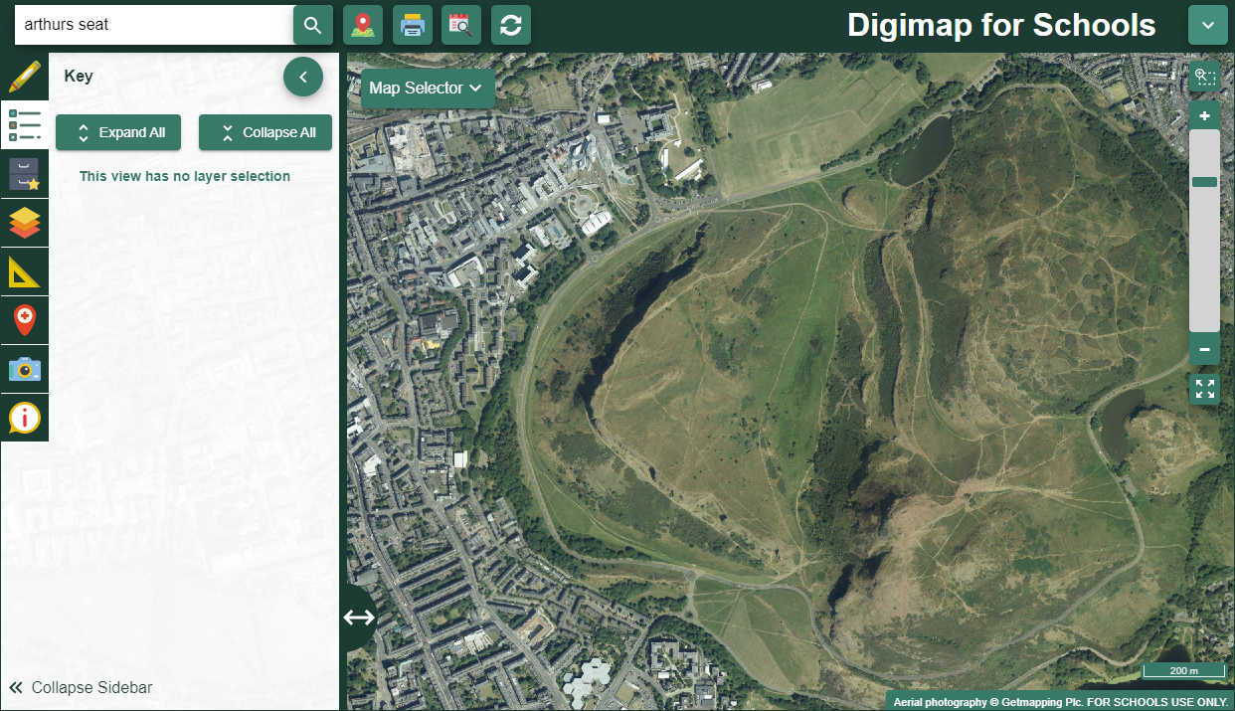

1. Describe what you can see. You might ask:

* What do you think scenery is like around Arthur’s Seat?
* Why might this be a good viewpoint?
* What would the ground be like here beneath your feet?
* What other features can you see on the aerial image? Can you find houses and roads?
* Why aren’t there any roads or houses built over ‘Arthur’s Seat’?
* What patterns can you see in the landscape?

1. Select the OS map and look for the symbol that means other tourist attractions or features.

Symbol for tourist feature

1. Zoom into these areas and switch to aerial view again to see what you can find out about them.
2. Can you find the Scottish Parliament building? Look at its shape on the map and guess what it will look like from the air.
3. Which is your favourite landmark in Edinburgh – Arthur’s Seat or the Scottish Parliament Building?

**Useful Vocabulary**: capital, feature, Holyrood Park, hill, Marilyn, mountain, parliament, tourist.

# 3 Caernarfon Castle

1. Enter ‘Caernarfon’ into the search box and select Caernarfon (Gwynedd).
2. Zoom in and look for the castle. It’s located on the coast, where the two bodies of water meet.
3. Once you have found the castle zoom in so that you can see the castle walls.

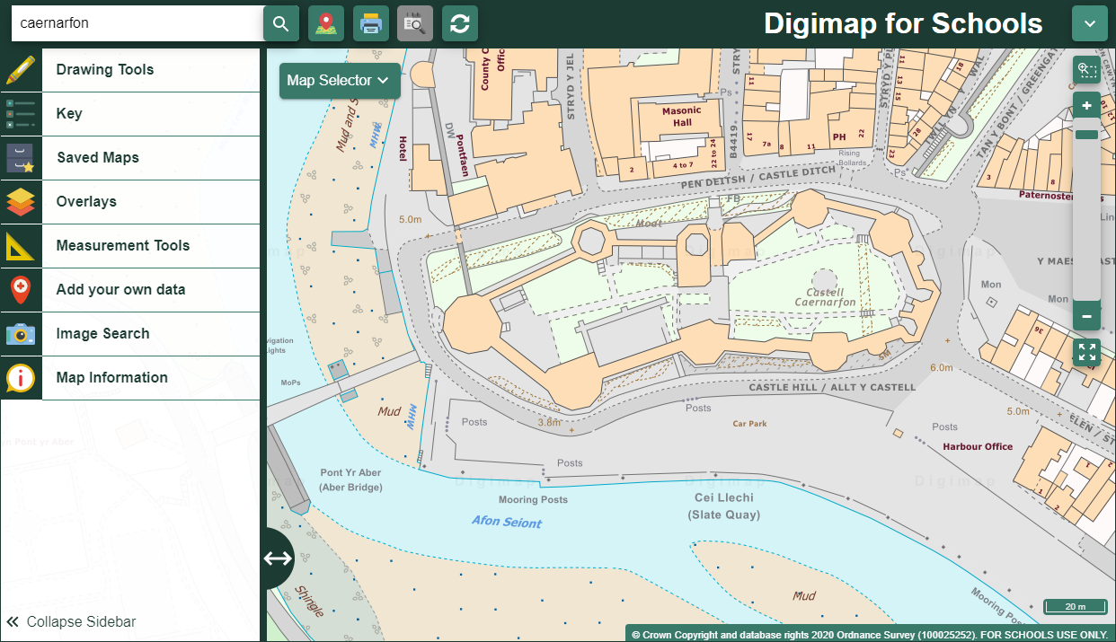

1. Open the Map Selector and select Aerial.
2. Discuss what you can see inside the castle walls.
3. Use the zoom feature to explore the castle and the area around it. You might ask children to identify and label:

* the river
* the bridge
* the car park
* the town

1. Ask children to work in pairs to find as many different features as they can.
2. Can they label them using different colours for ‘physical’ and ‘built’ or ‘human’ features? That could be a useful extension for more able children.
3. You could also play ‘spot the difference’. Put children in pairs and ask them to switch between the OS map and the aerial view and list all the things that the aerial view shows that the OS map doesn’t, e.g. the cars, the green grass inside the castle, the boats on the river etc.
4. You could also ask the children to find out which way the river is flowing. They will have to zoom out to answer this.

**Useful Vocabulary:**

bridge, castle, car park, estuary, mooring, river, town, turret

# Taking it further

1. Use the Image Search tool to locate images of your chosen locations, so that you can view your landmarks in three ways: on the map, through aerial imagery and as a photograph.
   * Select Image Search and enter your search terms to find matching images. NOTE: you can also enter an asterisk to see all available [Geograph](https://www.geograph.org.uk/) images at a location (only in the 5 most zoomed in maps).

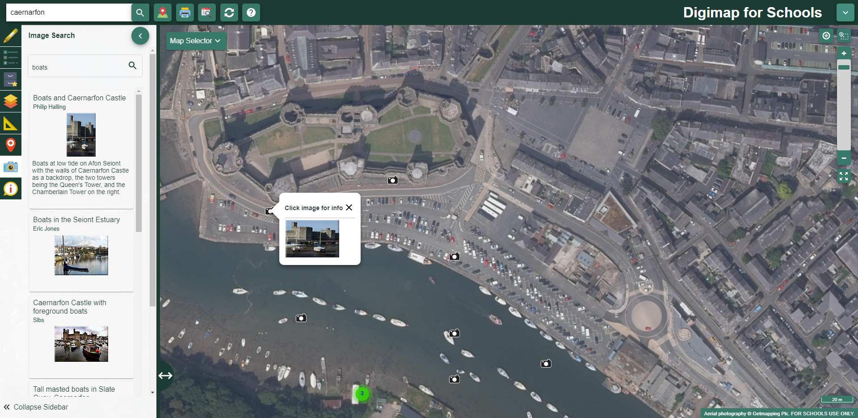

1. Research some facts about your landmark to develop links in literacy and history.
2. Select some landmarks that best represent your area and create a file of facts, maps and images.

# Copyright

©EDINA at the University of Edinburgh 2016  
This work is licensed under a Creative Commons Attribution-Non Commercial Licence Creative commons licence, CC BY NC

# Acknowledgements

© CollinsBartholomew Ltd (2019) FOR SCHOOLS USE ONLY

© Crown copyright and database rights 2020 Ordnance Survey (100025252). FOR SCHOOLS USE ONLY.

Aerial photography © Getmapping plc. Contains OS data. FOR SCHOOLS USE ONLY.

Historic mapping courtesy of the National Library of Scotland. FOR SCHOOLS USE ONLY.