Aerial Imagery – Quick Ideas
  - Marks on the landscape
Paula Owens
Geography Teaching Resource
7-11 years
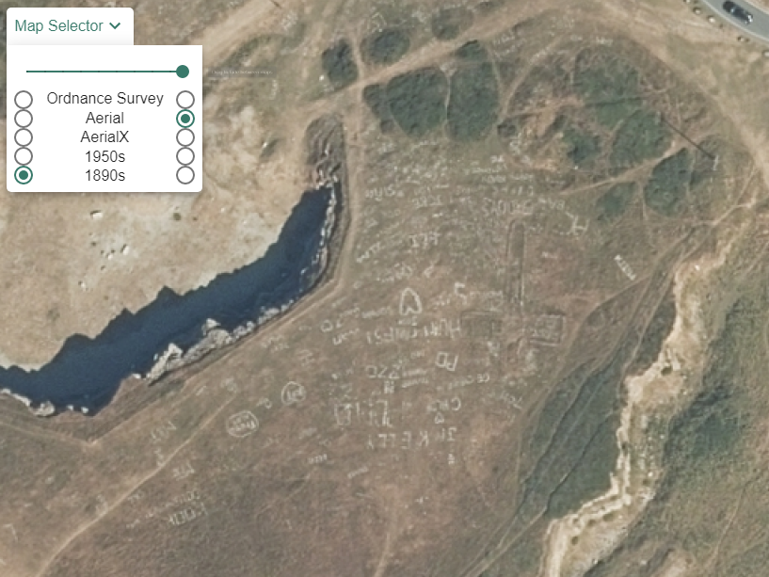

Contents
Digimap for Schools Geography Resources 3
Content and Curriculum Links 3
Marks on the Landscape 5
Penmaenmawr Quarry in North Wales 6
Skara Brae, Scotland 7
The Great Orme, Llandudno, Wales 8
Taking it further 9
Web links 9
Copyright 10
Acknowledgements 10

Digimap for Schools Geography Resources
These resources are a guide for teachers to demonstrate to the whole class or direct individual students as appropriate. Each activity has several ideas within it that you can tailor to suit your class and pupils. Some resources contain worksheets for direct distribution to pupils.
https://digimapforschools.edina.ac.uk/

Content and Curriculum Links
Level | Context | Location
7-11 years | Using aerial imagery | Various throughout Great Britain

Knowledge | Using Image Search with maps
Curriculum links (England)  Geography KS2 | - Name and locate counties and cities of the United Kingdom, geographical regions and their identifying human and physical characteristics, key topographical features (including hills, mountains, coasts and rivers), and land-use patterns.  - Use fieldwork to observe, measure, record and present the human and physical features in the local area using a range of methods, including sketch maps, plans and graphs, and digital technologies.
Curriculum links (Wales) | - Use maps, imagery and ICT to find and present locational information, e.g. draw sketch maps using symbols and keys. Interpret maps, and photographs including oblique, aerial and satellite images
Scottish Curriculum for Excellence  Social studies  Experiences and outcomes | - I can describe the major characteristic features of Scotland’s landscape  - I can discuss the environmental impact of human activity SOC 2-08a  - I can consider the advantages and disadvantages of a proposed land use development and discuss the impact this may have on the community.  SOC 2-08b
All: Literacy opportunities  All: Numeracy opportunities | Activities have identified opportunities for literacy and numeracy

Marks on the Landscape
What kind of marks do humans leave on landscapes they live in and why? Although different kinds of impacts and land-use are shown on maps, aerial images can give far more clues. Some marks can be left from hundreds or even thousands of years ago; some marks are mysterious, some show seasonal activity and some are permanent. As landscape detectives, investigate some different types of marks and discuss what they can tell us about human activity and impact.

Use these enquiry questions and children’s own to investigate different marks on the landscape.
• Where is this feature?
• Who made it?
• What is it?
• Who benefits?
• Why is it here?
• Who loses?

Here are some examples to get you started.

Penmaenmawr Quarry in North Wales
Quarries are dangerous places and people are often kept out because of this. With detailed aerial imagery you can explore places you might otherwise never see.
- Ask children what a quarry is and get their ideas.
- Then enter the Grid reference number SH700755 into the search bar on Digimap for Schools to locate it on a map.
- Ask children to describe the quarry using the map information only.
- Remember there is a map Key you can open on the left of the map.
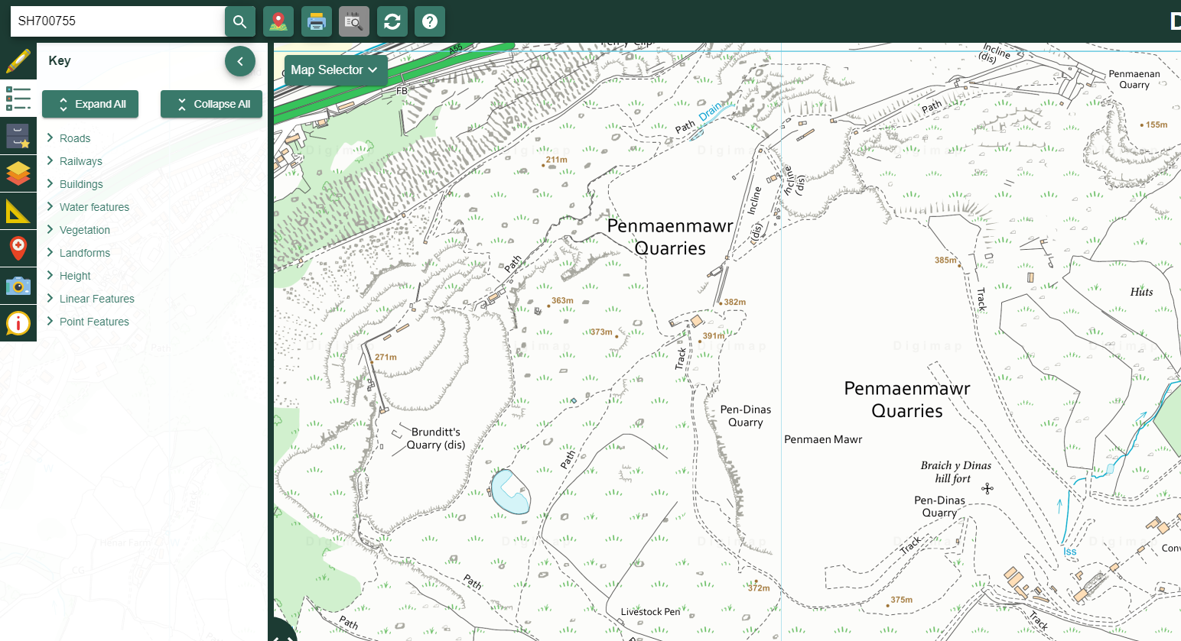
- Then open the Map Selector and select the Aerial view. From this you can zoom in further.
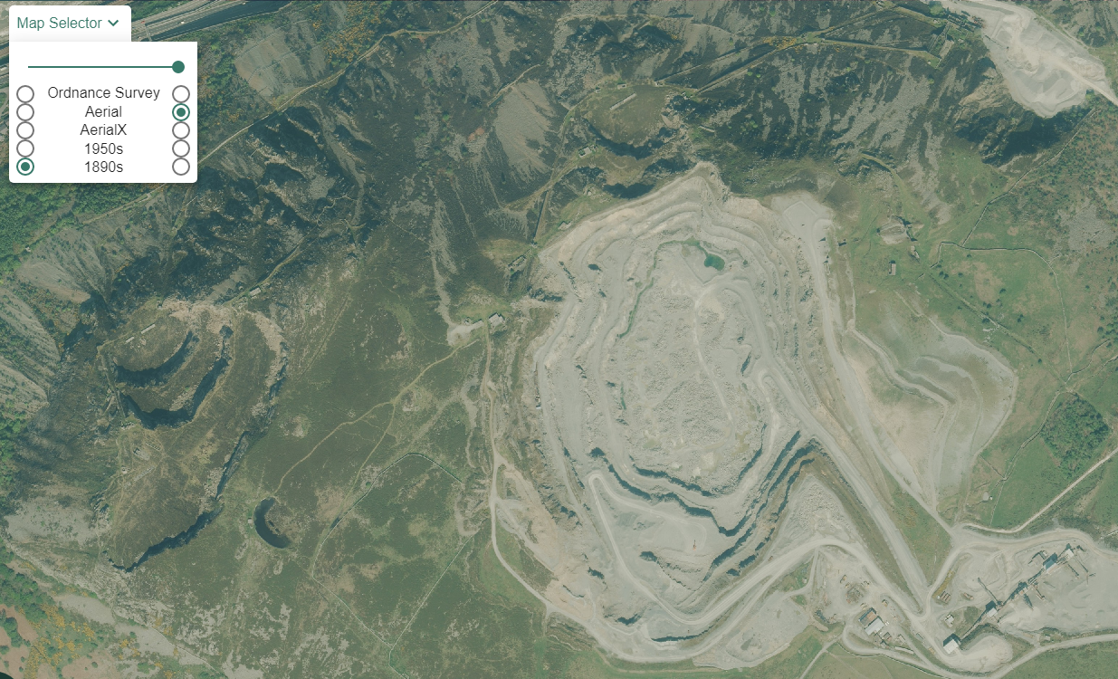

Skara Brae, Scotland

Skara Brae, is a Neolithic village on the shores of the Bay o' Skaill, in the West Mainland parish of Sandwick. It is one of Orkney's most-visited ancient sites.
- Enter the search term ‘Skara Brae’ into Digimap for Schools.
- Open the Drawing Tools.
- Add a marker to Skara Brae.
- Then select Aerial and explore this distant and remote part of the country for clues as to what is left behind and what attracted people there in the first place.
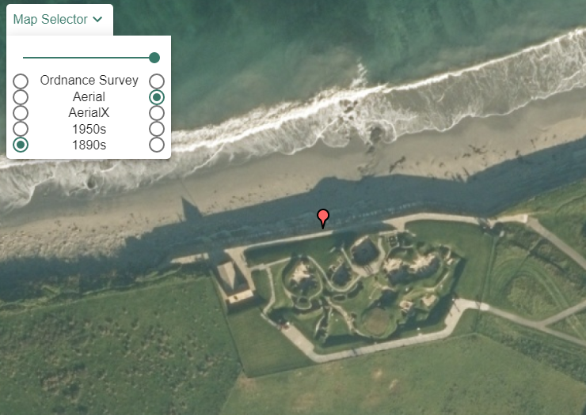

The Great Orme, Llandudno, Wales
If you explore the Great Orme using digital imagery you might find this graffiti. Is it modern or ancient and how do you know?
- The Grid Reference SH 7670183088 will take you to Bishop’s Quarries on the Great Orme.
- You can see a cross marked on the map. Discuss what kind of a feature this is before toggling to the aerial view to find it is part of a collection of graffiti.

- What kind of a landscape is this and how was the graffiti made?
- What kind of a quarry did this used to be and why is it disused?
- Is it connected to Penmaenmawr Quarry?

Taking it further
Start a class collection of marks found on landscapes in your locality and further away. Think of how you can categorise them. Research using Geography for Schools to help evidence your findings and solve some mysteries.

Web links
- Penmaenmawr Quarry https://www.theeyepenmaenmawr.org/Our-Heritage
- Skara Brae history http://www.orkneyjar.com/history/skarabrae/

Copyright
©EDINA at the University of Edinburgh 2016
This work is licensed under a Creative Commons Attribution-Non Commercial Licence

Acknowledgements
© CollinsBartholomew Ltd (2019) FOR SCHOOLS USE ONLY
© Crown copyright and database rights 2020 Ordnance Survey (100025252). FOR SCHOOLS USE ONLY.
Aerial photography © Getmapping plc. Contains OS data. FOR SCHOOLS USE ONLY.
Historic mapping courtesy of the National Library of Scotland. FOR SCHOOLS USE ONLY.

