Where does milk come from?

Paula Owens

Geography Teaching Resource

Primary
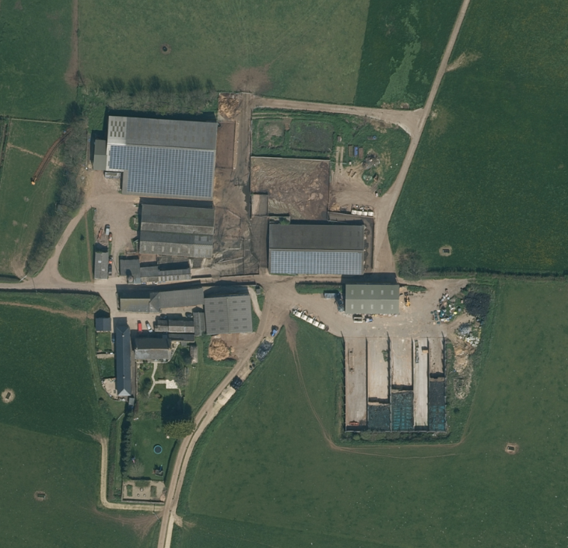

Contents
Digimap for Schools Geography Resources 3
Content and curriculum links 3
Activity 4
Introduction 4
Part 1 5
Tasks 5
Part 2 8
Tasks 8
Part 3 10
Tasks 10
Taking it further 11
Web links 11
Copyright 12
Acknowledgements 12

Digimap for Schools Geography Resources
These resources are a guide for teachers to demonstrate to the whole class or direct individual students as appropriate. Each activity has several ideas within it that you can tailor to suit your class and pupils. Some resources contain worksheets for direct distribution to pupils.
https://digimapforschools.edina.ac.uk/

Content and curriculum links
Level | Context | Location
Primary | Food and farming, resources and shops | Rural, dairy farm, Somerset.

Knowledge/Skills | Locating places using postcode and word searches/adding markers and labels/plotting and marking simple routes/knowing some of the ways that milk travels from farm to shop.
Curriculum links (England) | Understand key aspects of physical and human geography, including the distribution of natural resources, including food.
Curriculum links (Wales) | Knowledge and Understanding of the World: Use and make simple maps, to find where places are and how places relate to other places.  Geography: identify and describe natural and human features.
Scottish Curriculum for Excellence | Social Studies Outcomes: People, Place and Environment:1-13b, 2-14a, 2-12a

Activity
This activity investigates where milk comes from and what happens to it after it leaves the cow. Pupils explore a rural setting and the landscape that supports dairy farming then map the route that the milk takes from field to milking parlour, to dairy and then on to the shops. There are three parts to this activity so this could form part of a topic of work over several days or weeks. It also links well with locality fieldwork to investigate either a local farm and/or supermarket/shop.

Introduction
The dairy industry makes a major contribution to the British diet. British farmers produce around eleven billion litres of milk a year; that’s enough to fill 4,500 Olympic sized swimming pools. Five billion litres are sold as milk and around six billion litres of milk goes to make other dairy products such as cheese, butter and dried milk. Source: British Nutritional Foundation (2011).

There are more cows in Britain than there are people in Birmingham, Liverpool and Manchester put together, and dairy cows have passports! Yet many children have little idea of even the most basic things about the milk they see on supermarket shelves or pour on their cereal.

With the aid of the detailed maps from Digimap for Schools, children can begin to visualise where milk comes from and the process that brings milk into our homes.

This is the story of milk from one farm called Broadstone Farm, in a place called Middle Chinnock, in the county of Somerset. On this organic farm, a herd of 300 dairy cows produce around 7,000 litres of milk a day. A single cow can give as much as 60 litres each day.
The cows graze on the fields in the summer months and come indoors into the barns in the winter. Twice a day they go to the milking parlour to be milked. The milk is then kept cold in a big tank until the tanker arrives each day to take the milk to the local dairy at Roundham, where it is processed and put into plastic bottles. These milk containers are then labelled and sent off by lorry to shops and supermarkets.

Part 1
Find out what children already know about milk and have a litre of milk to show. If only it could talk to say where it’s come from! This is the story of a litre of organic milk made on a farm in Somerset.
- What county do you live in?
- Do you know where Somerset is?

Tasks
- Open Digimap for Schools. Use the search box and enter ‘Chinnock’.
- Select Chinnock Brook from the results list.
- Without moving the map, use the scale bar to zoom out as far as possible to Level 1.Then zoom in gradually, one level at a time until you can see ‘Somerset’. Which part of Britain is this place? (South-West England).
- Keep zooming until you can find the villages of East Chinnock, West Chinnock and Middle Chinnock. Middle Chinnock is the village you are looking for. Why do you think it is called ‘Middle’ Chinnock?
- Double click on Middle Chinnock and keep zooming in until you can find Broadstone Farm.
- Then double click on this place until you have zoomed in as far as you can. What can you see?
- Open and use the Key to help you identify and label:
  - Farm buildings
  - Man – made surface
  - Natural surface
- Use the Map Selector to switch to Aerial to help to visualise the surfaces.
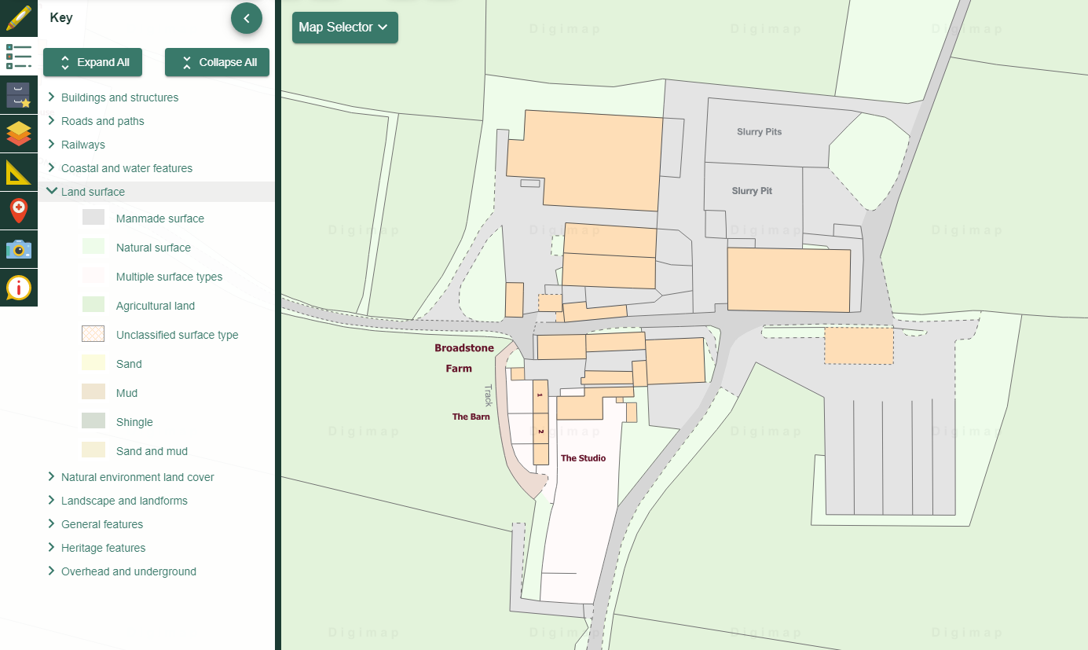

- Open the Drawing Tools.
- Select ‘Text’ then click on the map where you want your label to go.
- Can you answer these questions?
  - What colour on the map might show the fields where the cows graze?
  - In which parts of the farm might the cows be milked?
  - Why do you think there is such a large area of man-made hard surface around the farm buildings?

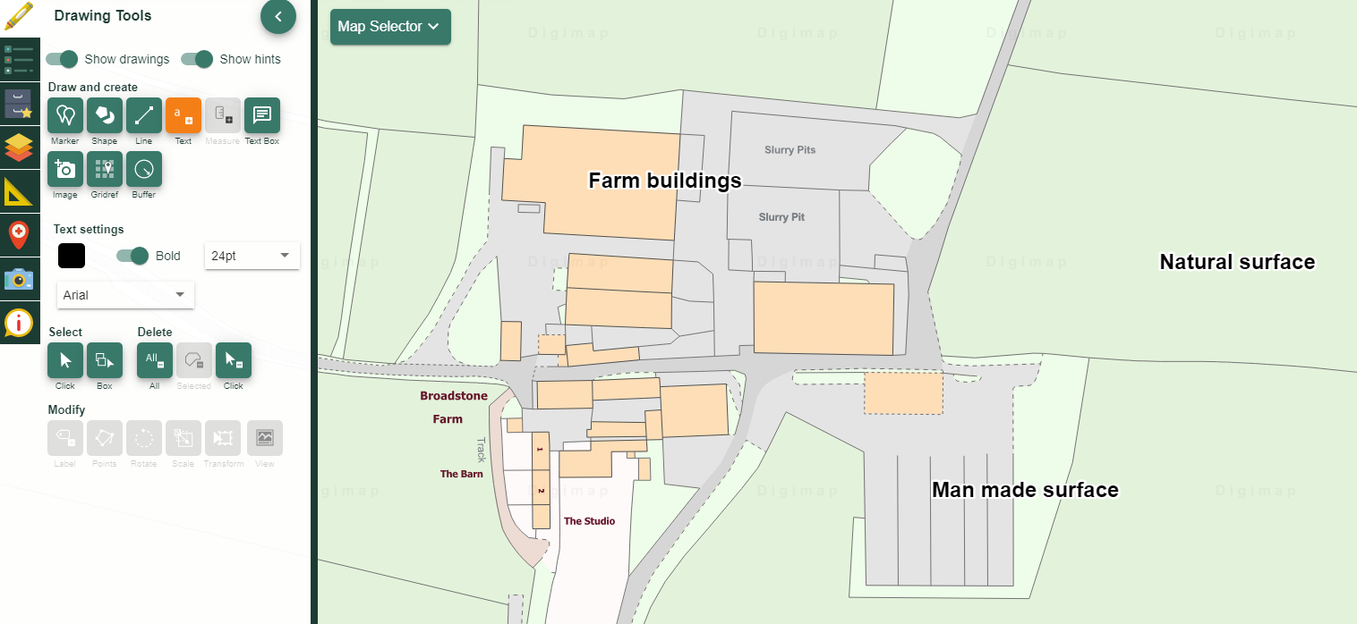

This farm has around 300 acres of land – you could describe this area by relating it to the size of your school to give pupils an idea of how large it is. As well as keeping the cows they have to grow enough high-quality grass to feed them.

- Give your map a title and save it.

Part 2
The milk travels to the local dairy at Roundham. You are going to find and plot the journey from farm to dairy.

Tasks
- Open a new map and this time find Broadstone Farm through a postcode search: TA18 7PN.
- Add a marker and label it Broadstone Farm.
  - Open the Drawing Tools.
  - Select ‘Add Marker’.
  - Choose your maker and click on the map.
  - Then select ‘Text’, choose the smallest text and click where you want it to go. Add the text.

- Repeat to find and label the dairy. The postcode is TA18 8RR.

- Use the scale bar to zoom out until you can see both the farm and the dairy. Look at the roads and decide what route between these two places you would take if you were a tanker driver. Mark the route on the map.

- Open the Drawing Tools select ‘Draw Line’.
- Select the colour you want to use.
- Click on the farm and ‘drive’ the line along the road, clicking each time the road bends so that you can follow it. Double click to finish.
- Add a measurement label to the line.

- Give your map a title and save it.
- Zoom out from your map and see how the route size changes.
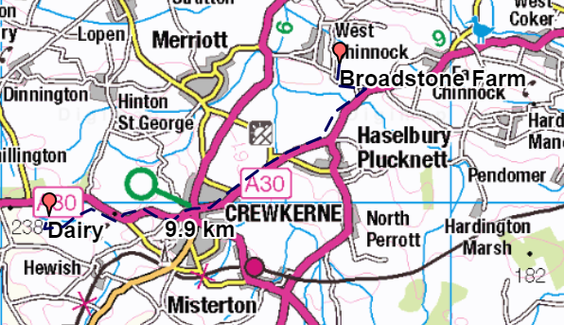

Part 3
Where does the milk go to from the dairy processing plant? Yeo Valley organic milk travels to many local and distant shops and supermarkets around the UK. For example, more than 200 supermarkets in the Waitrose chain stock it.

Tasks
- Do either town or postcode searches to find and mark just four of the many supermarkets that sell Yeo Valley organic milk from Somerset.
- Open your saved map of the farm and dairy and add these places.
- You do not need to worry about being accurate for this as the map will be viewed at a small scale, which means details can’t be seen.
- Add the markers to anywhere in the postcode search area.

• York YO31 7UL
• Newcastle NE99 1AB
• Maidstone ME16 0PX
• Crewkerne TA18 8DA

- Save map with a new title.
- Look at the map you have made and zoom out until all you can see all of the shops you have added. What does this tell you?

Although it is difficult to track milk from Broadstone Farm directly to a shop, Yeo Valley milk has a wide distribution area from its base in Somerset.

Taking it further
- Look again at the map showing Broadstone Farm and surrounding area. How many other farms can you find on the map? Make a list. What does this tell you about this area?
- Take a trip to your local shop or supermarket and investigate where the milk there comes from.
- Are there any dairy products made in your local area? How could you find out?
- Visit a local farm and find out what they do there.
- Investigate where other food stuffs come from. What foods in your lunchbox are local? Which are British? Which come from overseas?
- Pupils will enjoy watching the Yeo Valley adverts, which show ‘farmers’ singing.

Web links
• Coombe Farm and Dairy https://www.coombefarm.com/
• Broadstone Farm https://www.coombefarm.com/page/broadstone-farm/72/
• Dairy Council https://www.milk.co.uk/
• Food a Fact of Life https://www.foodafactoflife.org.uk/
• This is Dairy Farming https://www.thisisdairyfarming.com/
• Yeo Valley adverts

Copyright
©EDINA at the University of Edinburgh 2016
This work is licensed under a Creative Commons Attribution-Non Commercial Licence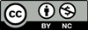

Acknowledgements
© CollinsBartholomew Ltd (2019) FOR SCHOOLS USE ONLY
© Crown copyright and database rights 2020 Ordnance Survey (100025252). FOR SCHOOLS USE ONLY.
Aerial photography © Getmapping plc. Contains OS data. FOR SCHOOLS USE ONLY.
Historic mapping courtesy of the National Library of Scotland. FOR SCHOOLS USE ONLY.

