Why use Aerial Imagery?
Paula Owens
Geography Teaching Resource
Primary

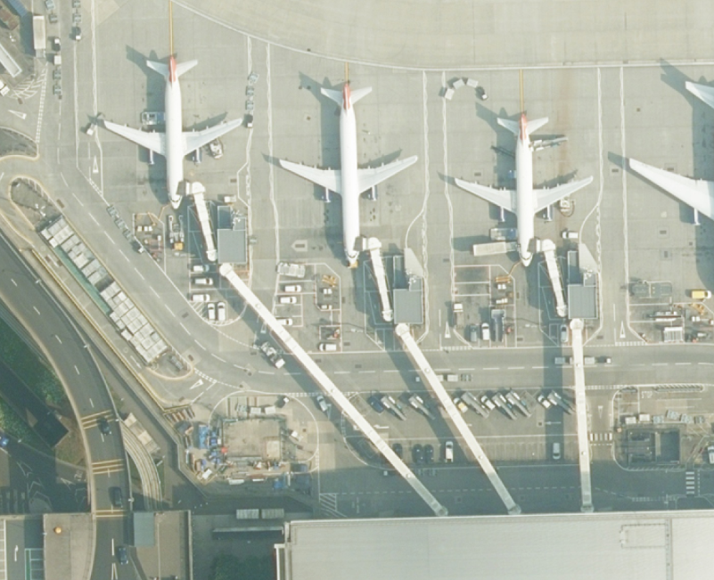

Contents
Digimap for Schools Geography Resources 3
Aerial images 3
What does an aerial imagery layer add to a map? 3
Developing understanding across the curriculum 4
Web links 4
Copyright 5
Acknowledgements 5

Digimap for Schools Geography Resources
These resources are a guide for teachers to demonstrate to the whole class or direct individual students as appropriate. Each activity has several ideas within it that you can tailor to suit your class and pupils. Some resources contain worksheets for direct distribution to pupils.
https://digimapforschools.edina.ac.uk/

Aerial images
Digimap for School’s aerial imagery layer enhances this existing high-quality map resource and adds an extra dimension for teachers and children to make use of in the classroom. The aerial imagery layer reveals the landscapes of Great Britain with such incredible clarity that you can read the writing on the side of planes in an airport or count the people outside the gates of Buckingham Palace!
Aerial images compliment map views perfectly and help young children make sense of abstract information. The aerial imagery layer from Digimap for Schools enables children to visualise the landscape, as viewed from above in detail, and then compare this to the corresponding mapped information, at the same scale. The Map Selector tool enables the user to easily alternate between map or aerial photography view without leaving the Digimap for School’s programme. This new layer of imagery enables young children to both interpret and better understand how maps work and what they represent.

What does an aerial imagery layer add to a map?
As well as the detail shown by Digimap for School’s map data, the additional layer of aerial photography lets you see:
- the colours of the landscape, giving clues about the time of year, vegetation cover and land use;
- shadows revealing clues about the time of day;
- signs of human activity past and present;
- the impact on landscapes of different settlements and patterns of land-use;
- aspects of human activity such as journeys and trade, with clear views of different types of shipping, including container ships and ferries, planes including light aircraft and passenger jets, other forms of transport, routes and termini;
- buildings, landmarks and other human and physical features in far more detail and colour;
- the difference in places at local and regional scales across Great Britain: lakes, woods, urban areas or mountain ranges are all clearly visible and support map-reading skills;
- the detail of a small area such as your garden, street or school grounds as seen from the air, revealing clues about vegetation, building materials and types of construction;
- glimpses into places you might never otherwise see.

Developing understanding across the curriculum
Use the additional wealth of clues, provided by this layer of digital aerial imagery, to help children develop their general vocabulary and knowledge of different places as well as their map skills. This new tool supports higher attainment in geography and across the wider curriculum as it provides a real context for learning and feeds curiosity.

Web links
- Ordnance Survey guide on Teaching maps skills in Primary:
https://www.ordnancesurvey.co.uk/documents/resources/teaching-map-skills-primary.pdf
- Progression in mapping guidance:
https://digimapforschools.edina.ac.uk/learning-resources/resource/progression-mapping.html

- Digimap for Schools resources:

- ‘Quick ideas: school grounds’ for 5–7 year olds. https://digimapforschools.edina.ac.uk/learning-resources/resource/using-aerial-imagery-quick-ideas-school-grounds.html
- ‘Landmarks’ for 5–7 year olds. https://digimapforschools.edina.ac.uk/learning-resources/resource/using-aerial-imagery-landmarks.html
- ‘Quick ideas: marks on the landscape’ for 7–11 year olds. https://digimapforschools.edina.ac.uk/learning-resources/resource/using-aerial-imagery-quick-ideas-marks-landscape.html
- ‘Transport, travel and trade’ for 7-11 year olds. https://digimapforschools.edina.ac.uk/learning-resources/resource/transport-travel-and-trade.html

Copyright
©EDINA at the University of Edinburgh 2016
This work is licensed under a Creative Commons Attribution-Non Commercial Licence

Acknowledgements
© CollinsBartholomew Ltd (2019) FOR SCHOOLS USE ONLY
© Crown copyright and database rights 2020 Ordnance Survey (100025252). FOR SCHOOLS USE ONLY.
Aerial photography © Getmapping plc. Contains OS data. FOR SCHOOLS USE ONLY.
Historic mapping courtesy of the National Library of Scotland. FOR SCHOOLS USE ONLY.

