Why was King Egfrith rash?

Will Tuft

A mystery lesson using maps

P6-7
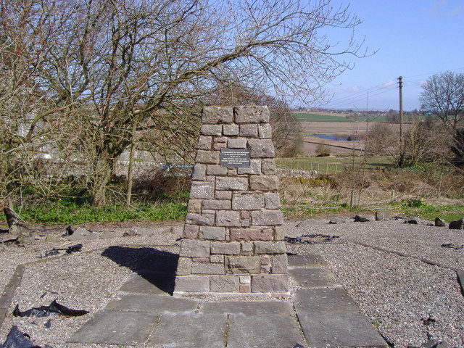
Battle of Dunnichen Hill memorial cairn
cc-by-sa/2.0 - © Euan Nelson - geograph.org.uk/p/770874

Contents
Contents 2
Digimap for Schools Geography Resources 3
Content and Curriculum Links 3
Introduction 4
Starter 5
Activity 5
Extension 9
Plenary 9
Copyright 10
Acknowledgements 10

Digimap for Schools Geography Resources
These resources are a guide for teachers to demonstrate to the whole class or direct individual students as appropriate. Each resource has several ideas within it that you can tailor to suit your class and pupils. Some resources contain worksheets for direct distribution to pupils.

Content and Curriculum Links
Scottish Curriculum for Excellence | I can use evidence to recreate the story of a place or individual of local historical interest.  SOC 1-03a  I can explain why a group of people from beyond Scotland settled here in the past and discuss the impact they have had on the life and culture of Scotland.  SOC 3-03a  I can discuss why people and events from a particular time in the past were important, placing them within a historical sequence.  SOC 2-06a

Learning Intention
Who won the battle of Dunnichen and why?

Success Criteria:
- All pupils will identify reasons for conflict.
- Most pupils will describe the evidence for victory.
- Some pupils will learn how to evaluate reasons to form a conclusion.

Equipment
- Digimap for Schools
- Playdoh
- Writing materials

Time allocated
1 lesson (2 if you would like to extend a mini essay around the topic)

Introduction
As this is a mystery style lesson, selecting a well-known battle would not allow pupils to evaluate the resources and come to their own conclusions without some bias. Therefore, the battle of Dunnichen is chosen as it fulfils the Experiences and Outcomes of the upper Primary level and allows some higher-level thinking skills to take place but is a lesser-known individual battle.

It also allows the usage of not solely maps but evidence from the time, meaning pupils do not just see this as an exercise in map analysis. The structure of the lesson would benefit from some prior knowledge of the chronology of the time and understanding of the Picts and Angles. The structure of the lesson and use of mapping would fit the majority of conflicts and therefore can be transposed into many historical scenarios. A good example would be the battle of Stirling Bridge, which was heavily dependent on the topology of the area.

Starter
- Display an image of a Pict and Angle warrior on the board, e.g.:
  - https://s-media-cache-ak0.pinimg.com/originals/be/d1/36/bed13686c059828a289a71b594090fd9.jpg OR
  - https://s-media-cache-ak0.pinimg.com/564x/e3/8c/92/e38c92e875e5b4ed918fe44e3c5fb330.jpg

- Ask questions such as:
  - Which group does this man belong to?
  - Which time frame?
  - What do you think he does?

This will establish prior knowledge and a grounding of what the Picts and Angles looked like. You could even ask, which of these men would win in battle and why?

Activity
The lesson is inherently a mystery with a map at its heart, so pupils will need access to Digimap for Schools for this portion of the lesson.
- Pupils (or a teacher) will need to login and locate Dunnichen Hill.
  - Verbally, encourage pupils to describe the location with reference to where you are.
  - Pupils could use the Drawing Tools to add a marker and label to the hill (see image showing menu below).
- Use the measurement tools on Digimap for Schools to identify exact distances (see image showing menu below).
  - This could be extended to class questioning such as ‘if we were 50 miles away at the time, would we have fought? why?’
  - This can be conducted with a paper copy of the ‘story map’ in front of the pupils or access to the map on Digimap for Schools itself.

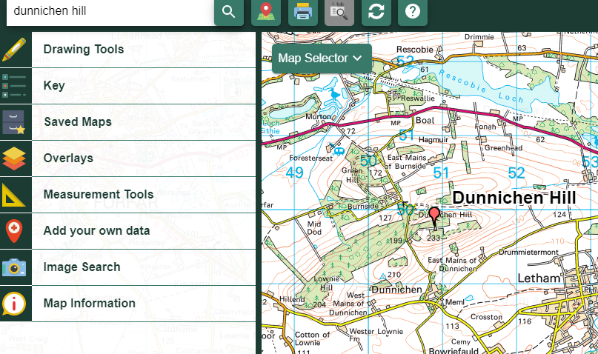

- Engage the pupils in discussion about why the Angles were moving Northwards and what the Picts were defending.

- Be prepared to zoom in and out of the map to show the wider picture of the country to aid understanding. This can also be completely independent, and pupils can conduct this element of the lesson.
Above: An example story map.
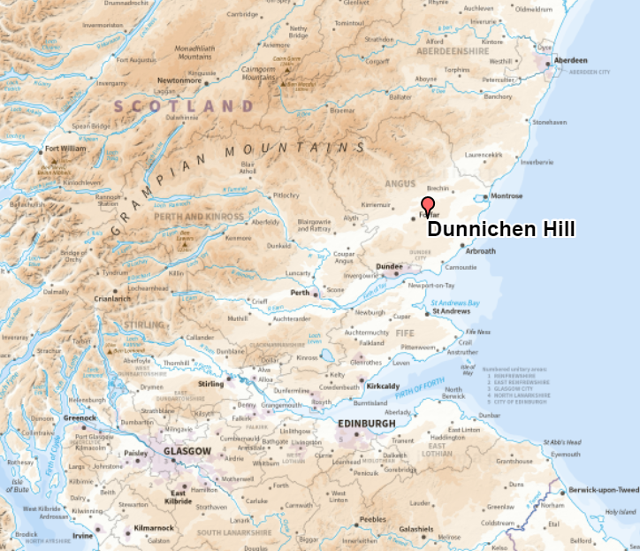
Above: A map to discuss the importance of Dunnichen as a strategic area to protect the North.

- Encourage pupils to explore the area around the battlefields and display a series of questions that require map analysis, such as why may this area have been good for battle? Why did the Picts decide to fight here? Why did they want to stop the Angles from moving North?

- Then, undertake the comprehension element using the Education Scotland resources:

  - (http://www.educationscotland.gov.uk/scotlandshistory/britonsgaelsvikings/battleofdunichen/index.asp ) which would involve questions related to the trap that Picts created and analysis of what Bede said of the conflict many years later ( which can also be used to answer the lesson title).
  - Wikipedia has a solid chronology of events to select information from https://en.wikipedia.org/wiki/Battle_of_Dun_Nechtain and add information.

Questions may include:

- Why did the Picts protect the North?
- Describe the trick played by the Picts.
- Imagine you are King Egfrith, would the trick work on you? Why?
- Would a similar trick work today or would Snapchat give it away?
- Why did Bede say the King was ‘rash’?

- The final element of the map usage would be a link to Pictish symbol stones and its relevance: https://www.aberdeenshire.gov.uk/leisure-sport-and-culture/archaeology/sites-to-visit/pictish-symbol-stones/

- Pupils are then encouraged to design and build a new symbol stone from playdoh to be held at Dunnichen that reflects the battle of Dunnichen and the most important reasons for the Picts victory.

Extension
- Provide more than one source of information for the comprehension task to develop the notion of bias in sources with more able pupils.
- For the stone, ask pupils to select an appropriate site for the stone to be set down and look for them to give reasons for the location, these could then be photo located onto the story maps. (Use the Add image tool in the Drawing Tools).
- Emphasise the importance of the judgements to each of the groups as this displays a higher level of Bloom’s taxonomy.

Plenary
3 symbol stones are chosen at random (or due to quality/interest/completion) to be presented to the class, describing how each shows the main reason for victory and how it was chosen.

Copyright
©EDINA at the University of Edinburgh 2016.
This work is licensed under a Creative Commons Attribution-Non Commercial Licence.

Acknowledgements
© CollinsBartholomew Ltd (2019) FOR SCHOOLS USE ONLY.
© Crown copyright and database rights 2020 Ordnance Survey (100025252). FOR SCHOOLS USE ONLY.
Aerial photography © Getmapping plc. Contains OS data. FOR SCHOOLS USE ONLY.
Historic mapping courtesy of the National Library of Scotland. FOR SCHOOLS USE ONLY.

