**A focus on rivers**

**Using images from Geograph**

Paula Owens

Geography Teaching Resource

7-11 years

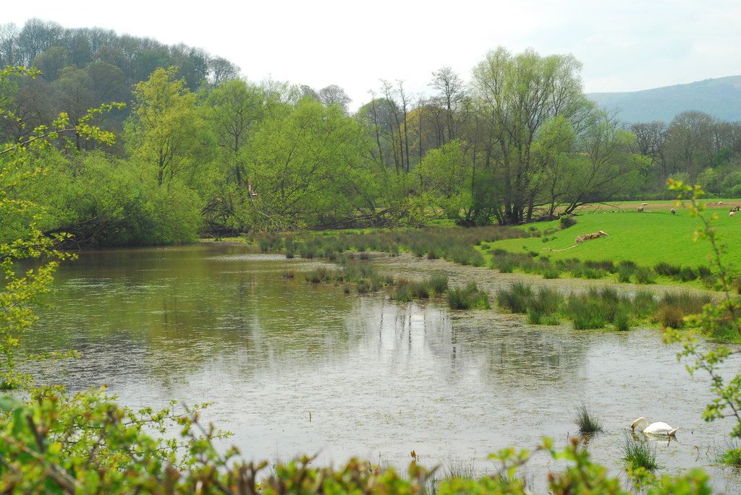

Figure Classic Oxbow Lake by John Winder

Contents

Digimap for Schools Geography Resources 3

Content and Curriculum Links 3

River Journey 5

River Glossary 5

Measuring river features 6

Patterns of land use 6

River Wildlife 6

River Stories and Poems 7

Literacy Links 7

Numeracy Links 8

Taking it further 8

Copyright 9

Acknowledgements 9

# Digimap for Schools Geography Resources

These resources are a guide for teachers to demonstrate to the whole class or direct individual students as appropriate. Each activity has several ideas within it that you can tailor to suit your class and pupils. Some resources contain worksheets for direct distribution to pupils.

<https://digimapforschools.edina.ac.uk/>

# Content and Curriculum Links

|  |  |  |
| --- | --- | --- |
| **Level** | **Context** | **Location** |
| 7-11 | Using Image Search | Various throughout Great Britain |

|  |  |
| --- | --- |
| **Knowledge** | **Using Image Search with maps** |
| Curriculum links (England)  Geography KS2 | * Name and locate counties and cities of the United Kingdom, geographical regions and their identifying human and physical characteristics, key topographical features (including hills, mountains, coasts and rivers), and land-use patterns. * Use fieldwork to observe, measure, record and present the human and physical features in the local area using a range of methods, including sketch maps, plans and graphs, and digital technologies. |
| Curriculum links (Wales)  Geography  (Opportunities for Digital Competency) | * Use maps, imagery and ICT to find and present locational information. Interpret maps, and photographs. * Identify and describe the spatial patterns of places and environments and how they are connected. Identify and describe natural and human features. |
| Scottish Curriculum for Excellence  Social studies  Experiences and outcomes | I can describe the major characteristic features of Scotland’s landscape SOC 2-07a  Having explored my local area, I can present information on different places to live, work and relax and interesting places to visit. SOC 2-10a  To extend my mental map and sense of place, I can interpret information from different types of maps and am beginning to locate key features within Scotland, UK, Europe or the wider world. SOC 2-14a |
| All: Literacy opportunities  All: Numeracy opportunities | Activities have identified opportunities for literacy and numeracy |

# 

# River Journey

Use the Image Search tool in the sidebar, to find images to help describe and annotate the mapped journey of a chosen river from source to sea. The images available in Digimap for Schools are from [Geograph](https://www.geograph.org.uk/), a project that aims to collect images for every square kilometre of Great Britain and Ireland.

1. Having identified your river, select points along its journey and browse the images available using search terms that include the river name.
2. What do the images tell you about the physical appearance of the river and the landscape it passes through?
3. What impact is the river having on human activity and settlement and what evidence can you find of human activity on the river?
4. Use the information from the map and the photographs to create a written report, slideshow presentation or illustrated talk about your river.
5. Include annotated maps that show distinct parts of the river’s journey.

# River Glossary

You could also create a glossary of river features using images. Use the Image Search to look for photographs and locations of river features such as e.g. ‘Waterfall’, ‘Estuary’, ‘Meander’, ‘Oxbow Lake’ ‘Tributary’ etc. Select examples from different rivers in Great Britain or from just within England, Scotland or Wales.

1. Work in pairs or small groups to create a class book illustrating a variety of river features.
2. Include a map showing location of each feature and add a text box with relevant details such as the feature name, size and any additional descriptive words.
3. Using the search term ‘waterfall’ for example to browse images will bring up many options.
4. You might select ‘Sgwd yr Eira’, an impressive waterfall found in South Wales.
5. Your map might then have a marker from the Drawing Tools marking exactly where the waterfall can be found and a text box with some information.
6. Your caption might read: *Waterfall: Sgwd yr Eira. River Hepste.*

Being able to browse images of this waterfall would reveal much visual information and may prompt you to write some brief descriptive text such as: *White, water, wall.*

# Measuring river features

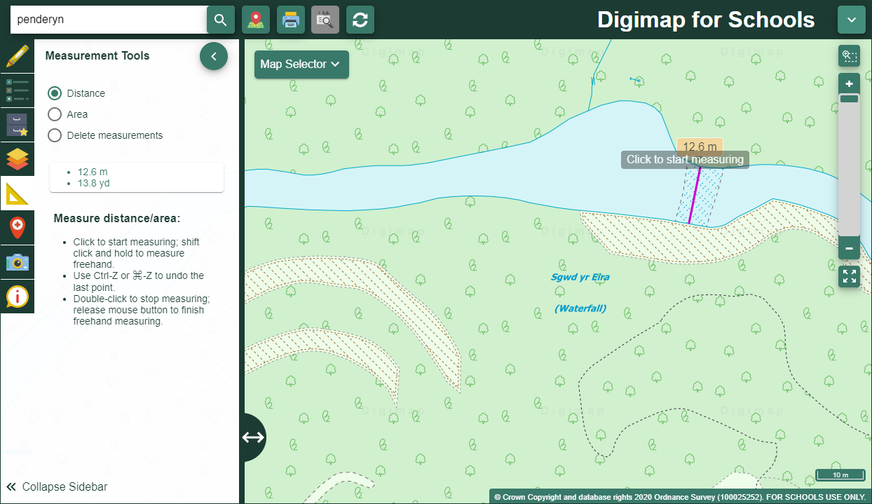Use the Measurement Tools to find out e.g. the width of a waterfall, a meander or an estuary. You could measure the area of features such as an Oxbow Lake or distinct patterns of land use.

# 

# Patterns of land use

1. Take a section of a river and highlight different patterns of land use along its length using the Draw polygon tool (in the Drawing Tools).
2. Then use the Measurement tools to measure and rank by area size.
3. Select appropriate images to illustrate these varying landscapes or use them as prompts to select appropriate descriptive terms that can be added to the map using text boxes.

# River Wildlife

Use ‘animal’ names and related search terms to investigate the wildlife along the course of a river and compare biodiversity and abundance at different locations. You could focus on one spot and investigate images in different seasons or focus on e.g. Spring across many rivers.

# River Stories and Poems

Use the research about rivers to create story settings. Describe a journey from source to sea. You could imagine that you are the river and describe the landscapes you pass through and how you change along the way. Use the beginning, middle and end of the river’s journey to structure your own writing.

Use the images to write descriptive phrases and create a bank of vocabulary that can be used to write short poems. Imagine yourself into a photograph and think about what you would see, hear and smell if you were really there. What would the rock by the waterfall feel like? What would the river sound like as it dropped over the edge of the waterfall into the plunge pool beneath?

A Haiku is a traditional three lined Japanese poem that can be written on many subjects. It does not have to rhyme but it has a strict format. A Haiku consists of 3 lines and 17 syllables.

Each line has a set number of syllables see below:

Line 1 – 5 syllables

Line 2 – 7 syllables

Line 3 – 5 syllables

Haiku convey a sense of a place and its essence. Take one image of a river feature such as a waterfall and use this to prompt your poem.

## Literacy Links

* Explaining specific terminology
* Writing reports
* Creating captions
* Developing descriptive terminology.
* Writing stories and poetry

## Numeracy Links

* Measuring features

# Taking it further

Use the ‘A focus on...’ approach to investigate other features. Here are some suggestions.

Focus on:

* a journey along a motorway such as the M4 or the M6 or a glossary of travel routes with mapped and illustrated examples.
* an annotated stretch of coastline or a glossary of coastline- related activities and features.
* a guide to the mountains and hills of…
* an animal such as a fox, kite, badger or deer. You could search for images and map hot spots where many sightings and photographs have occurred.
* a plant such as an Oak tree or a Daffodil. Investigate patterns of distribution and in the case of seasonal specific plants such as Daffodils, investigate the dates when photographs were taken and compare this to how far North or South the location was.
* types of housing in a village or town.
* prehistoric and ancient settlements and link with work in history. Look for sites of antiquity on the map too and search using suitable terms such as ‘hill fort’ ‘standing stones’ etc.

# Copyright

©EDINA at the University of Edinburgh 2016  
This work is licensed under a Creative Commons Attribution-Non Commercial Licence Creative commons licence, CC BY NC

# Acknowledgements

© CollinsBartholomew Ltd (2019) FOR SCHOOLS USE ONLY

© Crown copyright and database rights 2020 Ordnance Survey (100025252). FOR SCHOOLS USE ONLY.

Aerial photography © Getmapping plc. Contains OS data. FOR SCHOOLS USE ONLY.

Historic mapping courtesy of the National Library of Scotland. FOR SCHOOLS USE ONLY.