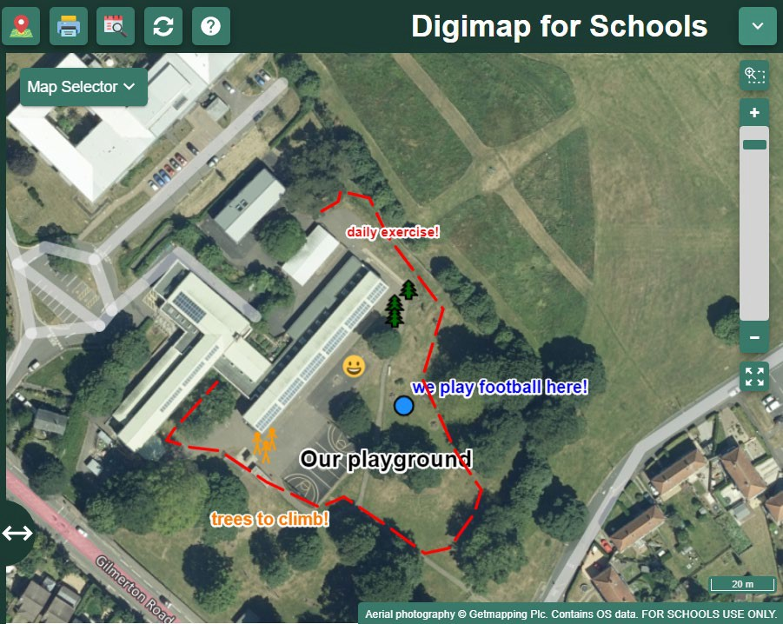
Digimap for Schools
An introduction for primary teachers

Rowena Pryor, Teaching and Learning Consultant

Digimap for Schools
Presenter
2020-03-29 15:10:48
--------------------------------------------
This is the interface/front page for Digimap for Schools. A detailed description of each feature can be found in the user guide at https://dfsresources.edina.ac.uk/resources/subject/primary-87/subject/using-digimaps-103
This PowerPoint gives an outline of the resource and initial examples of how it could be used with KS1 and KS2 children. NB Digimap for schools is a very powerful tool with lots of features but children can learn a lot from the use of just a few features – on which they can then build.
https://digimapforschools.edina.ac.uk/
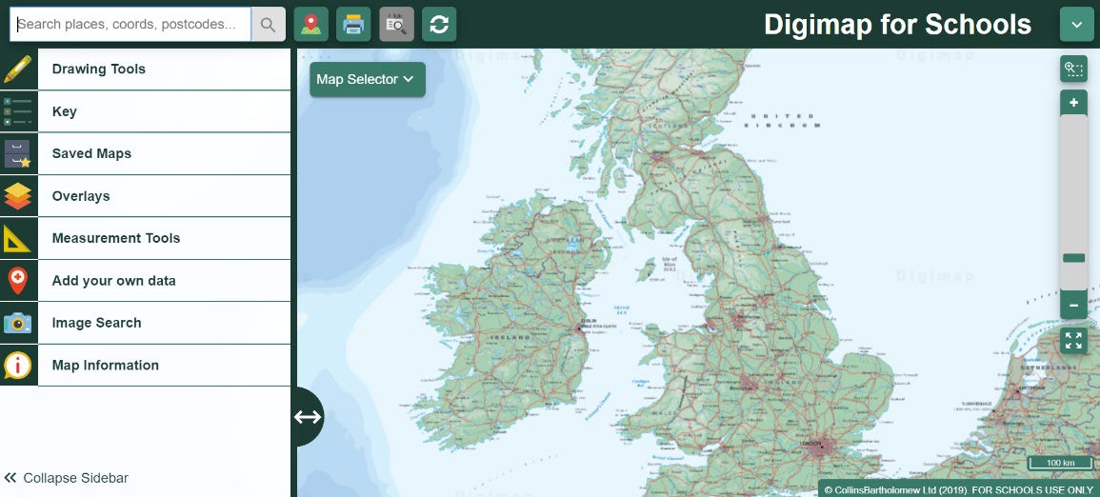

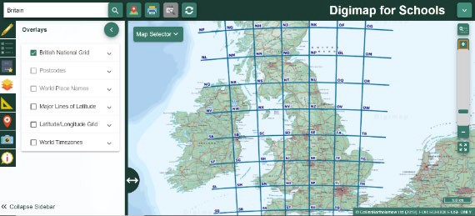
Two main aspects of DFS
- Britain
  - Ordnance Survey
  - Aerial photos
  - Geograph images
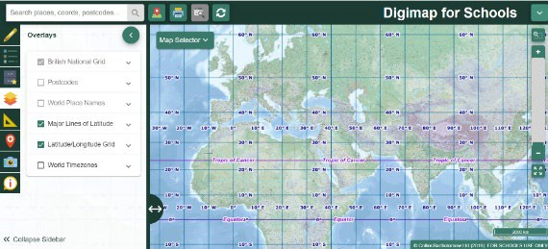
  - British National Grid references

- World maps
  - Collins Barthlolomew
  - OpenSteetMap

KS1 NC Programme of Study
Presenter
2020-03-29 15:10:49
--------------------------------------------
https://www.gov.uk/government/publications/national-curriculum-in-england-geography-programmes-of-study
At KS1 use of Digimap for Schools will be mainly teacher-led although some children may begin to add simple markers and labels.
The use of digital/computing is not specifically mentioned for KS1 (as it is in KS2) but it makes sense to introduce children to digital maps to prepare them for use at KS2.
Geographical skills and fieldwork
- use world maps, atlases and globes to identify the United Kingdom and its countries, as well as the countries, continents and oceans studied at this key stage
- use simple compass directions (north, south, east and west) and locational and directional language [for example, near and far, left and right], to describe the location of features and routes on a map
- use aerial photographs and plan perspectives to recognise landmarks and basic human and physical features; devise a simple map; and use and construct basic symbols in a key
- use simple fieldwork and observational skills to study the geography of their school and its grounds and the key human and physical features of its surrounding environment

KS2 NC Programme of Study
Presenter
2020-03-29 15:10:49
--------------------------------------------
https://www.gov.uk/government/publications/national-curriculum-in-england-geography-programmes-of-study
Geographical skills and fieldwork
- use maps, atlases, globes and digital/computer mapping to locate countries and describe features studied
- use the 8 points of a compass, 4- and 6-figure grid references, symbols and key (including the use of Ordnance Survey maps) to build their knowledge of the United Kingdom and the wider world
- use fieldwork to observe, measure record and present the human and physical features in the local area using a range of methods, including sketch maps, plans and graphs, and digital technologies

DFS Resources and help online
Presenter
2020-03-29 15:10:49
--------------------------------------------
There are lots of free, online step-by-step guides, activity ideas and help videos that accompany DfS. These can be used individually by teachers or as follow-on resources for in-school staff-training or meetings.
DfS is a very powerful resource. However, teachers don’t have to wait until they understand it all before using it with children! Knowing a few key skills within the software will enable you to start using the tool successfully especially if children are also directed to these resources and encourage to use them independently.
- There is a wide range of resources, with step by step instructions, that can be used at KS1 and KS2.
- When searching for resources filter by key stage or subject: https://dfsresources.edina.ac.uk/
- Help pages for individual features: https://digimapforschools.edina.ac.uk/help/key-areas/
- Quick guides and help videos can be found here: https://digimapforschools.edina.ac.uk/help/quick-guides/maps- places/

Tools • Can be used on a tablet or laptop (Chrome is best)
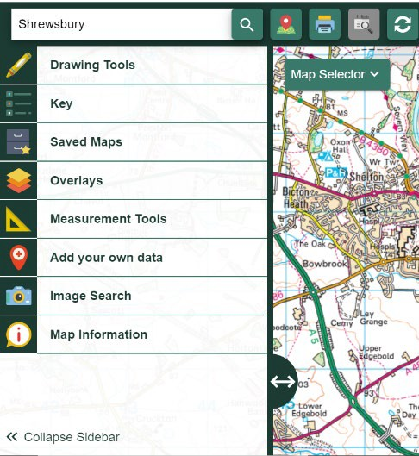
  - Wide range of tools
  - Search for places - specify UK or World
  - Draw on and annotate maps
  - Save your maps within the software, or
  - Print off your map as a PDF or JPG
  - Measure distances and areas
  - Add your own photos and other data
  - Search for images (Britain only)
  - Overlays –British National Grid and postcodes (Britain)
  - Overlays - Latitude/Longitude Grid, Timezones (world maps)
  - Sidebar can be collapsed to see more of the map

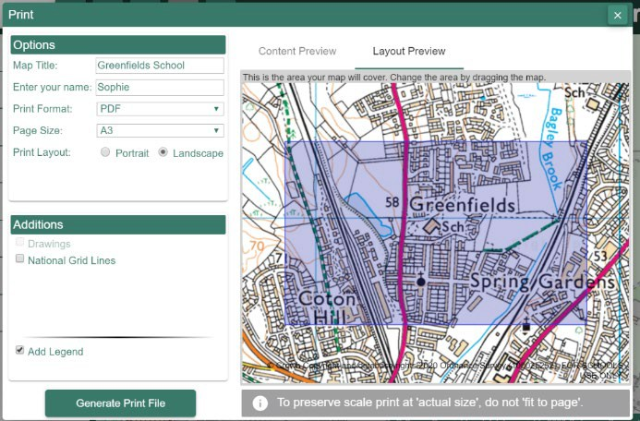
Printing maps

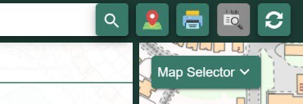
- Children can annotate paper maps
- Choose any map, scale, historical, aerial, Britain, world etc to print
- Choose A3 or A4, landscape or portrait
- Choose PDF (or JPG to insert in other documents)
- Select Layout Preview to check print area
- Include gridlines, titles, drawings, key
- NB rename your file as soon as it downloads

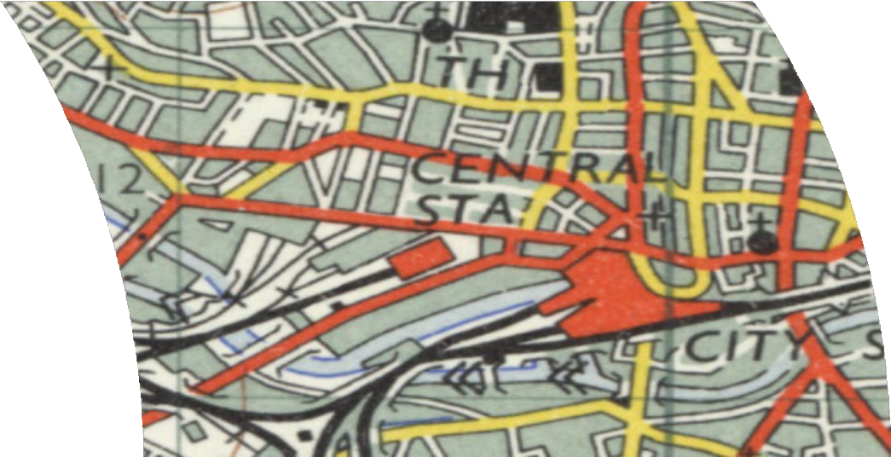
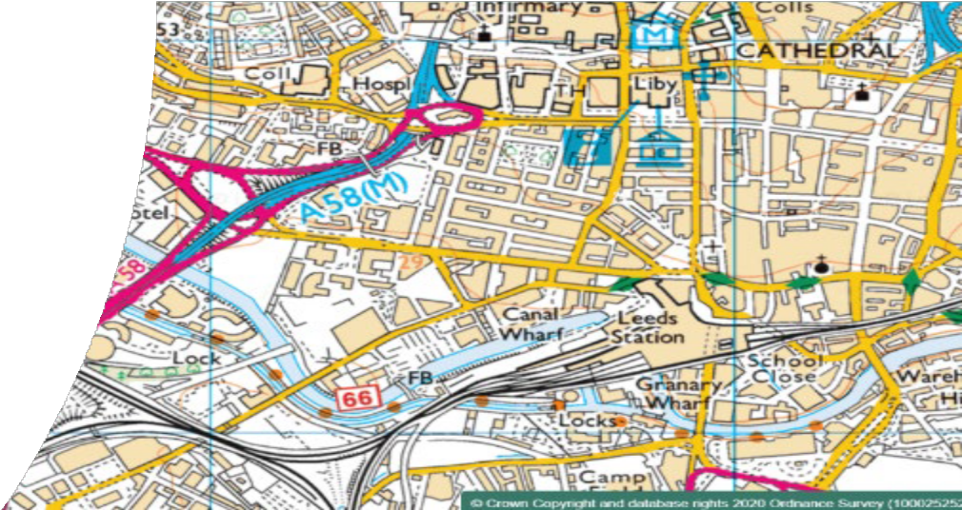
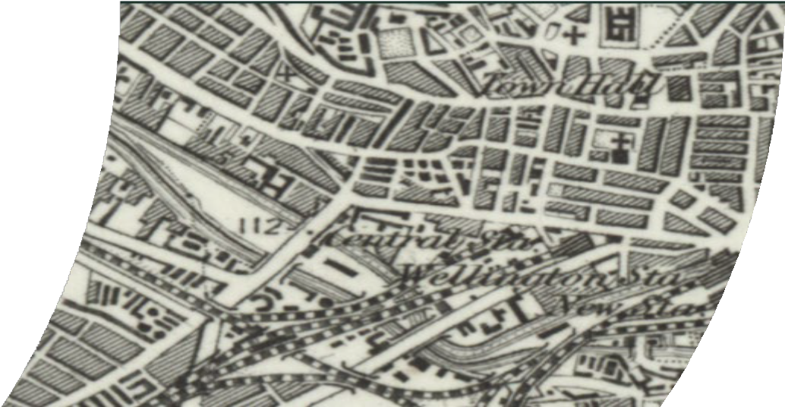
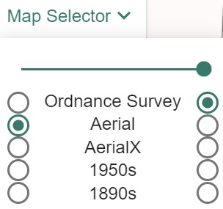
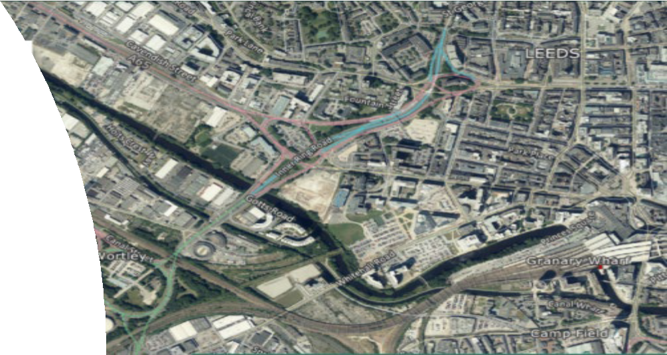
Map Selector
Presenter
2020-03-29 15:10:50
--------------------------------------------
Map Selector allows you to choose different map layers at various scales i.e. current day, aerial image, 1950s map and 1890s map. Print off these maps and get children can compare and contrast old with new or map with aerial image. Include ‘key/legend’ when you print. A separate PDF is produced which can be used with both online and printed maps.

Use slider to fade between one style of map and another.

Using historical maps of the local area to investigate change over time

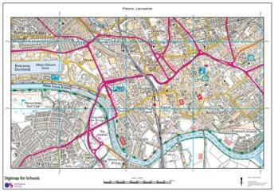
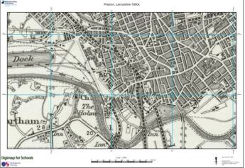
  - What features can you see on today’s map?
  - What features can you see on the 1890s (or 1950s) map?
  - What features appear on both maps?
  - Which features have disappeared?
today
1890s
?
  - Download a key/legend to help identify features

Zoom in and repeat at a larger scale

Large scale map and aerial image (start with your school)
- Compare and contrast
- Look for human and natural features
- What can be seen on the aerial but not on the map and vice versa

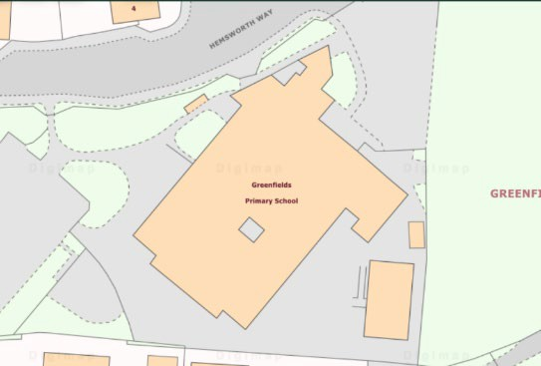
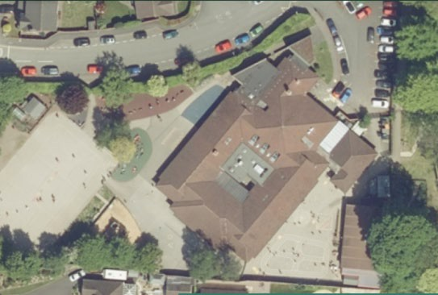

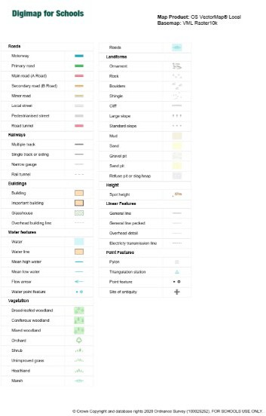
Identifying features of the local area using a key

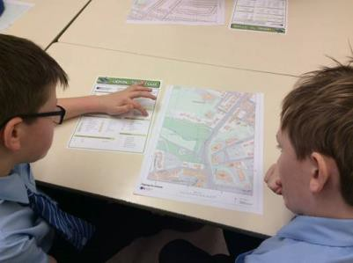
In pairs children explore a different A3 large-scale map of their local area using a key to identify physical and human geographical features, routes etc.

North, South, West and East
- Each overlapping map includes the school (north, south, east and west)
- The maps are then placed together to create a larger map of the area with the school in the centre.

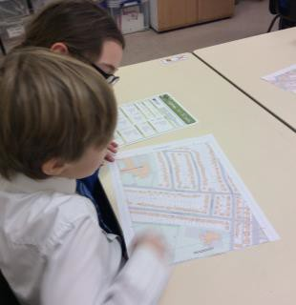
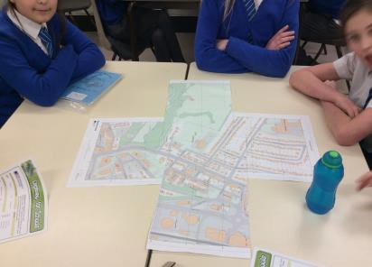
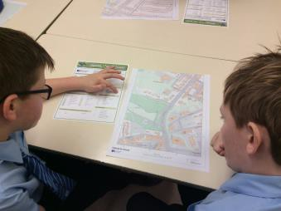

Studying geographical features e.g. rivers
Presenter
2020-03-29 15:10:50
--------------------------------------------
You can demonstrate geographical features more fully by sometimes printing off a series of maps then getting the children to piece them together like a jigsaw. This example shows the course of the River Derwent in the Lake District from its source to its mouth. This can of course be replicated with your local river or any other river or features in Britain (at varying scales). This example uses maps at a scale of 1:10000 You could also print off a series of maps of your town, village or the school itself. Create jigsaws from just 3 or 4 large scale maps for younger children.

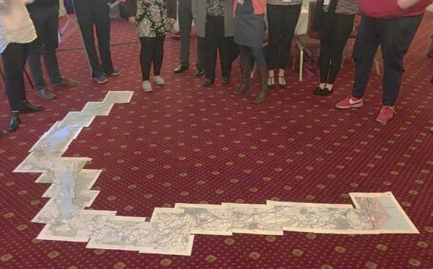
Course of the River Derwent in Cumbria (17 x A3 maps)

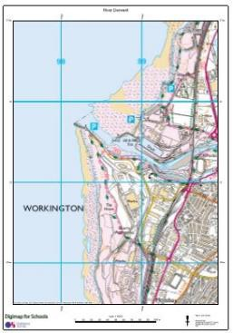

Scale 1:10000

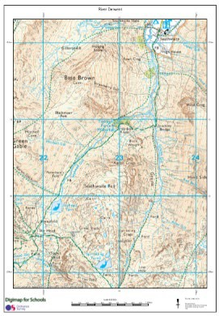
Mouth and source of the River Derwent in Cumbria

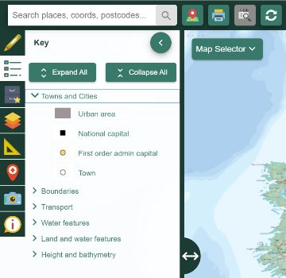
Map Keys (Legend)
Presenter
2020-03-29 15:10:51
--------------------------------------------
PDFs of the keys can only be printed off when you are printing a map of the relevant key. Just remember to tick the ‘print key’ box.
  - Each OS map/scale has a different key
  - The Historical maps and world maps also have separate keys
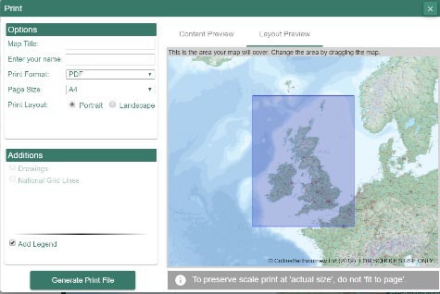
  - Tick the ‘Add Legend’ box when printing
  - Print these off as PDFs to use alongside the digital maps or with paper maps

Key Stage 1 activities/focus
    - Mainly teacher-led activities
    - Search by place or postcode
    - Identify differences between an aerial photo and a map
    - Large-scale map vs aerial photo of the schools grounds, locality
    - Physical/natural features vs human/man-made features
    - UK 4 countries and capital cities – zoom in to see features
    - Add simple markers or labels to online maps
    - View and annotate paper copies of the maps
    - Know about other digital maps e.g. Google Earth

Key Stage 2 activities/focus
- Use more features independently
- Historical maps
- World maps
- Scale
- Measurement tools – distance, area
- Overlays – latitude, longitude, time zones
- Know the difference between OS maps (Britain) and other maps
- Save and print maps. Annotate paper copies of the maps
- Cross-curricular

Progression summary (one example)
Presenter
2020-03-29 15:10:51
--------------------------------------------
This is just one example of progression within a school. Use of OS maps (including DfS) should be encouraged whenever studying the geography of Britain (including cross-curricular aspects e.g. journeys, trips, visits etc in other subjects).
It is important that children use Digimap for Schools in every year group to develop their skills and show progression. There are a number of free resources that can be used: https://dfsresources.edina.ac.uk/resources/subject/primary-87 The subject leader might allocate specific resources to each year group to ensure development of skills and to avoid overlap. The resources chosen will also depend on the places or topics studied in each year group.
Year | Activities/focus
Y1 | Teacher use of DfS maps and aerial photos on the big screen. Search by postcode and/or place name locally. Label school and zoom out to view its place in the UK. Visit other relevant places e.g. London in map and aerial view. Print off large scale maps and aerial photos of the school grounds. Children match and label features that they recognise.
Y2 | Children use DfS to search for their school or house and might add a simple label to their map or aerial photo with help. Maps can be saved within DfS or printed off for the children to add to later. Children use a pre-prepared map of the school grounds to follow a trail or search for an object.
Y3 | Draw a basic route on the map e.g. home to school. Add explanatory labels. Save personalised maps within DfS (these can be opened later on any device.) Save and print maps for children to label manually. Introduce historical maps. Zoom out/in to locate places further away e.g. Stone Henge, Roman features etc.
Y4 | Add photos to a map. Add other annotations e.g. markers or areas, and larger labels to explain features and places. Locate and measure rivers – local and/or nationally. Use printed off maps to use 4 figure coordinates to locate features. Use scale bars to calculate distances. Use world map to locate Russia and Europe. Use world time zones and major lines of latitude overlays.
Y5 | Zoom out and in to locate and identify ports, docks and shipping routes. Use historical maps to demonstrate changes over time. Use printed maps of various scales – understand larger and smaller scale maps. Locate and use help features within the software e.g. help pages, YouTube videos etc. Children print off maps as PDFs. Use latitude and longitude overlays on world map.
Y6 | Use a wider range of measuring and annotation tools. Use maps to discover and describe different types of patterns, land use, changes and place-names. Identify relief features e.g. contour lines, hills, mountains, slopes, valleys. Use 6 figure coordinates to locate features on printed maps. Save maps as jpegs and use in other software. Use keys and overlays on the world map.

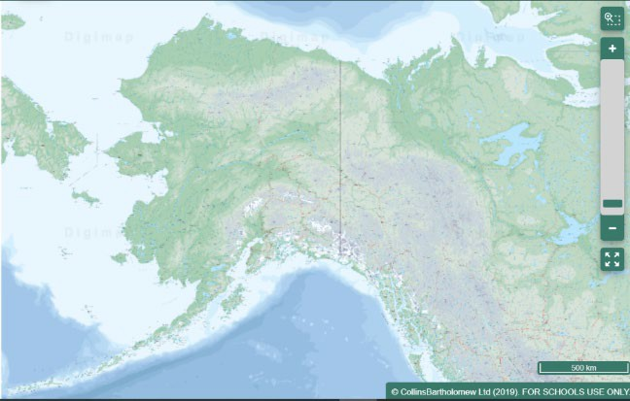
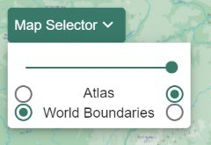
World Maps

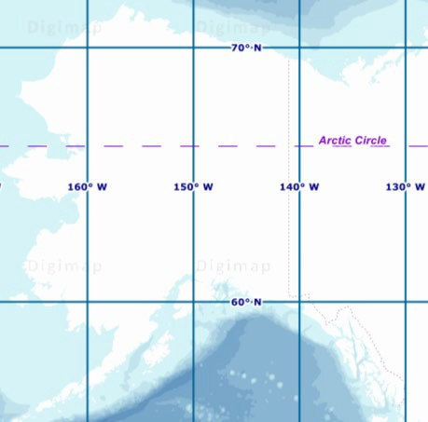
Latitude and Longitude Grid

Slide between Physical and Political maps

Overlays: World Timezones (e.g. Europe/Russia)

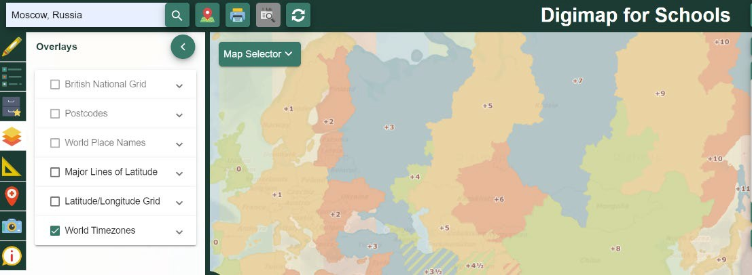

Annotating World Maps

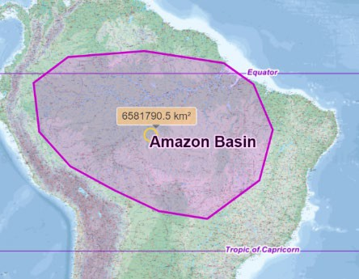
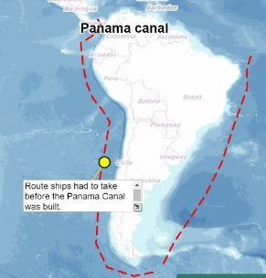
Using Measuring and Annotation Tools

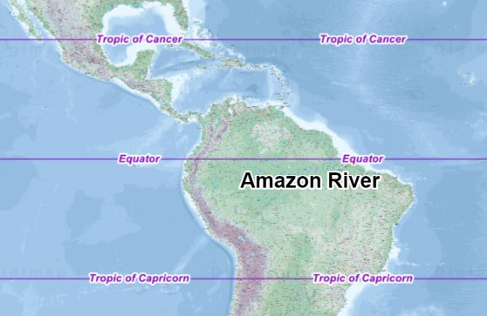
Major Lines of Latitude Overlay

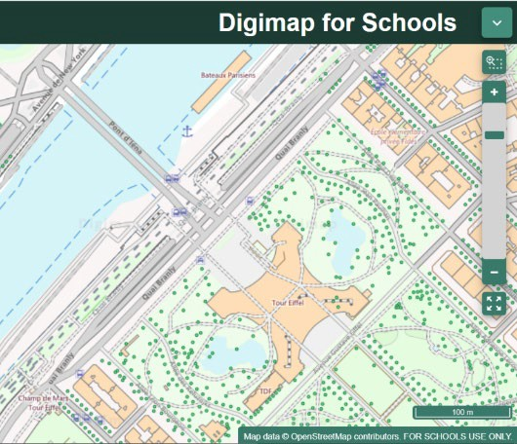
Large-scale city details

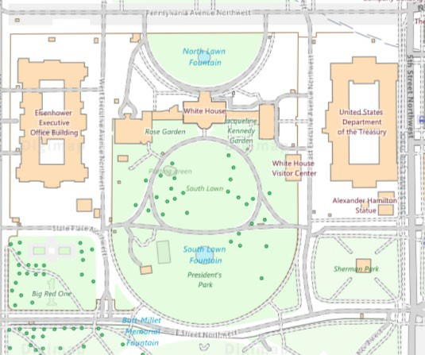
Washington DC, USA
Eiffel Tower, Paris
OpenStreetMap data

