Artful Maps

Patterns on Maps

Paula Owens

Geography Teaching Resource

Primary

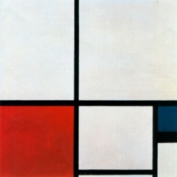
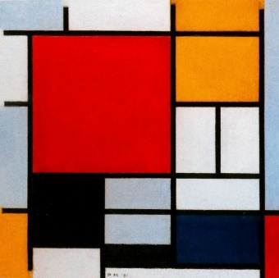
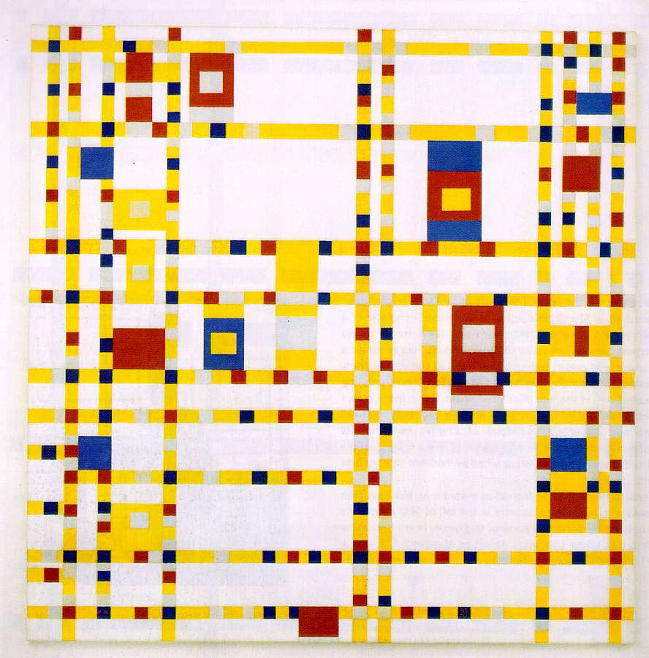
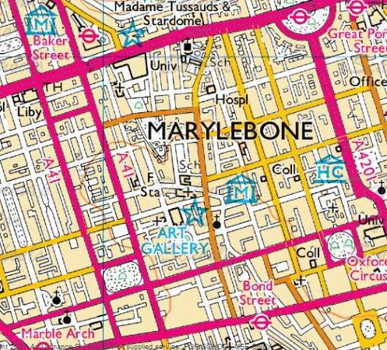
Contents
Digimap for Schools Geography Resources 3
Content and Curriculum links 3
Activity 4
Introduction 4
Main activity 4
Taking it further 7
Web links 7
Copyright 8
Acknowledgements 8

Digimap for Schools Geography Resources
These resources are a guide for teachers to demonstrate to the whole class or direct individual students as appropriate. Each activity has several ideas within it that you can tailor to suit your class and pupils. Some resources contain worksheets for direct distribution to pupils.
https://digimapforschools.edina.ac.uk/

Content and Curriculum links

Level | Context | Location
Primary | Patterns on maps | Anywhere

Knowledge | - recognising features and patterns in the landscape  - using maps at different scales  - adding labels  - using grid references  - Links with Art: learn about great artists
Curriculum links (England) | - Use maps to describe and understand key aspects of human and physical features
Curriculum links (Wales) | - Identify and describe the spatial patterns (distributions) of places and environments.  - Use maps, imagery and ICT to find and present locational information.
Scottish Curriculum for Excellence | - Social Studies Outcomes: People Place and Environment: 2-13a, 2-14a

Activity
Pupils investigate the patterns that features make on maps at given locations and choose some locations of their own. They select a map view as the inspiration for a painting or print, labelling it with a grid reference number so that the painting can be related to this particular place.

Introduction
Maps at different scales show us patterns that natural and man-made features make through their interpretations of reality. Using these symbols and lines shown in such a way helps pupils to remember places in different ways.
Students should select a map that they wish to use as an inspiration for their painting or block print and create their own individual piece of artwork.

Main activity
- Show the PowerPoint presentation to the class and identify what the main elements are in terms of colour, shape and pattern that are shown in the art, and how these are similar to the maps.
- What patterns can pupils find for themselves in the landscape? You may want to give a focus for a pattern search for example, capital cities, towns, roads and motorways, housing, rural areas. Or you could leave this as a free choice.

- Open Digimap for Schools.
- Type in the name of the city or town to explore:

- Suggest that they move and zoom the map until they find a view that they like. If anyone is stuck, the following searches can be used to provide inspiration:
  - Milton Keynes (city centre grid pattern)
  - Kings Sedge Moor (levels drainage pattern)
  - Bargod Taf (zoom out 2 levels to see valley road patterns)
  - Eday (zoom out 2 levels to see scattered islands)
  - Stirling (Stirling) to see multiple river bends
  - Grangemouth (zoom in to the oil refinery)
- Ask pupils to add a marker to somewhere near the centre of their map by opening the ‘Drawing Tools’ and add a ‘marker’. Click anywhere near the centre of the map to add the marker.

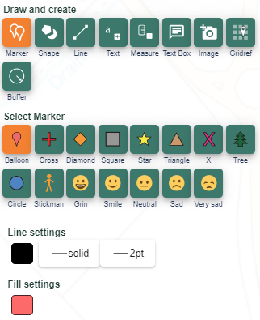

- Click on the ‘Place Grid Reference Tool’ and then click on the centre of your marker. A grid reference number will appear.

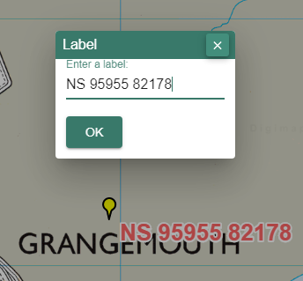

- Instruct pupils to give their map a title and save/print. They can then use this map to design a piece of abstract art. It might be useful to make two or three maps showing different patterns so that they can choose which one they want to work on. Finished artwork should be displayed next to the map which inspired it.

Taking it further
- Explore patterns at different scales
- Create artwork based on rural and urban patterns
- Create collage maps out of scrap materials
- Investigate Paintmap.com to find out how landscapes have inspired painters
- Design another map using the historical layers

Web links
Access to Mondrian paintings:www.ibiblio.org/wm/paint/auth/mondrian/
Access to Klee paintings: http://www.ibiblio.org/wm/paint/auth/klee
Paintmaps – a site where you can download free maps and add your own map data to maps: http://paintmaps.com/
Paintings Alley – free downloads of famous paintings: http://www.paintingsalley.com/
The Museum of Modern Art: www.moma.org
Create your own Picasso head: www.picassohead.com
NGA Kids Artzone: https://www.nga.gov/education/kids.html

Copyright
©EDINA at the University of Edinburgh 2016
This work is licensed under a Creative Commons Attribution-Non Commercial Licence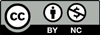

Acknowledgements
© CollinsBartholomew Ltd (2019) FOR SCHOOLS USE ONLY.
© Crown copyright and database rights 2020 Ordnance Survey (100025252). FOR SCHOOLS USE ONLY.
Aerial photography © Getmapping plc. Contains OS data. FOR SCHOOLS USE ONLY.

