Emergency Rescue
Paula Owens
Geography Teaching Resource
Secondary
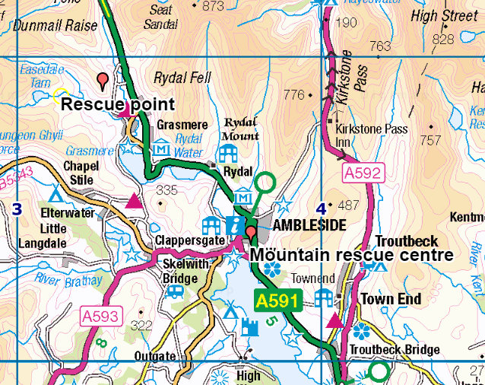

Contents
Contents 2
Digimap for Schools Geography Resources 3
Content and Curriculum Links 3
Introduction 4
Main activity 4
Web links 4
Activity 4
Tasks 5
The real-life story 7
Taking it further 8
Copyright 8
Acknowledgements 8

Digimap for Schools Geography Resources
These resources are a guide for teachers to demonstrate to the whole class or direct individual students as appropriate. Each activity has several ideas within it that you can tailor to suit your class and pupils. Some resources contain worksheets for direct distribution to pupils.
https://digimapforschools.edina.ac.uk/

Content and Curriculum Links

Activity
Taking on the role of a Mountain Rescue team to locate and reach someone in trouble in the Lake District, Cumbria. Pinpointing their location and choosing an effective route to reach them so that they can be brought to safety. See the accompanying PowerPoint.
Level | Context | Location
Secondary | Mountain rescue | Helm Crag, Lake District

Knowledge | - Using six-figure grid references.  - Adding Labels and Marker.  - Planning routes.
Curriculum links (England) | - Describe and understand key aspects of physical geography such as mountains.  - Use the eight points of a compass, four and six-figure grid references, symbols and key (including the use of Ordnance Survey maps) to build knowledge of the United Kingdom.
Curriculum links (Wales) | - Identify and locate places and environments using globes, atlases, and maps, for example, use coordinates and four figure references.
Scottish Curriculum for Excellence | - Social Studies Outcomes: People, Place and Environment: 2-12a, 2-13a, 2-14a

Introduction
The Langdale/Ambleside Mountain Rescue team (LAMRT) operates in parts of the central Lake District, Britain’s busiest mountain area. They deal with more than 100 incidents per year and are a self-funding dedicated team of ‘professional volunteers’ coming from all walks of life. Mountain Rescue teams need to know how to use Ordnance Survey maps in great detail as when there is an emergency they need to be able to locate the incident quickly and coordinate a safe rescue in the shortest time.

Main activity
Introduce the work of a Mountain Rescue team such as LAMRT and what they do. Explain that the class are going to take on the challenge of coordinating a rescue operation as LAMRT. This involves using map skills to quickly identify where an injured climber is and how to rescue them. The activity might be done in small groups or pairs.

Web links
- LAMRT http://www.lamrt.org.uk
- Mountain Rescue Organisation http://www.mountain.rescue.org.uk/mountain-advice
- View a short film of mountain rescue by helicopter: http://www.bbc.co.uk/britainfromabove/stories/roughcuts/mountainrescue.shtml
- National Grid guides: https://www.ordnancesurvey.co.uk/education/teacher-resources

Activity

The incident
A report has come in that a woman has slipped on very wet ground and sustained a suspected lower leg fracture. She might need treating at the scene and possible evacuation by air ambulance. Grid Reference: NY328088. Your HQ address is Low Fold, 1 Old Lake Road, Ambleside, Cumbria LA22 0DN.

Your task
locate the injured person’s position on a map, plan the best route to reach her by road and on foot and provide directions. Create a map that shows both your HQ and the location of the injured person and another at a larger scale that shows the terrain from the nearest road to the victim.

Tasks
- Open Digimap for Schools.
- Use the Search box to pinpoint your location by entering the postcode LA22 0DN.
- Zoom in as far as possible.
- The postcode shows the general area so you will have to search the map for the ‘Mountain Rescue Centre’.
- Place a marker here. Open Drawing Tools, select a marker and select the right spot on the map.
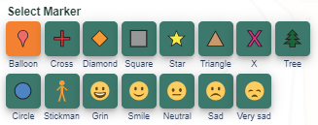
- Place a label next to this, to say ‘Mountain Rescue Centre’.
- Enter Grid Reference: NY328088 in to the search box.
- Select Overlays, then check British National Grid to add grid lines to the map.
- Zoom out two levels so you can see the two digit numbers on the grid.
- Find the easting that says 32.
- Remember the saying to help you remember which comes first in a Grid Reference:
  - “along the corridor (left to right or in an easterly direction for eastings) and up the stairs (bottom to top in a northerly direction for northings).”
- Each grid square equals 1km square so the third number (the 8) will represent 8 tenths of a kilometre into the square.
- Now you need to find the northings. The second set of figures in the Grid Reference is 088. So you need to find the northing 08 and go up 8/10 of a km.
  - Drop a marker on the map at this point and check you are right using the Place Grid Reference tool (highlighted in the image below).
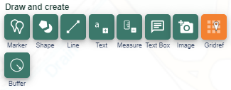
- Click next to the marker and add text to say ‘Rescue Point’.
- Zoom out until you can just fit both markers on the map.

- The rescue team will travel by Landrover as far as possible. Zoom in to the rescue area and work out which road they should take from Grasmere, to get as close as possible to the victim. A Landrover can travel on tracks, but not paths.
- Use ‘draw a line’ to work out the route you think might be best for the team to proceed on foot to the victim.
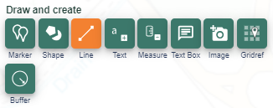
- Measure your route. Use the Add measurement label tool:
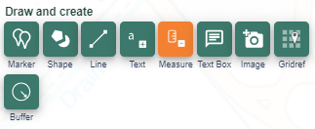
- Should they use the paths as much as possible or take a more direct route. Look at the aerial imagery to help you decide what shortcuts might be safe.
- How long in total do you think it will take them to travel from the Mountain Rescue Centre to the victim?

The real-life story
From Nick Owen, Team Leader, Langdale/Ambleside MRT:
The woman phoned 999 and notified the police, who in turn notified us (standard method of calling mountain rescue). Our team got notified 10 minutes or so in advance of helicopter and reached the woman about 2 or 3 minutes before the helicopter landed. The Ambulance service was also notified by police. They dispatched air ambulance from Penrith. The woman couldn’t give a grid reference but was able to give a good description of her location, which we then used local knowledge and maps to identify.

Taking it further
- Work in groups to role play ‘televised’ news interviews about the rescue with one group member acting as the interviewer, one as the victim and the rest as members of the Mountain Rescue team. Explain the weather conditions at the time, the terrain and the dangers involved.
- What sort of a person volunteers for a Mountain Rescue team? Explore the website of the LAMRT and find out about the people who give up their time to be a part of the team, the vehicles they use and the kind of equipment they need. What kinds of skills do people in the Mountain Rescue need to have? Write an advertisement for more members.
- Explain why and how people should go prepared for hikes and climbs in mountainous regions and particular how important it is to carry maps and a compass. Why are weather reports so important? Write some Top Tips for staying safe whilst hiking and climbing.
- Find out if phones with GPS are always reliable or not.

Copyright
©EDINA at the University of Edinburgh 2016
This work is licensed under a Creative Commons Attribution-Non Commercial Licence

Acknowledgements
© CollinsBartholomew Ltd (2019) FOR SCHOOLS USE ONLY.
© Crown copyright and database rights 2020 Ordnance Survey (100025252). FOR SCHOOLS USE ONLY.
Aerial photography © Getmapping plc. Contains OS data. FOR SCHOOLS USE ONLY.
Historic mapping courtesy of the National Library of Scotland. FOR SCHOOLS USE ONLY

