Fantasy Maps

Imaginary Features and Keys

Paula Owens

Geography Teaching Resource

Primary
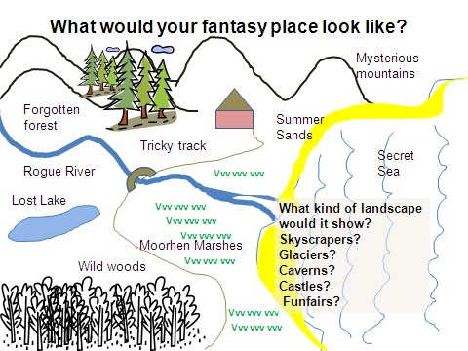

Contents
Digimap for Schools Geography Resources 3
Content and Curriculum Links 3
Activity 4
Introduction 4
Main activity 4
Fantasy Maps activity 5
Example Fantasy map 6
Taking it further 7
Copyright 9
Acknowledgements 9

Digimap for Schools Geography Resources
These resources are a guide for teachers to demonstrate to the whole class or direct individual students as appropriate. Each activity has several ideas within it that you can tailor to suit your class and pupils. Some resources contain worksheets for direct distribution to pupils.
https://digimapforschools.edina.ac.uk/

Content and Curriculum Links

Level | Context | Location
Secondary | Imaginary mapping: features and keys | Can be related to anywhere and can draw on different kinds of landscape features.

Knowledge / skills | - Using a key  - Reading and interpreting maps  - Using the Scale tool
Curriculum links (England) | Use maps and digital/computer mapping to describe features studied
Curriculum links (Wales) | Use maps, imagery and ICT to find and present locational information
Scottish Curriculum for Excellence | Social Studies Outcomes: People, Place and Environment: 2-10a, 2-14a

Activity
Using knowledge of landscape and mapping features to create a map of an imaginary place.

Introduction
Creating a map of an imaginary place helps pupils to apply some of their knowledge about maps. We all have favoured kinds of places and landscapes and for children this may be a theme park, a busy shopping centre, a zoo, a sandy beach, a mountain railway and so on.
In this activity children have to recap how different kinds of landscape features are represented and get inspiration from Digimap for Schools to draw and create their own map using their own and Ordnance Survey symbols.

Main activity
- If your pupils could create a fantasy place what would it look like?
- Would it be urban or rural? Or would it have both?
- What kind of landscape features would it have?
- Would it be by the sea or a river?
- Would there be woods or marshland?
- Would there be mountains or fields?
- Might it show a lighthouse or a castle?
- What would the features on the map be called?
- How would they show different features in a key?
You might want to have available some images of different kinds of landscape features and places and to have a range of map keys available (printed and laminated is a good idea) for pupils to use as they draw.

Show all or some of the map extracts in the PowerPoint. These show different kinds of landscapes and features that might be included on a drawn map. There is also an example of a ‘fantasy map’.

Fantasy Maps activity
- Open Digimap for Schools and look for places where you’ve been that you liked, perhaps somewhere you went on holiday? Or find somewhere that you’ve seen on the television or read about.
- Zoom in to see what it looks like on a map. Use the Search box and the Scale toolbar to help you.
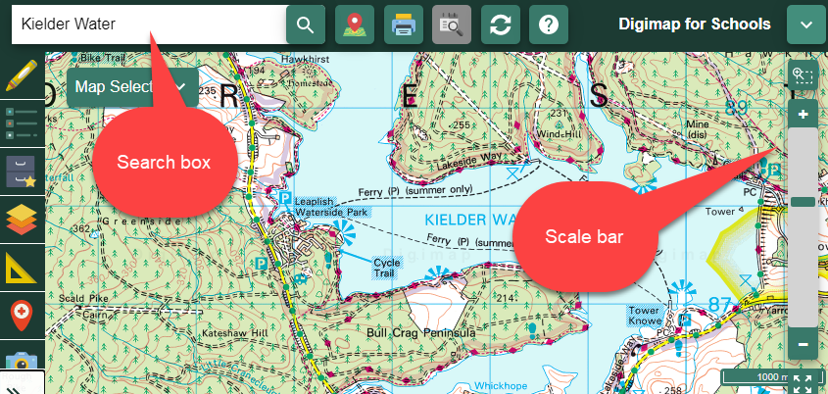
- Take a note of any interesting names that you find that you might use. If you find a map view that gives you lots of ideas you could save it and print it.
- Draw your fantasy map using the map keys from Digimap for Schools to help you draw and mark features.
  - You can find printable map keys in our resources centre. https://dfsresources.edina.ac.uk/resources/subject/using_digimap_for_schools-103
- Make a key on your map, using the shapes and labels options in the Drawing Tools.
- Make up interesting place names for some of your map characteristics such as Mystery Mountain.
- Describe your fantasy place and why you would like to be there.

Example Fantasy map

Taking it further
- In Digimap for Schools you can find place names that are unusual, quirky and sometimes strange. These can be a source of inspiration for map making. For example, the following places are all real places whose names fire the imagination. Make your own list of unusual place names and map their location:
- Slippery Stones
- Wet Car Wood
- Deadman’s Cove
- Baby’s Hill
- Sockenholes Farm
- Cat Castle
- Shark’s Fin
- Pricklegate
- Chimney Hill
- Scarlett Point
- Make 3D models of your fantasy place.
- Make another map to show what it might look like in five years’ time.
- Vote for the best fantasy place in the class. Give everyone one minute to describe it and say why it would be a good place to visit.
- Think about how you could make your place more environmentally friendly. What could be added? What might have to be taken away?

Copyright
©EDINA at the University of Edinburgh 2016
This work is licensed under a Creative Commons Attribution-Non Commercial Licence

Acknowledgements
© CollinsBartholomew Ltd (2019) FOR SCHOOLS USE ONLY
© Crown copyright and database rights 2020 Ordnance Survey (100025252). FOR SCHOOLS USE ONLY.
Aerial photography © Getmapping plc. Contains OS data. FOR SCHOOLS USE ONLY.
Historic mapping courtesy of the National Library of Scotland. FOR SCHOOLS USE ONLY.

