Flying High: White-tailed Eagles

Location and range of white-tailed eagles

Paula Owens

Geography Teaching Resource

Primary

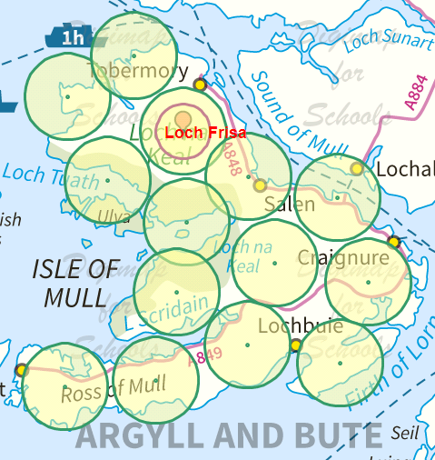

Contents
Contents 2
Digimap for Schools Geography Resources 3
Content and Curriculum Links 3
Activity 4
Introduction 4
Main activity 4
Weblinks 5
Information sheet: White-tailed Eagles 6
Mapping the White-tailed Eagles: pupil instructions 7
Taking it further 10
Copyright 11
Acknowledgements 11

Digimap for Schools Geography Resources
These resources are a guide for teachers to demonstrate to the whole class or direct individual students as appropriate. Each activity has several ideas within it that you can tailor to suit your class and pupils. Some resources contain worksheets for direct distribution to pupils.

Content and Curriculum Links
Level | Context | Location
Primary | Location and range of White-tailed Eagles | Isle of Mull, Scotland

Knowledge/Skills | Locating place, adding markers, using buffer tool, reading and interpreting topography and patterns of land-use.
Curriculum links (England) | Name and locate geographical regions and their identifying human and physical characteristics, key topographical features (including hills, mountains, coasts and rivers), and land-use patterns.  Use maps, atlases, globes and digital/computer mapping to locate countries and describe features studied.
Curriculum links (Wales) | Use maps, imagery and ICT to find and present locational information.  Identify and describe the spatial patterns (distributions) of places and environments and how they are connected.
Scottish Curriculum for Excellence | Social Studies Outcomes: People, Place and Environment: 2-07a, 2-08a.

Activity
Adding annotation to maps of the Isle of Mull to show the size of a typical territory of a White-tailed Eagle, investigating preferred habitats, discussing pros and cons of the reintroduction of this bird.

Introduction
The White-tailed Eagle, often referred to as Sea Eagle, is the largest bird of prey in the UK with a wingspan of 2.5 metres. During the early 20th century they became extinct in the UK due to illegal killing but now, thanks to a reintroduction programme, this bird is making a comeback.

Main activity
The first White-tailed Eagle chick to fledge from a Scottish (UK) eyrie in 70 years did so on the Isle of Mull in 1985. In 2013, with breeding having occurred every year since, there are 16 pairs established on the island representing something close to saturation level for Mull’s White-tailed Eagle population.
Introduce pupils to the White-tailed Eagle using the information sheet resources and web links with video clips. Explain that this bird’s territory ranges from about 30 km² to 70 km² but they can go further. A tagging programme means that several White-tailed Eagles on Mull are now tracked by satellite and their movements mapped.
The successful breeding of these birds on Mull has been a big tourist attraction and brought lots of money into the local economy. However, some farmers believe that this bird is threatening their livelihood and also the habitat of another iconic bird: the Golden Eagle. Is there enough space for everyone?
Hand out the worksheet and the information sheet provided.
The pupils will map the location of Loch Frisa and then map an area showing the typical range of a White-tailed Eagle territory. They should end up with a map that looks something like this, showing that the maximum number of breeding pairs that the Island of Mull could support would be 14–15.

Weblinks
General information and video clips of White-tailed Eagles: http://www.rspb.org.uk/wildlife/birdguide/name/w/whitetailedeagle/index.aspx
Find out why plans to reintroduce the White-tailed Eagle in East Anglia were blocked:
http://www.bbc.co.uk/news/10303266
How White-tailed Eagles were reintroduced to Scotland:
www.snh.org.uk/

https://www.rspb.org.uk/our-work/conservation/satellite-tracking-birds/tracking-mull-white-tailed-eagles/frequently-asked-questions/

Information sheet: White-tailed Eagles

Habitat
Scottish White-tailed Eagles prefer sheltered lochs or sea lochs rather than exposed coastal sites. They also prefer to nest in trees rather than on cliffs. On average, their territories range from 30–70 km², but much larger areas are possible depending on the availability of prey. Breeding adults stay close to their breeding territory throughout the year. Non-breeding birds may range widely to find sufficient food. In Britain, White-tailed Eagles are non-migratory; arguably the best time to spot this species is during the winter months when food is scarcer.

White-tailed Eagles on Mull
Loch Frisa is one of the best places to see spectacular views of White-tailed Eagles and there is a purpose-built hide there. One access point is at the south end of the Loch Frisa track, just off the main A848 Salen to Tobermory road, about three miles north of Salen. (Ordnance Survey Grid Reference NM 553 459).
https://mulleaglewatch.com/
Since 1998, a pair of White-tailed Eagles known as ‘Skye and Frisa’ has been nesting on Loch Frisa, Isle of Mull and raised one chick that year: https://community.rspb.org.uk/ourwork/b/scotland/posts/when-skye-met-frisa-a-love-story

Tagging and monitoring
There’s still a lot to learn about what young White-tailed Eagles do in their first three to four years of life in the UK. They don’t migrate like the ospreys but they do wander far and wide around Scotland, maybe elsewhere in the UK and Ireland, maybe to Europe! Who knows? The youngsters are fitted with small, solar-powered satellite tags that will transmit information about their journey. Initially, every hour – as long as the battery is charged up – the tag sends the exact position (within 20 metres) on the Earth, as well as details of direction, speed of flight and altitude via the Global Positioning System (GPS) to a computer system. This means that a very detailed picture of each bird’s route can be built.
It’s a hazardous first few months and years; where and for how long do they stop to roost and feed, when do they make their first long flights from Mull, when are they independent of the adults, where and when will they start to think about settling down to breed? Being able to track the birds’ journeys will add to our knowledge and understanding of the sea eagle’s lives and can help inform future conservation work. Read more on the RSPB website (link also in Web Links area).

Mapping the White-tailed Eagles: pupil instructions
- Open Digimap for Schools. Use the Search box to find ‘Loch Frisa’. Open Drawing Tools and select ‘Add marker’. Click on the loch. Then, select ‘Text’ choosing the text size Arial, 18pt. Click next to the marker and write ‘Loch Frisa’.
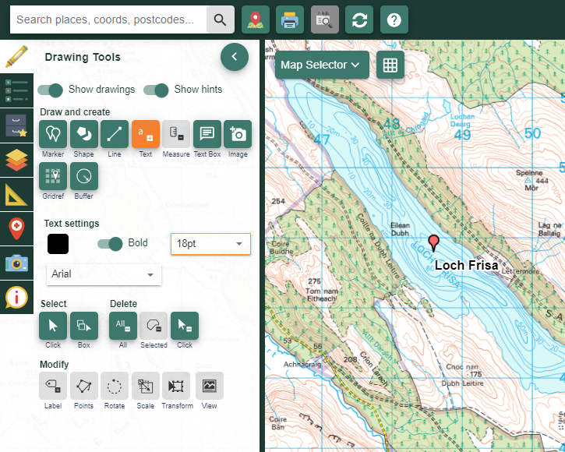
- You’re going to show on the map the area that a White-tailed Eagle might have as its territory. Skye and Frisa nest in the forests beside Loch Frisa so this will be your starting point. Zoom out to Level 5 so that you can see the coastline of the northern part of the Isle of Mull quite clearly as well as your marker showing Loch Frisa.
- Open ‘Drawing Tools’.
- Select the Buffer tool.
- Select point buffer.
- Select a 3 kilometre radius.
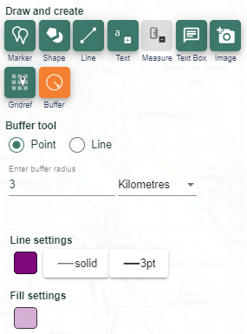

- Double-click on your marker on Loch Frisa and your map will now have a circle to show the minimum area required for a pair of nesting White-tailed Eagles.
- Add another buffer of 4.75 kilometre radius. Choose another colour for the outline. This shows a more comfortable territory for the birds.
- Zoom out one level to see the whole of Mull on the screen and keep adding circles of this size so that they do not overlap each other.
- Move the buffers around so that they do not touch.
- Check your circles to make sure they each contain habitat suitable for the birds. How many breeding pairs can the island support? If you have time add some more annotations to the map, such as the location of the purpose-built hide and rendezvous point for visitors. When you are happy with your map choose a view that you like, give the map a title, save it and then print it out.

Taking it further
- Research some of the eating habits of White-tailed Eagles and find out what kind of territory they like. Where are they likeliest to go apart from the Isle of Mull? Redraw areas to show territory but this time use the ‘Draw and create’ section and then select ‘Draw a freeform shape’ to show the areas of landscape that you think these White-tailed Eagles might prefer, thinking about the landscape features shown on the map such as for example, water, forest and so on.
- The reintroduction of White-tailed eagles is debateable. On the one hand it can interfere with farming and cost farmers money. On the other hand it acts as a popular tourist attraction benefiting the local economy. Make a list of the pros and cons of reintroducing this bird and have a class debate.
- Use some of the information from the satellite tracking programme of the White-tailed Eagles to make your own map showing some of their summer and winter locations.

Copyright
©EDINA at the University of Edinburgh 2016
This work is licensed under a Creative Commons Attribution-Non Commercial Licence

Acknowledgements
© CollinsBartholomew Ltd (2019) FOR SCHOOLS USE ONLY
© Crown copyright and database rights 2020 Ordnance Survey (100025252). FOR SCHOOLS USE ONLY.
Aerial photography © Getmapping plc. Contains OS data. FOR SCHOOLS USE ONLY.
Historic mapping courtesy of the National Library of Scotland. FOR SCHOOLS USE ONLY.

