Games and Stories
Six quick ideas for Primary activities
Paula Owens
Geography Teaching Resource
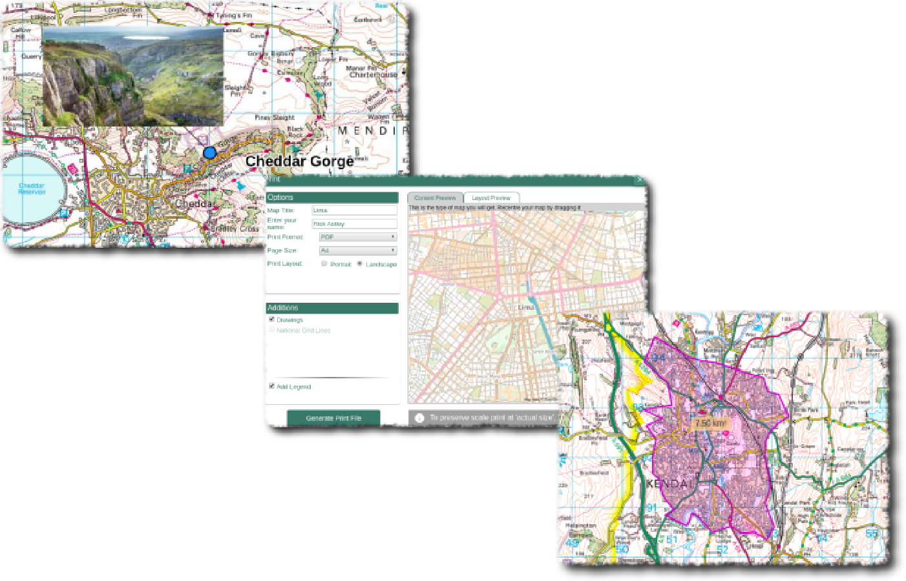
Primary

Contents
Digimap for Schools Geography Resources 3
Games and Stories 3
Games 3
1. Find Teddy 3
2. Jigsaws 3
Variations 3
3. Map Features Bingo 4
Extension 4
4. Talking point 4
5. Towns in ten 4
6. Map of the week 4
7. Spot the difference 5
8. Stories 5
Copyright 6
Acknowledgements 6

Digimap for Schools Geography Resources
These resources are a guide for teachers to demonstrate to the whole class or direct individual students as appropriate. Each activity has several ideas within it that you can tailor to suit your class and pupils. Some resources contain worksheets for direct distribution to pupils.
https://digimapforschools.edina.ac.uk/

Games and Stories
Young children can have lots of fun playing games using maps and at the same time be practising their skills in using, reading and making maps. Here are a few ideas.

Games

Find Teddy
Hide a teddy in the school grounds and provide a corresponding large scale map showing his location. See which group can find him first. If you laminate a set of maps of the school grounds you can replay this game using sticky dots to show Teddy’s location.

Jigsaws
Print off and laminate maps, particularly showing the local area, and cut them up into for example, 9 (3 x 3) sections. Put these into zipped wallets as games and make enough packs so that they can also be used for group work and discussion by the whole class in structured sessions. Ask pupils to choose a square from their pack and describe it to a partner first. Then see which group can put their map together the fastest. Digimap for Schools lets you print maps out at A3 size if you want larger maps. Make a variety of jigsaws using maps at different scales.

Variations
Withhold one of the jigsaw ‘squares’ and give pupils a blank square instead and ask them to try and draw what they think might be on it.
Get pupils to sit back to back. One describes a map square and the other has to draw it on a blank piece of paper.
Ask pupils to choose a map square. Then call out features from the relevant key while pupils check to see if they have that feature on their square. The first person to find three of the ‘called out’ features on their map wins.

Map Features Bingo
Make your own set of Bingo cards for the class using this website:

https://osric.com/bingo-card-generator/
In the input word box, put a list of named features that you might find on a specific map for example, a 1:25 000 scale map centred on your school. The level of difficulty can be varied for different age groups by deciding how many grid squares and which map features to include. You can then select the number of cards you want to make and simply print them off. Give groups of pupils a copy of the map from where the features were sourced and one of the Bingo cards. The first group to locate all of their features on their map shouts ‘Bingo’!

Extension
You could make this harder or use as a homework task by getting pupils to write the grid reference for each feature named on the Bingo card once it has been found.
Include some features not on the map! You will have to warn pupils.
Do some fieldwork in the locality for example, a local park or the high street.
Ask pairs of pupils to tick off found features on prepared Bingo cards and record their locations on printed maps of their area.
Ask pairs of pupils to record them on the map electronically using the Annotations bar if they have access to hand-held devices for example, Tablets or iPads.
Challenge pupils to devise their own Bingo cards.

Talking point
Give each group a different map to study and time to prepare a list of things they can say about it. Have a timed challenge with each group having a nominated person to read out their points. The group which can provide the most information wins.

Towns in ten
Each pair takes it in turn to choose a town in Great Britain using the same scale map. Their partner has ten questions to try and guess the town while the other person can only answer yes or no. Questions have to be about direction and location only for example: Is it in Wales? Is it south of Sheffield? Is it near the coast? Or you could play this game as a class.

Map of the week
Display a different A4 or A3 map on the wall in class each week with space for pupils to add comments each day. You could invite open or focused comments for example, would you like to live here and why? Summarise at the end of the week. Keep a class record of maps looked at in this way.

Spot the difference
Individually or in pairs using the 1890s and/or 1950s historical map ask pupils to identify changes that have occurred in the local area compared to today. Give students an allotted time to identify the changes. The individual or pair that has identified the most changes wins.
Such differences could include an increase in houses, reduction in open spaces and increase in roads.

Stories
Stories are powerful contexts for using and making maps, whether through real or imaginary tales, and maps make great reading material in themselves. Print and laminate a selection of maps and put them in the reading corner for children to access and read in any designated reading time.
Use maps to tell and illustrate stories wherever possible. For example, make some maps to accompany traditional tales by choosing locations and then adding labels and markers to show important parts of the story. You could try finding real locations for traditional tales such as: The Three Little Pigs; Hansel and Gretal, Cinderella and Little Red Riding Hood and using this to help with story writing and re-telling.
The Geographical Association also has some guidance on using maps with stories.
https://www.geography.org.uk/Primary-Geography-Handbook-Extension-Project--Maps-and-Stories

Copyright
©EDINA at the University of Edinburgh 2016
This work is licensed under a Creative Commons Attribution-Non Commercial Licence

Acknowledgements
© CollinsBartholomew Ltd (2019) FOR SCHOOLS USE ONLY
© Crown copyright and database rights 2020 Ordnance Survey (100025252). FOR SCHOOLS USE ONLY.
Aerial photography © Getmapping plc. Contains OS data. FOR SCHOOLS USE ONLY.
Historic mapping courtesy of the National Library of Scotland. FOR SCHOOLS USE ONLY.

