Make the most of maps!

This year, we purchased online access to a computer program called Digimap for Schools, which allows us to see and use maps from around the world. Some classes have already been using it.
In this pack, we have put together some suggestions about how you might like to use this package at home. We hope you enjoy using it!

Task 1 – Find your house!

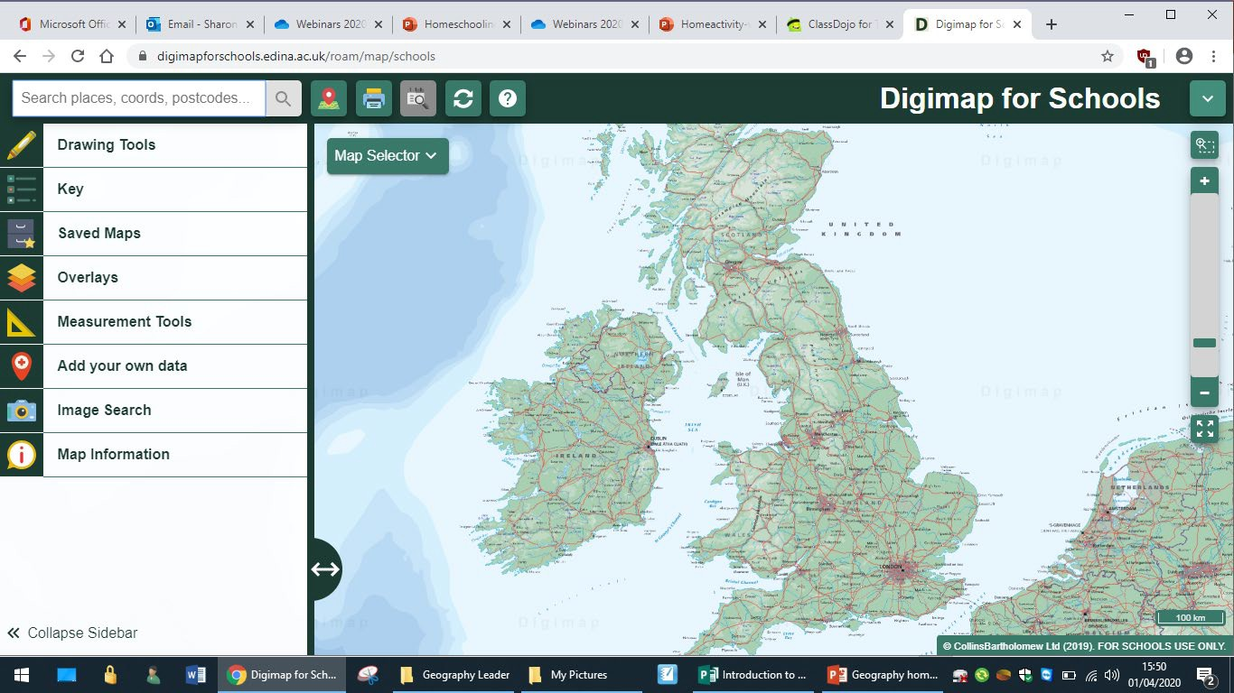
Type your postcode in here!

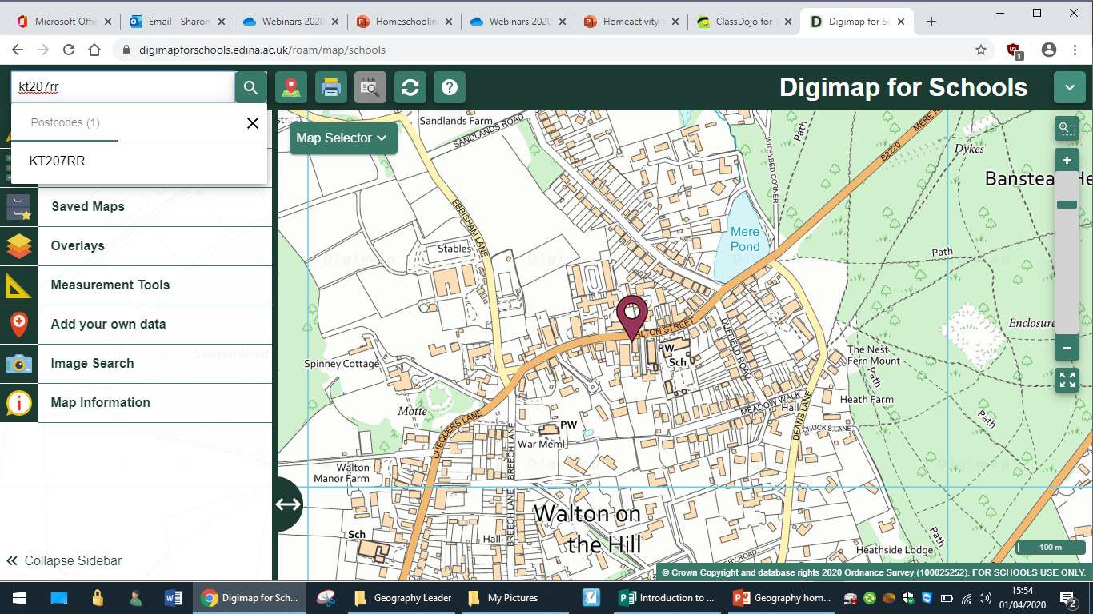
Task 1 – Find your house!

Use this slider bar to zoom in and out.

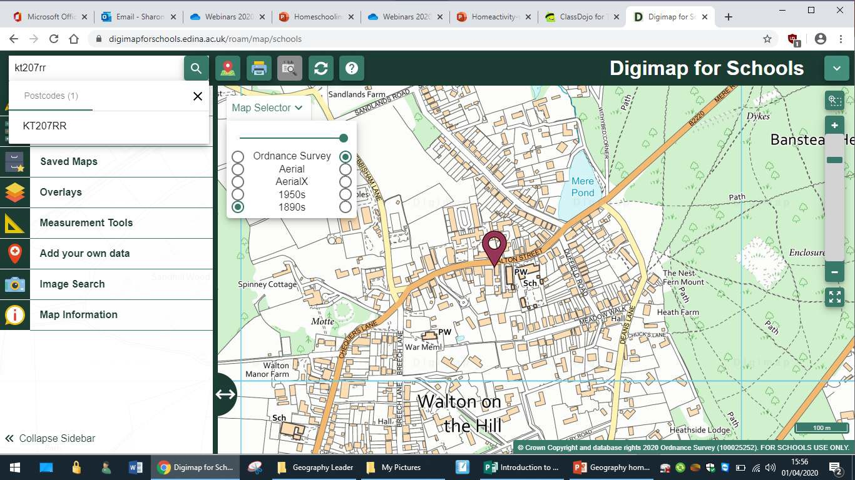
Task 1 – Find your house!
Use the “Map Selector” bar to change the view. You can slide between the modern map and other views using the slider above where it says Ordnance Survey.
Was your house there in 1890? Was your house there in 1950?
What does your house look like from above?

Task 2 – Plan a walk!

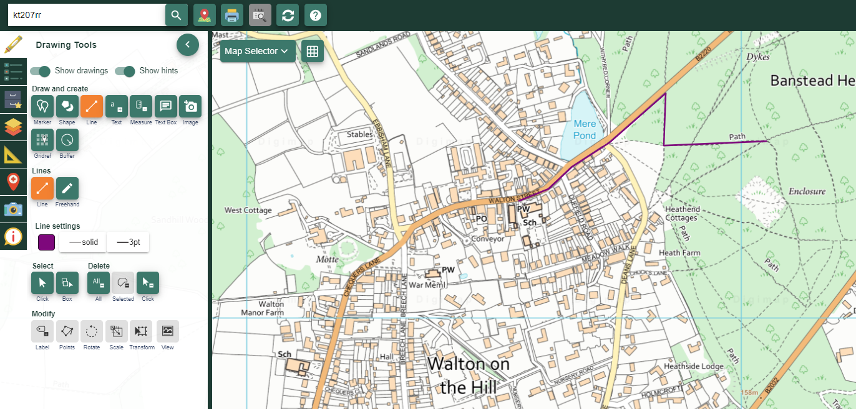
3. Draw a line to show where you want to walk. Click your mouse when you want to change direction. Do a double click when you have finished.
1. Click on drawing
tools

2. Choose the straight line drawing tool. Scroll down if you
want to change the colour of your line.

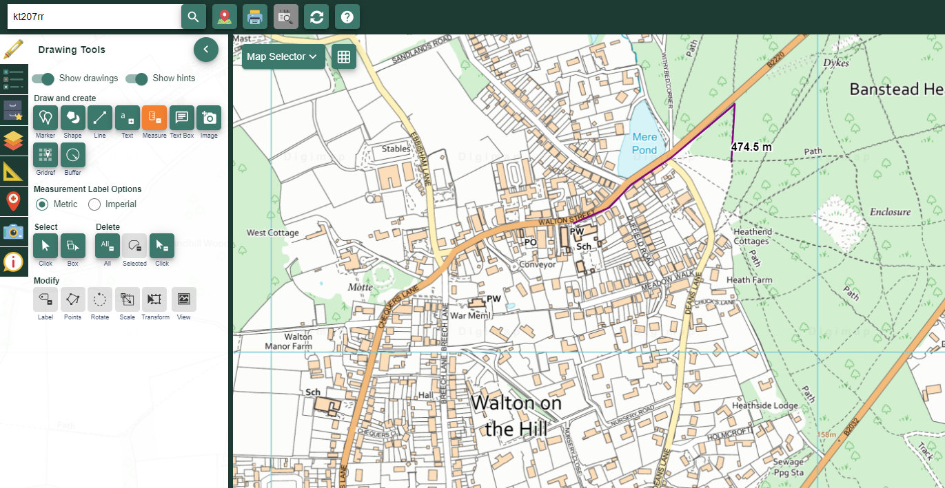
Task 3 – Measure the distance of your walk!
2. Click on the route you have drawn and it will tell you how
long it is!
1. Choose measurement
Tools

Task 4 – Use the key to find out what you might see on your walk!
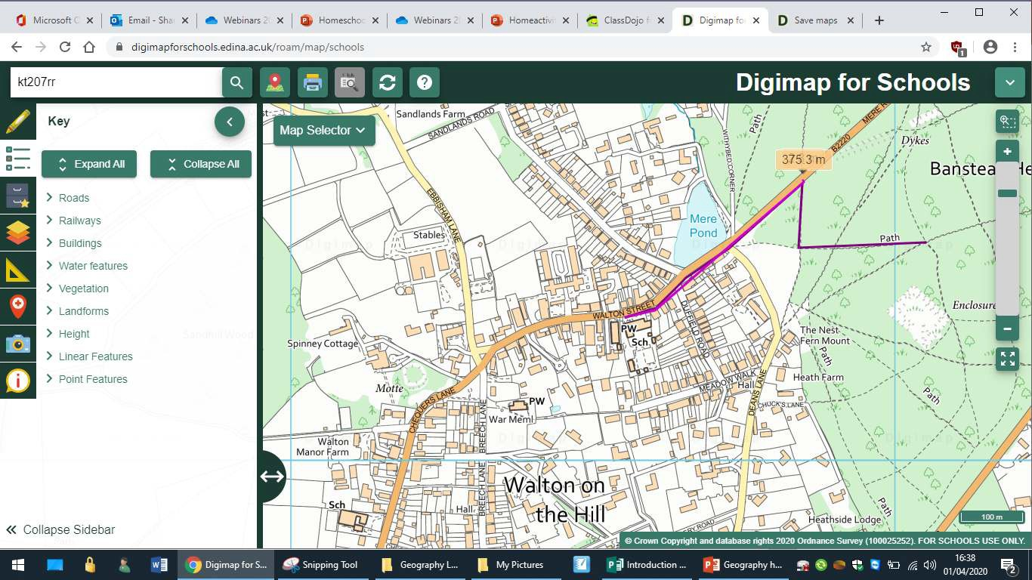
Click on the key tab.
The key is split up into different features.

Task 5 - Now go on your walk!
- If you would like to print your map out, follow these instructions.
- Time yourself on your walk and work out how long it takes you to walk 1km!
- I don’t recommend saving your map as it is accessible to anyone else who has our school log in details. This gives people information about where you live. Think about safety!
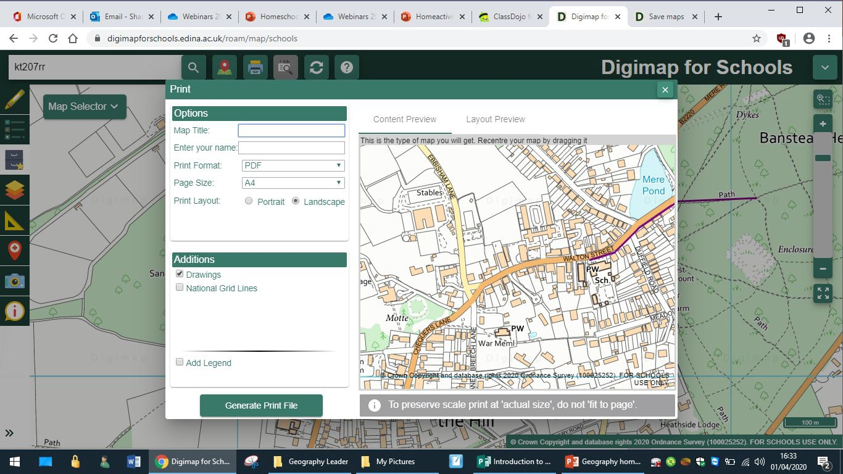
Click on the printer. Follow the instructions. The program will make a pdf of your map.

Task 6 – Take a look at your garden (or the area right next to where you live) and make a photo map
  - Take lots of photos of things that are in your garden and save them on your computer.
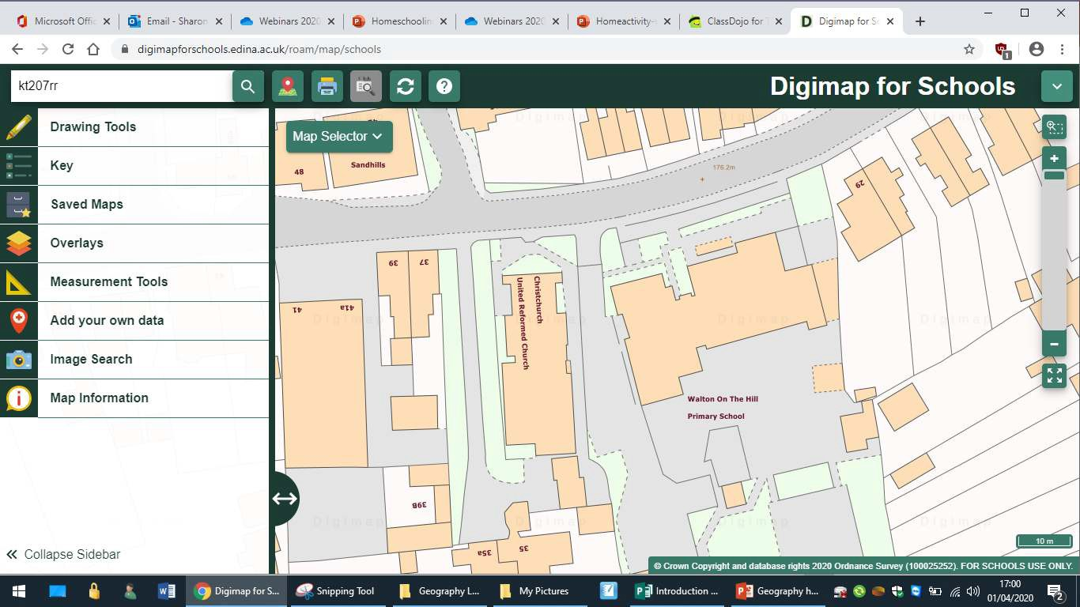
  - Open up Digimap for Schools. Zoom right in so you can see lots of details around the place where you live.

Task 6 – Take a look at your garden (or the area right next to where you live) and make a photo map

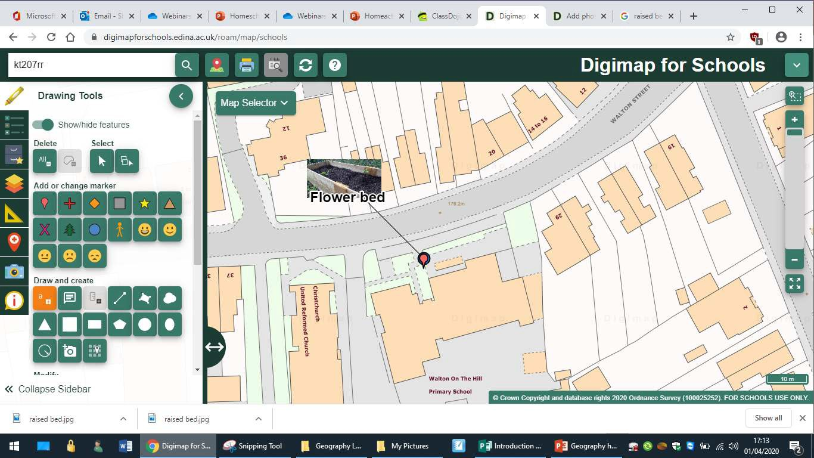
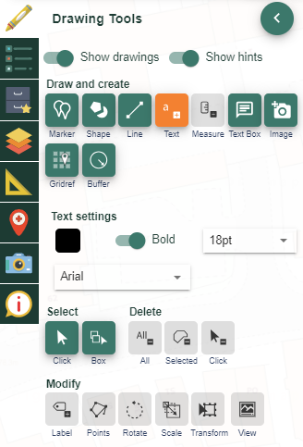
4. Use the writing tool to write a label

- Select the camera icon
- Point to where you want to put the picture
- Upload your chosen picture.

Task 7 – Beyond Walton-on-the Hill!
- Find these other towns in Surrey by using the symbols below. When you have marked them all on your map, zoom out to see where they all are in relation to one another.
- Can you describe where they are using words like North, south East and west?
- Can you zoom right out so you can see a map of Great Britain? Whereabouts in Great Britain are we?
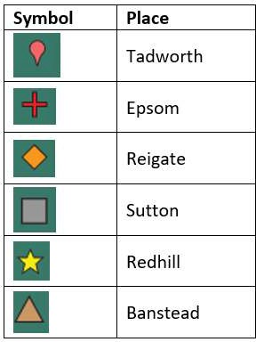

Task 7 – Beyond Walton-on-the-Hill How to add symbols
1. Type in the place name you
are searching for

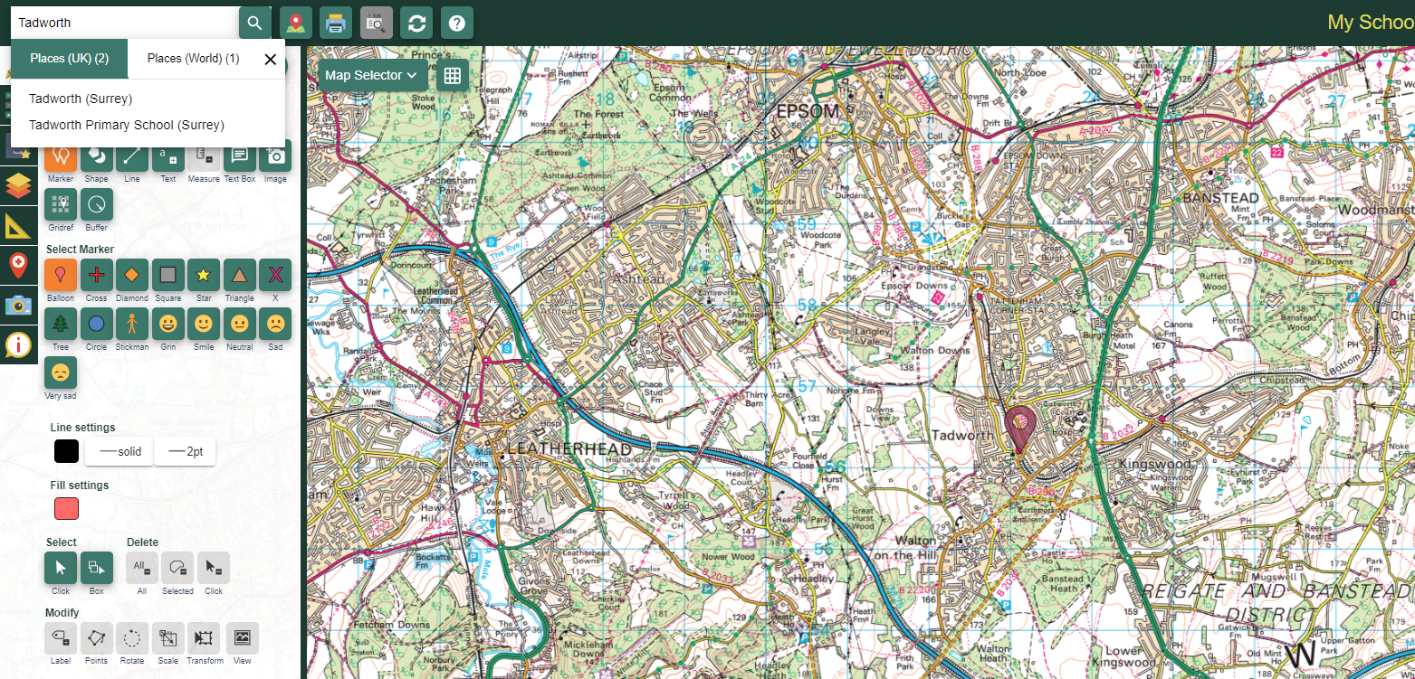

2. A marker will come up.
This will disappear.

3. Choose the
symbol you want to use by clicking on it, then clicking again on the map where
you want it to go.

Task 8 – Hunt the United Kingdom city!
  - Go to the folder of saved maps in digimps and choose the map called Hunt the UK city
  - Can you find out what each of the marked cities is called, and what part of the United Kingdom they are in? Complete the sheet which is on the next page.
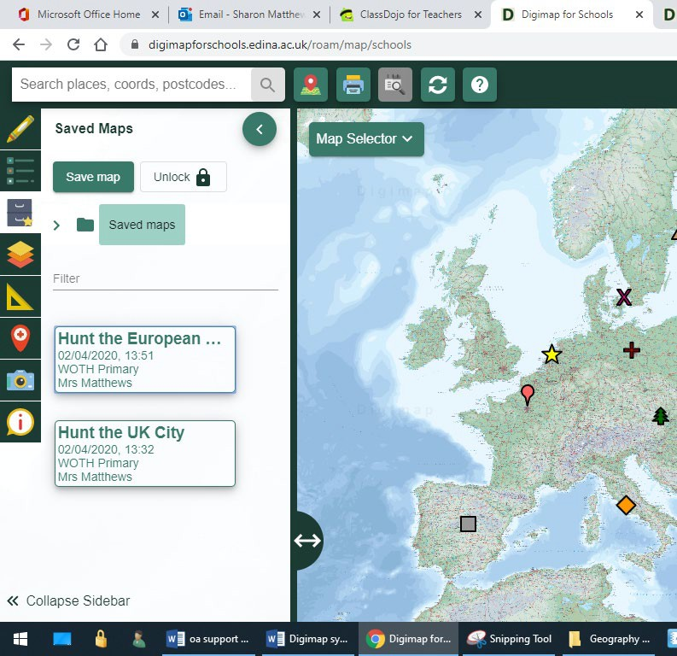
2. Choose “Hunt the UK city”
1. Go to saved maps

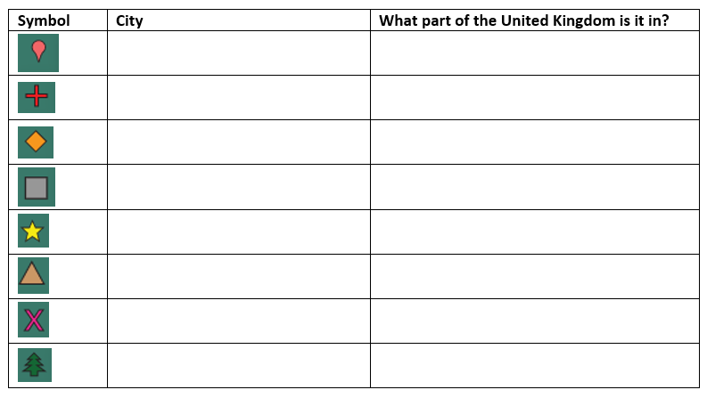
Task 8 – Hunt the UK city!

Task 9 – Make your own Hunt the Place game!
  - Most people have friends and family who live in other parts of the United Kingdom.
  - Find out the towns and cities where at least 5 friends or family members live (who don’t live in Surrey).
  - Make a map using the Digimap symbols to mark where they live.
  - Save your map if you would like to and get someone else in your family to guess where each place is that you have marked!
  - The instructions for how to save your map are on the next page.

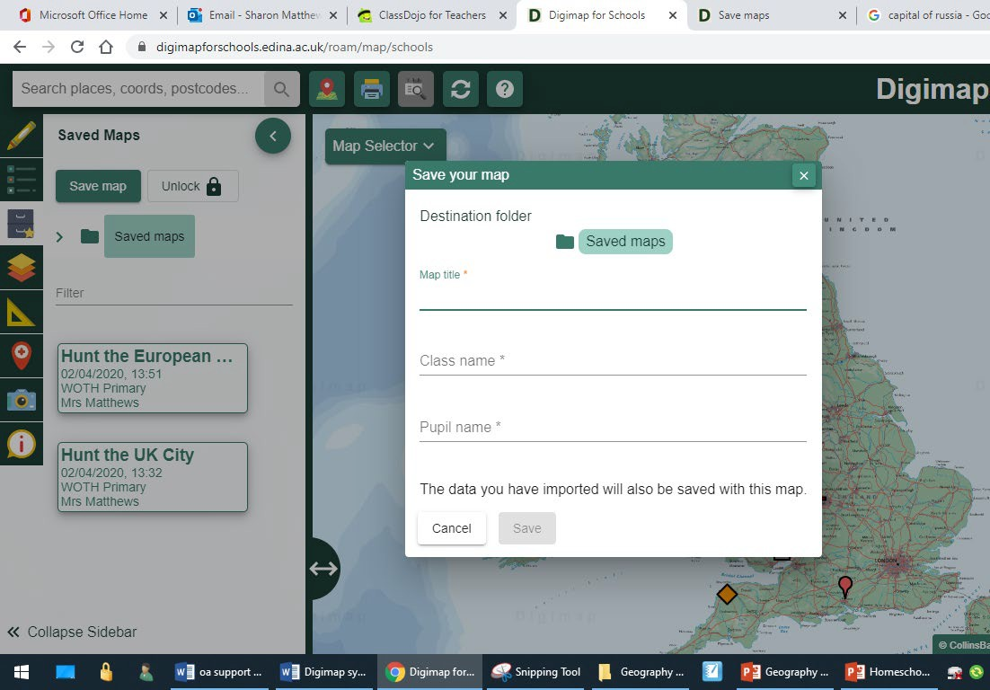
Task 9 – Hunt the Place How to save your work
- Call your map “Hunt the Place”
- Type your year group
- Type your name
- Click Save
1. Click on Saved Maps

Task 10 – Hunt the European city!
  - Go to the folder of saved maps in digimps and choose the map called Hunt the European city
  - Can you find out what each of the marked cities is called, and which country they are in? Complete the sheet which is on the next page.
2. Choose “Hunt
the European
city”
1. Go to saved maps

Task 10 – Hunt the European city!

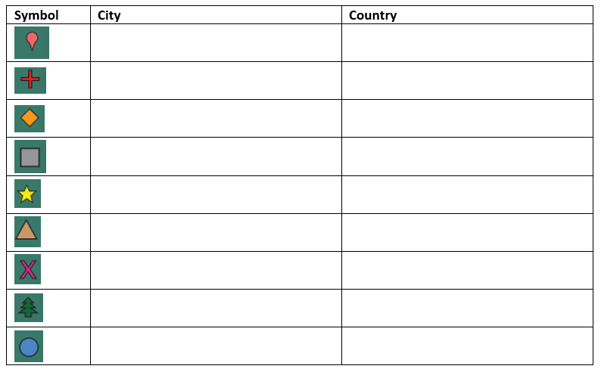

Task 11 – Find cities around the world
  - Use the random cities generator tool (link below) to create the name of a capital city and its country.
Random Capital cities

  - Use Digimaps to find the city and country and put a marker on it.

  - If you want to save your map so we can see it, please feel free to do so!

Task 12 – Guess the location!
  - This is fiendishly difficult, but if you are a geography expert, it is worth a try!

  - Use the random cities generator tool (link below) to create the name of a capital city and its country.
Random Capital cities

  - Zoom out on digimaps as far as it can go. Put a marker where you think the city is.
  - Then use the search bar to put a marker where the city actually is.
  - Measure the distance between your guess and the actual location using the measuring tool you used for Task 3. The aim is to get as close to the actual location as possible.
  - Record it on the table on the next page.

Task 12 – Guess the location!
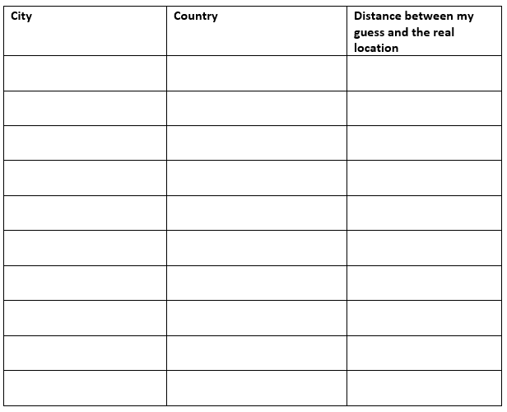

Task 13 – Explore for yourself!
  - Maps are wonderful! If you have enjoyed the activities in this pack, make up some map activities of your own and let me know if you think of a good one and I can share it with everyone else! You can email me on sharonmatthews@walton-on-the- hill.surrey.sch.uk.

  - Alternatively, on the home page of Digimap for Schools, you will find a number of other ideas. This is being updated regularly so keep checking!
