Is there biodiversity in our school?
Will Tuft
Biological fieldwork mapping
P6-S2 Science resource

Contents
Contents 2
Content and Curriculum Links 3
Introduction 4
Starter 4
Activity 5
Extension 8
Plenary 8
Copyright 9
Acknowledgements 9

Content and Curriculum Links

Curriculum for Excellence (Scotland) Experiences and Outcomes:
I can identify and classify examples of living things, past and present, to help me appreciate their diversity. I can relate physical and behavioural characteristics to their survival or extinction.

SCN 2-01a
I can sample and identify living things from different habitats to compare their biodiversity and can suggest reasons for their distribution.

SCN 3-01a
I can display data in a clear way using a suitable scale, by choosing appropriately from an extended range of tables, charts, diagrams and graphs making effective use of technology.

MTH 3-21a

MNU 1-03a
Having discussed the variety of ways and range of media used to present data, I can interpret and draw conclusions from the information displayed, recognising that the presentation may be misleading.

Learning intention:
Can we identify biodiversity in the school grounds?

Success Criteria:
- All pupils will learn how to collect data.
- Most pupils will learn how to create a choropleth map.
- Some pupils will learn how to justify conclusions with evidence.

Equipment:
Digimap for Schools, quadrats, writing materials

Time allocated:
2 lessons with write up.

Introduction
Biodiversity is a key aspect of the Es and Os for Science and as such, is an ideal way to embed data collection, mapping and report writing into lower school activities. Due to the difficulty of getting pupils out of the school for organised fieldtrips, these lessons are designed to include data collection taking place within the school grounds, somewhere pupils do not always explore within the learning framework. Obviously, the success of this data collection will be dependent on the environment of your school, but if there are fields, hedges, ponds or anything similar, it will work. The tasks are designed to be undertaken with some knowledge of biodiversity, so a class who are well into the topic would probably benefit most or it could be used to introduce fieldworking and accurate data collection.

Starter
Display an image of the Amazon rainforest with the question ‘where is the most biodiverse place on Earth?’ Give pupils 1-2 minutes to answer both these questions and through directed questioning, establish answers from the group. Follow this up with an image of the school with the question, ‘How biodiverse is our school?’ Explore pupil understanding with directed and open questioning.

Activity
Pupils will be conducting a biodiversity investigation of the school grounds. This can be flora or fauna, dependent on the characteristics of your school. It can be collated as class data or group data, again, dependent on age and ability and whether the aim is for individual reports as an activity.
- Display an OS map from Digimap for Schools of the school grounds and as a class, decide on how to split up the area (using the Draw Polygon tool in the Drawing Tools, pictured below) so that each group has a similar sized area to focus on. I would recommend each group having 2 or 3 areas. The size of the areas are up to the teacher and will depend on the efficiency of your pupils.
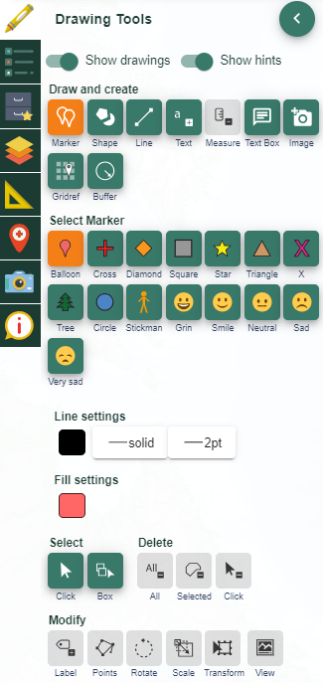

- Model the correct usage of a frame quadrat - these can be made with chicken wire or fast feet ladders or even meter rulers if required:
http://limpets.org/wp-content/uploads/2015/01/Build_quadrat.pdf
- and how to measure the amount of species in that area:
https://www.bbc.com/education/guides/zmxbkqt/revision
- Alternatively, if you have a long thin area like a hedge, point quadrats could be used and a transect formed (see images of point markers below).

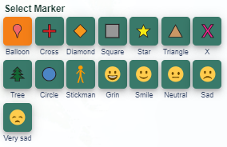

- Once modelled (alternatively, you could model the data collection at the sites), go to the sites and collect data for the areas. Pupils note down their data and once all site are completed, return to the classroom. Allow pupils to take photos of areas if they see something that could offer an explanation or an anomaly and add them to the school/class shared drive. The usage of tablets and a shared data collection sheet would be beneficial here.

- All pupils open up a map of the school and begin to plot polygons onto their maps to show the areas that were previously decided upon.
- They then create a key to delineate between the types of species they found, colour coding each species. This will allow them to start a choropleth map of the predominant species in each of the areas. Remember, you colour code the polygons BEFORE you draw them.
- Upon sharing their data with the rest of the groups, each pupil will build up a choropleth map of biodiversity.
- The Place standalone label tool will allow them to add a key if required.
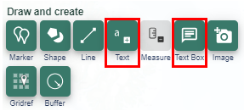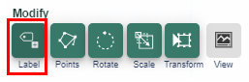

- To show the detail in their areas, pupils can also add a note to the map using the Place text box tool, showing the actual data they collected (see image above), transforming this into a pie chart or similar if required to create locational graphing, a highly effective presentation technique.

- Geo located photos and aerial photos can be included to enhance any possible conclusions that could be made from the data.

- This task could be extrapolated to include all the component parts of a scientific report, offering an excellent way to introduce this method to younger pupils.

Extension
Each area could be made even smaller to give a more reflective data set of the areas. Studying a 10x10m square will have less accurate results that 10 1x1m squares. This would also allow in incredibly detailed choropleth map, allowing minute differences in biodiversity to be identified and hopefully explained by pupils.

Plenary
Using the maps, pupils are invited to offer their reasons for the conclusions they have made. Why are there so many beetles in the area? Why so many wasps? The emphasis is on utilising the data and maps to support any judgements they are making. This informal conclusion could be individual or conducted through class questioning.

Copyright
©EDINA at the University of Edinburgh 2016
This work is licensed under a Creative Commons Attribution-Non Commercial Licence

Acknowledgements
© CollinsBartholomew Ltd (2019) FOR SCHOOLS USE ONLY
© Crown copyright and database rights 2020 Ordnance Survey (100025252). FOR SCHOOLS USE ONLY.
Aerial photography © Getmapping plc. Contains OS data. FOR SCHOOLS USE ONLY.
Historic mapping courtesy of the National Library of Scotland. FOR SCHOOLS USE ONLY.

