It’s a Rubbish Footprint
Investigating how much rubbish we send to landfill
Paula Owens
Geography Teaching Resource
Primary

Contents
Digimap for Schools Geography Resources 3
Content and Curriculum Links 3
Activity 3
Introduction 4
Main activity 4
Activity 5
Task 1 5
Task 2 6
Taking it further 8
Eco – School links 8
Other links 8
Copyright 9
Acknowledgements 9

Digimap for Schools Geography Resources
These resources are a guide for teachers to demonstrate to the whole class or direct individual students as appropriate. Each activity has several ideas within it that you can tailor to suit your class and pupils. Some resources contain worksheets for direct distribution to pupils.

Content and Curriculum Links
Level | Context | Location
Primary | Investigating how much rubbish we send to landfill | Great Britain

Knowledge/skills | Drawing areas/measuring areas
Curriculum links (England) | - Describe and understand key aspects of human geography, including land use  - Use maps, atlases, globes and digital/computer mapping to describe features studied
Curriculum links (Wales) | - Describe the causes and consequences of how places and environments change  - Use maps, imagery and ICT to find and present locational information
Scottish Curriculum for Excellence | Social Studies Outcomes: People, Place and Environment: 2-08a, 2-08b, 2-14a

Activity
Estimating and mapping the rubbish footprint of waste sent to landfill each week from individual households, the households of everyone at the school and all the households in Great Britain.

Introduction
UK households produced 26.7 million tonnes of waste in 2014, of which 44.9% was collected for recycling (source: www.gov.uk).
This figure is still quite low compared to some of our neighbouring EU countries, some recycling over 50% of their waste. There is still a great deal of waste which could be recycled that ends up in landfill sites which is harmful to the environment.
We generate about 177 million tonnes of waste every year in England alone. This is a poor use of resources and costs businesses and household’s money. It also causes environmental damage – for example, waste sent to landfill produces methane, a powerful greenhouse gas. (source: https://www.gov.uk/environment/waste-and-recycling 2013).
There were 27 million households in Great Britain in 2015. (source: https://www.ons.gov.uk/Office for National Statistics, 2015).
These 27 million households produce rubbish week by week destined for landfill. Burying our rubbish is unsustainable as we are running out of spaces. It’s also costly for the environment because pollutants contaminate soil and water and rotting rubbish produces methane, a gas implicated in global warming. It’s difficult to visualise the amount of rubbish we create each year and send to landfill but if we think in terms of the amount of area that it might cover, it can be represented visually using the mapping tools on Digimap for Schools. This helps pupils to better understand the scale of the problem and how important it is to reduce the amount of rubbish we send to landfill.

Main activity
How much rubbish do we throw out each year that can’t be recycled? What would it look like if it was left on top of the ground rather than being buried? How much space would be covered in rubbish? Before calculating what this might look like let’s make some reasonable assumptions.
Each household probably on average produces around one bag of rubbish per week (for landfill). If we tipped this rubbish out onto the ground it would probably cover about 1 square metre of ground, if it was spread out.

Activity

Task 1
- Decide as a class how realistic these assumptions are and whether you choose to accept them or not.
- You might decide to do your own ‘area test’ using a bag of rubbish, or to send a questionnaire home to find out how much rubbish each household usually puts out per week or fortnight.
- Or you can accept the 1 m² per week per household estimate and make a calculation based on the number of pupils in the schools. Decide with pupils how you can reasonably estimate the number of households represented by people at your school (you will need to subtract from the school total to allow for siblings but add to the number to take account of staff members). For example:

Each household creates 1 m² of rubbish each week = 52 m² per year.
A school with 200 pupils and staff would create about 200 m² of rubbish x 52 weeks = 10,400 m² per year (see the table below to help pupils calculate this).
Since there are 1 million square metres in a square kilometre that would mean that for every million households, a kilometre square of rubbish could be created each week. That is about 26 km² of rubbish each week for the households in Great Britain or 1,352 km² per year.
This is a table of rubbish production based on the assumption that a household produces a square metre equivalent of rubbish per week (adjust to represent approximate number of households).
Number of pupils in school | Rubbish produced per week m² | Rubbish produced per year m²
100 | 100 | 5200
150 | 150 | 7800
200 | 200 | 10400
250 | 250 | 13000
300 | 300 | 15600
350 | 350 | 18200
400 | 400 | 20800

Task 2
Pupils are going to ‘spread’ their own household’s rubbish of 52 m² on to a map of their house.
- Open Digimap for Schools and ask pupils to find their house using postcode search.
- Open the Measurement Tools and use the Measure Area tool to measure the area of the house. Note the measurement.
- Open Drawing Tools and from Draw and create area select a square or rectangle shape (the aim is to draw a shape of around 52 m²).
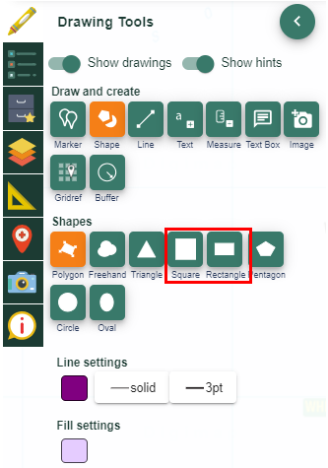
- Draw the shape on the map, estimating its size compare to the size of the house.
- To change the size of a shape use the scale tool in the Modify area.
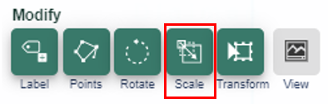
- Add a measurement label to see how big or small it is in square metres.
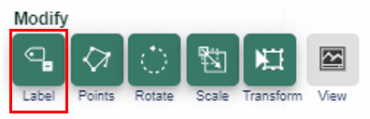
- Use the rotate tool in the Modify area to move the shape around until it covers the house.
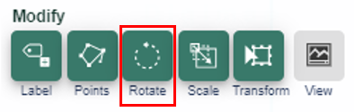

- When they are happy with the shape, pupils should move it to centre it over their house. Discuss with the class what would happen if there were no landfill sites and everyone had to keep their rubbish at home. What would they do with it?

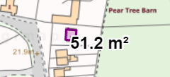

- Pupils should now zoom out and re-centre their map on the school, repeating the above exercise to show the annual rubbish footprint of all staff and pupils at the school.
- Draw a square covering approximately the area required and use the modify tools until it is approximately the right size.
- Add labels and discuss the fact that this is just ONE year’s worth of rubbish. How much of your school grounds would a year’s worth of rubbish blot out? Where would you ‘dump’ it?
- Finally, repeat the exercise using the assumed national figures of 26 km² rubbish per week from the 26 million households in Great Britain and 1352 km² per year. Ask pupils where they would put it on the map of Great Britain and to explain why? Would this much rubbish blot out an entire city?

TIP: this will be a large area so when moving it zoom out until you can just see the shape then select the shape and drag to new position. You can zoom in then and position it more carefully.
- Use the headlines in ‘Presentation Rubbish Headlines’ to talk about the problem of land fill and rubbish and how we might reduce what goes in our bins.

Taking it further
- Share your findings with parents, the local community, and even the local press. Use your maps in posters designed to encourage people to recycle more rubbish.
- Find out how you can monitor rubbish produced by the school premises or pupils’ own homes and use maps to show regular updates.
- Map the journey your rubbish makes from home to tip.
- Arrange a field trip to the nearest landfill and recycling centres.
- What did people do with their rubbish in the past? What do people who live abroad in remote areas (or illegal dwellings) where there is no collection?
- Discuss if it is fair for one country to export its rubbish to another country.

Eco – School links
https://www.eco-schools.org.uk/
https://www.ecoschools.global/
https://www.keepscotlandbeautiful.org/sustainable-development-education/eco-schools

Other links
Young People’s Trust for the Environment:
http://ypte.org.uk/factsheets/recycling/rubbish
Convert square Metres to square Kilometres:
https://www.asknumbers.com/AreaConversion.aspx

Copyright
©EDINA at the University of Edinburgh 2016
This work is licensed under a Creative Commons Attribution-Non Commercial Licence

Acknowledgements
© CollinsBartholomew Ltd (2019) FOR SCHOOLS USE ONLY
© Crown copyright and database rights 2020 Ordnance Survey (100025252). FOR SCHOOLS USE ONLY.
Aerial photography © Getmapping plc. Contains OS data. FOR SCHOOLS USE ONLY.
Historic mapping courtesy of the National Library of Scotland. FOR SCHOOLS USE ONLY.

