Landscape Alphabet
Paula Owens
Geography teaching resource
Primary

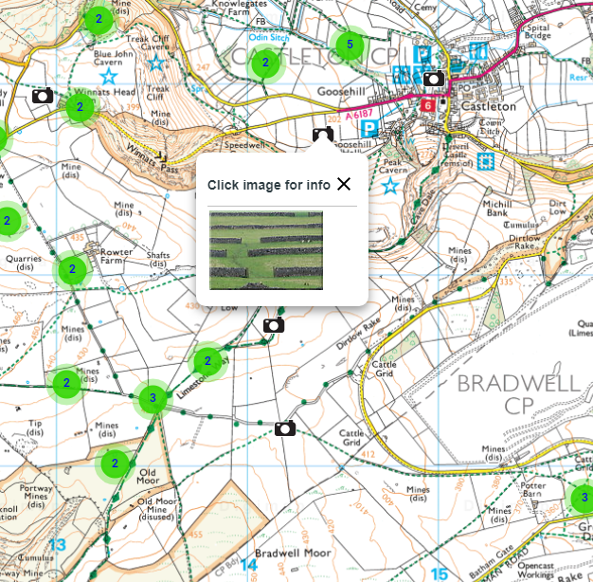

Contents
Contents 2
Digimap for Schools Geography Resources 3
Content and Curriculum links 3
Search for images 4
Developing Language 4
Like and Describe 5
Alphabet Match 5
Taking it Further 6
Copyright 7
Acknowledgements 7

Digimap for Schools Geography Resources
These resources are a guide for teachers to demonstrate to the whole class or direct individual students as appropriate. Each activity has several ideas within it that you can tailor to suit your class and pupils. Some resources contain worksheets for direct distribution to pupils.
https://digimapforschools.edina.ac.uk/

Content and Curriculum links

Activity
Using Digimap for Schools’ Image Search tool, where pupils can search for images from Geograph, to develop language.

Knowledge | Using Image Search tool
Curriculum links (England) | Geography KS1:  Name, locate and identify characteristics of the four countries and capital cities of the United Kingdom and its surrounding seas.  Use basic geographical vocabulary to refer to key physical features, (beach, cliff, coast, forest, hill, mountain, sea, ocean, river, soil, valley, vegetation, season and weather) and key human features, (city, town, village, factory, farm, house, office, port, harbour and shop).
Curriculum links (Wales) | Use and make simple maps, to find where places are and how places relate to other places.  Identify natural features, e.g. rivers, hills, beaches, and the human features, e.g. buildings, roads, bridges, of their own locality.  Begin to recognise differences between their own locality, localities in other parts of Wales and in different parts of the world.
Scottish Curriculum for Excellence | Social studies: SOC 1-07a - I can describe and recreate the characteristics of my local environment by exploring the features of the landscape.
All: Literacy opportunities  All: Numeracy opportunities | Activities have identified opportunities for literacy and numeracy.

Search for images
- Open the Image Search from the sidebar.
- Enter your search term.
- Clusters will appear on the map where there are images available.
- NOTE: you can enter an asterisk (*) to see all available images in an area – but only in the 5 most detailed scales.
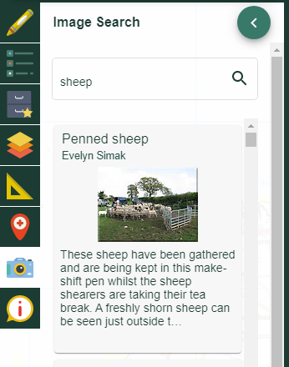

Developing Language
Developing language is a key part of all curricular work with younger children. The Geograph images, found in the Image Search, can be used to help children grasp and widen their vocabulary of a wide range of landscape features as well as their use of descriptive terminology.
Have a letter of the week to investigate jointly as a class and link this to landscape features or things you might find in landscapes. For example, you might introduce the terms ‘Mosque’ and Mountain for the letter M. You could search for and show some corresponding images on the Interactive White Board and talk about where on the map they are. Where are you more likely to find a Mosque? In the countryside or in a town? What about a Mountain? Why do children think this is so?

Like and Describe
Ask the class to choose an image they especially like and then list all the things they can see in it (this might be one image per class to begin with to model the process before children work in groups or in pairs). Having listed features, children could then think of some words to describe their chosen image. An extension might be to explain why they like it? One way to encourage children to contribute an idea is to use plastic building blocks that clip together. Each time a child contributes a new idea, they can physically add a building block to a tower that grows as it is passed around.

Alphabet Match
Give pairs of older children a written feature name and ask them to copy it into the Image Search box and browse the resulting photographs. They could select one they like and add a text box to the map at the appropriate point with the feature name.
Have a chart on the classroom wall where children can add their feature name to an alphabet sequence once they have found an image and added a feature to a map. Older children could write a sentence about a given feature whilst younger children could describe the feature using talk.
Or, instead of providing children with given words, ask them to create a Class Alphabet list of their own and find suitable images to illustrate their choices. The Image Search can help children find new words; it offers an elastic search in alphabetical sequence with suggestions that appear as you start to type. The range of images is also very varied. Or, you could have a partly completed alphabet list so that children have some given features to find and some blank gaps to research.

Apple tree | Beach | C | D | E
F | G | Hill | I | J
K | L | Mosque | N | O
Playground | Qu | River | S | Town
U | V | Wood | X | Yacht
Z

Taking it Further
- Search for features that you might expect to find in the school grounds so that you can work out of doors and find the features using first-hand experience. Compare the real feature to the photograph and talk about any differences between the two such as weather or time of year.
- Search for images of insects, birds or mammals near the school and write descriptive phrases or even four-line poems.
- Create a large flat tabletop map of the school grounds and make models of features you have found using modelling clay and junk material. Label them and add descriptive phrases.
- Create a wall display based on a map showing the school grounds and locality and the location of any images used for the Alphabet List.
- Take your own photographs of features, upload them to Digimap and add a label.

Copyright
©EDINA at the University of Edinburgh 2016
This work is licensed under a Creative Commons Attribution-Non Commercial Licence

Acknowledgements
© CollinsBartholomew Ltd (2019) FOR SCHOOLS USE ONLY
© Crown copyright and database rights 2020 Ordnance Survey (100025252). FOR SCHOOLS USE ONLY.
Aerial photography © Getmapping plc. Contains OS data. FOR SCHOOLS USE ONLY.
Historic mapping courtesy of the National Library of Scotland. FOR SCHOOLS USE ONLY.

