Landscape Fingerprints

Investigating mapping contours and mountainous landscape features

Paula Owens

Geography Teaching Resource

Primary
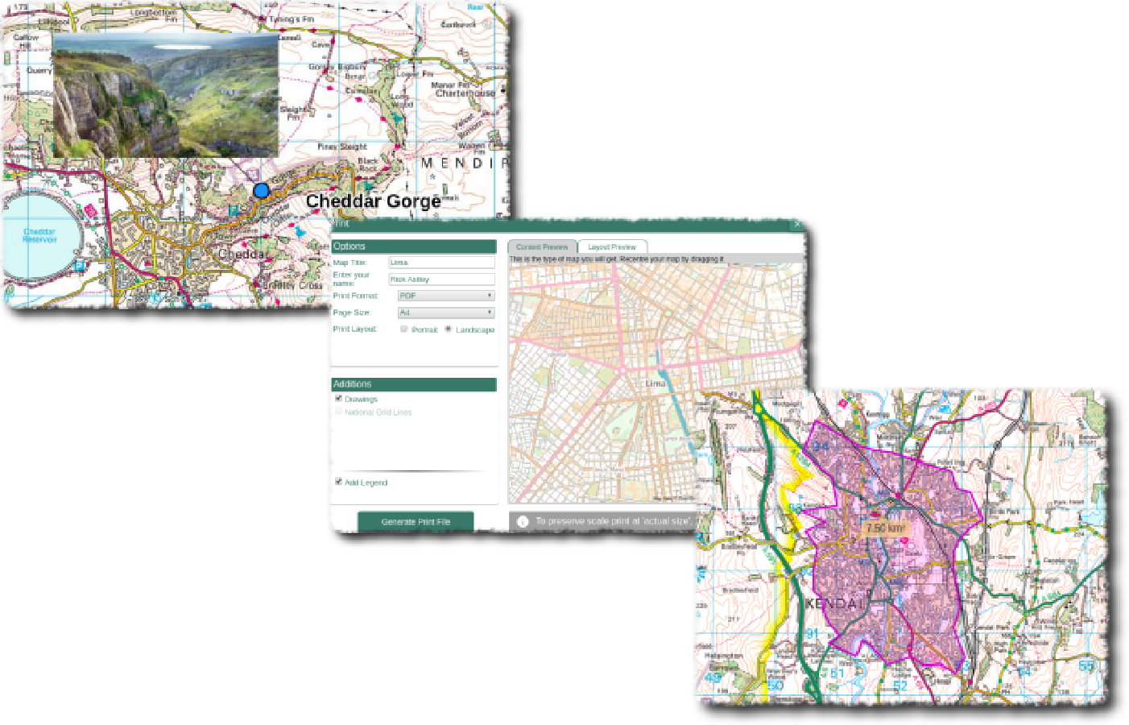

Contents
Digimap for Schools Geography Resources 3
Content and Curriculum Links 3
Activity 4
Introduction 5
Main activity 5
Taking it further 7
Web links 7
Copyright 9
Acknowledgements 9

Digimap for Schools Geography Resources
These resources are a guide for teachers to demonstrate to the whole class or direct individual students as appropriate. Each activity has several ideas within it that you can tailor to suit your class and pupils. Some resources contain worksheets for direct distribution to pupils.

Content and Curriculum Links

Level | Context | Location
Primary | Investigating mapping contours and mountainous landscape features | Ben Nevis (Scotland) Snowdon (Wales), Scafell Pike (England).  Adaptable for other places

Knowledge | - Beginning to understand contour patterns on a map  - Using the search tool  - Using the buffer tool  - Placing labels
Curriculum links (England) | Name and locate UK geographical regions and their identifying human and physical characteristics and key topographical features (including hills and mountains); use maps to describe their features
Curriculum links (Wales) | Use maps, imagery and ICT to find and present locational information; identify and describe natural features.
Scottish Curriculum for Excellence | Social Studies Outcomes; People, Place and Environment: 2-13a, 2-14a

Activity
- finding the highest peaks in England, Scotland and Wales
- using the buffer tool to select an area of contour pattern for each
- comparing and describing
It is useful if pupils have some prior knowledge of what a contour is, if not some familiarisation with this term might be needed although this activity could also be an introduction to the idea of contours.
This activity looks at the ‘fingerprints’ of the highest peaks in Scotland, England and Wales: Ben Nevis, Scafell Pike and Snowdon respectively.
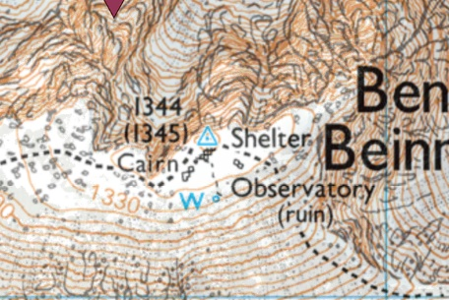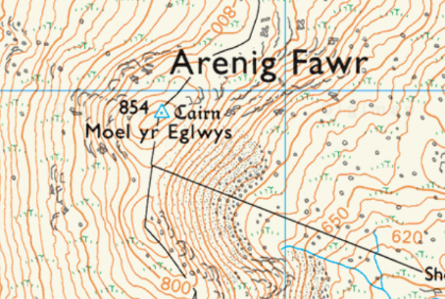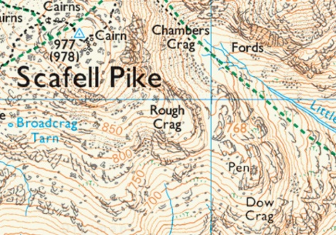
Pupils will find and record these fingerprints in a kilometre circle and compare them. The class could be divided up so that different groups make maps between them of each of these peaks, or pupils could try and work through each of the three peaks themselves.
Any hills or peaks in Great Britain can be used in this activity. Some other suggestions might include:
- Suilven (Caisteal Liath): NC153 183. Well known as part of the Inverpolly region of Scotland just north of Ullapool. It has a conical almost shear face that rises above the barren wilderness and is considered to be a classic mountain.
- Cnicht: SH644 466. Popularly known as the Matterhorn of Wales especially viewed from the south around Porthmadog.
- The Wrekin: SJ628081 by Telford, not a mountain but a distinctive large hilly outcrop.

Introduction
A contour is a line drawn on a map that joins points of equal height above sea level. The height and shape of the ground is shown on 1:25 000 scale maps by brown contour lines. Contour numbering reads uphill – in other words the top of the number is uphill and the bottom is downhill. The closer contour lines are together, the steeper the slope.
Ben Nevis (Scottish Gaelic: Beinn Nibheis) is the highest mountain in the British Isles (1,343 metres). It is located at the western end of the Grampian Mountains in the Lochaber area of the Scottish Highlands, close to the town of Fort William.
Snowdon (Welsh: Yr Wyddfa) is the highest mountain in Wales (1,085 metres) and the highest point in the British Isles outside Scotland. It is located in Snowdonia National Park (Parc Cenedlaethol Eryri) in Gwynedd.
Scafell Pike is the highest mountain in England (978 metres). It is located in the Lake District National Park, in Cumbria.
Pen Y Fan is the highest peak in South Wales and southern Britain (886 metres), situated in the Brecon Beacons National Park, Powys.
Examples are provided in the PowerPoint associated with this activity.

Main activity
- Ask pupils to look at their own fingerprints. They are unique to us and part of our individual identity. Contours of the landscape are like fingerprints in this respect; unique patterns of lines and swirls which reveal the shape of the landscape in terms of height, slope and shape.
- Open Digimap for Schools and ask them to enter a search term into the search box for example: ‘Ben Nevis’.

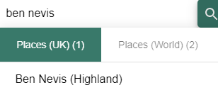

- Zoom in using the plus sign on the scale bar.
Discuss the patterns of contours and what they look like. Move the map if necessary, to centre Ben Nevis. They are going to ‘capture’ a kilometre circle of contour pattern.
- Open ‘Drawing Tools’ and select the buffer tool.
- Chose the line colour, then set the fill colour to transparent.
- Select the Point Buffer tool and set to 0.5 km to give a circle of 1 km.
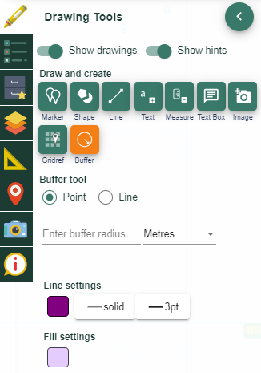

- Click on Ben Nevis to create the circle and switch off the tool.
- Move the circle you have created until you like the contour pattern it shows.
- Ask them to zoom in further and move the map by clicking and dragging with the mouse so that you can see the entire outlined circle. Once happy with the map you might want to print a copy.
- Discuss the contour features of these peaks with the class. Is it easy to tell which peak each kilometre circle is from? Do different peaks have their own unique patterns? Can you see anything else in that circle apart from contours?

Taking it further
Create and print a map of Great Britain showing the location of any kilometre circles used. On a display, link each location with the relevant close-up map showing that feature’s contours.
- Make a class book of landscape ‘fingerprints’, using the kilometre circle method. Beneath each one, write the key characteristics of that feature for example, height, shape, slope and so on. Look for interesting contour patterns in your area.
- Use Image Search in Digimap for Schools to find an appropriate image for your chosen hill or mountain and explain it using the contour map.
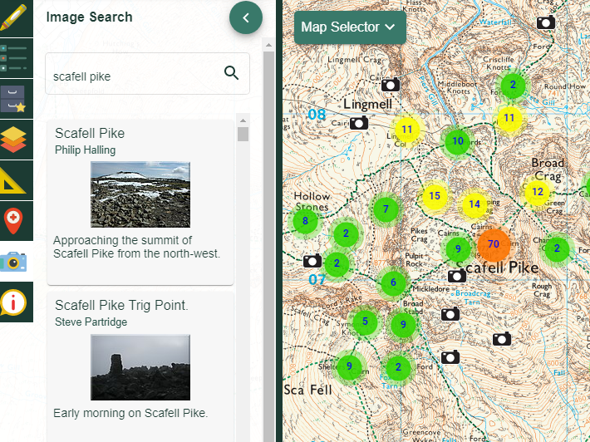
- Locate your studied peak on aerial imagery and look at the shape of the feature from overhead and compare with your map extract.
- Use the contour patterns to stimulate artwork.

Web links
About Scafell Pike: http://english-lake-district.info/maps.html
Ben Nevis information: http://www.munromagic.com/
Ordnance Survey resources on map reading and understanding contours: https://www.ordnancesurvey.co.uk/mapzone/map-skills
Webcam of Ben Nevis https://aboutfortwilliam.com/webcams/ben-nevis-and-fort-william

Copyright
©EDINA at the University of Edinburgh 2016
This work is licensed under a Creative Commons Attribution-Non Commercial Licence

Acknowledgements
© CollinsBartholomew Ltd (2019) FOR SCHOOLS USE ONLY
© Crown copyright and database rights 2020 Ordnance Survey (100025252). FOR SCHOOLS USE ONLY.
Aerial photography © Getmapping plc. Contains OS data. FOR SCHOOLS USE ONLY.
Historic mapping courtesy of the National Library of Scotland. FOR SCHOOLS USE ONLY.

