Landscape Poetry

Reading Landscape Features on Maps

Paula Owens

Geography Teaching Resource

Primary
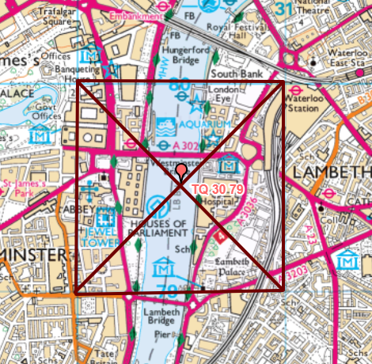

Contents
Digimap for Schools Geography Resources 3
Landscape Poetry 3
Activity 3
Introduction 4
Landscape poetry instruction sheet 4
Activity 1 – Poetry warm-ups 4
Activity 2 – Directional Poetry 4
Poetry Warm–Ups: Quick ideas to describe a place 7
Direction Poetry Worksheet 8
Taking it further 9
Web links 9
Copyright 9
Acknowledgements 9

Digimap for Schools Geography Resources
These resources are a guide for teachers to demonstrate to the whole class or direct individual students as appropriate. Each activity has several ideas within it that you can tailor to suit your class and pupils. Some resources contain worksheets for direct distribution to pupils.
https://digimapforschools.edina.ac.uk/

Landscape Poetry
Level | Context | Location
Primary | Reading landscape features on maps | Anywhere in GB

Knowledge/Skills | Reading and interpreting maps/drawing areas on maps/using a key/using eight cardinal points/using grid references to locate places.
Curriculum links (England) | Geography: use digital mapping to describe features studied. Describe and understand key aspects of human and physical geography.  English: develop range of writing, particularly grammar and vocabulary.
Curriculum links (Wales) | Geography: use maps, imagery and ICT to find and present locational information. Identify and describe natural and human features.  English: writing in a range of forms and in response to a wide range of stimuli.  Literacy Framework: use appropriate vocabulary, including subject-specific words and phrases.
Scottish Curriculum for Excellence | Social Studies Outcomes: People, Place and Environment:  2-07a, 2-10a, 2-14a  English: ENG 2-27a; ENG 2-31a

Activity
Choose a square kilometre of map and look at it closely to record clues about the landscape; gathering vocabulary to write a short, descriptive poem about the view in different directions from the centre of the square.

Introduction
Digimap for Schools provides a lot of information about the landscape of Great Britain through its various maps at different scales and the accompanying map keys. These maps show the detail of the terrain: vegetation, height and slope of the land; land use; water features; human features and much more.
In this activity, pupils use the maps to help them describe a place, gathering relevant geographical vocabulary and using compass directions to help them locate and remark on features.
If pupils find it hard to visualise the landscape just using the map, suggest they look at the area using aerial imagery as well.

Landscape poetry instruction sheet
What can we find out about a landscape from a map? How can a map help us describe it? How important are the words we choose?

Activity 1 – Poetry warm-ups
- Open Digimap for Schools and choose a place in your neighbourhood that is well known. Zoom in and discuss some specific features of this place using the key. Then zoom out a little and discuss the more general characteristics of this place. Work through the poetry warm-up sheet.

Activity 2 – Directional Poetry
- Choose a location (this can be nearby or anywhere in GB).
- Open the Overlays menu – check the British National Grid box.
- Draw round any of the grid squares on the map.
  - To do this open the Drawing Tools.
  - Open the Shapes menu.
  - Select the draw polygon tool.
  - Make sure your fill is transparent – see image below.
  - 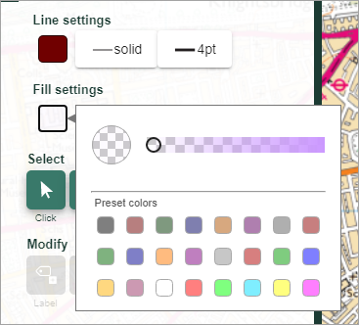
  - Click on one corner of the square and then each of the other corners, in turn and double click to finish.
- Now select your square and move it to where you want it. This will be your chosen area.
- Select ‘Draw line’ then draw diagonal lines across your square. Close the Drawing Tools. This area now matches your worksheet diagram.
- Use the Grid reference tool and write the grid reference of the centre of the square onto your worksheet.
- Your screen should look similar to the image below.

- Look at each triangle of map in turn and write down what you can find out on the worksheet.
  - Zoom in and out to see more detailed or less detailed maps.
  - Turn on the aerial map.
  - Add some adjectives to help build the description and think about your other senses. For example, is this a noisy or quiet place? What might you hear? What might you touch for example, buildings or grass or water or stone or rocks? Use your geographical imagination.
- Now write a poem about this place adding the direction to each line or couple of lines for example, ‘To the North/South/East/West I can see ...’ add as much description as you can. Save and print out your map showing your square clearly.

Poetry Warm–Ups: Quick ideas to describe a place
Name

Think of three different one word titles for a poem about this place.
Say three things that might be happening here.
Think of three things you might hear, smell or touch in this place.
Describe in three words something you can or might see at a large scale that is, ‘zoomed in’.
Describe in three words the general characteristics of this place at a smaller scale that is, ‘zoomed out’.
Choose one word to describe how you might feel in this place.
What features does the sun set/rise behind?
Write at least one phrase of alliteration to describe this place.

Direction Poetry Worksheet
Grid Reference:
Study the landscape shown on the map and describe what you might see if you were there.

N
E
W
S
NW
SW

SE
NE
Looking North I can see:

Looking South I can see:

Looking West I can see:

Looking East I can see:

Taking it further
- Make a display of the maps and poems.
- Do this activity through fieldwork using compasses and printed large scale maps of the area.
- Compare poems and descriptions of different grid squares in similar and different landscapes.

Web links
- Maps and Stories: https://www.geography.org.uk/Teaching-Resources

Copyright
©EDINA at the University of Edinburgh 2016
This work is licensed under a Creative Commons Attribution-Non Commercial Licence

Acknowledgements
© CollinsBartholomew Ltd (2019) FOR SCHOOLS USE ONLY
© Crown copyright and database rights 2020 Ordnance Survey (100025252). FOR SCHOOLS USE ONLY.
Aerial photography © Getmapping plc. Contains OS data. FOR SCHOOLS USE ONLY.
Historic mapping courtesy of the National Library of Scotland. FOR SCHOOLS USE ONLY.

