Where in the world
  - Resource number 1

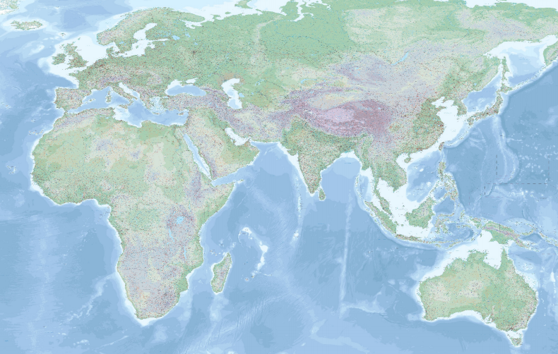

  - Emma Espley and Simon Catling
  - KS1

Table of Contents

Table of Contents 2
Introduction 3
Teaching and learning activities 5
Starter Activity: Defining ‘country’ 6
Main activity: Find your country 7
Finish activity: The world is changing 10
Acknowledgements 11
Copyright 11

Introduction
This resource aims to develop pupils’ locational knowledge. By accessing and using Digimap for Schools, it is hoped that pupils will learn about key features around the world.

What’s the theme?  Where in the world is/are …? | What are we exploring?  Pupils’ perceptions of the word ‘country’, e.g. living in the countryside/a rural area and living in a particular country, such as the United Kingdom.  - Where people live, e.g. in different countries around the world.  - Where these countries are located on a world map.  - What these countries are like, providing an opportunity to identify similarities and differences.
What’s the learning objective?  To access and use digital maps in order to learn about key features around the world. | What will pupils know, understand and be able to do after completing this?  All pupils will…  - be able to identify and locate their allocated country shape using Digimap for Schools.  Most pupils will, in addition…  - be able to provide two facts about their country shape.  Some pupils will, in addition…  - be able to provide at least three facts about their country shape.  - be able to write their facts on their allocated country shape, cut it out and place it in the correct location on a large world map pinned to a wall in the classroom.
The National Curriculum Programme of Study for Geography (England) | - Pupils should develop knowledge about the world, the United Kingdom and their locality. They should understand basic subject-specific vocabulary relating to human and physical geography and begin to use geographical skills, including first-hand observation, to enhance their locational awareness.
The World Around us (Northern Ireland) | - [The curriculum implies that pupils will build their knowledge of places, their location and characteristics, at different scales, locally, nationally and around the world, and that they will develop their skills and knowledge through using large scale maps, globes, world maps and atlases. This will occur through studies that meet the curriculum requirements.]
Curriculum for Excellence (Scotland) | Social Studies Outcomes - People, Place and Environment:  - 2-14a: To extend my mental map and sense of place, I can interpret information from different types of maps and am beginning to locate key features within Scotland, United Kingdom, Europe or the wider world.
Curriculum for Wales | Humanities area – Progression step 1:  - I have experienced a range of stimuli that have enthused and inspired me to imagine and be curious about my locality and Wales, as well as the wider world.  - I am beginning to communicate my observations in simple ways.

Which key words are relevant here?
world; map; world map; globe; land; sea; ocean; continent; country; island; country map; capital city; city; town; village; physical (natural) features; human (made by people) features; shape; outline; countryside; rural; urban; sea level rise; climate change.
How might I assess learning?  - Can a pupil identify and locate their allocated country using Digimap for Schools?  - Can a pupil provide at least two facts about their allocated country?  - Can a pupil locate their allocated country on a large world map pinned to a wall in the classroom? | What could we do next?  - Resources 2 and 3 from this series of Digimap for Schools resources.  - Ask pupils to draw a map of the world, either from memory or using the wall map as a reference. Depending on age or ability, you could ask pupils to draw different continents rather than the whole world.  - What do they include and why?  - How many places and features do they include?  - Compare their map with a world map and/or globe and discuss what they want to learn to improve and develop it.  - Take photos of their maps to refer back to.  - Repeat this exercise at a later date and compare their drawings.

Teaching and learning activities

 | Activity | What’s involved? | What do I need?
To start | Defining country | - Discussion of the word ‘country’. | - Display the word country on the interactive whiteboard.  - A large world map and a map of the United Kingdom pinned to a wall in the classroom. You will find A3 and A4 blank world maps in the Digimap for Schools resources area.  - A globe (optional).
Next | Find your country | - Find your allocated country using Digimap for Schools.  - Identify two facts about your country. | - Digimap for Schools login details.  - Access to 1 tablet or PC for every 2 pupils.  - Country outlines printed on separate sheets of paper (one per pupil/pair). You can download these from the Geography Association (n.b. will you need to register for a free account): https://www.geography.org.uk/teaching-resources/base-maps.  - A large world map pinned to a wall in the classroom.
To finish | The world is changing | - Discuss how the world is always changing.  - Start a ‘Countries’ list where pupils can add the names of countries. | - A large world map pinned to a wall in the classroom.  - A globe (optional).  - A large sheet of paper entitled ‘Countries’ on the classroom wall.
Acknowledgements:
The Everyday Guide to Primary Geography: Locational Knowledge by Simon Catling, p. 18-19.

Starter Activity: Defining ‘country’

- Ask pupils: “What does the word ‘country’ mean to you?”.
- Some pupils may say that they live ‘in the country’, implying that they live ‘in the countryside’/a rural area.
- Explain that everyone lives in ‘a country’ even when they live ‘in the countryside’.
- Ask pupils: “Which country do you live in?”.
- Other pupils may give examples of a country, e.g. Brazil.
- Explain that people live in many different countries around the world.
- Try and generate country names from the pupils.
- Use the world and United Kingdom wall maps to highlight the countries they name and other countries they may have heard of.

Main activity: Find your country

Ask pupils to log in to Digimap for Schools.
- Go to: https://digimapforschools.edina.ac.uk.
- Select Login in the top right corner.
- Enter username and password. The username and password are provided by Digimap for Schools when you subscribe. Everyone in your school can use the same login details.

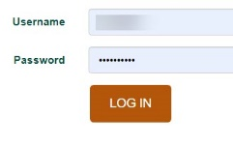

View a world boundaries map
- The map window will be centred on Great Britain.
- Ask pupils to zoom out by selecting the zoom to maximum extent button (circled in the image below).
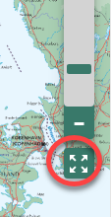

- Now switch to the World Boundaries map. This will make the country outlines clearer.
  - Open the Map Selector.
  - Select the button to the right of World Boundaries.
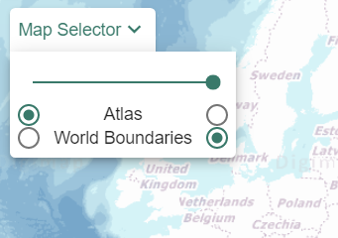

Identify a country
- Distribute a country outline to each pupil or pair. Depending on age or ability, you can choose countries that are easily recognisable. You could also concentrate on a particular continent or region.
- Can they identify the country that they have been given by its shape and can they find the country’s name and read it?
- Ask pupils to ‘zoom in’ on their country shape.

Find some key features
- Once they have identified the country, select the Atlas map from the Map Selector, which shows human and physical features.
- Now show them how to open the map key. Select Key from the sidebar.
- Ask them to select Expand All at the top…this will open all the key categories so they can see the symbols.
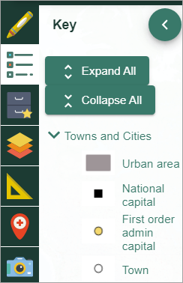

- Explain how they can use the key to identify a capital city, its main cities, rivers, mountains, etc.
- Discuss the name and describe the appearance of the various symbols you want to focus on – ask them if they know what the symbol for capital city or a mountain is.
- Ask pupils to explore some of their country’s key physical (natural) and human (made by people) features. Encourage them to talk about what the feature is and what it might look like.
- Can pupils label at least two key physical or human features on their country shape?
- They may wish to draw some small images on their country shape too.

Taking it further
- If they wish, pupils could access additional websites to discover further facts about their country. Perhaps, direct them towards two or three specific websites, e.g.:
  - National Geographic for Kids: https://www.natgeokids.com/uk/;
  - 3-D Geography: https://www.3dgeography.co.uk/facts-about-kenya.

Stick your country to the map
- Once pupils have labelled the facts on their country shape, ask them to cut it out, locate and stick it onto the large world map pinned to the classroom wall (refer to this as the class’ ‘Where in the world poster’).

Finish activity: The world is changing

- Ask pupils: “Will our ‘Where in the world poster’ ever be complete?”.
  - Explain that our world is forever changing/dynamic, e.g. some countries merge; some countries may disappear due to the effects of climate change (sea level rise); new land may emerge from the sea.
  - Encourage them to find the names and locations of new (to them) countries of which they like the names or find the names hard to pronounce.

- Begin a list headed 'Countries' to which the names of countries the pupils come across can be added over time. Include a question, such as: Can you find each country on the world map?
- Encourage pupils to continue to look for and add appropriate locational information from TV, radio, social media or the Internet to the large world map in the classroom.
These websites will be useful:
- The Week Junior;
- BBC Newsround;
- First News.

Acknowledgements

Geographical Association
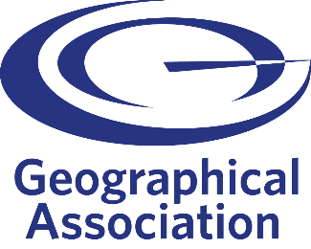
With thanks to the Geographical Association for allowing us to use excerpts from The Everyday Guide to Primary Geography: Locational Knowledge, by Simon Catling.

Map images
- © CollinsBartholomew Ltd (2019) FOR SCHOOLS USE ONLY.
- © Crown copyright and database rights 2020 Ordnance Survey (100025252). FOR SCHOOLS USE ONLY.
- Aerial photography © Getmapping plc. Contains OS data. FOR SCHOOLS USE ONLY.
- Historic mapping courtesy of the National Library of Scotland. FOR SCHOOLS USE ONLY.

Icons
- Black and white icons - location, directional sign, mountain ranges, compass, geography by Made x Made from the Noun Project.

Copyright
©EDINA at the University of Edinburgh, 2020.
This work is licensed under a Creative Commons Attribution-NonCommercial-ShareAlike Licence.

