**Story worlds – Ali’s Story**

**Resource number 2**

map showing possible route of Ali's journey


Emma Espley and Simon Catling

KS1

# Table of Contents

Table of Contents 2

Introduction 3

Teaching and learning activities 5

Starter Activity: Ali’s Story 6

Main activity: Identify Afghanistan 7

Finish activity: Making journeys 11

Acknowledgements 12

Copyright 12

# Introduction

This resource aims to develop pupils’ locational knowledge. By accessing and using Digimap for Schools, it is hoped that pupils will learn more about some of the places around the world that they encounter within the stories that they read and have read to them.

|  |  |
| --- | --- |
| What’s the theme? Where are stories set? | What are we exploring?  * Ofsted’s Education Inspection Framework and good practice emphasise the importance of ‘reading across the curriculum’. Illustrated books can be used to introduce pupils to a particular geographical theme, lead them on an enquiry-based journey across continents or discuss time differences around the world. * Here, we will explore some of the real places where stories are set. * Use a globe and a world map to locate places mentioned in books that you read. The approach in this resource can be applied to any story which is based on or mentions real places in the world. * Pupils could also access the Internet and reference books to discover more about these places. |
| What’s the learning objective? To access and use digital maps in order to encounter some of the places around the world that are mentioned in the stories that we read. | What will pupils know, understand and be able to do after completing this?All pupils will…  * be able to locate Afghanistan and the United Kingdom on a world map. * be able to name the continents that Afghanistan and the United Kingdom belong to.  Most pupils will, in addition…  * be able to recall in which direction and how far Ali had to travel in order to move from Afghanistan to the United Kingdom. * be able to locate other places on a world map that have been mentioned in stories that they have read.  Some pupils will, in addition…  * be able to describe and explain some of the emotional responses to journeys made. |
| NC Programme of Study for Geography (England) | * Pupils should develop knowledge about the world, the United Kingdom and their locality. They should understand basic subject-specific vocabulary relating to human and physical geography and begin to use geographical skills, including first-hand observation, to enhance their locational awareness. |
| The World Around us (Northern Ireland) | * [The curriculum implies that pupils will build their knowledge of places, their location and characteristics, at different scales, locally, nationally and around the world, and that they will develop their skills and knowledge through using large scale maps, globes, world maps and atlases. This will occur through studies that meet the curriculum requirements.] |
| Curriculum for Excellence (Scotland) | Social Studies Outcomes:   * 1-03a - I can use evidence to recreate the story of a place or individual of local historical interest. * 1-16a – I can contribute to a discussion between my needs and wants and those of others around me. * 2-14a - To extend my mental map and sense of place, I can interpret information from different types of maps and am beginning to locate key features within Scotland, United Kingdom, Europe or the wider world. |
| Curriculum for Wales | Humanities:   * I can recognise the distinct physical features of places, environments and landscapes in my locality and in Wales, as well as in the wider world. * I can describe how and where some places and environments are similar, and others are different. |
| How might I assess learning?  * Can pupils locate Afghanistan and the United Kingdom on a world map? * Can they show you the journey that Ali and his family undertook? * In which direction did they have to travel? * Did they have to travel a long or short distance? * Can pupils locate other places mentioned in the story books that you shared with them? * Can they put themselves in Ali’s shoes and describe and explain how he might have felt? | |
| What could we do next?  * Geography: Access the Internet and reference books to discover more about Afghanistan, the United Kingdom and other places mentioned in the stories that you have read. * English: Write a story about a journey that they have undertaken, considering how they travelled, places seen en route, the distance travelled, their personal experiences and feelings. * Maths: Measure the straight-line distance between places with a ruler and then use the scale line to calculate the exact distance. Could be at a simple plan or world map scale. | |
| Which key words are relevant here? world; world map; globe; journey; travel; transport; route; migration; Afghanistan; United Kingdom; direction; north; east; south; west; continent; Asia; Europe; country; near; far; distance; locate; location; place; emotions; feelings. | |

# Teaching and learning activities

|  |  |  |  |
| --- | --- | --- | --- |
|  | Activity | What’s involved? | What do I need? |
| To start | Ali’s Story icon of a woman reading a book | * Read the book and discuss why people make journeys. | * Book: [‘Ali’s Story’ by S. Maldonado and A. Glynne.](https://www.hachette.co.uk/titles/andy-glynne/seeking-refuge-alis-story-a-journey-from-afghanistan/9780750292078/) * A 3-minute animated video of the story [is available on the Vimeo website.](https://vimeo.com/44516196) |
| Next | Identify Afghanistan icon of a computer | * Find Afghanistan on the map. | * Digimap for Schools login details. * Access to 1 tablets or PC for every 2 pupils. * Book: Read ‘Ali’s Story’ by S. Maldonado and A. Glynne. * Other story books which the children are familiar with that are set in real places. * Some suggested books are: * ‘One World Together’ by C. Anholt and L. Anholt. * ‘The Magic Bicycle’ by B. Patten and A. Robins. * ‘Love, Your Bear Pete’ by D. Sheldon and T. Hurt Newton. |
| To finish | Making journeys icon of speech bubble | * Discuss how Ali might have felt on his journey. | * Book: [‘Ali’s Story’ by S. Maldonado and A. Glynne.](https://www.hachette.co.uk/titles/andy-glynne/seeking-refuge-alis-story-a-journey-from-afghanistan/9780750292078/) |

**Acknowledgements:**

The Everyday Guide to Primary Geography: Locational Knowledge by Simon Catling, p. 18-19.

# Starter Activity: Ali’s Story

1. Ask pupils: “How do people travel from one country to another?”.
2. Ask pupils: “Why do people travel from one country to another?”.
3. Record their responses on a whiteboard.
4. Read ‘Ali’s Story’ by S. Maldonado and A. Glynne. In this book, Ali tells of his life in Afghanistan and his migration to the United Kingdom, where his family eventually settle.
5. A 3-minute animated video [is available on the Vimeo website.](https://vimeo.com/44516196)
6. Note down ‘migration’ on the whiteboard if this was not a reason mentioned earlier by pupils.

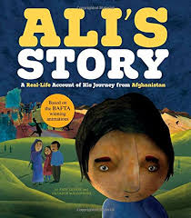

# Main activity: Identify Afghanistan

## Ask pupils to log in to Digimap for Schools

1. Go to: <https://digimapforschools.edina.ac.uk>.
2. Select **Login in the top right corner.**
3. Enter username and password. The username and password are provided by Digimap for Schools when you subscribe. Everyone in your school can use the same login details.

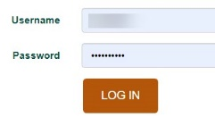

## View a world boundaries map

1. The map window will be centred on the United Kingdom.
2. Ask pupils to **zoom out by selecting the zoom to maximum extent button** (circled in the image below).

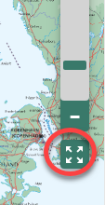

1. Now switch to the World Boundaries map. This will make country outlines clearer.
2. **Open the Map Selector.**
3. Select the button next to **World Boundaries.**

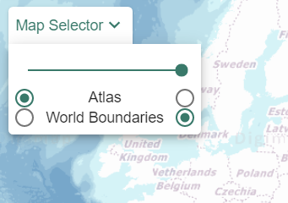

## Identify Afghanistan

1. Challenge pupils to locate Afghanistan. Explain that it is found on the continent of Asia. They may need to type ‘Afghanistan’ in the search box.

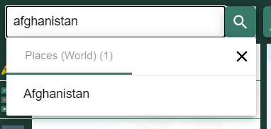

1. When they select Afghanistan from the search results, a red marker appears in the centre of Afghanistan.

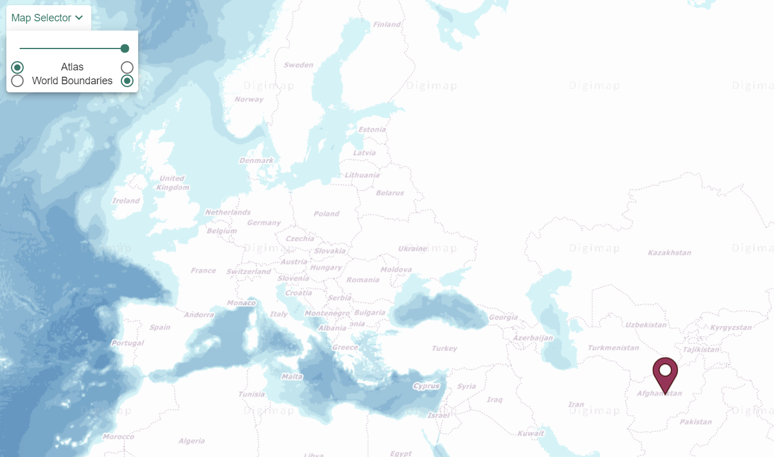

1. Get pupils to travel from Afghanistan to the United Kingdom, by panning the map.
2. Ask pupils: “In which direction did you travel?”.
   1. Pupils can select the small compass on the map window to view a larger compass.
   2. Remind them of the 4 points of the compass and that the top of the map is north.

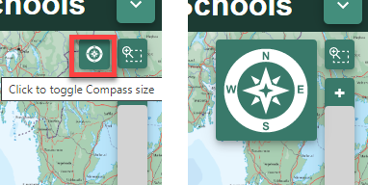

1. Ask pupils: “Is Afghanistan near to or far from the United Kingdom?”.
   1. Encourage a discussion about making journeys to find out pupils’ travel experiences and think about how long (in time) journeys can take.

## Other story books

1. Share pages from other story books that pupils are familiar with. Identify the setting of each story and again challenge pupils to locate each place.
2. Perhaps, give them a clue as to which continent it is found on?
3. Pose the above questions to them each time.

# Finish activity: Making journeys

1. Ask pupils: “How do you think Ali felt on his journey from Afghanistan to the United Kingdom?”.
2. Ask pupils:
   1. “Have any of you been on a long journey like Ali?”.
   2. “If so, where did you travel from and to?”.
   3. “How did you feel?”. Encourage pupils to think about what they enjoyed and what was boring about their journey.
3. Pupils could make an emotional map of a journey they took or of Ail’s journey. The Drawing Tools offer a range of emojis, as well as text, line and shape tools (see menu image below).

map showing possible route with emojis


# Acknowledgements

## Geographical Association

[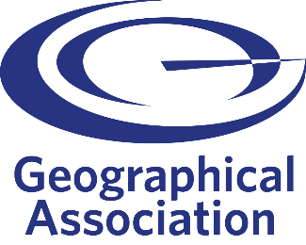](https://www.geography.org.uk/)

With thanks to the Geographical Association for allowing us to use excerpts from [*The Everyday Guide to Primary Geography*: *Locational Knowledge*](https://www.geography.org.uk/Shop/The-Everyday-Guide-To-Primary-Geography-Locational-Knowledge/9781843774686)*,* by Simon Catling.

## Map images

* © CollinsBartholomew Ltd (2019) FOR SCHOOLS USE ONLY.
* © Crown copyright and database rights 2020 Ordnance Survey (100025252). FOR SCHOOLS USE ONLY.
* Aerial photography © Getmapping plc. Contains OS data. FOR SCHOOLS USE ONLY.
* Historic mapping courtesy of the National Library of Scotland. FOR SCHOOLS USE ONLY.

## Icons

* Black and white icons - location, directional sign, mountain ranges, compass, geography by Made x Made from [the Noun Project](https://thenounproject.com/).

# Copyright

© EDINA at the University of Edinburgh, 2020.

Creative Commons BYNCSA license logo

This work is licensed under a [Creative Commons Attribution-NonCommercial-ShareAlike Licence.](https://creativecommons.org/licenses/by-nc-sa/4.0/)