Worksheet: My daily items

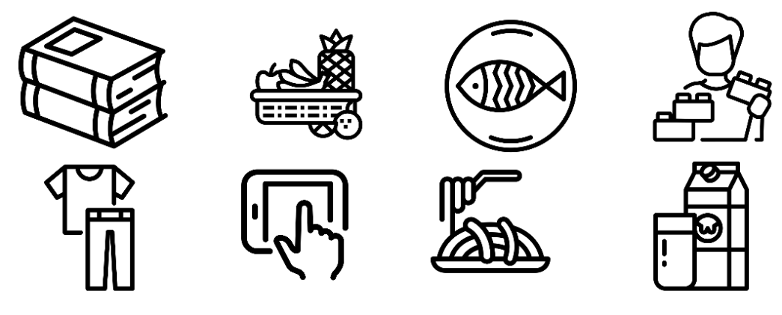
My item | Where has it come from? | How far has it travelled?
1

2

3

4

5

6

7

8

9

10

