The world came to my place today
  - Resource number 3

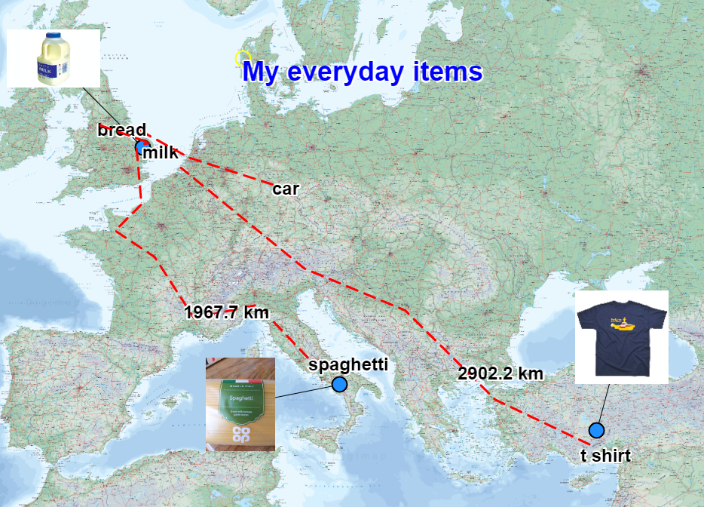

  - Emma Espley and Simon Catling
  - KS2

Table of Contents

Table of Contents 2
Introduction 3
Teaching and learning activities 6
Starter Activity: The World came to my place today 7
Worksheet: My daily items 8
Main activity: Where in the world 9
Main activity 2: Mapping it 10
Finish activity: Global Footprints 15
Acknowledgements 16
Copyright 16

Introduction
This resource aims to develop pupils’ locational knowledge. By accessing and using Digimap for Schools, it is hoped that pupils will learn more about some of the places around the world that they have connections with.
What’s the theme?  What is my world of everyday goods like? | What are we exploring?  - Ofsted’s Education Inspection Framework emphasises the importance of ‘reading across the curriculum’.  - Illustrated books can be used to introduce pupils to a particular geographical theme, lead them on an enquiry-based journey across continents or discuss time differences around the world.
What’s the learning objective?  To access and use digital maps in order to encounter some of the places around the world that they have connections with. | What will pupils know, understand and be able to do after completing this?  All pupils will…  - be able to list ten items that their family use or consume every day.  - be able to say if the items are natural or made/manufactured.  - be able to access the Internet to find out where each of the ten items that they listed originate.  - be able to locate the source of origin of each of the ten items that they listed on a world map e.g. digital/hard copy/globe.  Most pupils will, in addition…  - be able to annotate a world map to show their world of everyday goods, e.g. identify each item (perhaps, including an image), its source of origin and consider how it might have arrived at its final destination.  - be able to identify which of their everyday items has the largest and smallest global footprint.  - be able to provide one or two ways in which they might reduce their global footprint in terms of the everyday goods that they use or consume.  Some pupils will, in addition…  - be able to identify similarities and differences in the items that families consume on a day-to-day basis.  - be able to articulate any surprising findings from their research.  - be able to identify which of their everyday items has the largest and smallest global footprint.  - be able to provide at least three ways in which they might reduce their global footprint in terms of the everyday goods that they use or consume.
NC Programme of Study for Geography (England) | - Pupils should extend their knowledge and understanding beyond the local area to include the United Kingdom and Europe, North and South America. This will include the location and characteristics of a range of the world’s most significant human and physical features. They should develop their use of geographical knowledge, understanding and skills to enhance their locational and place knowledge.
The World Around us (Northern Ireland) | - [The curriculum implies that pupils will build their knowledge of places, their location and characteristics, at different scales, locally, nationally and around the world, and that they will develop their skills and knowledge through using large scale maps, globes, world maps and atlases. This will occur through studies that meet the curriculum requirements.]
Curriculum for Excellence (Scotland) | Social Studies Outcomes:  - 2–08a - I can discuss the environmental impact of human activity and suggest ways in which we can live in a more environmentally-responsible way.  - 2-14a - To extend my mental map and sense of place, I can interpret information from different types of maps and am beginning to locate key features within Scotland, United Kingdom, Europe or the wider world.
Curriculum for Wales | Humanities:  - I can recognise the distinct physical features of places, environments and landscapes in my locality and in Wales, as well as in the wider world.  - I can recognise that my actions and those of others impact upon communities and the environment.

How might I assess learning?
- Can pupils list ten items that their family use or consume every day?
- Can they say if the items are natural or made/manufactured items?
- Can pupils locate the origin of the ten items that their family use or consume every day on a world map/globe?
- Can pupils explain how each item is likely to have reached its final destination (where they bought it)?
- Can pupils make use of Digimap for Schools to produce an annotated map including the above information, e.g. name and/or image of item; source of origin of item; means of transporting item from its source of origin to its final destination/the consumer?
- Can pupils identify one or two ways that they might reduce their global footprint?

What could we do next?
- Geography: Use stories to introduce the idea of time differences around the world. Encourage pupils who have visited different time zones to talk about their experiences too.
- Access an online webcam located in a city on the other side of the world to illustrate that while it is daytime in the United Kingdom it is night there.
- You could also use a torch and a globe to demonstrate this … shine the torch on the United Kingdom to show where it is daytime and identify a place on the other side of the world where it is night.
- Geography: Instigate an enquiry to find out where everyday goods are disposed of.
- English: Challenge pupils to write their own story based on a journey to real cities, features, countries, seas, etc. Pupils could use Digimap for Schools to identify a starting point, the places that they would pass through and a finishing point. Encourage pupils to share their stories with each other afterwards.

Which key words are relevant here?
world; world map; globe; country; continent; ocean; sea; land; journey; transport; source of origin; destination; use; consume; consumer; everyday goods; United Kingdom; global footprint; seasonal; local; trade; Fair Trade.

Teaching and learning activities
 | Activity | What’s involved? | What do I need?
To start | The World came to my place today | Share a story with pupils. Ask them to make a list of items they use every day. | - Book: ‘The World Came to My Place Today’ by J. Readman and L. Roberts.
Activity 2 | Where in the world | Pupils research the source of their everyday items. | - In advance – pupils make a list of everyday items and find out their origin – see worksheet below.  - Labels from food packaging for common items, e.g. pasta, rice, beans.  - Internet access for research purposes.
Activity 3 | Mapping it | Annotate a world map to show the source of items. | - Digimap for Schools login details.  - Access to 1 tablets or PC for every 2 pupils.
To finish | Global footprints | Pupils discuss which items have the largest global footprint | - A copy of pupils’ world maps or an interactive whiteboard with Digimap for Schools displayed.  - A large world map attached to a wall in the classroom, string and drawing pins (optional). Blank maps are available from the Digimap for Schools resources area.
Acknowledgements:
The Everyday Guide to Primary Geography: Locational Knowledge by Simon Catling, p. 20-21.

Starter Activity: The World came to my place today

- Share the story, ‘The World Came to My Place Today’ by J. Readman and L. Roberts, with pupils. This offers insights into the sources of everyday goods and encourages pupils to think about their links with the wider world.
- Ask pupils to list ten items that their family use or consume every day. We have added a worksheet with some prompts.
- Invite pupils to share their lists with the rest of the class.
- Ask pupils: “Are there any similarities or differences in the things that we purchase every day?”

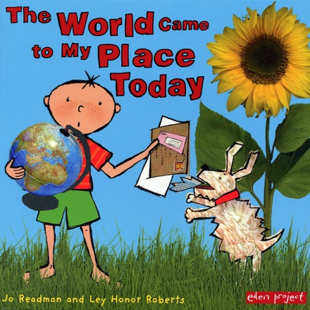

Worksheet: My daily items

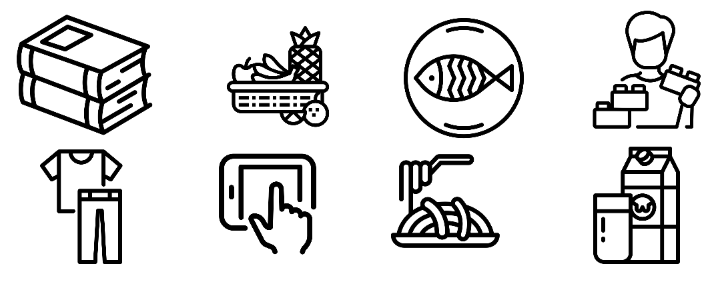
My item | Where has it come from? | How far has it travelled?
1

2

3

4

5

6

7

8

9

10

Main activity: Where in the world

Where has it come from?
Pupils should try and find out where their items have come from within the world. This could be done as homework so that pupils can look at labels of items to find their origin. Pupils could:
- Look at the labels on food items.
- Look at the labels on their clothes.
- Access the Internet to research items they are unsure about:
  - Where do baked beans come from?
  - Where do haricot beans grow?
  - Where do tuna fish live?

How far has it come?

- Pupils can use the following website to calculate how far their item may have travelled:
https://www.foodmiles.com/
- Try to find out how the items reach their final destination, e.g. the place where they bought it.

Any surprises?
After conducting their research, ask pupils: “Is there anything that surprised you at all?”

Main activity 2: Mapping it

Challenge pupils to use the tools in Digimap for Schools to create a map to show their world of everyday goods.
The steps below show how they could achieve this – depending on the age group you may not want to do all the steps. Let’s start with pasta.

Login to Digimap for Schools
- Go to: https://digimapforschools.edina.ac.uk.
- Select Login in the top right corner.
- Enter username and password. The username and password are provided by Digimap for Schools when you subscribe. Everyone in your school can use the same login details.

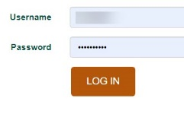

Find the place
- Pupils can search with country, town or postcode to find the place of origin.
  - If they know where the country/town is, they can pan and zoom to get there.
- Let’s look for pasta. Our label says ‘Made in Italy’.
- Type Italy in the search box.
- Select Italy from the results list.
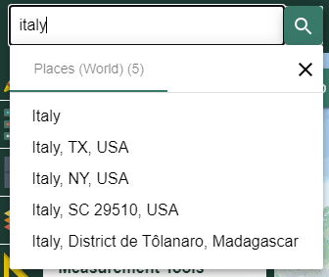

Add a label
- Open the Drawing tools.
- Select the Text button, highlighted on the image below.
- Click or tap on the map where you want to add the text.
- Type in your text, e.g. Spaghetti.
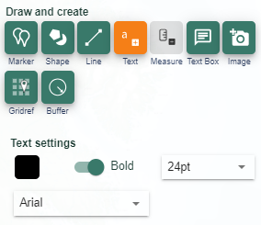

Draw route lines
Pupils could add lines between the place of origin and their home town or country.
- Open the Drawing tools.
- Select the Add line button, as shown on the image below.
- Move down and select a line colour, style and weight.
- Now click or tap on the map where you want to start your line – click or tap at each point, then double click or double tap to finish.
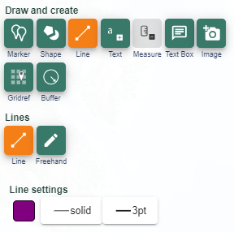

Measure
To add a measurement label to a route line, we have a tool.
- Open the Drawing tools.
- Select Add measurement label – highlighted on image below.
- Select Metric or Imperial – metric is the default.
- A measurement is added.
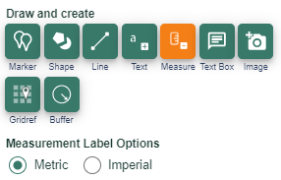

Add images
Pupils could add images, either their own images of items or images provided by the teacher. They need to be able to access the images on the computer or tablet they are using.
- Open the Drawing tools.
- Select the Add Image button, as shown on the image below.
- Click or tap on the map where you want to add the image.
- Now click Choose Image.
- Find the image on your computer.
- Select Open.
- Finally select Upload.
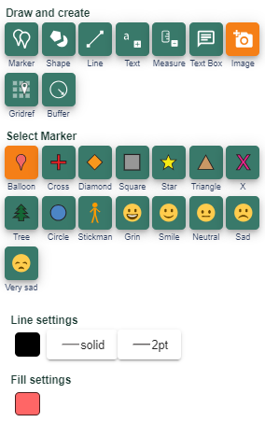

Print maps

- Open the print menu from the toolbar above the map window.
- Options include to add a title and your name.
- Select PDF and A4.
- IMPORTANT: Check the Layout Preview. Select the words Layout Preview above the map.
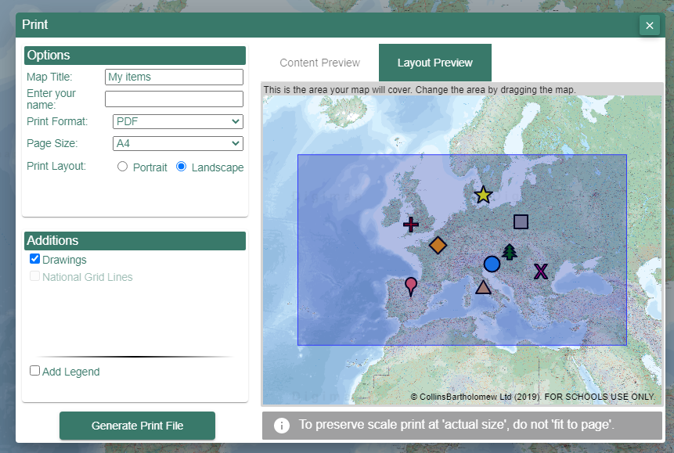
  - Layout Preview will show you if your map print will cover the area you want. If the shaded box doesn’t cover the area you want, close the print menu and try zooming in until the shaded box covers your area.

See our sample map:

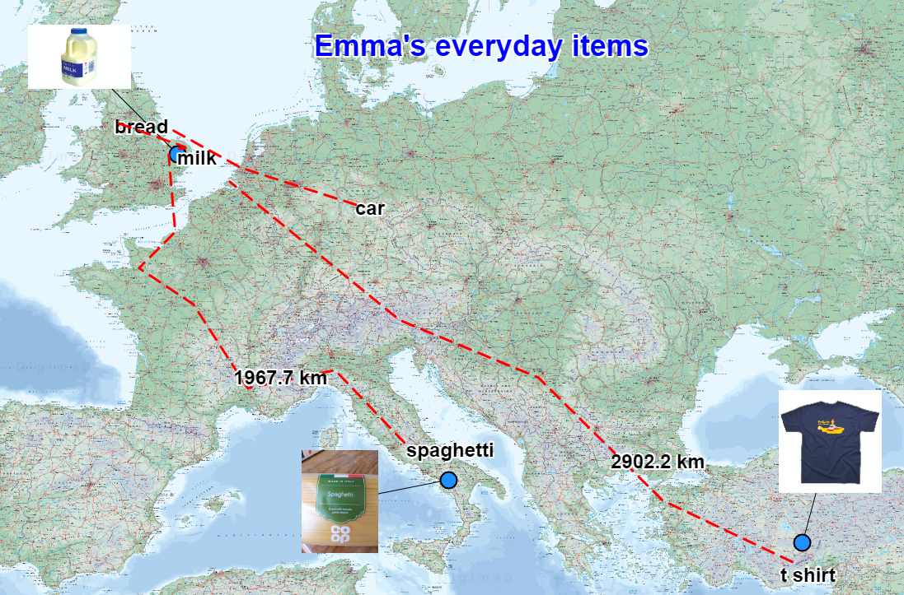

Classroom map
You could create an everyday goods display in the classroom too. Pupils could print images or bring in packaging of their everyday items and locate their origins on a large world map on the classroom wall using string and drawing pins.

Finish activity: Global Footprints

Introduce the idea of a global footprint and discuss this with pupils, using some examples they recognise.
Ask pupils:
- “Which of their everyday items had the largest global footprint?”.
- “Which of their everyday items had the smallest global footprint?”.
Next, ask pupils:
- “How might you reduce your global footprint in terms of the everyday goods that you use or consume?”.

Acknowledgements

Geographical Association
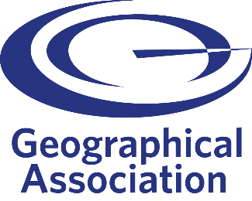
With thanks to the Geographical Association for allowing us to use excerpts from The Everyday Guide to Primary Geography: Locational Knowledge, by Simon Catling.

Map images
- © CollinsBartholomew Ltd (2019) FOR SCHOOLS USE ONLY.
- © Crown copyright and database rights 2020 Ordnance Survey (100025252). FOR SCHOOLS USE ONLY.
- Aerial photography © Getmapping plc. Contains OS data. FOR SCHOOLS USE ONLY.
- Historic mapping courtesy of the National Library of Scotland. FOR SCHOOLS USE ONLY.

Icons
- Black and white icons - location, directional sign, mountain ranges, compass, geography by Made x Made from the Noun Project.

Copyright
©EDINA at the University of Edinburgh, 2020.
This work is licensed under a Creative Commons Attribution-NonCommercial-ShareAlike Licence.

