Topically where
  - Resource number 4

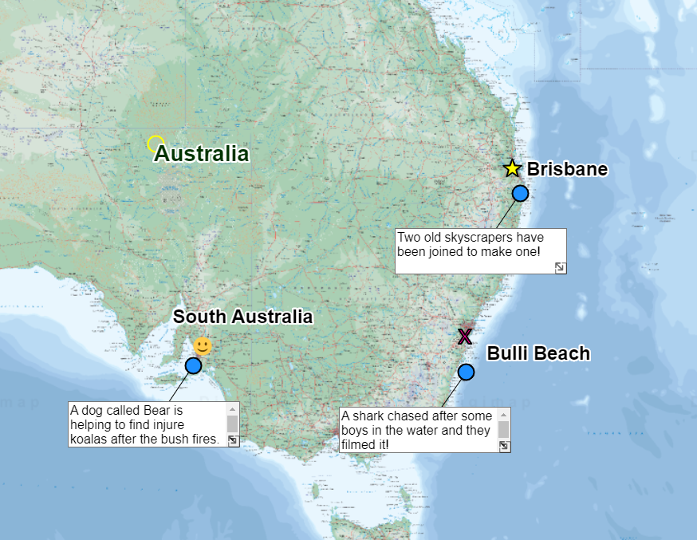

  - Emma Espley and Simon Catling
  - KS2

Table of Contents

Table of Contents 2
Introduction 3
Teaching and learning activities 5
Starter Activity: What’s in the news? 6
Worksheet: Topical Places list 7
Main activity: Mapping the news 8
Finish activity: Why so topical? 13
Taking it further 13
Acknowledgements 15
Copyright 15

Introduction
This resource aims to develop pupils’ locational knowledge. By accessing and using Digimap for Schools, it is hoped that pupils will learn more about some of the places that are mentioned in the media.
What’s the theme?  What makes a place 'topical’? | What are we exploring?  - Places are ‘topical’.  - When a significant event occurs, it is often reported in the media. Usually, the place is identified, along with many physical and human features, in order to situate the event within the world. Maps at various scales are frequently included in news reports; this helps us relate where the event has occurred to places that we are already familiar with, thus extending our mental maps.
What’s the learning objective?  To access and use digital maps in order to locate some of the places around the world that are mentioned in the media. | What will pupils know, understand and be able to do after completing this?  All pupils will…  - be able to conduct an investigation and create a list of all the places and features that have been mentioned in the media recently.  - be able to use the search facility to locate all the places and features that have mentioned in the media recently on a world map.  Most pupils will, in addition…  - be able to record the frequency of places and features mentioned in the media.  - be able use the search facility and the tools available to produce an annotated map to show all the places and features that have mentioned in the media recently.  - be able to identify and describe any patterns that are shown on their map.  Some pupils will…  - be able to try and classify their results so that they are more manageable.  - be able to explain why some places appear to be mentioned in the media more than others.
NC Programme of Study for Geography (England) | - Pupils should extend their knowledge and understanding beyond the local area to include the United Kingdom and Europe, North and South America. This will include the location and characteristics of a range of the world’s most significant human and physical features. They should develop their use of geographical knowledge, understanding and skills to enhance their locational and place knowledge.
The World Around us (Northern Ireland) | - [The curriculum implies that pupils will build their knowledge of places, their location and characteristics, at different scales, locally, nationally and around the world, and that they will develop their skills and knowledge through using large scale maps, globes, world maps and atlases. This will occur through studies that meet the curriculum requirements.]
Curriculum for Excellence (Scotland) | Social Studies:  - 2-14a: To extend my mental map and sense of place, I can interpret information from different types of maps and am beginning to locate key features within Scotland, United Kingdom, Europe or the wider world.
Curriculum for Wales | Humanities:  - I can present what I have discovered in a variety of ways and draw simple conclusions.  - I can recognise the distinct physical features of places, environments and landscapes in my locality and in Wales, as well as in the wider world.

How might I assess learning?
- Can pupils conduct an investigation into the places and features mentioned in the media recently?
- Are they able to list the names of countries, cities, regions, rivers, deserts, mountains, etc.?
- Are they able to record how many times each place or feature is mentioned?
- Are they able to classify their results so that they are more manageable?.
- Can pupils use the search facility and the tools available to produce an annotated map to show all the places and features that have mentioned in the media recently? (They should note the name of the place or feature and why it has hit the headlines).
- Can pupils identify and describe any patterns that are shown on their map?
- Can pupils explain why some places appear to be mentioned in the media more than others?

What could we do next?
- See our Taking it further section, below.

Which key words are relevant here?
world; world map; globe; continent; ocean; sea; country; region; city; physical (natural) features; human (made by people) features; rivers; mountains; deserts; media; patterns; list; record; classify; analyse; describe; explain; annotation; annotated map.

Teaching and learning activities

 | Activity | What’s involved? | What do I need?
To start | What’s in the news? | - Pupils record places recently mentioned in the News and associated features. | - Selection of current newspapers.  - PCs/tablets so pupils can access online news sites.  - ‘Topical places’ worksheet.
Main activity | Mapping the news | - Pupils create an annotated map of places recently mentioned in the media. | - Login details for Digimap for Schools.  - Tablets or PCs for pupils, say 1 per pair.
To finish | Why so topical? | - Pupils discuss why places are topical. | - Copies of the pupils’ news maps.

Acknowledgements:
The Everyday Guide to Primary Geography: Locational Knowledge by Simon Catling, p. 22-23.

Starter Activity: What’s in the news?

- Gather a number of recent national and international newspapers and/or provide access to digital news sources.
- In small groups, get pupils to conduct an investigation into the places and features mentioned in the media recently. In order to make things more manageable, different groups could be allocated different countries or continents.
- They should make a list of the names of countries, cities, regions, rivers, deserts, mountains, etc.
- They should also record how many times each place or feature is mentioned.
- Suggest that they try and classify their results, e.g. by type of place (country, region and city) or feature (physical/natural and human).
- Later, invite each small group to share their findings with the rest of the class.

News websites

- BBC Newsround provides news for children age 6 to 12.
- First News Live is a free weekday broadcast for young people made by Sky News and First News.
- Dogo News is a site for children with an international perspective.
- The Week Junior is a current affairs magazine and website for ages 8 to 14.

Worksheet: Topical Places list

Name | What is it?  A physical (natural) or human (made by people) feature?  A region, country, city, town, village? | Why is it in the news? | How many times is it mentioned?

Main activity: Mapping the news

Challenge pupils to use the search facility and the tools available to help them produce an annotated map to show all the places and features that have been mentioned in the media recently. They should note the name of the place or feature and why it has hit the headlines.
The steps below should how they could achieve this. See our sample map below.

Login to Digimap for Schools
- Go to: https://digimapforschools.edina.ac.uk.
- Select Login in the top right corner.
- Enter username and password. The username and password are provided by Digimap for Schools when you subscribe. Everyone in your school can use the same login details.

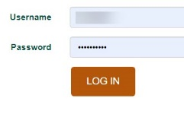

Find the place
- Pupils can search with country, town or postcode to find the place of origin.
  - If they know where the country/town is, they can get to the location without searching. They can zoom in/out and click (or touch) and drag the map to move around.
- Let’s look for Australia.
- Type Australia in the search box.
- Note the results are in two lists – United Kingdom and World.
- Select Australia from the World results list.
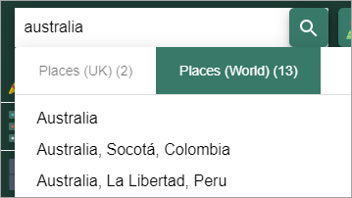

Add a label
- Open the Drawing tools.
- Select the standalone label text, highlighted on the image below.
- Click or tap on the map where you want to add the label.
- Type in your text, e.g. New Zealand.
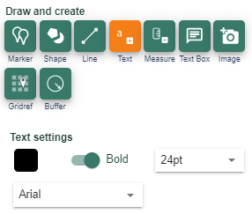

Add a paragraph of text
- Open the Drawing tools.
- Select the text box button, highlighted on the image below.
- Click or tap on the map where you want to add the box.
- Type in your text.
- You can resize the box if all the text is not visible – use the small arrows at the bottom right of the box to make it bigger.
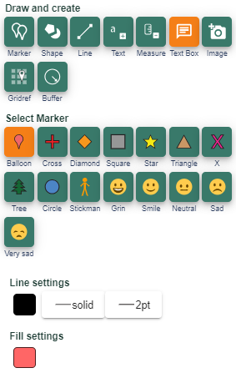

Add a marker
There is a range of markers and emojis available.
- Open the Drawing tools.
- Select any marker – they are orange when selected.
- Select the spot on the map and a marker is placed.
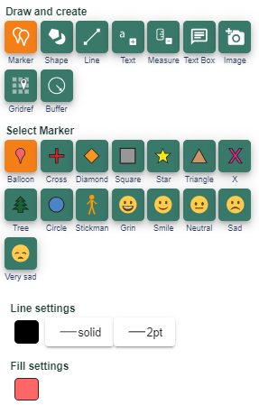

Print maps
Afterwards, pupils should print a copy of their map and analyse it with the others in their small group. Do they notice any patterns?
- Select the print menu - you’ll find it above the map.
- Options:
  - Input a title, e.g. ‘Carol’s news map’;
  - Select PDF;
  - Select A4;
  - Select Landscape/portrait.
- Make sure Drawings is ticked.
- IMPORTANT: Check the Layout Preview. Select the words Layout Preview above the map.
  - Layout Preview will show you if your map print will cover the area you want. If the shaded box doesn’t cover the area you want, close the print menu and try zooming in until the shaded box covers your area.
- Now select Generate Print file.
- A print file is downloaded which you can then open.
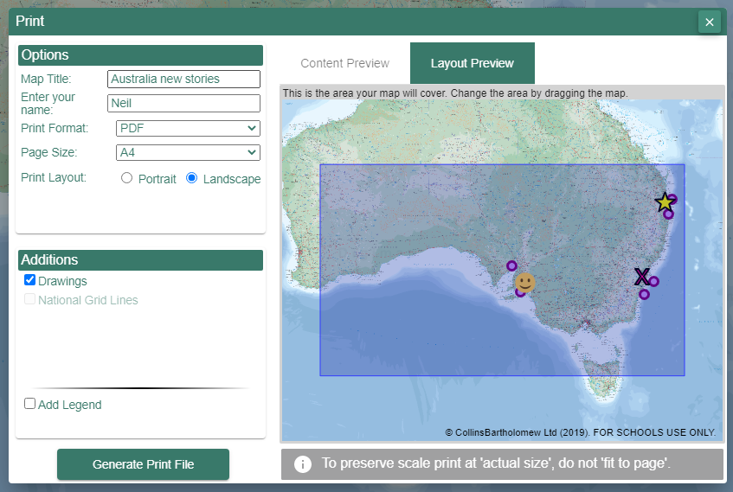

See our sample map:

Finish activity: Why so topical?

Ask pupils: “Some places appear to be mentioned in the media more than others. Why do you think this might be?”.
Places may also become ‘topical’ if they are the setting for a popular television drama series, cinematic film, outdoor theatre production, music festival or sporting event.
Places where past events have taken place are important too as this can enhance our understanding of happenings today.

Taking it further

English
Many television series and cinematic films are recorded in real places around the world and trailers are posted online, e.g. BBC; Channel 4; You Tube.
- Identify a trailer that is suitable for the age group that you teach and vet the content before using it in class.
- Firstly, show the class an extract from the trailer all the way through. Explain that, although many television series or cinematic films are works of imagination, the settings are often real places.
- Show the extract a second time, pausing to discuss each change of scene and allowing pupils to make notes.
- Use the timer to divide the extract into short sections, designating one to each small group of pupils.
- Challenge each group to discover as much as they can about the setting/s in their allocated section.
- Next, they should attempt to write and record a ‘voiceover’, which provides locational information (with maps and images) about the setting/s shown in their section of the trailer.
- Invite each group to present their ‘voiceover’ to the rest of the class.

History
Pupils could find out and write about historical events, sites, countries, areas and features. This helps them to develop a sense of where and how people lived and the events that occurred.

Art
Discover more about artists and their home town, region, country and places they visited or where their art is on display. Pupils could create their own artworks, influenced by a particular style or place.

Art/Music
Pose place-related questions, such as:
- ‘Which city is shown in this painting?’;
- ‘Where is it?;
- ‘What was it like?’;
- ‘When was this music composed?’;
- ‘Where did the composer live?;
- ‘What was it like to live there then?’.
This enables pupils to find the ‘where’ in the wider curriculum.

Acknowledgements

Geographical Association
With thanks to the Geographical Association for allowing us to use excerpts from The Everyday Guide to Primary Geography: Locational Knowledge, by Simon Catling.

Map images
- © CollinsBartholomew Ltd (2019) FOR SCHOOLS USE ONLY.
- © Crown copyright and database rights 2020 Ordnance Survey (100025252). FOR SCHOOLS USE ONLY.
- Aerial photography © Getmapping plc. Contains OS data. FOR SCHOOLS USE ONLY.
- Historic mapping courtesy of the National Library of Scotland. FOR SCHOOLS USE ONLY.

Icons
- Black and white icons - location, directional sign, mountain ranges, compass, geography by Made x Made from the Noun Project.

Copyright
©EDINA at the University of Edinburgh, 2020.
This work is licensed under a Creative Commons Attribution-NonCommercial-ShareAlike Licence.

