Discovering where in altases
  - Resource number 5

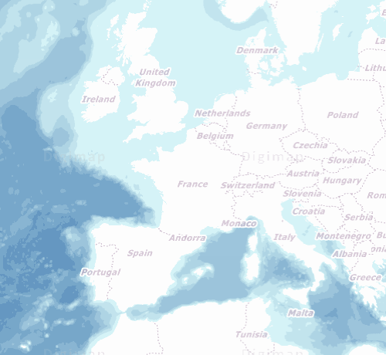

  - Emma Espley and Simon Catling
  - KS1

Table of Contents

Table of Contents 2
Introduction 3
Teaching and learning activities 5
Starter Activity: The Atlas 6
Main activity: Never Eat Shredded Wheat! 7
Worksheet: Never Eat Shredded Wheat!!!! 9
Finish activity: Compass challenge 12
Taking it further 13
Acknowledgements 14
Copyright 14

Introduction
This resource aims to develop pupils’ locational knowledge. By accessing Digimap for Schools, it is hoped that pupils will learn how to use an online atlas in order to explore places and features around the world.
What’s the theme?  What can an atlas tell you? | What are we exploring?  - The use and history of atlases.  - The four points of the compass, e.g. north; east; south and west.  - Key physical (natural) and human (made by people) features around the world.
What’s the learning objective?  To learn how to use an online atlas in order to explore places and features around the world. | All pupils will…  - be able to recognise different types of atlas and explain when they might be used.  - be able to use an online atlas, including its search facility, to help locate a particular place.  - be able to recall the four main points of the compass.  - be able to ‘travel’ in a specific direction when requested to do so, e.g. north; east; south; west.  - be able to identify the direction in which they have ‘travelled’, e.g. north; east; south; west.  Most pupils will, in addition…  - be able to identify Gerardus Mercator and explain why he is considered to be a significant individual.  - be able to identify places and features seen on their ‘travels’.  Some pupils will, in addition…  - be able to identify places and features ‘seen’ on their ‘travels’, classifying the latter into those that are physical (natural) and human (made by people).  - be able to create their own ‘challenges’ for others in the class to complete.
NC Programme of Study for Geography (England) | - Pupils should extend their knowledge and understanding beyond the local area to include the United Kingdom and Europe, North and South America. This will include the location and characteristics of a range of the world’s most significant human and physical features. They should develop their use of geographical knowledge, understanding and skills to enhance their locational and place knowledge.
The World Around us (Northern Ireland) | - [The curriculum implies that pupils will build their knowledge of places, their location and characteristics, at different scales, locally, nationally and around the world, and that they will develop their skills and knowledge through using large scale maps, globes, world maps and atlases. This will occur through studies that meet the curriculum requirements.]
Curriculum for Excellence (Scotland) | Social Studies:  - 2-14a: To extend my mental map and sense of place, I can interpret information from different types of maps and am beginning to locate key features within Scotland, United Kingdom, Europe or the wider world.
Curriculum for Wales | Humanities:  - I can recognise the distinct physical features of places, environments and landscapes in my locality and in Wales, as well as in the wider world.

How might I assess learning?
- Show pupils an example of an atlas. Do they know what it is and when it might be used?
- Show pupils an image of Gerardus Mercator. Do they know who he is and why he is considered to be a significant individual?
- Can pupils tell you how atlases have changed over time?
- Can they recall the four main points of the compass, e.g. north; east; south; west?
- Can pupils use an online atlas, including its search facility, to help them locate a particular place? Are they able to identify which country it is in and on which continent it is found?
- Are pupils able to ‘travel’ in the direction that they are asked (either north, east, south or west) until they reach the edge of their screen and identify places or features that lie in that compass direction?
- Can pupils give examples of physical (natural) or human (made by people) features?
- Can pupils recall the direction that they have ‘travelled’, e.g. from a start to an end point?

What could we do next?
- See our Taking it further section, below.

Which key words are relevant here?
atlas; world; world map; country map; continent; country; ocean; sea; key; compass; compass points; north; east; south; west; physical (natural) features; human (made by people) features; place; capital city; city; mountains; rivers, lake; desert.

Teaching and learning activities
 | Activity | What’s involved? | What do I need?
To start | The Atlas | - An introduction to Atlas, Mercator and the different types of atlases. | - Our powerpoint with images (optional).  - A collection of different atlases, e.g. My First Atlas; Primary School Atlas; The Times Atlas of the World; Digimap for Schools; Road Atlas…  - An image of Gerardus Mercator.
Main activity | Never Eat Shredded Wheat! | - Pupils search for world countries, then move north, east, south or west and record what they see. | - Login details for Digimap for Schools.  - Tablets or PCs for pupils, say 1 per pair.  - Printed ‘Never Eat Shredded Wheat’ worksheets.
To finish | Compass challenge | - Pupils create challenges for their classmates. | - Login details for Digimap for Schools.  - Tablets or PCs for pupils, say 1 per pair.

Acknowledgements:
The Everyday Guide to Primary Geography: Locational Knowledge by Simon Catling, p. 22-23.

Starter Activity: The Atlas
You can use our supplied powerpoint for this discussion activity or the notes below to introduce the points to pupils.

Who was Atlas?
In Greek mythology, Atlas was a leader of the Titans in their war against Zeus (the King of the Gods). After their defeat, he was condemned to carry the heavens upon his shoulders.

Mercator and his atlas
The first collection of maps of the world, countries and regions was published by Gerardus Mercator in 1595. Mercator chose to call it an Atlas (after the Greek Titan Atlas) and the term has become synonymous with bound collections of maps.

How atlases have developed
- Display a collection of atlases. Ask pupils: “What are these?”.
- Ask pupils: “When might you use them?”.
Over the years, world atlases have developed enormously, ranging from very detailed reference atlases, e.g. The Times Atlas of the World, to more simplified ones aimed at very young children, e.g. My First Atlas. There are also atlases that have a specific purpose, e.g. road atlases for navigation; thematic atlases to show climate or land use. Some atlases are online/electronic and contain up-to-date information about places and features around the world, e.g. Digimap for Schools.

Compass points
- Introduce pupils to the 4 main points of the compass, i.e. north; east; south; west.
- How can they remember NESW:
  - Never Eat Shredded Wheat,
  - Naughty Elephants Spray Water,
  - Never Eat Slimy Worms.
- Ask the pupils to make up their own mnemonic to remember NESW – from their suggestions select a class mnemonic to use.

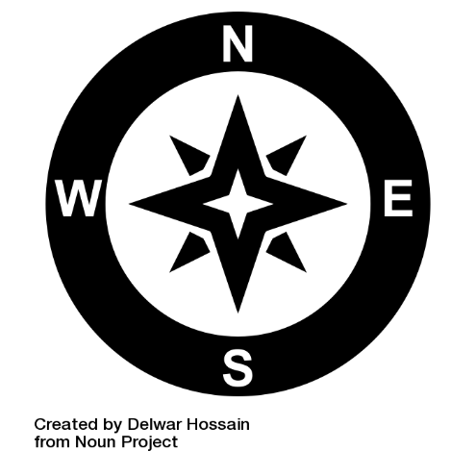

Main activity: Never Eat Shredded Wheat!

Login to Digimap for Schools
- Go to: https://digimapforschools.edina.ac.uk.
- Select Login in the top right corner.
- Enter username and password. The username and password are provided by Digimap for Schools when you subscribe. Everyone in your school can use the same login details.

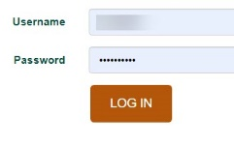

Directions refresher
- Ask pupils to select the small compass on the map window to view a larger compass.
  - Remind pupils of the four main points of the compass, e.g. north; east; south; west.
  - Remind pupils that north is always at the top of the map in Digimap for Schools.

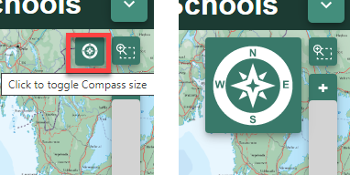

- Remind them of their class mnemonic for NESW, or these ones:
  - Never Eat Shredded Wheat,
  - Naughty Elephants Spray Water,
  - Never Eat Slimy Worms.

Identify countries in a direction

- Select a country, e.g. USA.
- Get pupils to use the search box to help them locate it on a world map.
- Next, challenge pupils to ‘travel’ either north, east, south or west until they reach the edge of their screen.
- Ask them to identify any countries they see on the way and note them in the table below.
- Selecting world boundaries may be helpful to see country names more clearly:
  - Open the Map Selector tool.
  - Select the button to the right of World Boundaries.
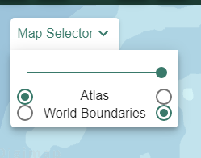

Worksheet: Never Eat Shredded Wheat!!!!

Country | Travel to the … | Which countries did you see? | Which places and features did you see?
USA | North | Canada | Rocky Mountains, Bighorn Mountain, Lake Winnipeg
Russia | East
Australia | West
Poland | East
Italy | North
Uganda | South
Saudi Arabia | West

Identify map features
- Repeat the steps, but this time ask pupils to identify any places or features that lie in that compass direction.
- For this, the Atlas map will be more useful.
  - Open the Map Selector Tool.
  - Select the button to the right of Atlas.
- Remind pupils they can zoom in at any point if they are interested in seeing more detail.
  - Use the plus sign on the scale bar to zoom in – see image below.

View map key
- It might help pupils to view the map key.
- Select Key from the sidebar at the left.

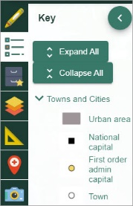

Find the direction

- Next, give pupils a starting point and places and features seen en route to your destination. Our powerpoint has some examples for you.
- Ask pupils: “In which direction have I travelled?”.
- Repeat the above activity several times.

Example
- Started at Edinburgh.
- Left the train at Glasgow.
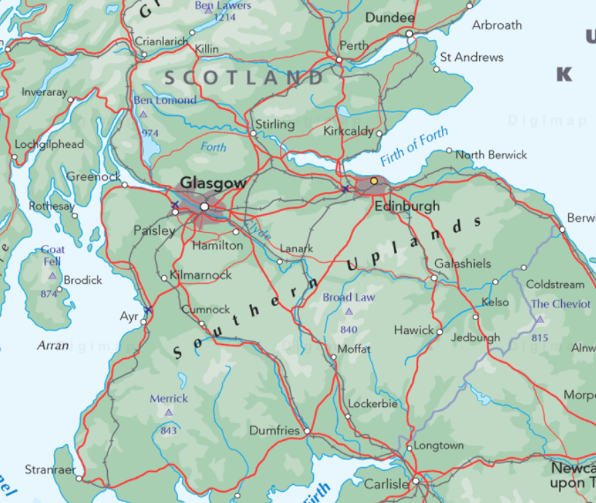

Finish activity: Compass challenge

Invite pupils to create similar ‘challenges’ to the above for the rest of the class to complete.

I started at ………………………………………………………

I went to………………………………………………………….

I saw……………………………………………………………….

I passed………………………………………………………

I finished at ………………………………………………….

Taking it further

English/’Reading across the curriculum’
Read/listen to/watch a suitable version of the Greek myth about how the Titan Atlas came to hold up the heavens and discuss:

- Atlas: The Titan God of Endurance, Strength And Astronomy - (Greek Mythology Explained) – 5 minutes 46 seconds: https://www.youtube.com/watch?v=lOslovZl9OE.

- https://kids.britannica.com/kids/article/Atlas/390238.

- https://www.thoughtco.com/greek-god-who-carried-world-shoulders-117215.

- https://www.theoi.com/Titan/TitanAtlas.html.

Geography
On a globe or in the atlas, ask pupils to look for interesting names of places or features – perhaps, because it is in another language or is hard or fun to pronounce?
Encourage pupils to use the Internet to find out about that place and/or locate it on a globe or world map and ask their peers for help in pronouncing its name.

Acknowledgements

Geographical Association
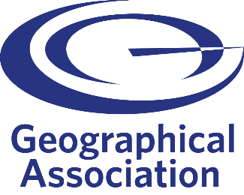
With thanks to the Geographical Association for allowing us to use excerpts from The Everyday Guide to Primary Geography: Locational Knowledge, by Simon Catling.

Map images
- © CollinsBartholomew Ltd (2019) FOR SCHOOLS USE ONLY.
- © Crown copyright and database rights 2020 Ordnance Survey (100025252). FOR SCHOOLS USE ONLY.
- Aerial photography © Getmapping plc. Contains OS data. FOR SCHOOLS USE ONLY.
- Historic mapping courtesy of the National Library of Scotland. FOR SCHOOLS USE ONLY.

Icons
- Black and white icons - location, directional sign, mountain ranges, compass, geography by Made x Made from the Noun Project.

Copyright
©EDINA at the University of Edinburgh, 2020.
This work is licensed under a Creative Commons Attribution-NonCommercial-ShareAlike Licence.

