Discovering where in altases
  - Resource number 6

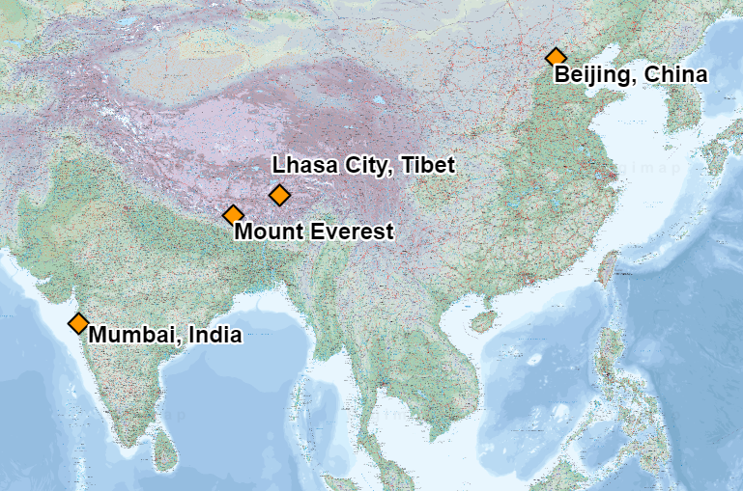

  - Emma Espley and Simon Catling
  - KS2

Table of Contents

Table of Contents 2
Introduction 3
Teaching and learning activities 6
Starter Activity: The Atlas 7
Main activity: Never Eat Shredded Wheat! 8
Worksheet: Never Eat Shredded Wheat!!!! 11
Finish activity: Compass challenge 14
Taking it further 15
Acknowledgements 16
Copyright 16

Introduction
This resource aims to develop pupils’ locational knowledge. By accessing and using Digimap for Schools, it is hoped that pupils will learn how to use an online atlas in order to explore places and features around the world.
What’s the theme?  What can an atlas tell you? | What are we exploring?  - The use and history of atlases.  - The eight points of the compass, e.g. N; NE; E; SE; S; SW; W; NW.  - Key physical (natural) and human (made by people) features around the world.
What’s the learning objective?  To learn how to use an online atlas in order to explore places and features around the world. | What will pupils know, understand and be able to do after completing this?  All pupils will…  - be able to explain that there are different types of atlas maps, giving examples of some and their uses.  - be able to study a particular map and make use of a key to identify and locate at least three features.  - be able to make use of the Internet to source images of three of the features that they identified on the map.  - be able to use an online atlas, including its search facility, to help them locate a particular place and identify in which country and on which continent it is found.  - be able to recall the eight points of the compass, e.g. N; NE; E; SE; S; SW; W; NW.  - be able to ‘travel’ in a specific direction when requested to do so, e.g. N; NE; E; SE; S; SW; W; NW.  - be able to identify the direction in which they have ‘travelled’, e.g. N; NE; E; SE; S; SW; W; NW.  Most pupils will, in addition…  - be able to identify places and features seen on their ‘travels’.  Some pupils will, in addition…  - be able to study a particular map and make use of a key to identify and locate at least eight features.  - be able to make use of the Internet to source images of three of the features that they identified on the map, consider if each is as they expected it to be and, if not, suggest a more accurate symbol to use.  - be able to identify places and features ‘seen’ on their ‘travels’, classifying the latter into those that are physical (natural) and human (made by people).  - be able to create their own ‘challenges’ for others in the class to complete.
NC Programme of Study for Geography (England) | - Pupils should extend their knowledge and understanding beyond the local area to include the United Kingdom and Europe, North and South America. This will include the location and characteristics of a range of the world’s most significant human and physical features. They should develop their use of geographical knowledge, understanding and skills to enhance their locational and place knowledge.
The World Around us (Northern Ireland) | - [The curriculum implies that pupils will build their knowledge of places, their location and characteristics, at different scales, locally, nationally and around the world, and that they will develop their skills and knowledge through using large scale maps, globes, world maps and atlases. This will occur through studies that meet the curriculum requirements.]
Curriculum for Excellence (Scotland) | Social Studies:  - 2-14a: To extend my mental map and sense of place, I can interpret information from different types of maps and am beginning to locate key features within Scotland, United Kingdom, Europe or the wider world.
Curriculum for Wales | Humanities:  - I can recognise the distinct physical features of places, environments and landscapes in my locality and in Wales, as well as in the wider world.

How might I assess learning?
- Can pupils provide examples of the different types of atlas maps and their uses?
- Can pupils study a particular map and make use of a key to identify and locate a number of features?
- Can pupils make use of the Internet to source images of three of the features that they identified on the map? Is each one as they expected it to be? If not, could they suggest a more accurate symbol to use?
- Can pupils recall the eight points of the compass, e.g. N; NE; E; SE; S; SW; W; NW?
- Can pupils use an online atlas, including its search facility, to help them locate a particular place? Are they able to identify which country it is in and on which continent it is found?
- Are pupils able to ‘travel’ in the direction that they are asked (either N; NE; E; SE; S; SW; W or NW) until they reach the edge of their screen and identify places or features that lie in that direction?
- Can pupils give examples of physical (natural) or human (made by people) features?
- Can pupils recall the direction that they have ‘travelled’, e.g. from a start to an end point?

What could we do next?
- See our Taking it further section, below.

Which key words are relevant here?
atlas; world; world map; globe; country map; continent; country; ocean; sea; key; compass; compass points; N; NE; E; SE; S; SW; W; NW; physical (natural) features; human (made by people) features; place; capital city; city; mountains; rivers, lake; volcano; desert; atlas map symbols.

Teaching and learning activities
 | Activity | What’s involved? | What do I need?
To start | The Atlas | - An introduction to Atlas, Mercator and different types of atlases. | - Our powerpoint with images (optional).  - A collection of different atlases, e.g. My First Atlas; a primary atlas; a junior atlas; The Times Atlas of the World; Digimap for Schools; Road Atlas … or the images in our powerpoint may be suitable if no atlases are available.  - An image of Gerardus Mercator and his first atlas (see powerpoint).
Main activity | Never Eat Shredded Wheat! | - Pupils search for world countries, then move in a particular direction and record what they see.  - Then, challenge them to identify a direction from destinations on a journey. | - Login details for Digimap for Schools.  - Tablets or PCs for pupils, say 1 per pair.  - Printed ‘Never Eat Shredded Wheat’ worksheets.
To finish | Compass challenge | - Pupils create journey challenges for their peers. | - Login details for Digimap for Schools.  - Tablets or PCs for pupils, say 1 per pair.
Acknowledgements:
The Everyday Guide to Primary Geography: Locational Knowledge by Simon Catling, p. 24-25.

Starter Activity: The Atlas
You can use our supplied powerpoint for this introductory activity or the notes below to introduce the following points. It is very helpful to have a display of different atlases in the classroom to stimulate and interest children.

Who was Atlas?
In Greek mythology, Atlas was a leader of the Titans in their war against Zeus (the King of the Gods). After their defeat, he was condemned to carry the heavens upon his shoulders.

Mercator and his atlas
The first collection of maps of the world, countries and regions was published by Gerardus Mercator in 1595. Mercator chose to call it an Atlas (after the Greek Titan Atlas) and the term has become synonymous with bound collections of maps.

Present day atlases
Explain that there are different types of atlas maps, e.g. hard copies that can be extremely detailed, such The Times Atlas of the World, or very simple ones, e.g. My First Atlas; those that are for a specific purpose, such as road atlases for navigation or thematic atlases to show aspects, such as climate and land use; electronic/online versions, like Digimap for Schools.

Compass points
- Introduce pupils to, or remind them of, the 8 points of the compass, i.e. north; north-east; east; south-east; south; south-west; west; north-west.
- How can they remember NESW?
  - Never Eat Shredded Wheat;
  - Naughty Elephants Spray Water;
  - Never Eat Slimy Worms.
- Challenge pupils to create their own mnemonic to remember the compass points. Select one to be the class mnemonic.

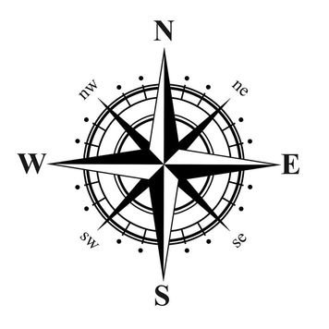

Main activity: Never Eat Shredded Wheat!

Display an Atlas map

- Go to: https://digimapforschools.edina.ac.uk.
- Select Login in the top right corner.
- Enter username and password. The username and password are provided by Digimap for Schools when you subscribe. Everyone in your school can use the same login details.

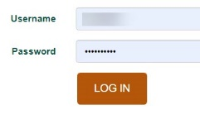

- Display an Atlas map of an area, e.g. North America, South America or Europe.
  - Open the Map Selector to check your map selection. The image below shows the Atlas map is displayed (the button to the right of Atlas is selected).
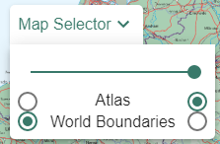
- Give pupils clues about what it shows and ask them to come and locate each feature on the big screen.

Pupils identify features
- Next, ask pupils to log in to Digimap for Schools.
- Select Key from the sidebar at the left, so that key physical and human features are visible.

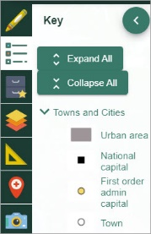

- Give pupils five minutes to study an Atlas map (the green world map that is displayed when you open Digimap for Schools) of a country or continent.
- After five minutes, ask pupils: “What does the map show?”.
- Ask pupils: “How did you locate these features?” or “How did you know it was a mountain?”.
  - Discuss which symbols they referred to. Highlight the various point, line and shape symbols, colours and words and link to the key.
- Suggest pupils use the Internet to source images of three of the features that they identified to find what they are really like.
  - Ask pupils: “Did each one appear as you expected it to?”.
- Ask pupils: “Could you devise a more accurate symbol?”

Directions refresher
- Remind pupils of the eight points of the compass, i.e. N; NE; E; SE; S; SW; W and NW.
- Remind them of their class mnemonic for the compass points, or these reminders:
  - Never Eat Shredded Wheat;
  - Naughty Elephants Spray Water;
  - Never Eat Slimy Worms.
- Ask pupils to select the small compass on screen to display a larger compass. The image below highlights the location of the compass.
  - Remind them that north is always at the top of the maps in Digimap for Schools.
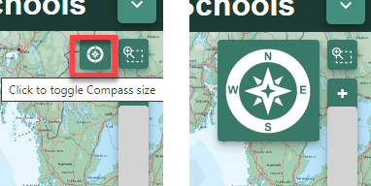

Identify countries in a direction

- For this step, selecting world boundaries may be helpful to see country names more clearly:
  - Open the Map Selector tool.
  - Select the button to the right of World Boundaries.
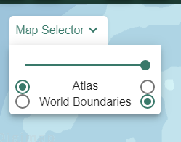
- Select a country, e.g. Mexico. There are some suggestions in the table below. You might create your own list and examples as appropriate for your pupils.
- Get pupils to use the search facility to help them locate it on a world map.
- Next, challenge pupils to ‘travel’ either N; NE; E; SE; S; SW; W or NW until they reach the edge of their screen.
- Ask them to identify countries that lie in that direction.
- Repeat the above activity several times.

Worksheet: Never Eat Shredded Wheat!!!!

Country | Travel to the … | Which countries did you see? | Which places and features did you see?
Mexico | North | USA, Canada | Rocky Mountains, Bighorn Mountain, Lake Winnipeg
Russia | South-East
Australia | South-East
Poland | North-West
Italy | South-West
Uganda | South-East
Saudi Arabia | West

Identify map features
- Repeat the steps, but this time ask pupils to identify any places or features that lie in that direction.
- Ask pupils: “Which of these features might be considered to be physical (natural) or human (made by people)?”.
- For this, the Atlas map will be more useful.
  - Open the Map Selector Tool.
  - Select the button to the right of Atlas.
- Remind pupils they can zoom in at any point if they are interested in seeing more detail.
  - Use the plus sign on the scale bar to zoom in – see image below.

Find the direction
- Next, give pupils a starting point and places and features seen en route to your destination. Our powerpoint file has some examples for you.
- Ask pupils: “In which direction have I travelled?”.
- Repeat the above activity several times.

Example
- Started in London.
- Passed through Birmingham.
- Stopped in Liverpool.
- Finished in Belfast.

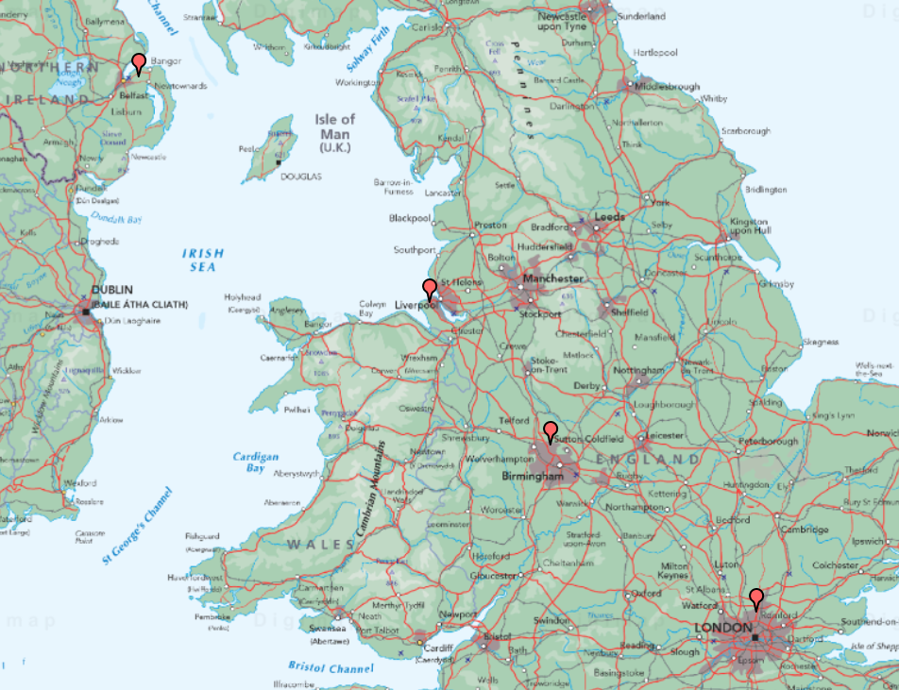

Finish activity: Compass challenge

Invite pupils to create similar ‘challenges’ to the above for the rest of the class to complete.

I started at ………………………………………………………

I travelled to………………………………………………………….

I visited……………………………………………………………….

I passed through………………………………………………………

I finished at ………………………………………………….

Taking it further

How the atlas got its name

For Geography/History/English

Distribute copies of the handout, ‘How the atlas got its name’. Provide images of the historical maps it mentions too. Get pupils to write about one of the historical atlas maps. Alternatively, ask pupils to compare how the world appeared then with how it is represented today in a modern atlas.

Same place, different atlas maps

For Geography

Get pupils to find a place or feature on different maps in an atlas.
To introduce or recap on pupils’ understanding of map scales, ask questions, such as:
- ‘Why is New York (for example) shown larger and smaller on different maps?’;
- ‘Is it still in the same place?’;
- ‘Are some features missing?’ ‘Why?’;
- ‘What can we say about the ways the city is presented on different maps in an atlas?’.

Encourage pupils to compare maps of the same continents, countries and oceans in different atlases.

Acknowledgements

Geographical Association
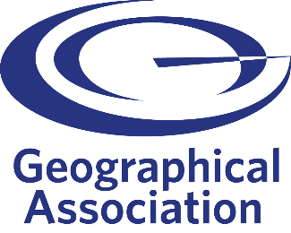
With thanks to the Geographical Association for allowing us to use excerpts from The Everyday Guide to Primary Geography: Locational Knowledge, by Simon Catling.

Map images
- © CollinsBartholomew Ltd (2019) FOR SCHOOLS USE ONLY.
- © Crown copyright and database rights 2020 Ordnance Survey (100025252). FOR SCHOOLS USE ONLY.
- Aerial photography © Getmapping plc. Contains OS data. FOR SCHOOLS USE ONLY.
- Historic mapping courtesy of the National Library of Scotland. FOR SCHOOLS USE ONLY.

Icons
- Black and white icons - location, directional sign, mountain ranges, compass, geography by Made x Made from the Noun Project.

Copyright
©EDINA at the University of Edinburgh, 2020.
This work is licensed under a Creative Commons Attribution-NonCommercial-ShareAlike Licence.

