Locating places and features
  - Resource number 7

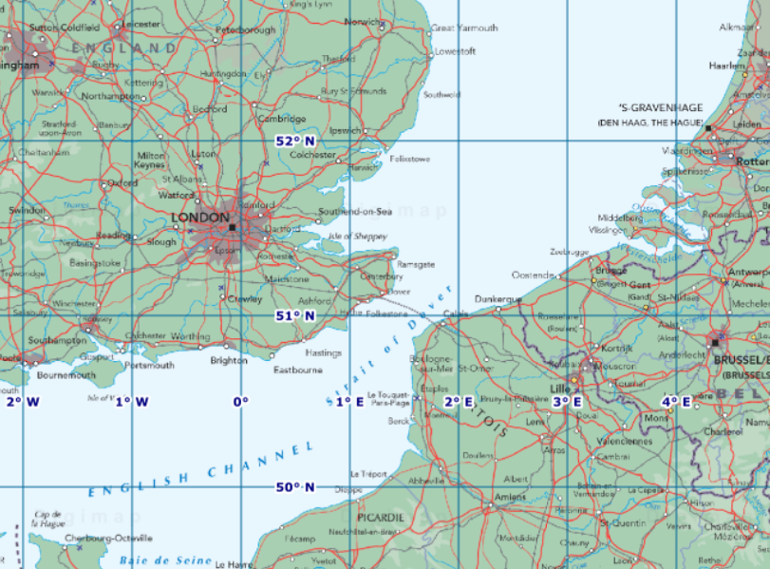

  - Emma Espley and Simon Catling
  - KS2

Table of Contents

Table of Contents 2
Introduction 3
Teaching and learning activities 5
Starter Activity: What are latitude and longitude? 6
Main activity: Grid line challenge 11
Worksheet: Grid line challenge 14
Finish activity: GPS uses and accuracy 16
Taking it further 17
Acknowledgements 18
Copyright 18

Introduction
This resource aims to develop pupils’ locational knowledge. By accessing and using Digimap for Schools, it is hoped that pupils will learn about the role of grid lines on maps.
What’s the theme?  Why are there horizontal and vertical lines on maps? | What are we exploring?  - Latitude and longitude.  - Main lines of latitude and longitude, e.g. Equator; Tropic of Cancer; Tropic of Capricorn; Arctic Circle; Antarctic Circle; Prime Meridian.  - The significance of latitude and longitude.  - GPS uses.
What’s the learning objective?  To learn about the role of grid lines on maps. | What will pupils know, understand and be able to do after completing this?  All pupils will…  - be able to define latitude and longitude.  - be able to identify the main lines of latitude and longitude on a world map.  - be able to explain why latitude and longitude are significant.  - be able to use Digimap for Schools to provide a latitude and longitude reading for a specific place or feature.  - be able to explain what the letters GPS stand for.  - be able to list one use of GPS.  Most pupils will, in addition…  - be able to list three uses of GPS.  Some pupils will, in addition…  - be able to name some of the countries through which a specific line of latitude or longitude runs.  - be able to use Digimap for Schools to provide a latitude and longitude reading for a specific place or feature and interpret the figures.  - be able to list at least five uses of GPS.  - be able to assess how accurate GPS is and give clear reasoning to justify their viewpoint.
NC Programme of Study for Geography (England) | - Pupils should extend their knowledge and understanding beyond the local area to include the United Kingdom and Europe, North and South America. This will include the location and characteristics of a range of the world’s most significant human and physical features. They should develop their use of geographical knowledge, understanding and skills to enhance their locational and place knowledge.
The World Around us (Northern Ireland) | - [The curriculum implies that pupils will build their knowledge of places, their location and characteristics, at different scales, locally, nationally and around the world, and that they will develop their skills and knowledge through using large scale maps, globes, world maps and atlases. This will occur through studies that meet the curriculum requirements.]
Curriculum for Excellence (Scotland) | Social Studies:  - 2-14a - To extend my mental map and sense of place, I can interpret information from different types of maps and am beginning to locate key features within Scotland, United Kingdom, Europe or the wider world.
Curriculum for Wales | Humanities:  - I can recognise the distinct physical features of places, environments and landscapes in my locality and in Wales, as well as in the wider world.

What could we do next?
- See Taking it further, below.

How might I assess learning?
- Do pupils know the difference between latitude and longitude?
- Can they identify the main lines of latitude and longitude on a world map, e.g. Equator; Tropic of Cancer; Tropic of Capricorn; Arctic Circle; Antarctic Circle; Prime Meridian?
- Can pupils recall some of the countries through which a specific line of latitude and longitude runs?
- Can pupils explain why latitude and longitude is significant?
- Can pupils provide a latitude and longitude reading for a specific place or feature and interpret the figures, e.g. north or south of the Equator/in the Northern Hemisphere or Southern Hemisphere; east or west of the Prime Meridian/relate to time zones … either behind or in front of GMT/United Kingdom?
- Can pupils explain what the letters GPS stand for? (global positioning systems)
- Can pupils list a number of uses of GPS?
- Do pupils consider GPS to be accurate? Can they provide clear reasoning to support their viewpoint?

Which key words are relevant here?
atlas; world; world map; globe; latitude; longitude; horizontal; vertical; lines; grid; grid reference; grid square; atlas index page; alphanumeric; four-figure and six-figure grid references; north; east; south; west, tropics; polar regions; Equator; Tropic of Cancer; Tropic of Capricorn; Arctic Circle; Antarctic Circle; North Pole; South Pole; Prime Meridian; Greenwich Mean Time (GMT); global positioning systems (GPS).

Teaching and learning activities
 | Activity | What’s involved? | What do I need?
To start | Latitude and longitude | - Introduce pupils to latitude and longitude.  - Find out how to identify the latitude and longitude references/readings for a particular location using Digimap for Schools. | - Digimap for Schools login details.  - GA information sheet about latitude and longitude.
Main activity | Grid line challenge | - Challenge pupils to identify the latitude and longitude references/readings for twelve places. | - Digimap for Schools login details.  - Access to 1 tablet or PC for every 2 pupils.  - A list of twelve places or features to find the latitude and longitude references/readings for – we provide suggestions below.
To finish | GPS research | - Discuss GPS and its uses.  - Pupils research GPS uses and assess its accuracy.  - Pupils report their findings. | - A list on the classroom wall to record GPS uses.

Acknowledgements:
The Everyday Guide to Primary Geography: Locational Knowledge by Simon Catling, p. 26-27.

Starter Activity: What are latitude and longitude?

- Log in to Digimap for Schools.
- Make sure you are viewing an Atlas map – check this in the Map Selector tool on the map window.
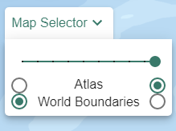
- Zoom to maximum extent, with the button on the map window (pictured below).
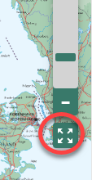
- Open Overlays from the sidebar and check two boxes; Latitude and Longitude Grid and Major Lines of Latitude.
- Your map should like similar to the image below:

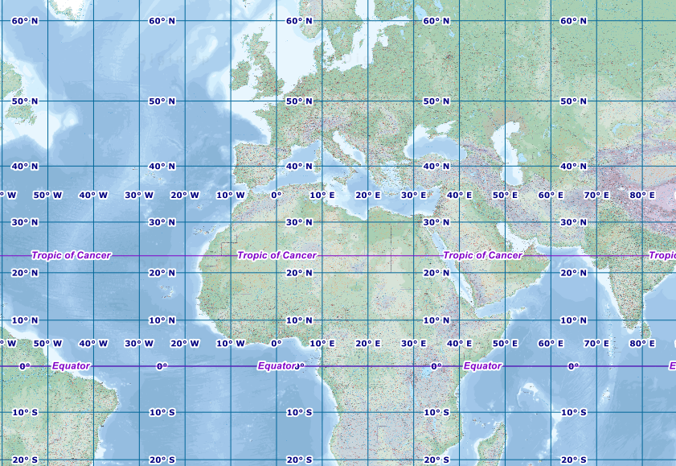

What are latitude and longitude?
- Explain what latitude and longitude are. Refer to the provided information sheet about latitude and longitude (from the Geographical Association). The information below may be helpful.

Most types of maps have evenly spaced horizontal and vertical lines that form a grid. These grid lines enable us to locate a place or feature precisely on a map. Some maps have letters along the top and numbers down the side, forming an alphanumeric grid that can be used to identify a grid square and locate places, e.g. those listed in the index of an atlas. Other maps have only numbers; four-figure grid references allow a grid square to be identified and six-figure grid references enable a particular feature to be located within it.
World maps display lines of latitude and longitude and use degrees as the unit of numbering. Lines of latitude and longitude are referred to by individuals, such as sailors and pilots, to identify exactly where they are and to help them navigate around the world. Maps are visual representations of data, so grid references allow us to pinpoint specific places and features around the world with a high level of accuracy. Nearly everything within the world can be located and tracked via grid references, including hand-held electronic devices like smartphones.

Identify key lines
- Together identify the key lines of latitude, with the Major Lines of Latitude overlay.
- Invite pupils to trace each line on the big screen and name the countries through which each one passes.
- Point out the Prime Meridian and the International Date Line – although these are not identified on our overlays, you can show pupils:
  - The Prime Meridian is the 0-degree line that runs through Greenwich.
  - The International Date Line is 180 degrees and is at either edge of the world map.
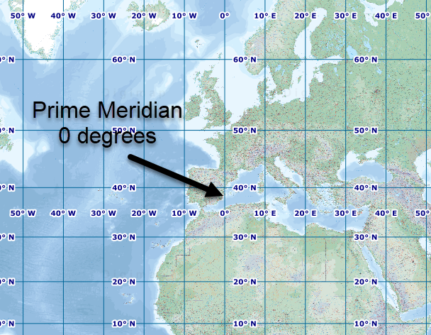
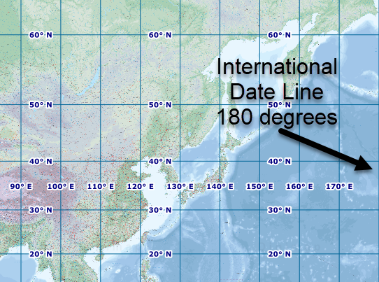

- Point out the numbers in degrees … north and south (longitude) and east and west (latitude) and the intervals between them.
- Select Map Information from the sidebar and explain what the latitude and longitude reading implies.

Identify latitude and longitude
- Demonstrate how you can find out the latitude and longitude reference of a place or feature using Digimap for Schools. There are 2 options:

Option 1: Use the grid lines:
  - First navigate to your place or feature. Click or touch and drag to move the map in any direction, as well as zooming in or out with the plus and minus signs.
  - Use the grid lines to identify the lines a location sits at. For example, Vancouver is 49 degrees North, 123 degrees West.
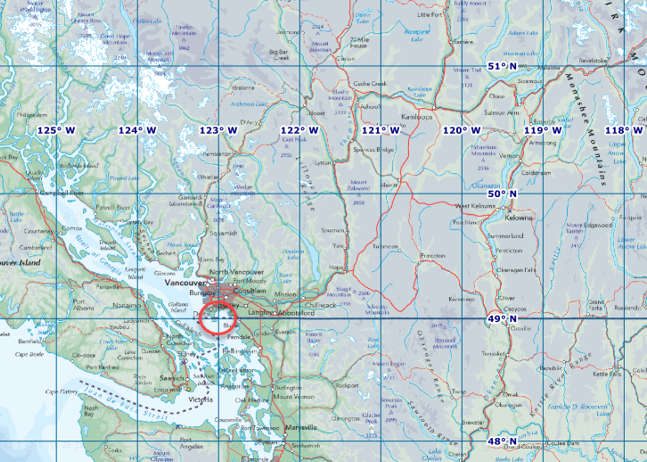

Option 2: Coordinate Capture tool:
  - Open Map Information from the sidebar.
  - Switch on the Coordinate Capture button.
  - Select the place on the map you want to capture.
  - Coordinates are displayed in the menu on the left.
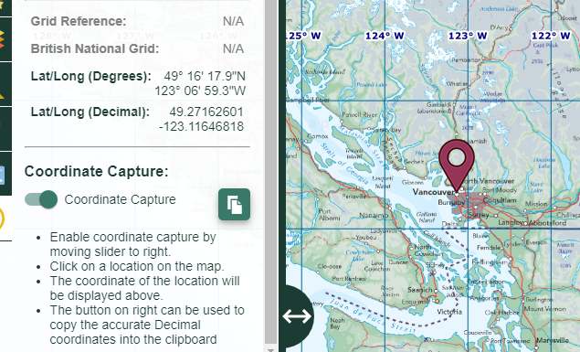

Main activity: Grid line challenge

Ask pupils to log in to Digimap for Schools and customise their map to display an Atlas style map, the Latitude and Longitude grid, the Major Lines of Latitude and the map key – steps are outlined below.

Login
- Go to: https://digimapforschools.edina.ac.uk.
- Select Login in the top right corner.
- Enter username and password. The username and password are provided by Digimap for Schools when you subscribe. Everyone in your school can use the same login details.

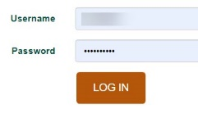

- At Atlas style map is displayed by default but do check to make sure the pupils are viewing the Atlas map – see image below.
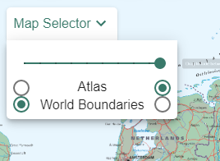

Turn on latitude and longitude lines
- Select Overlays from the sidebar at the left.
- Check two of the boxes:
  - Major lines of latitude;
  - Latitude and longitude.
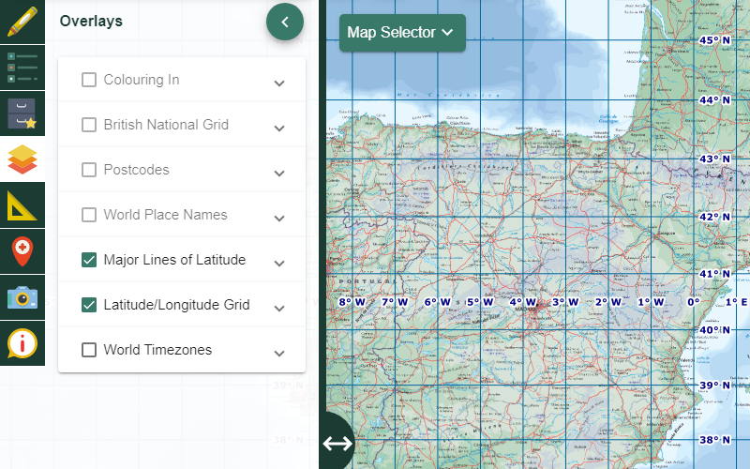

Turn on map key
- Select Key from the sidebar at the left, so that key physical and human features are visible.

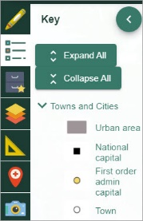

Grid line challenge

- Provide pupils with twelve places or features and ask them to write down the latitude and longitude reference/reading for each one. The next two pages could be printed and provide images and suggestions.
- IMPORTANT: Ask pupils to try to move the map to get to the places rather than use the search facility. If they search for a city, they could end up at a scale where they latitude/longitude grid is not displayed.
- Afterwards, ask individuals to provide you with an answer for the given places or features, each time challenging them to explain what the latitude and longitude reference tells them about its location, e.g. north or south of the Equator/in the Northern Hemisphere or Southern Hemisphere; east or west of the Prime Meridian/you could also relate to time zones … either behind or in front of GMT/United Kingdom.

Worksheet: Grid line challenge

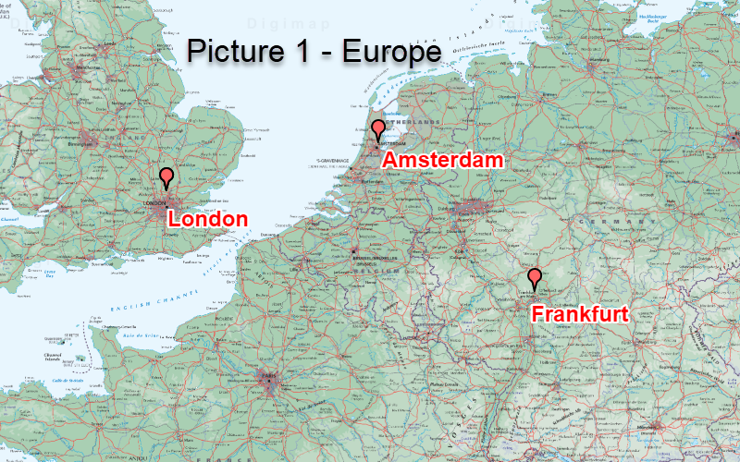
Picture 1 | Line of latitude | Line of longitude
London, England
Amsterdam, Holland
Frankfurt, Germany

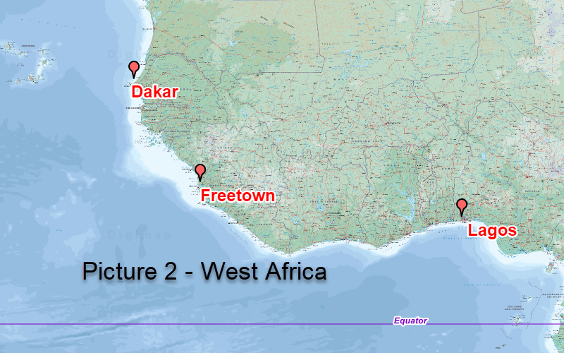

Picture 2 | Line of latitude | Line of longitude
Lagos, Nigeria
Freetown, Sierra Leone
Dakar, Senegal

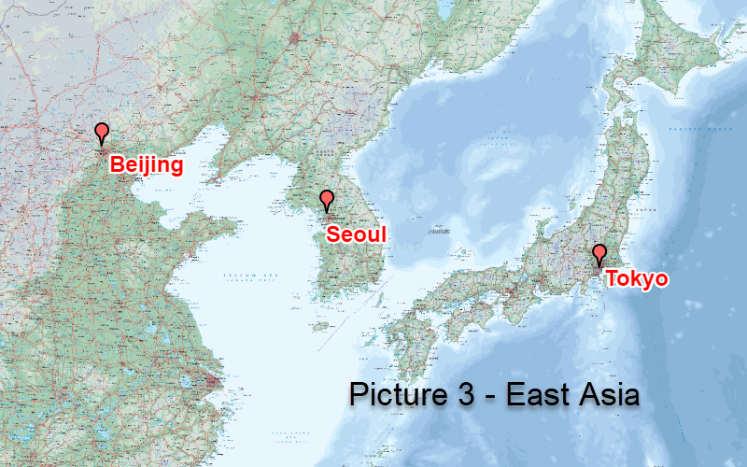
Picture 3 | Line of Latitude | Line of longitude
Beijing, China
Tokyo, Japan
Seoul, South Korea

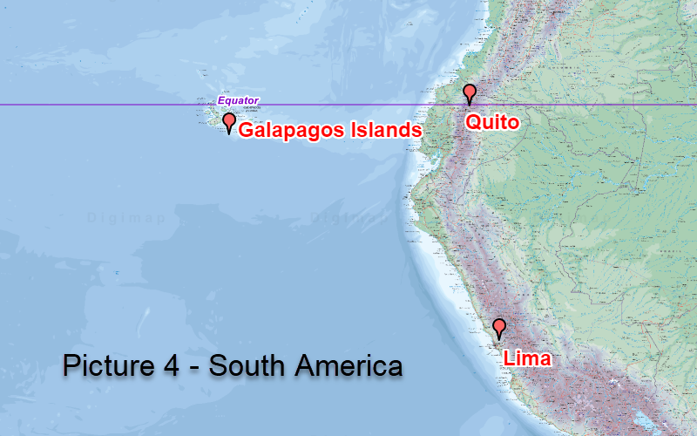

Picture 4 | Line of latitude | Line of longitude
Galapagos Islands
Quito, Ecuador
Lima, Peru

Finish activity: GPS uses and accuracy

GPS research
- Explain what GPS is – the following websites may be helpful:
  - https://spaceplace.nasa.gov/gps/en/;
  - https://www.gps.gov/systems/gps/.

- Afterwards, toggle between the different map types available in Great Britain, e.g. Ordnance Survey, Aerial and Aerial X, to highlight one of the uses of GPS. You can select different maps with the Map Selector tool on the map window:
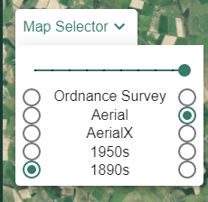
- Discuss how different organisations use co-ordinates generated from latitude and longitude in global positioning systems (GPS) to learn about the behaviour of wildlife, e.g. tracing the seasonal migration of birds; to ensure aeroplanes and ships are on course; to locate gritter lorries during the winter months of the year.
- Start a list of GPS uses in class and encourage pupils to conduct further research and add to it as they uncover more uses of GPS.
- Invite pupils to share their research findings with the rest of the class.
- Ask pupils: How accurate do you consider GPS to be?

Taking it further

Geography

Get pupils to work in pairs to find out about the origin of latitude and longitude:
- Why and how have the lines been used over the centuries and by whom?
You may wish to steer them towards the following websites:
- https://www.bbc.co.uk/bitesize/topics/zvsfr82/articles/zd4rmfr;
- http://www.primaryhomeworkhelp.co.uk/time/latitude.html;
- https://school.eb.co.uk/levels/foundation/article/latitude-and-longitude/440861.

Acknowledgements

Geographical Association

With thanks to the Geographical Association for allowing us to use excerpts from The Everyday Guide to Primary Geography: Locational Knowledge, by Simon Catling.

Map images
- © CollinsBartholomew Ltd (2019) FOR SCHOOLS USE ONLY.
- © Crown copyright and database rights 2020 Ordnance Survey (100025252). FOR SCHOOLS USE ONLY.
- Aerial photography © Getmapping plc. Contains OS data. FOR SCHOOLS USE ONLY.
- Historic mapping courtesy of the National Library of Scotland. FOR SCHOOLS USE ONLY.

Icons
- Black and white icons - location, directional sign, mountain ranges, compass, geography by Made x Made from the Noun Project.

Copyright

This work is licensed under a Creative Commons Attribution-NonCommercial-ShareAlike Licence

Note that Ordnance Survey, Aerial and historical maps are not available for display in Northern Ireland.

