My country, my place
  - Resource number 8

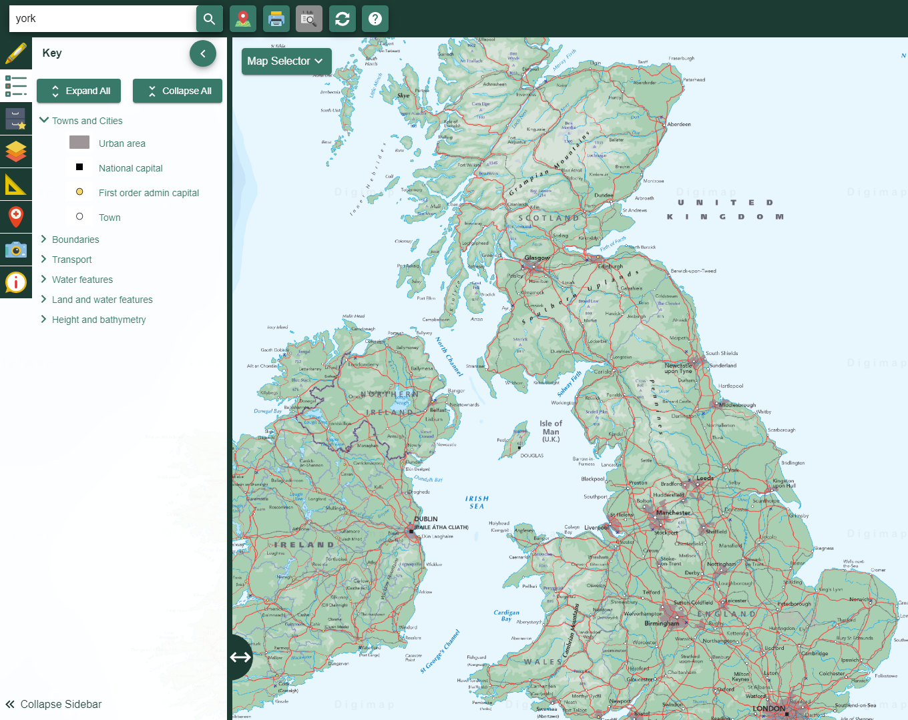

  - Emma Espley and Simon Catling
  - KS1

Table of Contents

Table of Contents 2
Introduction 3
Teaching and learning activities 6
Starter Activity: Towns and cities 7
Main activity: Directions challenges 10
Challenge 1: As the crow flies! 11
Challenge 2: The big search 11
Finish activity: Create a challenge 12
Taking it further 12
Acknowledgements 14
Copyright 14

Introduction
This resource aims to develop pupils’ locational knowledge. By accessing and using Digimap for Schools, it is hoped that pupils will learn about the different aspects of a country.
What’s the theme?  What is my country like? | What are we exploring?  Pupils’ locational knowledge of their country is based on what they have read or heard about in the media, discussions with members of their family and travel.  Their national mental maps are very much dependent on their personal experiences; they may include the capital and other cities, resorts and features or simply focus on places close to where they live.  Studying their country should include looking at rural and urban areas, coastlines, seas and ports, so that they can truly appreciate the diversity of landscapes within the United Kingdom.  It is important to emphasise the connections between different parts of their country and other countries.  They need to know what is where as well, so that they can point out examples from their own country.
What’s the learning objective?  To learn about the different aspects of a country. | What will pupils know, understand and be able to do after completing this?  All pupils will…  - be able to explain the difference between a town and a city.  - be able to list five examples of towns and cities that they have either visited or heard of and which are found within the United Kingdom.  - be able to name the capital city (e.g. London) and locate it on a map of the United Kingdom.  - be able to ‘travel as the crow flies’, e.g. in a straight line, from one place to another.  - be able to use the search facility to locate particular towns or cities and head north, east, south or west from each one.

Most pupils will, in addition…
- be able to list at least eight examples of towns and cities that they have either visited or heard of and which are found within the United Kingdom.
- be able to explain that towns and cities differ in size.

Some pupils will, in addition…
- be able to list at least ten examples of towns and cities that they have either visited or heard of and which are found within the United Kingdom.
- be able to explain that towns and cities differ in size and how the key or size of their name can be used to help them understand which settlements are larger or smaller than others.
- be able to explain what makes a capital city so significant.
- be able to classify features seen in the landscape, e.g. physical (natural) or human (made by people).
NC Programme of Study for Geography (England) | - Pupils should extend their knowledge and understanding beyond the local area to include the United Kingdom and Europe, North and South America. This will include the location and characteristics of a range of the world’s most significant human and physical features. They should develop their use of geographical knowledge, understanding and skills to enhance their locational and place knowledge.
The World Around us (Northern Ireland) | - [The curriculum implies that pupils will build their knowledge of places, their location and characteristics, at different scales, locally, nationally and around the world, and that they will develop their skills and knowledge through using large scale maps, globes, world maps and atlases. This will occur through studies that meet the curriculum requirements.]
Curriculum for Excellence (Scotland) | Social Studies:  - 2-14a - To extend my mental map and sense of place, I can interpret information from different types of maps and am beginning to locate key features within Scotland, United Kingdom, Europe or the wider world.
Curriculum for Wales | Humanities:  - I can recognise the distinct physical features of places, environments and landscapes in my locality and in Wales, as well as in the wider world.

How might I assess learning?
- Can pupils explain the difference between a town and a city?
- Can pupils list examples of towns and cities that they have either visited or heard of and which are found within the United Kingdom?
- Can pupils use the search facility within Digimap for Schools to help them locate these towns and cities on a map of the United Kingdom?
- Can pupils explain that towns and cities differ in size and how the key or size of their name can be used to help them understand which settlements are larger or smaller than others?
- Can pupils name the capital city (e.g. London) and locate it on a map of the United Kingdom?
- Can pupils explain what makes a capital city so significant?
- Can pupils ‘travel as the crow flies’, e.g. in a straight line, from one place to another and identify cities passed through en route?
- Can pupils use the search facility to locate particular towns or cities and identify features that you might see if you headed north, east, south or west?
- Can pupils classify features seen in the landscape, e.g. physical (natural) or human (made by people)?

What could we do next?
- See the Taking it Further section, below.

Which key words are relevant here?
atlas; world; continent; Europe; United Kingdom; British Isles; England; Northern Ireland; Scotland; Wales; Republic of Ireland; country; country map; direction; north; east; south; west; mountains; rivers; coast; islands; land; sea; ports; region; towns; main cities; capital city; London; physical (natural) and human (made by people) features; landmarks; landscape; diversity.

Teaching and learning activities
 | Activity | What’s involved? | What do I need?
To start | Towns and cities | - Pupils discuss the difference between towns and cities.  - Identify major towns and cities within the United Kingdom on a map.  - Learn how to use the search facility in Digimap for Schools. | - Digimap for Schools login details.  - A large screen.  - White board and pens.  - What’s in a name? handout (provided courtesy of the Geographical Association).
Main activity | Directions Challenges | - Pupils travel ‘as the crow flies’ between two locations and identify towns and cities seen en route.  - Pupils search for a town or city and identify features, towns and cities seen to the north, east, south or west of that location/point. | - Digimap for Schools login details.  - Access to 1 tablet or PC for every 2 pupils.  - Printed ‘challenge’ worksheets.
To finish | Create a challenge | - Pupils create and share similar challenges. | - Digimap for Schools login details.  - Access to 1 tablet or PC for every 2 pupils.

Acknowledgements:
The Everyday Guide to Primary Geography: Locational Knowledge by Simon Catling, p. 28-29.

Starter Activity: Towns and cities

- Log in to Digimap for Schools and project it on a large screen.
- A map centred on the United Kingdom is displayed when you first login.
- Zoom in once or twice, focusing on your area, to show the main towns and cities. Your screen should look similar to the image below.
- Ask pupils: “What is the difference between a town and a city?”.
- Ask pupils: “Which towns and cities have you heard of or visited and why?”.
- Record their responses on the white board.
- Discuss the responses in conjunction with the ‘What’s in a name?’ handout.

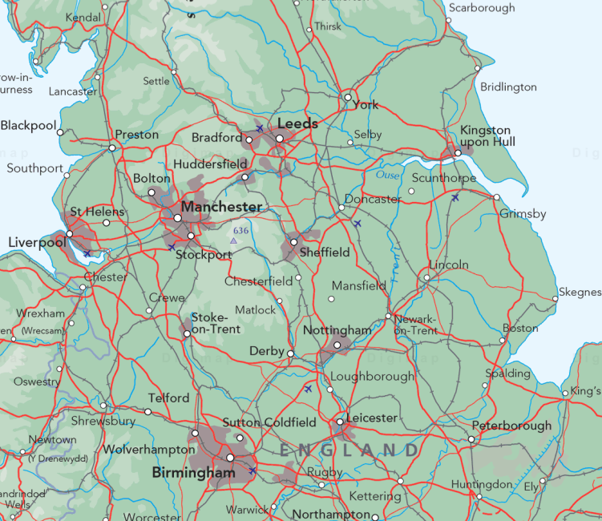

Finding towns and cities
- Next, invite pupils to locate these towns and cities on the large screen.
- If they do not know where a town or city is located, then demonstrate how they could use the search box in the top left of the screen to help them pinpoint where it is.
  - Explain there are two results lists (UK and World) and that they need to select the right result.
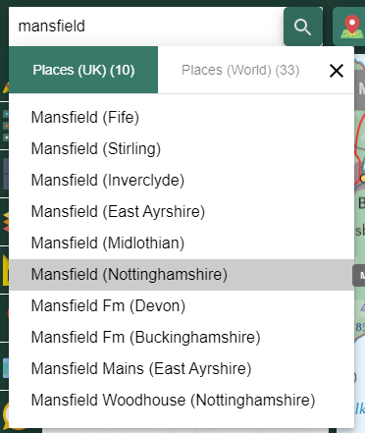

Capital cities
- Explain that towns and cities vary greatly in size. Point out how different size towns and cities are shown on the map/in the key, including the capital city.
- Refer to the ‘What’s in a name?’ handout to discuss why London is the capital of the United Kingdom.
- Name and find the capitals of Northern Ireland, Wales and Scotland.
- Identify London on the map.
- Ask pupils: “What is significant about a country’s capital city?”
  - Emphasise that it is usually where Parliament, the President/reigning Monarch’s palace and other important government buildings are located.
  - Zoom in on London or your regional capital and try to identify some landmarks.

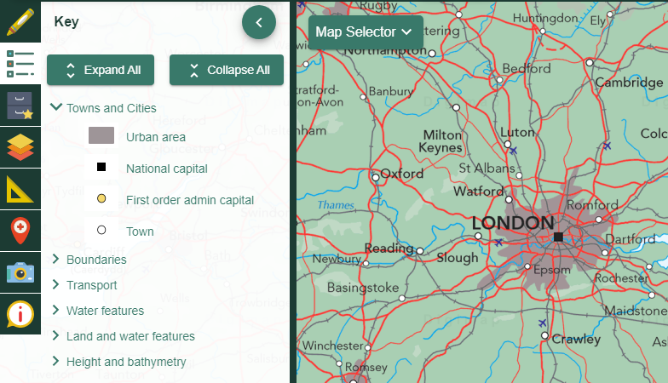

Map selection
At this point, you could also demonstrate how it is possible to toggle between maps, e.g. from Ordnance Survey to Aerial and Aerial X, in order to help identify features within the landscape.
- Open the Map Selector on the map window.
- Select the button to the right of any map name, to display that map.
- In the image below, we are displaying an Aerial map of London.
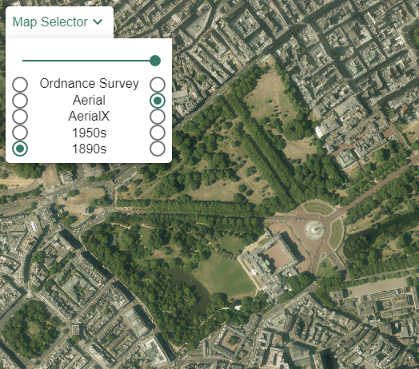

Main activity: Directions challenges

Login

Ask pupils to log in to Digimap for Schools.
- Go to: https://digimapforschools.edina.ac.uk.
- Select Login in the top right corner.
- Enter username and password. The username and password are provided by Digimap for Schools when you subscribe. Everyone in your school can use the same login details.

Challenge 1: As the crow flies

Explain that pupils will be working in pairs and ‘travelling as the crow flies’, e.g. in a straight line, from one place to another for this activity.
- Make sure the pupils are viewing Ordnance Survey maps, at a scale that shows major towns and cities.
- Set the class different challenges, e.g. ‘If I was travelling from London to Cardiff, which cities might I pass through?’ (Reading and Bristol). A table of suggestions can be found below.

Challenge 2: The big search
- Next, ask pupils to use the search box to locate particular towns or cities.
- Challenge them to tell you what well-known features, towns and cities they would see if they headed north, east, south or west. A table of suggestions is below.
- Select Key from the sidebar at the left, so that key physical and human features are visible.

Challenge 1: As the crow flies!
Travel in a straight line. What towns and cities do you pass through on the way?
Your route | Towns and cities passed through
Travel from London to Cardiff | Reading and Bristol
Travel from Birmingham to Norwich
Travel from Exeter to London
Travel from Stoke on Trent to Belfast
Travel from Edinburgh to Aberdeen
Travel from Newcastle-upon-Tyne to Leeds
Travel from Glasgow to London

Challenge 2: The big search
Search for the place. Then move north; east; south; west. Write down any well-known features, towns and cities you find in each direction.
Find the place | North | East | South | West
York
Exeter
Swansea
Londonderry
Stirling
Keswick

Finish activity: Create a challenge

- Invite pupils to set similar challenges to the above for the rest of the class.
- Ask pupils: “If you could visit one town or city in the United Kingdom, which would you choose and why?”.

Taking it further

Geography

Pictorial maps
Gather a variety of newspapers, magazines, holiday/tourist brochures, city guides, postcards, etc. and cut out images of physical (natural) and human (made by people) features within the United Kingdom/British Isles. Add sticky labels to each one (including its name, what it is and where it is found, e.g. county, region and country). You could colour-code the sticky labels too; one colour for physical (natural) features and another colour for human (made by people) features. Ask pupils to try and locate each image on a large map of the United Kingdom/British Isles pinned to the classroom wall. When pupils have identified its correct location, attach the image to the map with string and a drawing pin/blu-tak.

A playground national map
Working with the class and using atlases, chalk a large outline map of your country on the school playground. Get pupils to choose a specific place or feature and add a label. Then, ask them to make journeys (using toy vehicles, planes and ships) between the chosen places, perhaps marking in motorways, shipping and air routes? Alternatively, with permission, paint the map on a suitable wall outdoors and invite pupils to mark places on it using labels or chalk. Take a photo of the marked map and use it in the classroom.

Geography/English

Living on an island
Discuss and identify islands or island groups that are either part of a country (e.g. the Orkney Isles) or self-governing countries in their own right (e.g. the Isle of Man). Provide examples of storybooks or myths based on islands.
Examples can be found by accessing the websites below:
- Guardian island-based storybooks: www.theguardian.com/childrens-books-site/2015/sep/13/top-10-islands-in-childrens-fiction

- Booktrust island storybooks: www.booktrust.org.uk/news-and-features/features/2018/august/5-best-childrens-books-set-on-islands-chosen-by-cat-doyle/

- Scottish Island-based myths: www.scotsman.com/lifestyle-2-15039/six-ancient-myths-from-the-scottish-islands-1-4171756

Provide appropriate storybooks and/or island-based myths.
Invite pupils to write a story based on a real island. They should refer to real places/features on the island and include a map to show where it is.

Acknowledgements

Geographical Association

With thanks to the Geographical Association for allowing us to use excerpts from The Everyday Guide to Primary Geography: Locational Knowledge, by Simon Catling.

Map images
- © CollinsBartholomew Ltd (2019) FOR SCHOOLS USE ONLY.
- © Crown copyright and database rights 2020 Ordnance Survey (100025252). FOR SCHOOLS USE ONLY.
- Aerial photography © Getmapping plc. Contains OS data. FOR SCHOOLS USE ONLY.
- Historic mapping courtesy of the National Library of Scotland. FOR SCHOOLS USE ONLY.

Icons
- Black and white icons - location, directional sign, mountain ranges, compass, geography by Made x Made from the Noun Project.

Copyright
©EDINA at the University of Edinburgh 2020.
This work is licensed under a Creative Commons Attribution-NonCommercial-ShareAlike Licence

