Exploring time zones
  - Resource number 9

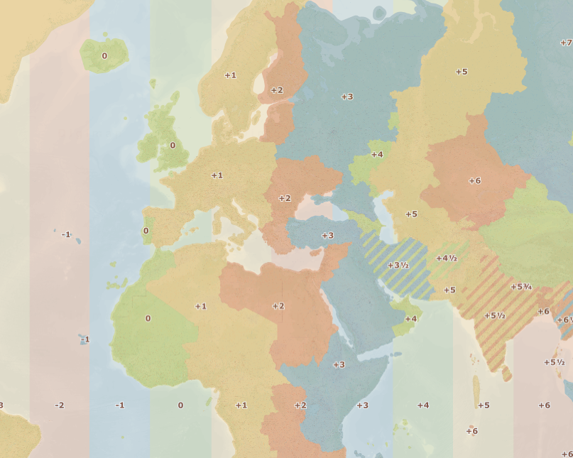

  - Emma Espley and Simon Catling
  - KS2

Table of Contents

Table of Contents 2
Introduction 3
Teaching and learning activities 6
Starter Activity: Time zones 7
Main activity: Time travellers 9
Finish activity: Webcam watch 12
Taking it further 12
Acknowledgements 15
Copyright 15

Introduction
This resource aims to develop pupils’ locational knowledge. By accessing and using Digimap for Schools, it is hoped that pupils will learn more about the Earth’s rotation and time zones.
What’s the theme?  How many different time zones are there throughout the world? | What are we exploring?  - Time zones.  - The Earth’s rotation has helped scientists devise a method for delineating time zones using lines of longitude.
What’s the learning objective?  To understand that there are different time zones throughout the world. | What will pupils know, understand and be able to do after completing this?  All pupils will…  - be able to explain how the world is divided into different time zones.  - be able to identify key lines of longitude, e.g. Prime Meridian (0⁰) and the International Date Line (IDL) (180⁰).  - be able to use Digimap for Schools to investigate time zones and record answers to some of the questions on the sheet provided.  - be able to mark on the flight path from their selected airport in the United Kingdom to another destination within the world and add an annotation to indicate how long the flight takes and through how many different time zones it passes.  - be able to locate the city shown in the webcam on a world map.  - be able to compare the time in the city shown in the webcam with the current time in the United Kingdom and calculate the difference.

Most pupils will, in addition…
- be able to mark on the flight paths from their selected airport in the United Kingdom to two or more destinations within the world and add annotations to indicate how long each flight takes and through how many different time zones it passes.
- be able to locate the cities shown in various webcams on a world map.

Some pupils will, in addition…
- be able to outline some of the advantages and disadvantages of having different time zones.
- be able to use Digimap for Schools to investigate time zones and record answers to all of the questions on the sheet provided.
- be able to mark on the flight paths from their selected airport in the United Kingdom to four destinations within the world and add annotations to indicate how long each flight takes and through how many different time zones it passes.
- be able to relate to others living in different places within the world and provide realistic suggestions as to what they might be doing at a certain time.
NC Programme of Study for Geography (England) | - Pupils should extend their knowledge and understanding beyond the local area to include the United Kingdom and Europe, North and South America. This will include the location and characteristics of a range of the world’s most significant human and physical features. They should develop their use of geographical knowledge, understanding and skills to enhance their locational and place knowledge.
The World Around us (Northern Ireland) | - [The curriculum implies that pupils will build their knowledge of places, their location and characteristics, at different scales, locally, nationally and around the world, and that they will develop their skills and knowledge through using large scale maps, globes, world maps and atlases. This will occur through studies that meet the curriculum requirements.]
Curriculum for Excellence (Scotland) | Social Studies:  - 2-14a - To extend my mental map and sense of place, I can interpret information from different types of maps and am beginning to locate key features within Scotland, United Kingdom, Europe or the wider world.
Curriculum for Wales | Humanities:  - I can recognise the distinct physical features of places, environments and landscapes in my locality and in Wales, as well as in the wider world.

How might I assess learning?
- Can pupils explain how the world is divided into different time zones?
- Are pupils able to identify key lines of longitude, e.g. Prime Meridian (0⁰) and the International Date Line (IDL) (180⁰)?
- Can pupils outline some of the advantages and disadvantages to having different time zones throughout the world?
- Answers to questions on the ‘Investigating time zones recording sheet’.
- Can pupils mark on the flight path/s from their selected airport in the United Kingdom to one or more destinations within the world and add an annotation/s to indicate how long each flight takes and through how many different time zones it passes?
- Can pupils locate the city/cities of the webcam/s on a world map?
- Are pupils able to compare the time in … with the current time in the United Kingdom and calculate the difference?
- Are pupils able to relate to others living in different places within the world and provide realistic suggestions as to what they might be doing at a certain time?

What could we do next?
- See the Taking it Further section, below.

Which key words are relevant here?
atlas; world; world map; globe; latitude; longitude; vertical; International Date Line (IDL); Greenwich Mean Time (GMT); Prime Meridian; time zones; Earth; rotation; day; night; light; dark; season; time; clock; watch; hours; north; east; south; west; Northern Hemisphere; Southern Hemisphere.

Teaching and learning activities
 | Activity | What’s involved? | What do I need?
To start | Time zones | - Use a globe and the time zones overlay in Digimap for Schools to explain time zones. | - Globe.  - Torch.  - Digimap for Schools login details.
Main activity | Time travellers | - Pupils use Digimap for Schools to record answers to questions relating to time zones, e.g. select a time zone, find the cities within it and their countries.  - Pupils select an airport within the United Kingdom and an overseas destination, then track the flight path and note any time zone changes. | - Printed copies of ‘Investigating time zones recording sheet’, provided courtesy of the Geographical Association.  - Digimap for Schools login details.  - Access to 1 tablet or PC for every 2 pupils.  - Internet access.
To finish | Webcam watch | - Access a webcam in a city on the opposite side of the world.  - Pupils locate the city on a world map and compare the time there with the time in the United Kingdom. | - Digimap for Schools login details.  - Internet to access various webcams.
Acknowledgements:
The Everyday Guide to Primary Geography: Locational Knowledge by Simon Catling, p. 30-31.

Starter Activity: Time zones

- Firstly, spin a globe. Explain that the Earth takes 24 hours or one day to rotate 360⁰ and one hour to rotate 15⁰. Knowing this has helped scientists divide the world into different time zones, which are generally 15⁰ of longitude apart.
- Log in to Digimap for Schools.
- Zoom out as far as you can, using the Zoom to maximum extent button (under the scale bar). See image below.
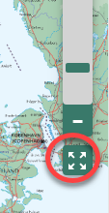
- Open the Overlays menu.
  - Check the boxes next to World Time zones and Latitude/Longitude Grid.
- Open the Map Selector (on the map window).
  - Select the button to the right of World Boundaries.
- Your screen should look similar to the image below.
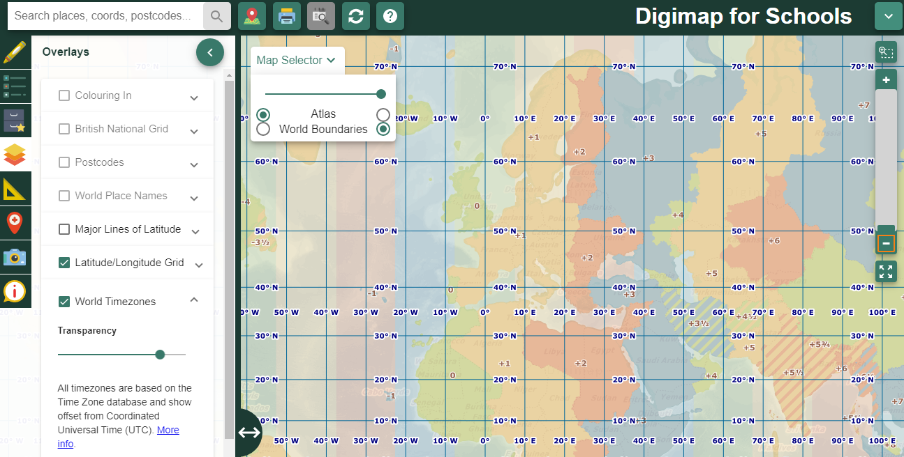
- Point out that moving west 15⁰ usually means going back one hour, while moving east 15⁰ implies going forward one hour.
- If you travel north or south within a time zone, then the time generally stays the same.
- Explain that not all time zones align neatly with lines of longitude, however; e.g. China has one time zone across the whole country, whereas Russia has several time zones.
- Next, shine a torch on the globe. Explain that when it is midday at the Prime Meridian/0⁰ longitude (which passes through Greenwich in London, United Kingdom, hence also Greenwich Mean Time [GMT]), it is dark on the other side of the world. This is at 180⁰ longitude, also known as the International Date Line (IDL), which is an imaginary line where the date changes. Point out that the IDL is not straight; this is so that island countries within the Pacific Ocean can use the same date.
- Ask pupils: “Is it helpful to have different time zones?”.

Main activity: Time travellers

Ask pupils to log in to Digimap for Schools.
- Go to: https://digimapforschools.edina.ac.uk.
- Select Login in the top right corner.
- Enter username and password. The username and password are provided by Digimap for Schools when you subscribe. Everyone in your school can use the same login details.

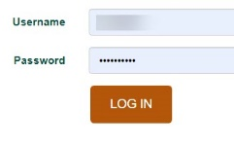

Pupils will need to customise their screen so that they are viewing a map with world boundaries, time zones and lines of latitude and longitude shown.
- Open the Overlays menu.
  - Check the boxes next to Time zones and Latitude/Longitude Grid.
- Open the Map Selector (on the map window).
  - Select the button to the right of World Boundaries.

Investigating time zones
- Explain to pupils that they are going to be ‘time travellers’.
- Ask pupils to use Digimap for Schools to help them answer the various questions on the ‘Investigating time zones recording sheet’ (provided as a separate handout).

Flight paths
- Next, get pupils to work in pairs.
- Explain that they should make use of the Internet to help them select an airport in the United Kingdom and a destination that is either to the north, east, south and west.
- They should track the flight path, noting any time zone changes.
  - The following website might be useful – pupils can see flights that are currently in the air: https://www.flightradar24.com/.

- Using Digimap for Schools, they should mark the flight path on a world map and add an annotation to indicate how long the flight takes and through how many different time zones it passes (an example of this can be seen in the image below).
- Repeat the above for other destinations, e.g. if pupils travelled in a northerly direction to begin with, ask them to explore destinations to the east, south and west.

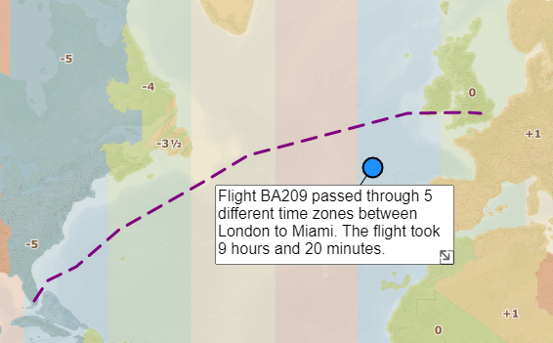

Adding drawings
- Open the Drawing Tools.
  - Select the line tool, which is highlighted in the image below.
  - Select the colour and style of line required.
  - Click or tap on the map to draw the first point of the line. Keep clicking or tapping at each point and double click or tap to finish the line.

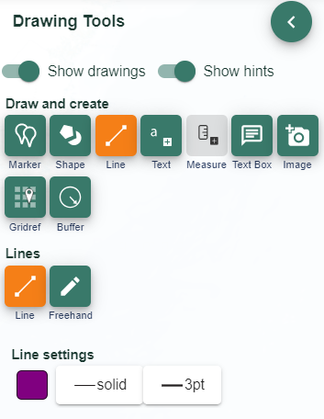

Finish activity: Webcam watch

- Log in to Digimap for Schools.
- Project a map with world boundaries – select World Boundaries from the Map Selector.
- Access the Internet and show a webcam in a city on the opposite side of the world.
  - This website allows you to select webcams from different countries: https://www.skylinewebcams.com/.
- Invite pupils to locate the city on a world map projected on the large screen.
- Webcams often display the time. Ask pupils: “Compare the time in … with the current time in the United Kingdom. What is the difference?”.
- Ask pupils: “What do you think people might be doing in …?”.
- Repeat this activity for other cities throughout the world.

Taking it further

Geography

Travels with my family
- Ask pupils who have travelled to other countries whether their destination time was ahead of or behind when they set off. What was the time difference?
- How many time zones did they cross?
- Locate the place they visited on a world map or globe.
- How did they and their family adjust to being in a different time zone?
- How did the change in time affect them going out and returning home?
- If they crossed the International Date Line, in which direction were they flying?
- Did they gain or lose a day?

The time along the way
- Ask some pupils to plan a journey travelling west from the United Kingdom and others to plan a journey going east.
- Stipulate that they must all reach the International Date Line at 180⁰ of longitude.
- They must choose several locations along the way too, and, when they stop off at each one, they should write a postcard home.

On each postcard, they must include:
- the time;
- how many time zones they have passed through.
Afterwards, they could use the Internet to select and attach an image or draw an appropriate picture for the front of their postcard. You will find a template postcard below.

Sample postcard

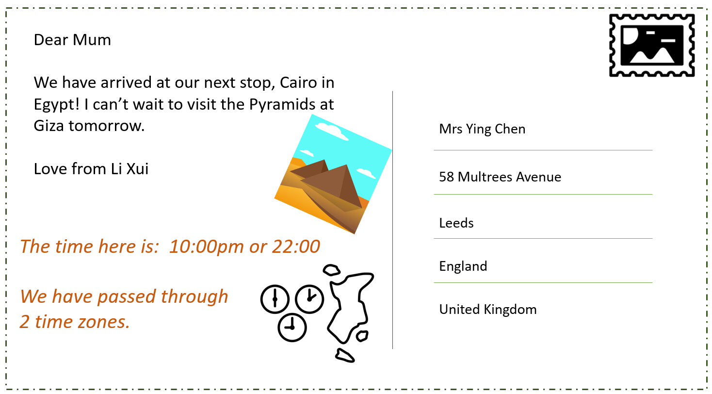

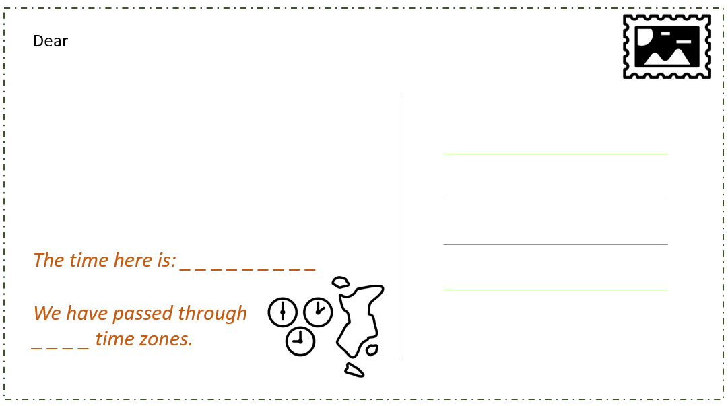

Acknowledgements

Geographical Association

With thanks to the Geographical Association for allowing us to use excerpts from The Everyday Guide to Primary Geography: Locational Knowledge, by Simon Catling.

Map images
- © CollinsBartholomew Ltd (2019) FOR SCHOOLS USE ONLY.
- © Crown copyright and database rights 2020 Ordnance Survey (100025252). FOR SCHOOLS USE ONLY.
- Aerial photography © Getmapping plc. Contains OS data. FOR SCHOOLS USE ONLY.
- Historic mapping courtesy of the National Library of Scotland. FOR SCHOOLS USE ONLY.

Icons
- Black and white icons - location, directional sign, mountain ranges, compass, geography by Made x Made from the Noun Project.

Copyright
©EDINA at the University of Edinburgh 2020.
This work is licensed under a Creative Commons Attribution-NonCommercial-ShareAlike Licence

