Developing place knowledge
  - Resource number 11

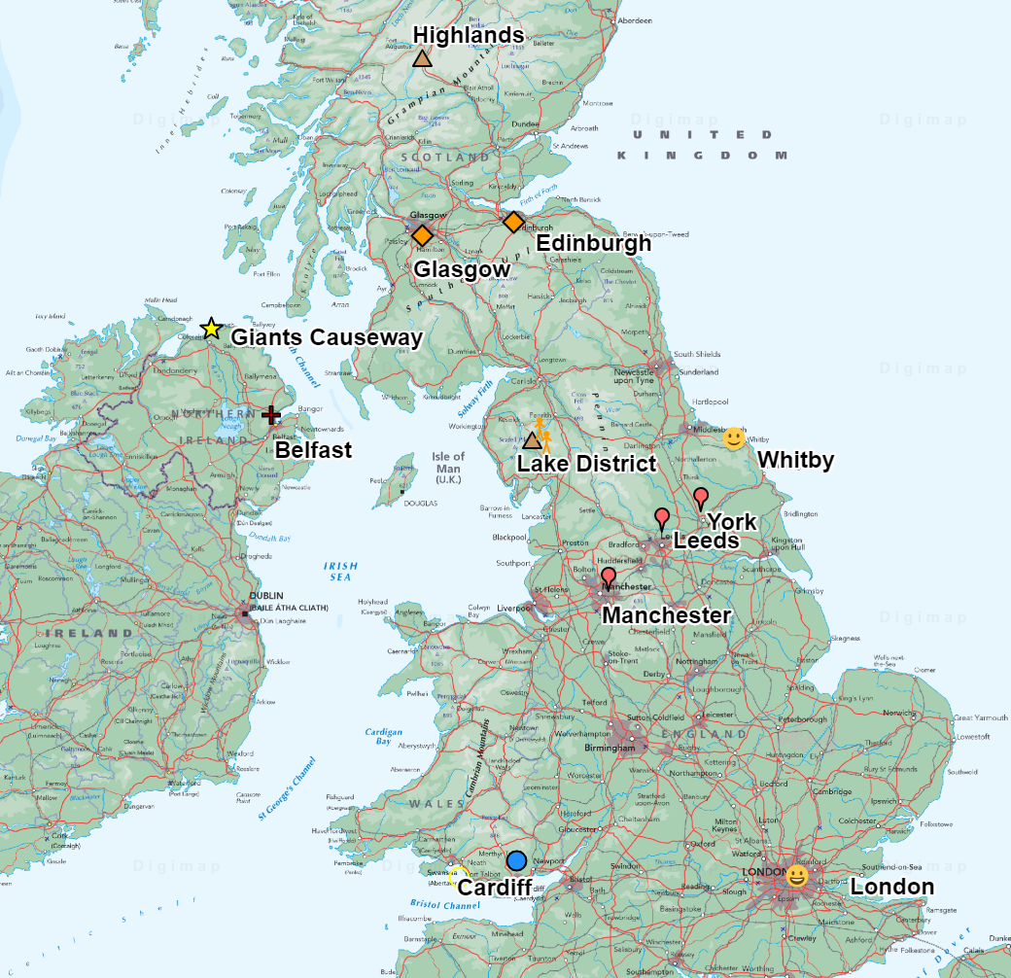

  - Emma Espley and Simon Catling
  - KS1

Table of Contents

Table of Contents 2
Introduction 3
Teaching and learning activities 6
Starter Activity: Places we know 7
Main activity: Our map of places 8
Finish activity: Best and least-known places 11
Taking it further 11
Acknowledgements 12
Copyright 12

Introduction
This resource aims to develop pupils’ locational knowledge. By accessing and using Digimap for Schools, it is hoped that pupils will be able to justify the value of their local to global locational knowledge.
What’s the theme?  Which places or features should we know about? | What are we exploring?  - Should there be a shared world knowledge that is learnt so that there is a commonality in our local, national and global mental maps? Perhaps, this would help when we attempt to discuss features, places and events around the world?  - Here, we encourage pupils to think about the places and features that they know about locally. Are they significant to them? If so, in what ways? If not, then why not?  - Which places at the national and global scale have their parents/carers introduced to them and why?  - Is the locational knowledge that pupils share with each other determined by what they have studied in geography alone or within the wider curriculum?  - Which places should pupils know about nationally and globally?
What’s the learning objective?  To consider the places or features we should know about. | What will pupils know, understand and be able to do after completing this?  All pupils will…  - be able to identify three places or features that they know about within the United Kingdom.  - be able to locate their identified places or features on a map of the United Kingdom that is projected onto the large screen when invited to do so.  - be able to state how/why they know about a particular place or feature.  - be able to analyse the annotated map projected on the large screen and identify the most common places or features that were mentioned by individuals.  - be able to identify which parts of the country are least known about.  - be able to list three ‘must know’ places or features within the United Kingdom.

Most pupils will, in addition…
- be able to identify at least five places or features that they know about within the United Kingdom.
- be able to analyse the annotated map projected on the large screen and identify the most common places or features that were mentioned by individuals and give one or two reasons as to why this is.
- be able to list at least five ‘must know’ places or features within the United Kingdom.

Some pupils will, in addition…
- be able to identify more than ten places or features that they know about within the United Kingdom.
- be able to locate their and others’ identified places or features on a map of the United Kingdom that is projected onto the large screen when invited to do so.
- be able to produce their own annotated map of the United Kingdom to highlight the places and features that they know about and state how/why they know about each one.
- be able to analyse the annotated map projected on the large screen, or their own annotated map if they have completed one, and identify the most common places or features that were mentioned by individuals and give several reasons as to why this is.
- be able to list ten or more ‘must know’ places or features within the United Kingdom.
NC Programme of Study for Geography (England) | - Pupils should extend their knowledge and understanding beyond the local area to include the United Kingdom and Europe, North and South America. This will include the location and characteristics of a range of the world’s most significant human and physical features. They should develop their use of geographical knowledge, understanding and skills to enhance their locational and place knowledge.
The World Around us (Northern Ireland) | - [The curriculum implies that pupils will build their knowledge of places, their location and characteristics, at different scales, locally, nationally and around the world, and that they will develop their skills and knowledge through using large scale maps, globes, world maps and atlases. This will occur through studies that meet the curriculum requirements.]
Curriculum for Excellence (Scotland) | Social Studies:  - 2-14a - To extend my mental map and sense of place, I can interpret information from different types of maps and am beginning to locate key features within Scotland, United Kingdom, Europe or the wider world.
Curriculum for Wales | Humanities:  - I can recognise the distinct physical features of places, environments and landscapes in my locality and in Wales, as well as in the wider world.

How might I assess learning?
- Can pupils give examples of places or features that they know about within the United Kingdom?
- When invited to do so, can pupils locate the identified places or features on a map of the United Kingdom that is projected onto the large screen?
- Are pupils able to state how/why they know about a particular place or feature?
- Are pupils able to analyse the annotated map projected on the large screen, or their own annotated map if they have completed one, and identify the most common places or features that were mentioned by individuals and give reasons as to why this is?
- Can pupils identify which parts of the country are least known about?
- Can pupils list a number of ‘must know’ places within the United Kingdom?

What could we do next?
- See the Taking it Further section, below.

Which key words are relevant here?
atlas; world; globe; map; local; global; places; annotation; location; direction; continent; country; city; physical (natural) features; human (made by people) features.

Teaching and learning activities
 | Activity | What’s involved? | What do I need?
To start | Places we know | - Prompt pupils to tell you places they know about within the United Kingdom.  - Create a list on the whiteboard. | - White board and marker pens.
Main activity | Our map of places | - Project a map of the United Kingdom on the large screen.  - Annotate the map with markers and labels.  - Alternatively, pupils can create their own annotated map. | - Digimap for Schools login details.  - Access to 1 tablet or PC for every 2 pupils.
To finish | Best and least-known places | - Prompt pupils to consider the best and least known places and why.  - Create a list of ‘must know’ places. | - Digimap for Schools login details.

Acknowledgements: The Everyday Guide to Primary Geography: Locational Knowledge by Simon Catling, p. 34-35.

Starter Activity: Places we know

- Ask pupils: “Which places or features do you know about within the United Kingdom?”. You may need to give some prompts, e.g.:
  - within the local area;
  - where their favourite sports team is;
  - where they might go on days out;
  - where their extended family live;
  - where they have been on holiday;
  - somewhere else they have heard about.
- Make a list on the white board. Add an asterisk (*) next to the ones that are mentioned by several pupils.

Main activity: Our map of places

Pupil-led
If pupils are already familiar with Digimap for Schools, then you might suggest that they produce their own annotated map of the United Kingdom to highlight the places and features that they know about and how/why they know about them.

Teacher-led
- Go to: https://digimapforschools.edina.ac.uk.
- Select Login in the top right corner.
- Enter username and password. The username and password are provided by Digimap for Schools when you subscribe. Everyone in your school can use the same login details.

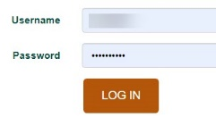

- When you first login, the map is centred on the United Kingdom and displays an Atlas map.
  - You can select the start again button (circled in the image below) to load the map of the United Kingdom.
- Invite pupils to locate the listed places or features on a map of the United Kingdom that is projected onto the large screen.
- You could add an annotation next to each place or feature with their name and how/why they know about it.
  - Open the Drawing Tools.
  - To add any marker, select the marker and then select the location on the map to place it.
  - The label tool is highlighted in the image below.
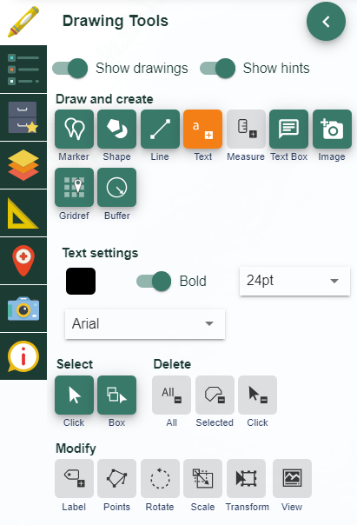
- Add the same marker to those that were mentioned by several pupils, e.g. those places or features that you added an asterisk (*) next to when constructing an initial list.
- Save the map within Digimap for Schools.
- An example of how your Digimap for Schools screen may look is shown in the image below:

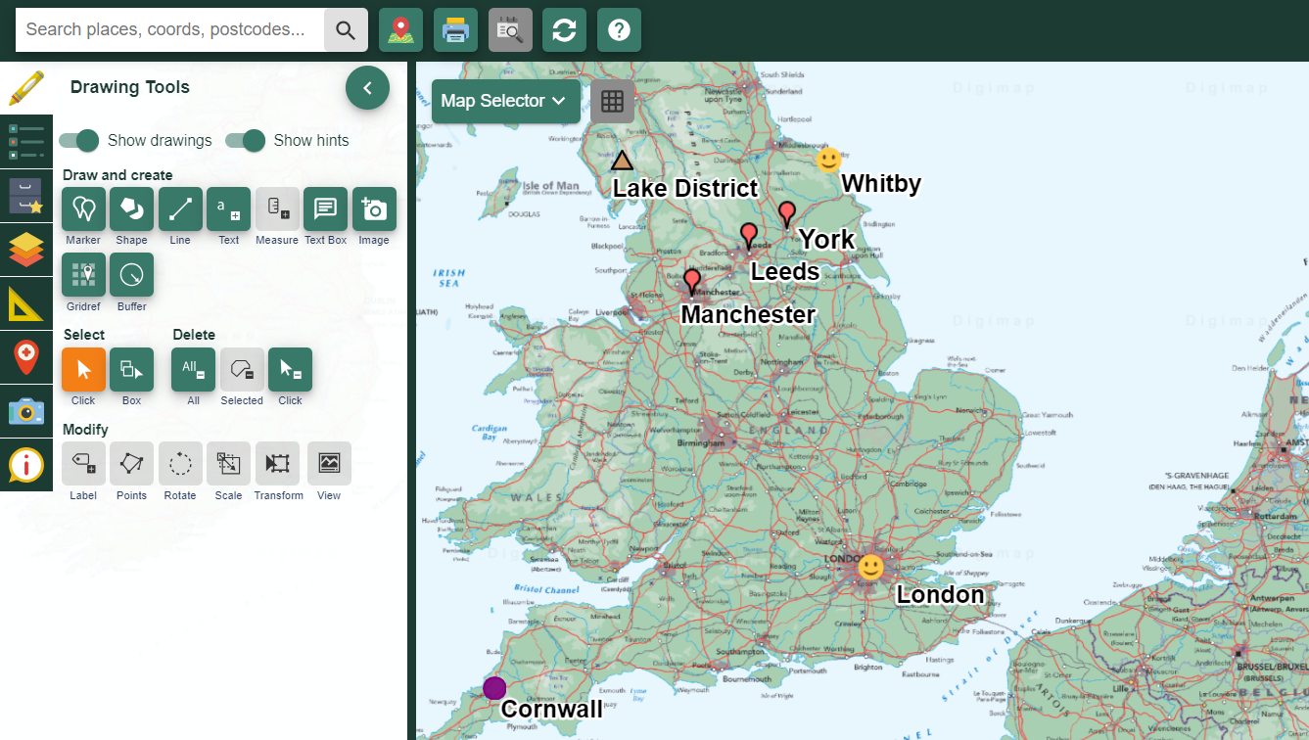

Finish activity: Best and least-known places

- Encourage pupils to analyse the annotated map projected on the large screen, or their own annotated map if they have completed one.
- Ask pupils:
  - What were the most common places or features that were mentioned by pupils?
  - Why do you think these places or features were mentioned by several pupils?
  - Which parts of the country do pupils know least about?
- As a class, make a list of the ‘must know’ places within the United Kingdom.

Taking it further

Geography

Travelling around a map
Provide a super-size foldable world map or use one painted on the playground. Have a globe and atlases available with toy aeroplanes, boats, lorries, coaches, ships, yachts, cars, etc. Mark and label places and invite pupils to travel from one place to another using an appropriate form of transport. They can study routes on the globe and work out where to go on the map (great circles are an interesting challenge). Encourage pupils to name the places they wish to visit, find out how to get there and show their route and modes of travel to a partner. (They must give compass directions and name places their route passes through).

Digitally where?
- Ask pupils to find out which places on other continents their family members have digital contacts with, e.g. use Facetime to keep in touch with a cousin in Edmonton, Canada. Create a digital contacts map together to visualise the distribution of family and friends across the world. As social media platforms are typically for age 13 upwards, remind pupils of the importance of staying safe online and not talking to people that they do not know.

- Alternatively, ask pupils which places they have heard about in the media and locate these on a world map.

Acknowledgements

Geographical Association
With thanks to the Geographical Association for allowing us to use excerpts from The Everyday Guide to Primary Geography: Locational Knowledge, by Simon Catling.

Map images
- © CollinsBartholomew Ltd (2019) FOR SCHOOLS USE ONLY.
- © Crown copyright and database rights 2020 Ordnance Survey (100025252). FOR SCHOOLS USE ONLY.
- Aerial photography © Getmapping plc. Contains OS data. FOR SCHOOLS USE ONLY.
- Historic mapping courtesy of the National Library of Scotland. FOR SCHOOLS USE ONLY.

Icons
- Black and white icons - location, directional sign, mountain ranges, compass, geography by Made x Made from the Noun Project.

Copyright
© EDINA at the University of Edinburgh, 2020.
This work is licensed under a Creative Commons Attribution-NonCommercial-ShareAlike Licence

