Developing place knowledge
  - Resource number 12

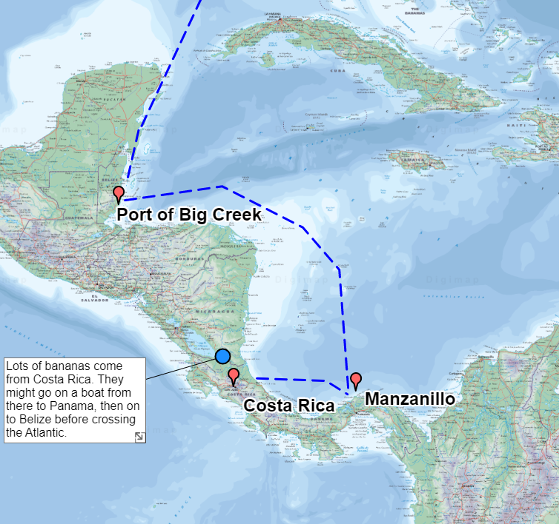

  - Emma Espley and Simon Catling
  - KS2

Table of Contents

Table of Contents 2
Introduction 3
Teaching and learning activities 6
Starter Activity: Interdependence 7
Main activity: Follow the recipe 8
Worksheet: My ingredient 9
Worksheet: Our top World places 13
Finish activity: Take a vote! 14
Taking it further 14
Acknowledgements 15
Copyright 15

Introduction
This resource aims to develop pupils’ locational knowledge. By accessing and using Digimap for Schools, it is hoped that pupils will be able to justify the value of their local to global locational knowledge.
What’s the theme?  Which places or features should we know about? | What are we exploring?  - Should there be a shared world knowledge that is learnt so that there is a commonality in our local, national and global mental maps? Perhaps, this would help when we attempt to discuss features, places and events around the world?  - Here, we encourage pupils to think about the places and features that they know about locally. Are they significant to them? If so, in what ways? If not, then why not?  - Which places at the national and global scale have their parents/carers introduced to them and why?  - Is the locational knowledge that pupils share with each other determined by what they have studied in geography alone or within the wider curriculum?  - Which places should pupils know about nationally and globally?
What’s the learning objective?  To consider the places or features we should know about. | What will pupils know, understand and be able to do after completing this?  All pupils will…  - be able to explain what the term ‘interdependence’ means.  - be able to give an example as to how people in the United Kingdom are interdependent on other country/countries around the world.  - be able to select one ingredient/product from a recipe and use the Internet to investigate several things about it.  - be able to draw the route that their chosen ingredient/product takes.  - be able to compile a list of features and places that all 11 year olds should be able to locate on a world map.

Most pupils will, in addition…
- be able to select one ingredient/product from a recipe and use the Internet to investigate many things about it.
- be able to draw the route that their chosen ingredient/product takes, adding at least three annotations at appropriate points to share the findings of their research.
- be able to compile a list of features and places that all 11 year olds should be able to locate on a world map and justify some of their choices.

Some pupils will, in addition…
- be able to give five examples as to how people in the United Kingdom are interdependent on other country/countries around the world.
- be able to select one ingredient/product from a recipe and use the Internet to investigate many things about it.
- be able to draw the route that their chosen ingredient/product takes, adding at least five annotations at appropriate points to share the findings of their research.
- be able to explain how food links our country with other parts of the world.
- be able to compile a list of features and places that all 11 year olds should be able to locate on a world map and justify their choices fully.
NC Programme of Study for Geography (England) | - Pupils should extend their knowledge and understanding beyond the local area to include the United Kingdom and Europe, North and South America. This will include the location and characteristics of a range of the world’s most significant human and physical features. They should develop their use of geographical knowledge, understanding and skills to enhance their locational and place knowledge.
The World Around us (Northern Ireland) | - [The curriculum implies that pupils will build their knowledge of places, their location and characteristics, at different scales, locally, nationally and around the world, and that they will develop their skills and knowledge through using large scale maps, globes, world maps and atlases. This will occur through studies that meet the curriculum requirements.]
Curriculum for Excellence (Scotland) | Social Studies:  - 2-14a - To extend my mental map and sense of place, I can interpret information from different types of maps and am beginning to locate key features within Scotland, United Kingdom, Europe or the wider world.
Curriculum for Wales | Humanities:  - I can recognise the distinct physical features of places, environments and landscapes in my locality and in Wales, as well as in the wider world.

How might I assess learning?
- Can pupils explain what the term ‘interdependence’ means?
- Can pupils give examples as to how people in the United Kingdom are interdependent on other country/countries around the world?
- Are pupils able to select one ingredient/product from a recipe and use the Internet to investigate things about it?
- Are pupils able to draw the route that their chosen ingredient/product takes, adding annotations at appropriate points to share the findings of their research?
- Can pupils explain how food links our country with other parts of the world?
- Are pupils able to compile a list of features and places that all 11 year olds should be able to locate on a world map and justify their choices fully?

What could we do next?
- See the Taking it Further section, below.

Which key words are relevant here?
atlas; world; globe; map; local; global; places; annotate; annotation; location; direction; route; continent; country; city; physical (natural) features; human (made by people) features; source; destination; origin; product; ingredient; consume; research and development; technology; food; consumables; education; jobs; multi-national companies (MNCs); pandemic; crime; terrorism; justify.

Teaching and learning activities
 | Activity | What’s involved? | What do I need?
To start | Interdependence | - Prompt pupils to tell you places they know about within the United Kingdom.  - Create a list on the whiteboard. | - White board and marker pens.
Main activity | Follow the recipe | - Pupils research one ingredient from a recipe. They complete the template provided.  - Pupils map the ingredients’ source and how it reached its destination.  - Pupils work in small groups to create a list of features and places that all 11 year olds should be able to locate on a world map. | - Digimap for Schools login details.  - Access to 1 tablet or PC for every 2 pupils.  - Recipe taken from a cookbook or online source, e.g. https://www.bbcgoodfood.com/recipes.  - ‘My recipe’ template.  - ’Our top world places’ template.  - Internet access.  - Large world map or globe. You will find printable world maps in the Digimap for Schools resources centre.
To finish | Take a vote! | - Pupils to share their suggestions.  - The class votes on the top ten places. | - White board and marker pens.
Acknowledgements: The Everyday Guide to Primary Geography: Locational Knowledge by Simon Catling, p. 34-35.

Starter Activity: Interdependence

- Ask pupils: “What does the term interdependence mean?”.
- Share a definition of interdependence with pupils, e.g.:
Interdependence = the dependence of two or more people or things on each other.
- Ask pupils: “How are people in the United Kingdom interdependent on other places around the world?”.
- Encourage pupils to consider what they consume in their daily lives;
  - research and development, e.g. pandemics, new technology;
  - education, e.g. sharing new approaches to teaching and learning, such as mastery maths; jobs in multi-national companies (MNCs);
  - sport, e.g. football teams, Olympics;
  - support with tackling crime, drug gangs, terrorism.

Main activity: Follow the recipe

Research an ingredient
- Provide pupils with a copy of your favourite recipe.
- Get pupils to work in pairs.
- State that they must choose one ingredient from your favourite recipe and use the Internet to investigate:
  - how and where this ingredient/product is grown;
  - where it passes through en route, e.g. from its source to its destination;
  - how it reaches its destination;
  - where it is processed;
  - what it is used for.

A template has been provided on the next page for pupils to complete.

Worksheet: My ingredient
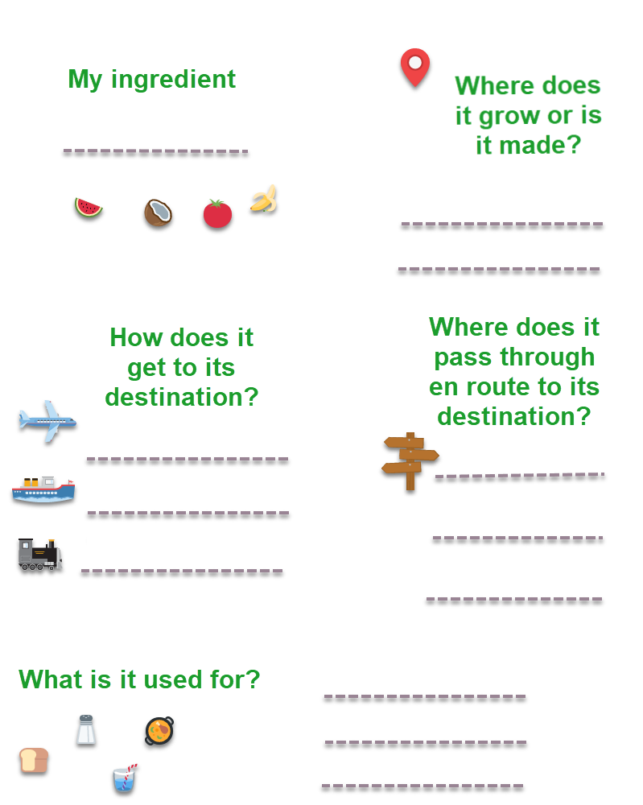

Draw the route
- Next, ask pupils to log in to Digimap for Schools.
- Go to: https://digimapforschools.edina.ac.uk.
- Select Login in the top right corner.
- Enter username and password. The username and password are provided by Digimap for Schools when you subscribe. Everyone in your school can use the same login details.

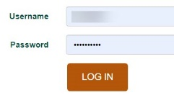

- When you first login, the map is centred on the United Kingdom and displays an Atlas map.
- Pupils should zoom out as far as they can, with the zoom to maximum extent button (circled).
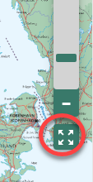

- Challenge pupils to draw the route that their chosen ingredient/product takes, adding annotations at appropriate points to share the findings of their research.
- Open the Drawing Tools.
  - The add line button is circled on the image. Select the add line button.
  - Select colour and line style settings.
  - Click or tap at each point on the map to add a line. Double click or tap to finish.

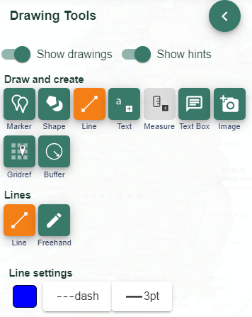

Pupils may be able to create annotations similar to the image below:
- Afterwards, ask pupils: “How does food link our country with other parts of the world?”.
- You could hold a ‘where’s where’ taster meal, inviting pupils to bring in samples of their favourite food from around the world and use a world map or globe to locate the origin of each dish.

Where should we know?
- Reorganise the room as if a committee meeting were to take place.
- Explain to the class that they must compile a list of all the features and places that every 11 year old should be able to locate on a world map.
- You could set criteria that they must meet, e.g. It must include:
  - physical (natural) features;
  - famous places;
  - major cities;
  - countries;
  - capitals and holiday resorts.
- Alternatively, you could suggest they must note x number of places and x number of features or add a limit to the total number of places and features that can be listed.
- Ask pupils to work in pairs to complete their research.
- A template is provided below for pupils to complete.

Worksheet: Our top World places
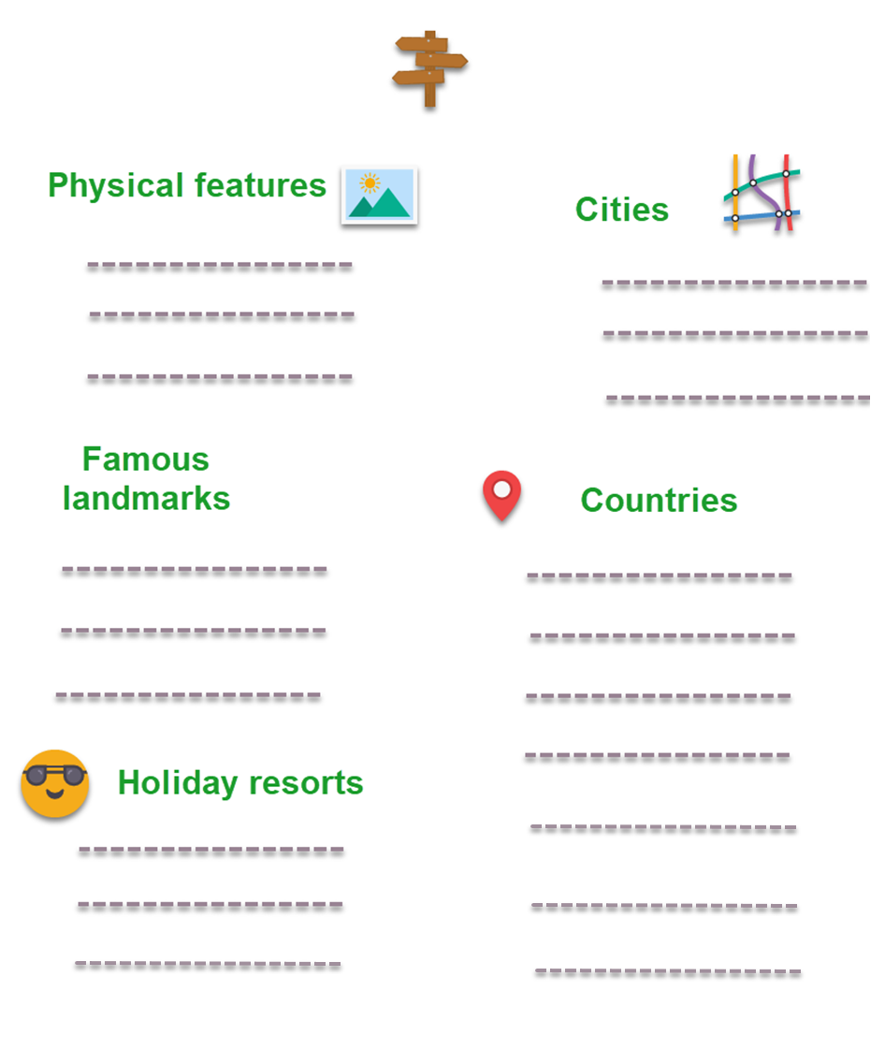

Finish activity: Take a vote!

- Invite pupils to share their suggestions with the rest of the class.
- Hold a class vote to determine the top ten features and top ten places that every 11 year old should be able to locate on a world map.

Taking it further

Geography

Digitally where?
- Ask pupils to find out which places on other continents their family members have digital contacts with, e.g. use Facetime to keep in touch with a cousin in Edmonton, Canada. Create a digital contacts map together to visualise the distribution of family and friends across the world. As social media platforms are typically for age 13 upwards, remind pupils of the importance of staying safe online and not talking to people that they do not know.

- Alternatively, ask pupils which places they have heard about in the media and locate these on a world map.

English/literacy
Write a persuasive letter to the Head Teacher and Governors outlining the features and places that all 11 year olds should be able to locate on a world map.

History
List or draw mental maps locating countries, places and events that pupils have encountered within history topics.

Acknowledgements

Geographical Association
With thanks to the Geographical Association for allowing us to use excerpts from The Everyday Guide to Primary Geography: Locational Knowledge, by Simon Catling.

Map images
- © CollinsBartholomew Ltd (2019) FOR SCHOOLS USE ONLY.
- © Crown copyright and database rights 2020 Ordnance Survey (100025252). FOR SCHOOLS USE ONLY.
- Aerial photography © Getmapping plc. Contains OS data. FOR SCHOOLS USE ONLY.
- Historic mapping courtesy of the National Library of Scotland. FOR SCHOOLS USE ONLY.

Icons
- Black and white icons - location, directional sign, mountain ranges, compass, geography by Made x Made from the Noun Project.

Copyright
© EDINA at the University of Edinburgh, 2020.
This work is licensed under a Creative Commons Attribution-NonCommercial-ShareAlike Licence.

