Magic telescope

Reading map features and looking at aerial images

Paula Owens

Primary

Contents
Content and Curriculum Links 3
Activity 3
Introduction 3
Main activity 4
Tasks 4
What’s best? - Activity 7
Suggestions 7
Taking it further 8
Copyright 9
Acknowledgements 9

Content and Curriculum Links
Level | Context |  |  | Location
Primary | Reading map features |  |  | Anywhere in GB
Knowledge |  |  | Reading and interpreting map features. Using Zoom to Area function. Drawing a fixed shape area. Placing labels.
Curriculum links (England) |  |  | Describe and understand key aspects of human and physical geography, use maps and digital mapping to locate and describe features.
Curriculum links (Wales) |  |  | Knowledge and Understanding of the World: Begin to recognise differences between their own locality, localities in other parts of Wales and in different parts of the world; learn about how and why people and places are linked. Geography: Use maps to compare and contrast places.
Scottish Curriculum for Excellence |  |  | Social Studies Outcomes: People, Place and Environment:2-13a, 2-14a

Activity
Pupils draw a very small area of search using a small-scale outline map of Great Britain, not knowing what kind of place they will find until they zoom in. When they do this, they have to use the landscape features as a clue to say what people might do there, and add labels to their map. They then compare this to the aerial image to understand the relative value of maps and images.

Introduction
When you first open up Digimap for Schools, the map you are shown, by default, shows the outline of Great Britain.
As you 'zoom’ into the map, features come into focus until you reach the fully 'zoomed in' level, which reveals a good deal of detail about places. What is important is that pupils realise how detail increases as we move from a small scale to a large scale (‘zoomed in') view and how this can give us information about what a place is like and what people might be able to do there.

Main activity
Explain that pupils are going to use a magic telescope on the map of Great Britain to zoom in and find out what that place is like. But that they have to make the magic telescope first before they can have a look. Pupils could work alone or in pairs. You could make this a challenge to see who can find out the most things.

Tasks
Open up Digimap for Schools. Explain that the map they can see doesn’t really give much detail and discuss what it does show. Pupils can choose anywhere on the map of Great Britain to focus their telescope.

- Making the telescope. Open the Drawing Tools.
- Find the Draw and Create menu.
- Select the circle shape.
- Select your line colour.
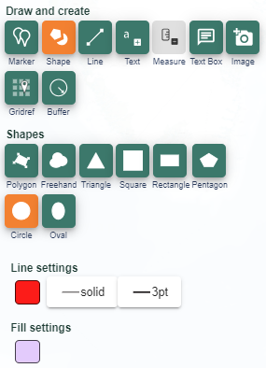

- Under Fill Settings, make sure your circle will be transparent. The image below shows the setting for this.
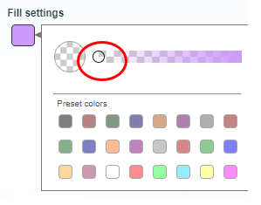

- Now choose your location on the` map of Great Britain.
- Click once to start drawing a small circle. Pull your mouse out a very small way and click again to finish.
- You should have a tiny circle on the map that you can just see. If you have a large circle drawn you need to delete it and try again. Close the Drawing Tools when you have finished.
  - Pupils could see what happens when they draw a large circle and how difficult it is to zoom in very far without losing sight of the circle outline.
- Now zoom in on the circle you have just drawn. Keep repeating until your circle fills up the screen.
- Your mystery place is revealed.
  - Where is it?
  - What kind of a place is it?
  - What can you do there?
  - Use the map clues and the map key to help you find out as many things as you can about the area inside your circle as seen through your Magic Telescope.
- Now select Aerial from the Map Selector.
- Look at the aerial image and see what you can find. What does the image show you that the map doesn’t?
- When you have examined the map and aerial image carefully and made notes, you can add some labels.
- Select the Drawing Tools.
- Select Place Standalone Label.
- Then select the font, text colour and size you want.
- Write what people can do there and the name of the features.
- Type your text in the box and click on the map to place the label.

- Complete the table below using the suggestions supplied. Add in some more ideas of your own if you can.

What’s best? - Activity

Maps are best for:
Aerial images are best for:
Both are good for:

Suggestions

- Seeing traffic and people
- Measuring how big your garden is
- Following a footpath
- Counting swimming pools in gardens
- Looking to see solar panels on roofs
- Deciding if you would like to visit an area
- Showing what is underneath trees
- Seeing the shape of roofs

Taking it further

- Challenge pupils to predict what they will find in their ‘magic telescope’, Can they pinpoint an urban/rural/seaside/riverside/mountainous and so on area through their location skills using an outline map? Could they use an atlas to help choose where to focus? This will help pupils become familiar with larger patterns in Great Britain such as where the major urban areas are found.

- Have a class challenge to see who can get the nearest to a major feature, such as the city of Edinburgh, the River Thames or Snowdon.

Copyright
©EDINA at the University of Edinburgh 2016
This work is licensed under a Creative Commons Attribution-Non Commercial Licence

Acknowledgements
© CollinsBartholomew Ltd (2019) FOR SCHOOLS USE ONLY
© Crown copyright and database rights 2020 Ordnance Survey (100025252). FOR SCHOOLS USE ONLY.
Aerial photography © Getmapping plc. Contains OS data. FOR SCHOOLS USE ONLY.
Historic mapping courtesy of the National Library of Scotland. FOR SCHOOLS USE ONLY.

