Map Detectives

Facts about Great Britain

Paula Owens

Geography Teaching Resource

Primary
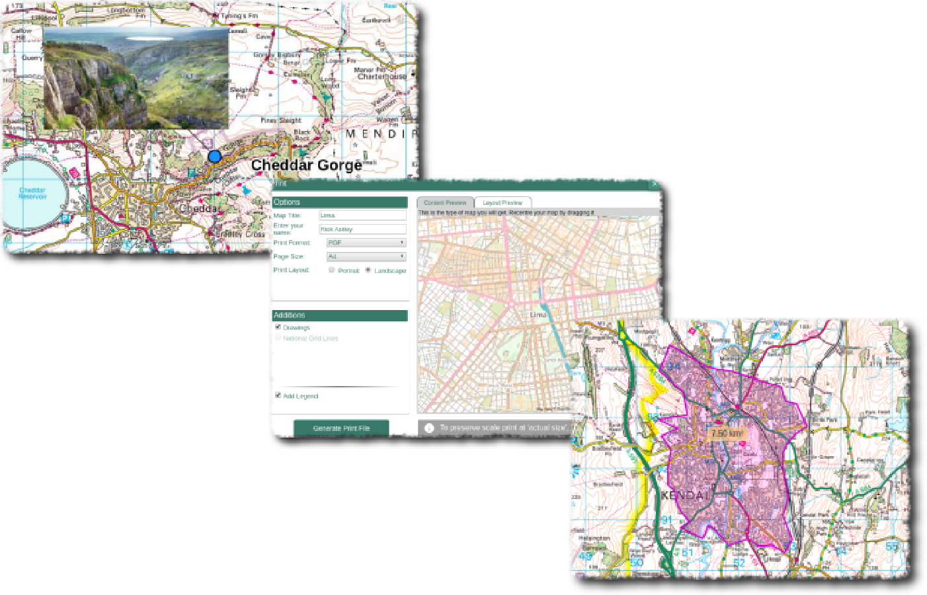

Contents
Digimap for Schools Geography Resources 3
Content and Curriculum Links 3
Activity 3
Introduction 3
Tasks 4
Taking it further 4
Web link 4
Map Detectives – Activity Page 1 5
Map Detectives – Activity Page 2 6
True or False Answers 7
Copyright 8
Acknowledgements 8

Digimap for Schools Geography Resources
These resources are a guide for teachers to demonstrate to the whole class or direct individual students as appropriate. Each activity has several ideas within it that you can tailor to suit your class and pupils. Some resources contain worksheets for direct distribution to pupils.

Content and Curriculum Links
Level | Context | Location
Primary | Facts about Great Britain | Great Britain, various

Knowledge | Finding and reading information from maps/using a map key at different scales/investigating maps at different scales/using grid references/using the measuring tool
Curriculum links (England) | Enquiry, using maps, knowing how to locate places and identify features, using geographical vocabulary, describing landscape features and characteristics
Curriculum links (Wales) | Identify and locate places and environments using globes, atlases and maps. Use maps, imagery and ICT to find and present locational information.
Scottish Curriculum for Excellence | Social Studies Outcomes: People, Place and Environment: SOC 2-14a

Activity
Researching given information to check whether it is true or false; if the latter, adding the correct information. Researching and compiling own ‘True’ or ‘False’ statements.

Introduction
This activity encourages enquiry: using maps and their keys at different scales to read and interpret information about places and landscape features. It also helps to build some core knowledge through the use of active enquiry.

Tasks
- Ask pupils to use one of the provided sets of ‘True’ or ‘False’ statements and read each statement carefully. They will need to use clues in the statements, such as place names, to help them search for and locate that place to find out if the statement is true or not.

- Sometimes they may have to zoom in and out on the map to find the answer.

- Remind pupils to use the measuring tool or add a marker to help them with some of the questions. They will also find it helpful to open up and use the map key.

- Pupils will have to decide if a statement is ‘True’ or ‘False’. If it is true ask them to try and add some additional information. If it is false, ask them to say why and give the right answer.

- Pupils will need to check their answers. Ask them which statements were the trickiest and why.

- Challenge pupils to make up a ‘True’ or ‘False’ statement of their own, making sure that they have the correct answer. They can use these to challenge others in the class.

Taking it further
- Choose a theme such as the local area, rivers, mountains or country parks.
- Choose one of the statements that interested you and do some more research about that area.

Web link
http://www.primaryhomeworkhelp.co.uk/geography/

Map Detectives – Activity Page 1
Research these statements using the maps and map keys to help you. Add extra information if true such as a grid reference or correct details if false. Make up your own true or false statements.

 | Statements 1–6 | TRUE/FALSE | Additional or correct information.
1 | Newcastle has an international airport.
2 | There is a Nature Reserve at St Bees Head.
3 | St Bees Head is on the east coast of England.
4 | The Caledonian Canal is a canal in Scotland that connects the Scottish east coast at Inverness with the west coast at Corpach, near Fort William.
5 | The Cuillin Hills is a range of rocky mountains located on the Isle of Mull, Scotland.
6 | You can catch a ferry, hovercraft or a plane from Ryde, Isle of Wight

Map Detectives – Activity Page 2
Research these statements using the maps and map keys to help you. Add extra information if true such as a grid reference or correct details if false. Make up your own true or false statement.

 | Statements 7–12 | TRUE/ FALSE | Additional or correct information.
7 | London zoo is located near the eastern boundary of Regent’s Park, London.
8 | Cadair Idris is a mountain reserve within the Snowdonia National Park. (Tip – try marking Cadair Idris then zooming out to see if it lies within the National Park).
9 | The Red River flows into the sea at Gwithian Bay, Cornwall.
10 | Red River Valley is a Local Nature Reserve located beside the Red River in Cornwall.
11 | The M25 Motorway around London is exactly 100 km in distance from start to finish.
12 | Windsor, Oxford (Oxfordshire) and Cambridge (Cambridgeshire) are all towns on the River Thames.

True or False Answers

- TRUE: Newcastle has an international airport grid reference NZ 193 715.
- TRUE: There is an RSPB Reserve, see grid reference NX959118.
- FALSE: St Bees Head is on the west coast, just south of the town of Whitehaven.
- FALSE: The Caledonian Canal is a canal in Scotland that connects the Scottish east coast at Inverness grid reference NH 648 430, with the west coast at Corpach near Fort William.
- FALSE: The Cuillin Hills are located on the Isle of Skye. Grid reference NG 45 20.
- FALSE: You can catch a ferry or hovercraft but there is no airport at Ryde, Isle of Wight. Grid Reference SZ 593 929. There is also a station for rail journeys within the island.
- FALSE: The zoo (ZSL) is located on the northern boundary. Grid reference TQ 280 834.
- TRUE: Cadair Idris is a spectacular place with a variety of landscapes and terrain that includes rugged summits and glacial lakes. It lies within the Snowdonia National Park a few kilometres south of Dolgellau.

- TRUE: The Red River flows into Gwithian Bay. Grid reference SW 582 422.
- TRUE: Red River Valley has been designated a Local Nature Reserve. Previously this was a mining area: the waste from this industry gave the river its name. A mix of natural and human regeneration has helped to improve the area. Grid reference SW 621 420.
- FALSE: The M25 is an orbital motorway with a length of approximately 188 km.
- FALSE: Windsor and Oxford are towns on the River Thames but Cambridge (Cambridgeshire) lies on the River Cam. Grid Reference TL 441 568.

Copyright
©EDINA at the University of Edinburgh 2016
This work is licensed under a Creative Commons Attribution-Non Commercial Licence

Acknowledgements
© CollinsBartholomew Ltd (2019) FOR SCHOOLS USE ONLY
© Crown copyright and database rights 2020 Ordnance Survey (100025252). FOR SCHOOLS USE ONLY.
Aerial photography © Getmapping plc. Contains OS data. FOR SCHOOLS USE ONLY.
Historic mapping courtesy of the National Library of Scotland. FOR SCHOOLS USE ONLY.

