

Mini mapping ideas Primary

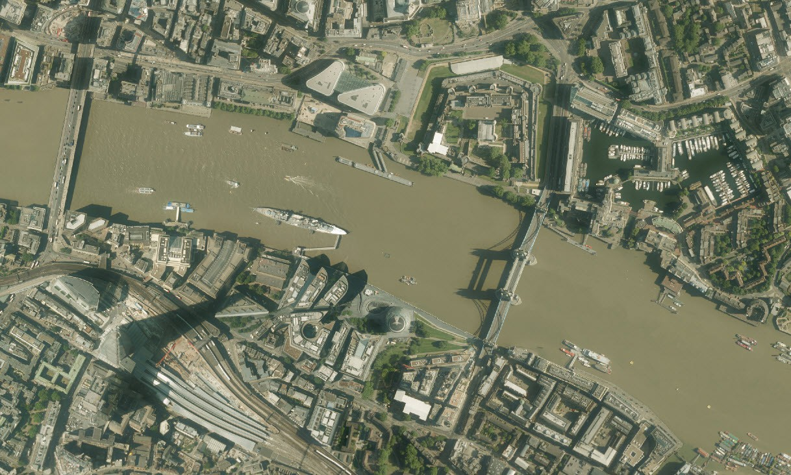

Learning areas

* name and locate the world’s seven

continents and five oceans

* name, locate and identify characteristics of the four countries and capital cities of the United Kingdom and its surrounding seas

Locational knowledge



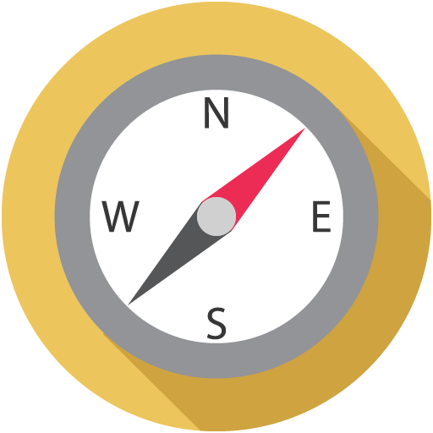

**Aerial landmarks**

Select a landmark in each capital city of the UK.

Search for one, e.g. Buckingham Palace. With the landmark at the centre of the

map, select an Aerial map.

Pupils work together to [answer questions](https://dfsresources.edina.ac.uk/resource/using-aerial-imagery-landmarks) [on the aerial image](https://dfsresources.edina.ac.uk/resource/using-aerial-imagery-landmarks) e.g.

* what time of year do you think it is?
* how many cars are parked?

**The Americas**

Search for a country in Central America and label it e.g.

Panama. Open Overlays and turn on Major Lines of Latitude. Zoom out as far as you

can. Identify North, Central and South America and label.

[The Americas](https://dfsresources.edina.ac.uk/resource/americas)  resource suggests how to explore physical features of the continent.

**My food**

Ask pupils to photograph labels from a range of food items at home.

Search for the countries. Add a marker to each country. Label the country with the food from there.

Zoom to a map of the world. Measure the distances from each country to your home.

**Holiday memories**

Ask pupils for countries they have visited or want to visit. Search for and label some countries.

Discuss one, e.g. did they go to the

beach? What sea did they swim in? What animals are found there? Does it have mountains? Add drawings and labels to build a picture of a country.



Mini mapping ideas Primary

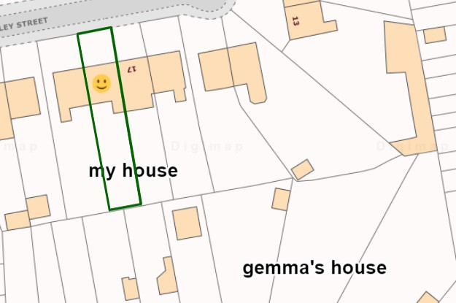

Learning areas

* understand geographical similarities and differences through studying the human and physical geography of a small area of the United

Kingdom, and of a small area in a contrasting non-European country

Place knowledge





**Spot the difference**

[Give pupils an 1890s](https://dfsresources.edina.ac.uk/resource/games-and-stories) [map](https://dfsresources.edina.ac.uk/resource/games-and-stories) and a current map of the same area (ideally their town). Help them orient themselves with some landmarks.

Ask each group to find differences, giving examples

e.g. housing, roads, railways, industry. Follow up by drawing the changes on screen.

**Where do I live?**

[Pupils enter their](https://dfsresources.edina.ac.uk/resource/where-do-i-live) [postcode](https://dfsresources.edina.ac.uk/resource/where-do-i-live), zoom in as far as they can and identify their home. They

may have to guess if not all houses numbered.

Add a marker, ‘My House’ label and draw around the house and garden (depending on age). Add other markers and labels e.g. where they play, the corner.

**My happy place**

Add markers to a map of your town to reflect your feelings. Find a range of markers in the Drawing Tools.

Ask pupils to add smiley faces for places that make them happy, neutral face for places they are not sure about and a star for the best place of all.

**Magic telescope**

[Pupils zoom in on](https://dfsresources.edina.ac.uk/resource/magic-telescope) [an area to find out](https://dfsresources.edina.ac.uk/resource/magic-telescope) [more about it.](https://dfsresources.edina.ac.uk/resource/magic-telescope) First they draw a circle (the ‘telescope’) anywhere on a map, then zoom in as far as they can.

* Where is it?
* What kind of place is it?
* What can you do there?

Select an aerial map. What does it reveal?



Mini mapping ideas Primary

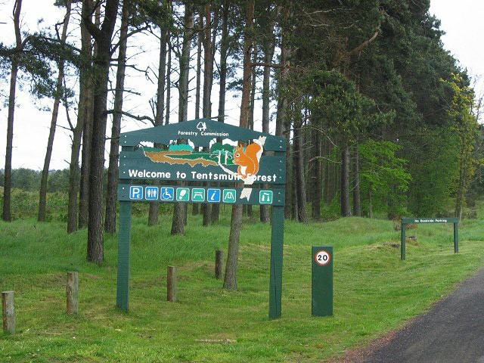

Learning areas

use basic geographical vocabulary to refer to:

* key physical features, including: beach, cliff, coast, forest, hill, mountain, sea, ocean, river, soil, valley, vegetation, season and weather
* key human features, including: city, town, village, factory, farm, house, office, port, harbour and shop

Human and physical geography



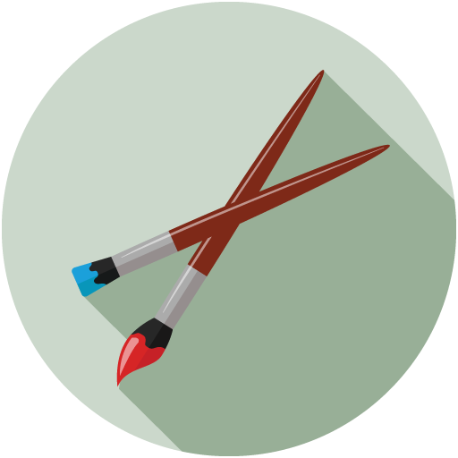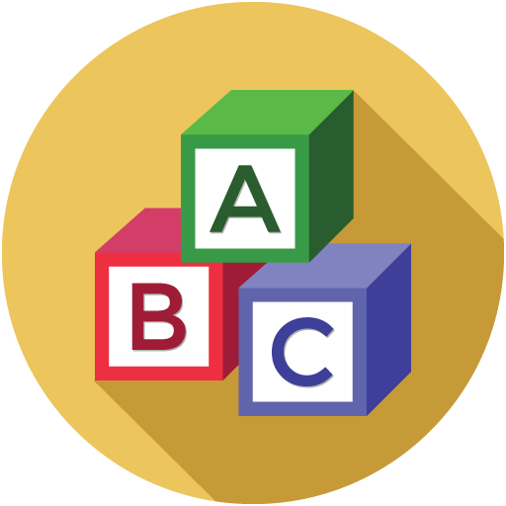

**The Gruffalo...**

...and other stories! [Read a popular story](https://dfsresources.edina.ac.uk/resource/games-and-stories) [and find a real-life](https://dfsresources.edina.ac.uk/resource/games-and-stories) [location for it.](https://dfsresources.edina.ac.uk/resource/games-and-stories)

First, discuss the features the place needs e.g. a wood. Then suggest or elicit some nearby places. Navigate to the place in Digimap for Schools. Use

the aerial map to add markers and labels for key story locations.

[**My dream island**](https://dfsresources.edina.ac.uk/resource/my-dream-island)

A new island has been discovered in the Hebrides!

The pupils have to decide the features the island will have. A village, town, ferry port, road, river, mountains? Use [My](https://dfsresources.edina.ac.uk/resource/my-dream-island)  [Island Worksheet](https://dfsresources.edina.ac.uk/resource/my-dream-island) to help them decide.

Now create the island in Digimap for Schools. Use the Map key worksheet

to help decide how to draw the features.

**Map detectives**

Work as a class to create a list of

[physical and human](https://dfsresources.edina.ac.uk/resource/locality-detectives) [features](https://dfsresources.edina.ac.uk/resource/locality-detectives) e.g. beach, river, houses, shops, park, woods.

Pupils use a screen map of their town or area, and the map Key to create a list of features they find. Work in teams and see whose list is longest. Now choose a nearby town and compare.

**Alphabet Match**

Start a [Class](https://dfsresources.edina.ac.uk/resource/landscape-alphabet) [Alphabet list of](https://dfsresources.edina.ac.uk/resource/landscape-alphabet) [landscape features](https://dfsresources.edina.ac.uk/resource/landscape-alphabet), ideally things found near the school e.g. tree, playground. Try to have a letter of the week.

Open the Image Search and try to find images of the features. Create a wall chart with the list and an A3 map, or create a table top map with clay.



Mini mapping ideas Primary



Learning areas

* use maps, atlases, globes and digital mapping to locate countries
* use compass points, 4 and 6 figure grid refs, symbols and keys to build knowledge of UK and wider world
* use fieldwork to observe, measure, record and present human and physical features with sketch maps, plans, graphs and digital technologies

Geographical skills





**Map my walk**

Plan a short walk. Give pupils a printed map they can write and draw on. Stop at points to check your location and observe. Follow up on screen, e.g.:

* draw a line to show the route
* add images
* add markers
* add a measurement label to the line

**Towns in ten**

Introduce the 4 compass points. In pairs, take it in turn to choose a town from a map.

The partner has ten questions (location and direction) to guess the town - answers are yes or no.

* is it in Wales?
* is it north of

Sheffield?

* is it near the coast?

**Teddy Hunt**

Hide a teddy in the school grounds and provide a detailed map showing his location.

See which group can

find him first!

Afterwards, ask the pupils to complete some phrases to describe where Teddy was, e.g:

* beside the ....
* opposite the ....

**Treasure Hunt!**

Pupils turn on the Grid Lines overlay and input a ‘secret code’ - a grid reference.

Then they follow a trail of written clues to find the treasure,

e.g. head North and look for the caravan park.

Our [Treasure Hunt](https://dfsresources.edina.ac.uk/resource/treasure-hunt)  [resource](https://dfsresources.edina.ac.uk/resource/treasure-hunt) has 3 hunts prepared for you.