My Dream Island
Human and physical features of the environment
Paula Owens
Geography Teaching Resource
Primary

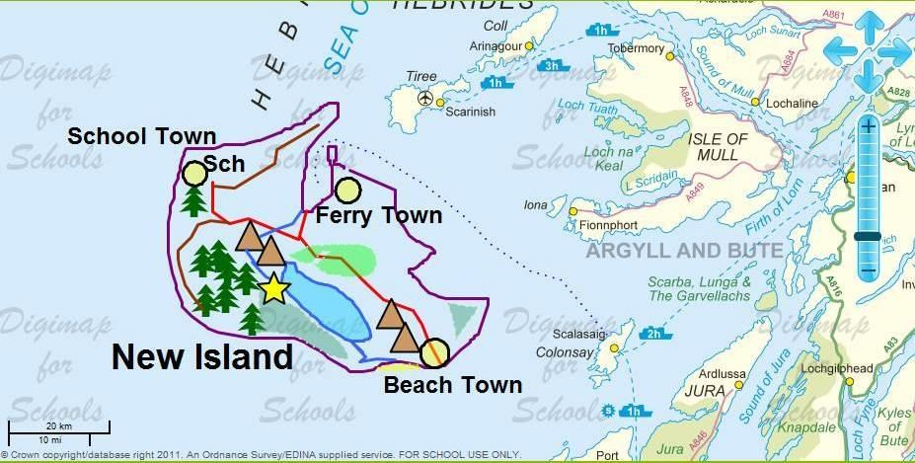

Contents
Digimap for Schools Geography Resources 3
Content and Curriculum Links 3
Activity 3
Introduction 3
Main activity 4
Taking it further 4
Web links 4
My Dream Island 5
Worksheet: My island features 7
Copyright 8
Acknowledgements 8

Digimap for Schools Geography Resources
These resources are a guide for teachers to demonstrate to the whole class or direct individual students as appropriate. Each activity has several ideas within it that you can tailor to suit your class and pupils. Some resources contain worksheets for direct distribution to pupils.

Content and Curriculum Links

Level | Context | Location
Primary | Human and physical features of the environment | Inner Hebrides, Scotland, but could be adapted to other areas of the coastline of Great Britain.

Knowledge/Skills | Using a range of drawing tools: adding labels and markers; drawing lines and areas, changing colours.
Curriculum links (England) | Use digital mapping to locate and describe human and physical features.
Curriculum links (Wales) | Use maps, imagery and ICT to find and present locational information. Identify and describe natural and human features.
Scottish Curriculum for Excellence | Social Studies Outcomes: People, Place and Environment: 1–13a, 2–13a, 1–14a, 2–14a.

Activity
Pupils create a new island by drawing it on a map, then annotate it to show human and physical features, including transport links to the mainland.

Introduction
The Hebrides comprise a widespread archipelago or cluster of islands off the NW coast of Scotland. There are two main groups of islands: the Outer and the Inner Hebrides. People living on these islands have to travel to the mainland either by boat or plane.
Although this activity is focused on creating an imaginary island in this region, it could be carried out anywhere in the coastal waters of Great Britain.

Main activity
Explain to the class that a new island has been discovered in the Hebrides! You have to go there immediately and map the new island, showing what you think it could look like in the future. Include some settlements, roads and natural features.
No one knows much about this island except that it lies south of the Island of Tiree and west of the Island of Iona in the Inner Hebrides.
There is a worksheet to assist pupils with this activity:
- My Island Features, to help them decide what to put on their island.

Taking it further
- Make a display of your islands and explain why they would be a great place to live. Decide which features are important when choosing a good place to live and vote for the best one.
- Look at some storybooks about islands, for example:
Katie Morag and the Two Grandmothers – Mairi Hedderwick
The Little Island (Dell Picture Yearling) – Margaret Wise Brown and Leonard Weisgard
An Island Grows – Lola M Schaefer and Cathie Felstead

Web links
A boat trip from Skye:
https://www.bbc.co.uk/bitesize/clips/zjwmpv4
Getting to the Outer Hebrides by boat:
https://www.bbc.co.uk/bitesize/clips/z3mc7ty
Barnaby Bear visits the Orkney islands:
https://www.youtube.com/watch?v=MDEiA1k8XOQ

My Dream Island
- Open Digimap for Schools and find the ‘Inner Hebrides’ using the search box.
- Find the islands of Tiree and Iona by zooming using the scale bar and moving the map.
- Zoom to Level 4 which should provide a comfortable scale to work with.
- You have to ‘find’ the island and map it. Draw an outline to show where it is and what shape it is.
- Open the Drawing Tools and select ‘Draw Line’.
- Choose the Line colour you want before starting to draw.
- Click to start drawing and hold down the Shift key, which will let you draw in freehand. Make sure the island is big enough to give you room to add features and labels later on.
- Now think about what features it might already have, what features might develop over time and what features might be built. You also need to think about how people will get to the island. Find the nearest island to yours that has ferry crossings and map a route from there to your island. You might also want to add an airport.

TIP: use worksheet ‘My Island Features’ to think about this first and make a list. You could sketch them onto your drawing of an island to help you plan and get ideas from the map Key.

- If you make a mistake, remember that you can move or delete features by using the tools from the Modify and Delete areas of the Drawing Tools.
- If you are working on your map for a while you might want to save it so that you don’t lose it. Then you can open the map again later.
- You will also have to give your island a name and label other places.
- Open the Drawing Tools and choose your type size, font and colour and select ‘Place standalone label’. You will need a larger font size for the island name than the island features, for example, Arial font sizes 26 and 18.
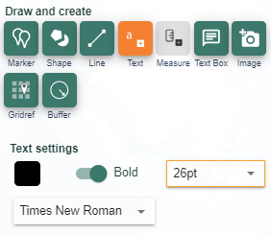
- Then click outside of your Island and write the name of your island. Next, choose a smaller text and click next to the features you want to name, such as towns and school.
- Use ‘Sch’ to label the school.
- Once you have made your labels you can move them into their best position.
- When you are happy with your map save it making sure it has a title.
- Then use the Print menu to create a PDF file for printing. Decide whether portrait or landscape view is best.

Worksheet: My island features
Which of these features will your island have? How will they appear on your map?
Feature | How will this be drawn on the map?  Some ideas are missing can you add them? | Draw how you will show this feature using coloured pens
Town | Draw shape, circle, choose black outline colour and yellow fill.
Village
Main road | Add line, choose red outline colour.
Track | Add line, choose brown outline colour.
School | Place label, write ‘Sch’
Ferry port
Beach: sandy or shingle | Draw area, draw a freeform shape, choose yellow outline and yellow fill.
Forest and trees | Draw area, draw a freeform shape, choose green outline and fill and 50% transparency.  Add marker, choose tree icon.
Mountain | Add marker, choose brown triangles.
River | Add line, choose blue outline colour.
Lake | Draw area, draw a freeform shape, choose blue outline and fill.
Beauty spot | Place marker, choose star.
Ferry route to the island | Add line, select dotted, thin, choose outline colour blue.

My Island is called:
Towns:

Copyright
Select fill colour
Select line colour
©EDINA at the University of Edinburgh 2016
This work is licensed under a Creative Commons Attribution-Non Commercial Licence

Acknowledgements
© CollinsBartholomew Ltd (2019) FOR SCHOOLS USE ONLY
© Crown copyright and database rights 2020 Ordnance Survey (100025252). FOR SCHOOLS USE ONLY.
Aerial photography © Getmapping plc. Contains OS data. FOR SCHOOLS USE ONLY.
Historic mapping courtesy of the National Library of Scotland. FOR SCHOOLS USE ONLY.

