My Top Tourism Trail
Local area enquiry
Paula Owens
Geography Teaching Resources
Secondary
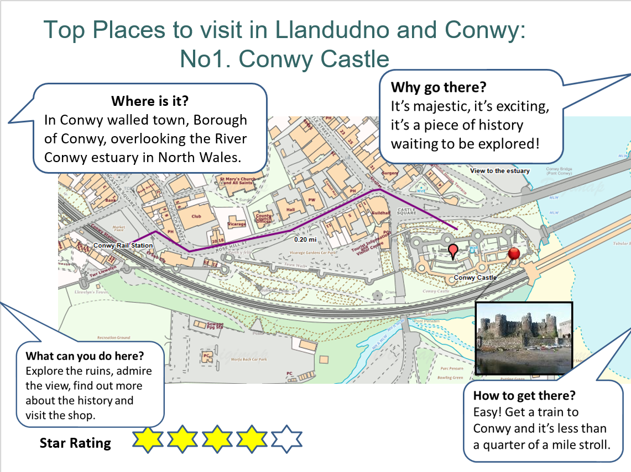

Contents
Digimap for Schools Geography Resources 3
Content and Curriculum Links 3
Activity 3
Introduction 4
Main Activity 4
Web links 4
Copyright 5
Acknowledgements 5

Digimap for Schools Geography Resources
These resources are a guide for teachers to demonstrate to the whole class or direct individual students as appropriate. Each activity has several ideas within it that you can tailor to suit your class and pupils. Some resources contain worksheets for direct distribution to pupils.

Content and Curriculum Links

Level | Context | Location
Secondary | Local area enquiry | Your local area

Knowledge | - Locating places  - Adding information to maps  - Making maps at relevant scales to suit context  - Identify routes  - Measuring distances
Curriculum links (England) | Use digital/computer mapping to locate and describe features studied
Curriculum links (Wales) | Use maps, imagery and ICT to find and present locational information. Follow directions, estimate and calculate distances
Scottish Curriculum for Excellence | Social Studies Outcomes: People, Place and Environment SOC 2-10a, SOC 2-14a

Activity
Identifying favourite places in the locality and mapping them and writing a tourist guide.

Introduction
In this activity, children become the experts as they have to agree between them the top five or ten places in their locality before mapping them and then describing how to get there and why they are worth visiting.

Maps can be easily made at different scales to show both where places are in the locality and what they are like.

This activity is ideal for fieldwork. Local places can be evaluated at first hand, and pupils can take their own photographs to add to the leaflets they make.

Main Activity
- What are the best places to go to in the neighbourhood and why? Where are they and how do you get there?
- The task is to identify these places and make a leaflet with maps explaining the answers to these questions.
- Discuss favourite places as well as places that ought to be included.
- Draw up a short list and vote as a class to choose for example, five or ten places.
- Everyone could locate and map where these places are on a map showing the local area.
- Then, children could collaborate and work on just one place per group; using the maps to research more information for their leaflet.
- The accompanying PowerPoint presentation gives an example of what the finished product for the main activity might look like.

Web links
Young Geographers Go Local: https://www.geography.org.uk/Young-Geographers-Go-Local

Copyright
©EDINA at the University of Edinburgh 2016
This work is licensed under a Creative Commons Attribution-Non Commercial Licence

Acknowledgements
© CollinsBartholomew Ltd (2019) FOR SCHOOLS USE ONLY
© Crown copyright and database rights 2020 Ordnance Survey (100025252). FOR SCHOOLS USE ONLY.
Aerial photography © Getmapping plc. Contains OS data. FOR SCHOOLS USE ONLY.
Historic mapping courtesy of the National Library of Scotland. FOR SCHOOLS USE ONLY.

