Patterns of Land Use

Looking at different areas in GB and comparing land use

Paula Owens

Geography Teaching Resource

Primary
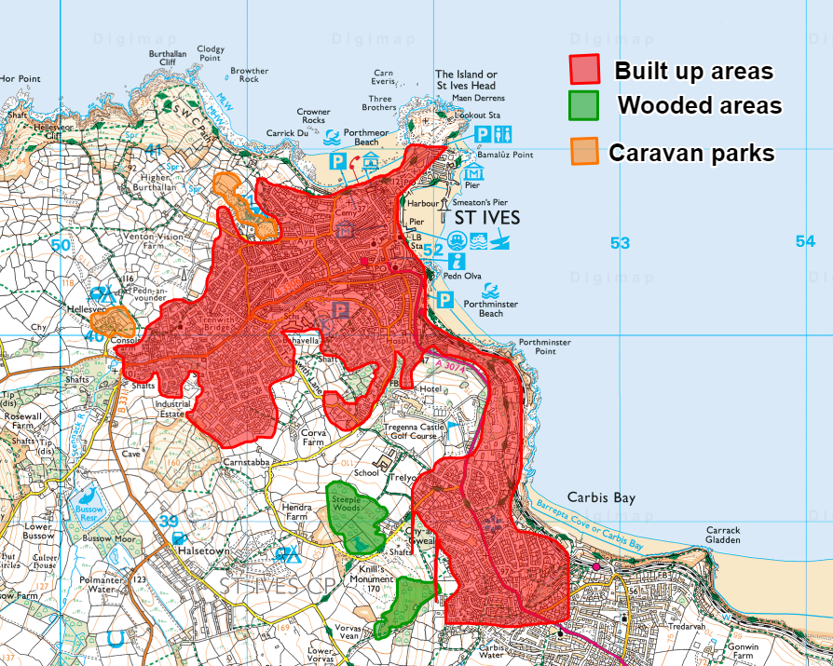

Contents
Digimap for Schools Geography Resources 3
Content and Curriculum Links 3
Activity 3
Introduction 4
Main activity 5
Tasks 6
Taking it further 10
Copyright 11
Acknowledgements 11

Digimap for Schools Geography Resources
These resources are a guide for teachers to demonstrate to the whole class or direct individual students as appropriate. Each activity has several ideas within it that you can tailor to suit your class and pupils. Some resources contain worksheets for direct distribution to pupils.

Content and Curriculum Links
Level | Context | Location
Primary | Looking at different areas in GB and comparing land use. | Anywhere within GB.

Knowledge | Drawing and highlighting areas.
Curriculum links (England) | Name and locate land use patterns in the UK.  Understand geographical similarities and differences.  Use digital mapping to describe features studied.
Curriculum links (Wales) | Use maps, imagery and ICT to find and present locational information. Identify and describe the spatial patterns (distributions) of places and environments.
Scottish Curriculum for Excellence | Social Studies Outcomes: People, Place and Environment SOC 2–13a; SOC 2–08b.

Activity
Finding and highlighting simple patterns of land use such as built and non-built up areas, and using this to offer reasons why things are where they are and explain how and why places are different.

Introduction
This activity develops observational and interpretative skills as pupils have to actively identify different kinds of land use on the maps. This helps children to think about why features are located where they are and how places have developed over time. When different places are compared at the same scale it highlights some of the similarities and differences between them.

The ‘Patterns of Land Use’ Presentation gives examples of maps that show land use comparisons in four different coastal places: Newquay, Ceredigion on the west Wales coast; Weymouth, Dorset, on the south coast on England; Fraserburgh, Aberdeenshire on the east coast of Scotland, and Ullapool in the Highlands, on the west coast of Scotland.

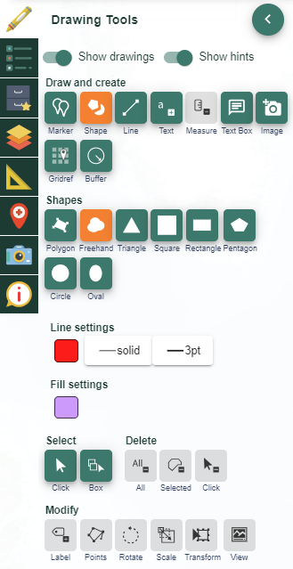

Main activity
The key tool you will be using for this activity is the ‘Drawing Tools’:
- Decide which places you want to compare and the patterns of land use you are going to highlight.
- Using one colour from the Drawing tools to highlight just one type of land use for example, built areas.
- Then progress to include other land use types such as Nature Reserves and caravan sites from an agreed colour key using the options on Digimap for Schools.
- It’s helpful to select Aerial from the Map Selector tool for this activity.

Tasks
Open Digimap for Schools and enter the search term for your chosen place into the search box, for example, St Ives, Cornwall. Zoom in so the map looks similar to this:
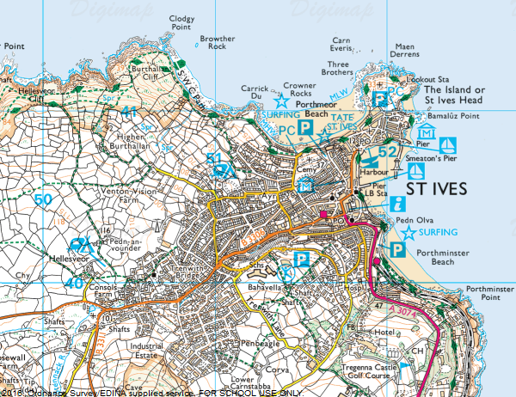
- You should be able to see areas which are mainly built-up and others that have few buildings.
- Start by highlighting the built-up areas.
- Open the Drawing Tools.
- Select Draw freehand polygon.
- Under line and fill settings:
  - choose red using ‘Line’ and ‘Fill options’ (it’s helpful to have the outline and fill the same colour).

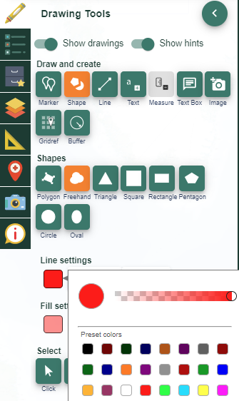

- Click and hold on the place where you want to start and drag the pointer around the edge of the shape slowly. Release the click when you have finished. You can practice doing this and delete the area and start again until you are happy. Remember, you’re not trying to show every detail just the general shape.

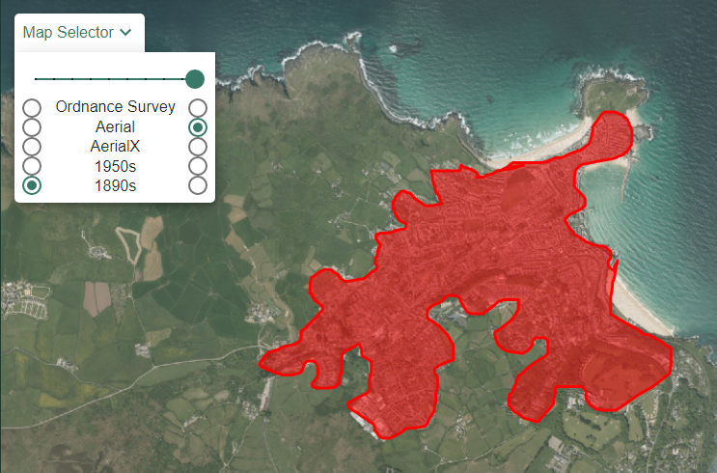
- Some areas might be too large to cover in one go so may have to be done in small segments.
- When you have finished drawing an area, pan the map around to see what you might draw around next. Also look at the aerial imagery to see the caravan sites . Here are some suggestions of things you could look for:
  - Woods and forests (use green)
  - Lakes and reservoirs (use blue)
  - Caravan and campsites (use orange)
  - Not built-up (use yellow)
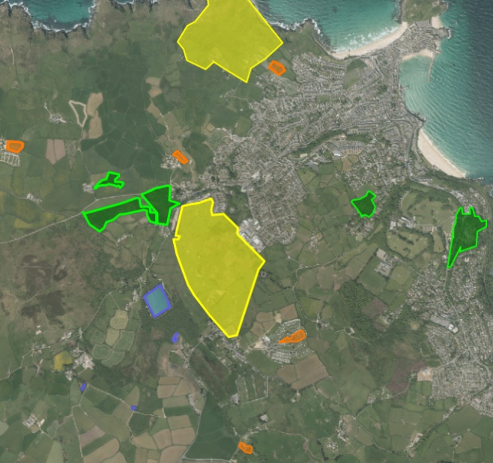

- If you make a mistake, use the Delete tools.
- Use the Add Measurement Label tool to add labels to, for example, the built-up areas.
- Try adding a key to the map:
  - You could do this with the Drawing tools (see example in image below) e.g. create shapes in the relevant colours and then add labels to them.
  - Or you could create a key as an image (using Paint or Powerpoint or similar) then upload as an image to your map.

- Discuss where the built-up areas are on each map and how settlements are arranged. Where are the open spaces? Why are they there? Why do some patterns stop suddenly? For example, there might be a natural boundary such as a cliff or a forest or a man-made boundary such as a road.
  - Look at the historical maps of the area, how has the land-use changed?
  - Discuss what the resorts are like in the winter.
  - Consider the advantages and disadvantages of a proposed land use development and discuss the impact this may have on the community.

Taking it further
- Open up the saved maps and add more details. Use the Add Measurement Label tool on for example, the built-up areas.
- Use markers and labels to highlight all the National Parks in Great Britain. Research and compare them.
- Consider the advantages and disadvantages of a proposed land use development and discuss the impact this may have on the community.

Copyright
©EDINA at the University of Edinburgh 2016
This work is licensed under a Creative Commons Attribution-Non Commercial Licence

Acknowledgements
© CollinsBartholomew Ltd (2019) FOR SCHOOLS USE ONLY
© Crown copyright and database rights 2020 Ordnance Survey (100025252). FOR SCHOOLS USE ONLY.
Aerial photography © Getmapping plc. Contains OS data. FOR SCHOOLS USE ONLY.
Historic mapping courtesy of the National Library of Scotland. FOR SCHOOLS USE ONLY.

