Photographic!: Image Search

Paula Owens

Geography Teaching Resource

7-11 years

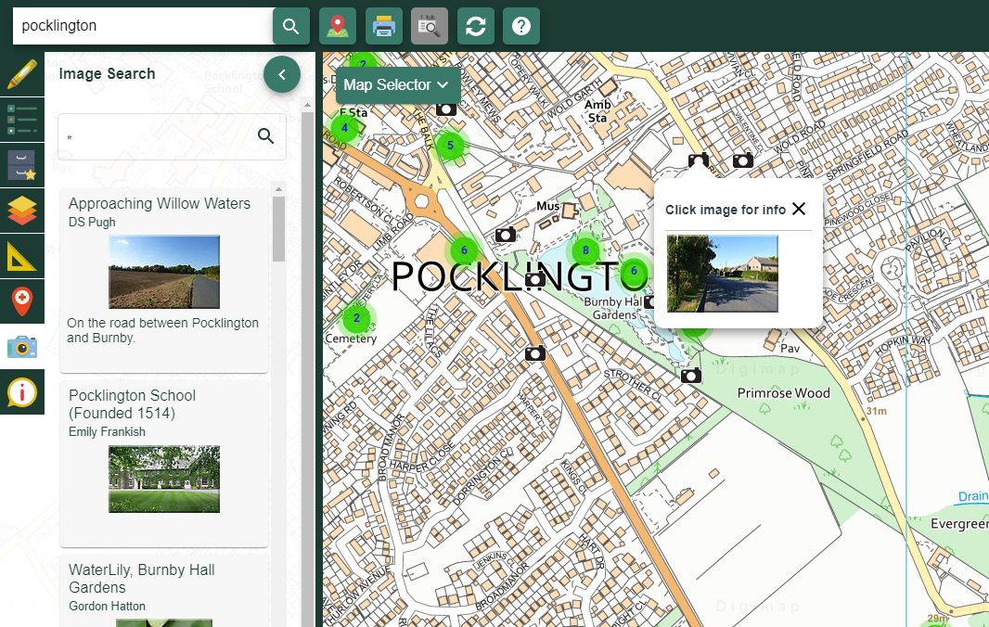

Contents
Content and Curriculum Links 3
Photographic! 4
Literacy Links 5
Numeracy Links 5
Fieldwork opportunities 6
Copyright 7
Acknowledgements 7

Content and Curriculum Links
Level | Context | Location
7-11 years | Using Geograph images | Various throughout Great Britain

Knowledge | Using Geograph images with maps
Curriculum links (England)  Geography KS2 | - Name and locate counties and cities of the United Kingdom, geographical regions and their identifying human and physical characteristics, key topographical features (including hills, mountains, coasts and rivers), and land-use patterns.  - Use fieldwork to observe, measure, record and present the human and physical features in the local area using a range of methods, including sketch maps, plans and graphs, and digital technologies.
Curriculum links (Wales)  Geography  (Opportunities for Digital Competency) | - Use maps, imagery and ICT to find and present locational information. Interpret maps, and photographs.  - Identify and describe the spatial patterns of places and environments and how they are connected. Identify and describe natural and human features, e.g. weather conditions, types of buildings.
Scottish Curriculum for Excellence  Social studies  Experiences and outcomes | - I can describe the major characteristic features of Scotland’s landscape SOC 2-07a.  - Having explored my local area, I can present information on different places to live, work and relax and interesting places to visit. SOC 2-10a.  - To extend my mental map and sense of place, I can interpret information from different types of maps and am beginning to locate key features within Scotland, UK, Europe or the wider world. SOC 2-14.
All: Literacy opportunities  All: Numeracy opportunities | Activities have identified opportunities for literacy and numeracy

Photographic!
Select a location using Digimap for Schools and click on the Image Search menu in the sidebar.
To browse the images that are available for your location, enter an asterisk (*) in the Image Search search box and hit return.
NOTE: It is only possible to browse all images for a location in the 5 most detailed maps in Digimap for Schools. When you are in less detailed maps, there can be too many images to display. In less detailed maps, you must enter a search term. Find your location first, make sure you’re in one of the 5 most detailed maps, then enter your asterisk.

A good place to start is where you live or your school locality. Browse the images that appear. Are there lots of images to view or just a few (in comparison with other places nearby for example)? What scale of map are you viewing? (If you are comparing localities it is helpful to examine places at the same scale). You could investigate some, or all, of the following enquiry questions.
- What does the number of available images tell you about your chosen place? Is it well visited for example? Or inaccessible? Do you think this is this a popular tourist attraction and can you explain why?
- What kind of features are shown most in the available photographs? Does one feature appear more than most? Why do you think this is?
- Are there any images of animals? If so, which animals feature most?
- What impression do you get of the locality by browsing the photographs? Is it a positive one? How similar or different is it to your own impression of the locality? Decide on a workable area of map to investigate and then count and classify the images you can find, offering explanation for your findings. Highlight the area you have investigated on the map and add text boxes with your key findings.

Literacy Links
- Create a short spoken or written report about the number and type of features you have found in an area. Use maps and images to back up your report.
- Create lists and tables of features and short captions to accompany them.

Numeracy Links
- Locate your chosen area, remembering the limitation of the 5 most detailed maps.
- Locate e.g. the grid square of the map you are investigating and give Grid References to identify its location. To view British National Grid Lines, open Overlays and check British National Grid.
- Or use an area tool in the Drawing Tools and highlight an area of interest – this may be a grid pattern as above or it may be an irregular shape.
- Or decide on a point around which to centre the investigation and use the Buffer Tool to highlight a circular area after first selecting the radius.
- Use the Measurement Tools to calculate the chosen area in either square metres or kilometres.
- Once your search area has been clearly identified and located, use the Image Search Tool to find images within it using your search term. Either count or estimate how many images can be found there.
- Is there an even distribution of photographs or are there ‘hotspots’? Zoom in further if necessary to investigate patterns and record what you find using the Drawing Tools.
- Identify and count any recurring features in the photographs.
- Select a workable number of photographs within your area and classify them. Think of the most useful criteria to use, for example, you might use the seasons to classify images of woods or other living things.
- Present your findings using diagrams charts or graphs. You could also add numbers and text to a map of the area e.g. ‘3 churches in 1 km2’.

Fieldwork opportunities
- Investigate image locations if they are within walking distance and take your own photograph of the same feature.
- Upload your image to Geograph or directly to a map in Digimap for Schools using the Add Photo Tool in the Drawing Tools.
- Add some descriptive text, a Grid Reference and a date.
- Can you find the exact spot where you think an image was taken? Draw an annotated sketch map of the landscape taking the same view as the photographer.

Copyright
©EDINA at the University of Edinburgh 2016
This work is licensed under a Creative Commons Attribution-Non Commercial Licence

Acknowledgements
© CollinsBartholomew Ltd (2019) FOR SCHOOLS USE ONLY
© Crown copyright and database rights 2020 Ordnance Survey (100025252). FOR SCHOOLS USE ONLY.
Aerial photography © Getmapping plc. Contains OS data. FOR SCHOOLS USE ONLY.
Historic mapping courtesy of the National Library of Scotland. FOR SCHOOLS USE ONLY.

