Picture Detectives

Matching Images and Clues to Map References

Paula Owens

Geography Teaching Resource

Primary
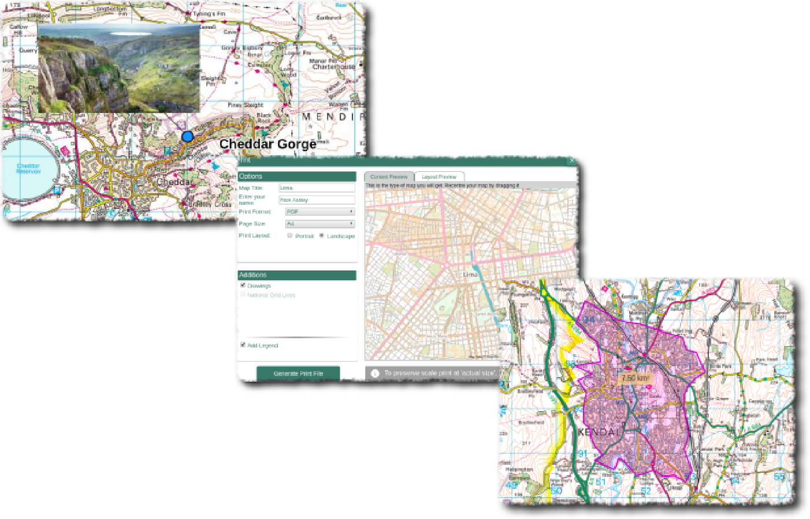

Contents
Contents 2
Digimap for Schools Geography Resources 3
Content and Curriculum Links 3
Activity 3
Introduction 3
Main activity 4
Tasks 4
Resources 5
A.) Answers sheet 6
B.) Picture Detectives: Solve the mystery of where these pictures were taken! 7
C.) Picture Detectives: match the photo and find the places! 8
D.) Picture Detectives: most likely to...? 9
E.) Picture Detectives: most likely to ...? 10
F.) Picture Detectives: most likely to ...? 11
G.) Picture Detectives: most likely to …? 12
Taking it further 13
Links 13
Copyright 14
Acknowledgements 14

Digimap for Schools Geography Resources
These resources are a guide for teachers to demonstrate to the whole class or direct individual students as appropriate. Each activity has several ideas within it that you can tailor to suit your class and pupils. Some resources contain worksheets for direct distribution to pupils.
https://digimapforschools.edina.ac.uk/

Content and Curriculum Links
Level | Context | Location
Primary | Matching images and clues to map references | Various locations and can be adapted for use anywhere

Knowledge/Skills | Using four and six figure grid references to find places, reading and interpreting maps, using a map key, placing labels and annotating maps
Curriculum links (England) | Use the eight points of a compass, four-figure grid references, symbols and key (including the use of Ordnance Survey maps) to build their knowledge of the United Kingdom; use maps and digital mapping to locate and describe features
Curriculum links (Wales) | Identify and locate places and environments using maps; use maps, imagery and ICT to find and present locational information
Scottish Curriculum for Excellence | Social Studies Outcomes: People, Place and Environment: 2-13a, 2-14a

Activity
Matching descriptions, of what people are most likely to do in a place, with muddled grid references; finding out the location of photographs taken around Great Britain.

Introduction
Maps, images and descriptive writing all offer us clues about places: where they are, what they are like and what you can do there. Digimap for Schools uses symbols and labels at various scales and these provide very detailed information about places and landscapes shown on the map. This activity is designed to help pupils read and interpret that information.

Main activity
Before you begin you may wish to discuss some familiar places with the class and where they might be most likely to for example, go shopping, go for a walk, ride a bike, and so on. Discuss how maps can help you identify what you can do in a place.
The activity provides a set of 20 photographs organised on four sheets, showing various locations around Great Britain. There are six worksheets to choose from offering three different levels of challenge. The first two use all the photographs and the last four each use just one photograph sheet Each worksheet has a description of what you might do in that place and a grid reference. These have all been muddled up. Pupils will act as detectives to find out where these places are.
The following instructions are suitable for all worksheets.

Tasks
- Open Digimap for Schools.
- Select Overlays.
- Check the box next to British National Grid.
- Type one of the grid references from a worksheet into the search box.
- When the map opens pupils look at the clues on the map to find out what this place is like and to match each of the grid references with a picture and a ‘most likely to’ description. They may find the following helpful:
  - Using the map key to help identify features, symbols and letters.
  - Zooming in and out of the map view to look at different scales.
  - Moving the map a little to explore the features shown.
  - TIP: If they lose the place they are exploring while moving the map, hit ‘search’ again to re-centre the map on the grid reference.
- In addition to completing the worksheet you may also ask pupils to use the Drawing tools to label all of the places with the photo number and a title for example, 1. Derby Station. To do this:

- Select Add standalone label.
- Select the text colour, font and type size.
- Then click on a location where the photo was taken. Write the name of the place with the number of the photograph.
- When all of the photographs are found pupils can give the map a title, save and print as required.
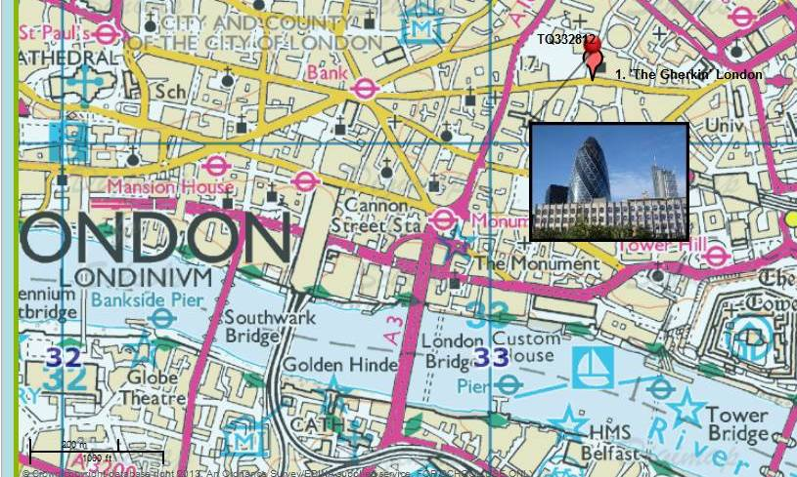

Resources
A. Answers sheet for teachers with image numbers, grid references and descriptions.
B. Worksheet – 20 descriptions and grid references. Photograph numbers are already given for each description.
C. Worksheet – as above, but picture numbers not given (slightly harder for higher ability pupils).
D. Worksheet – descriptions and grid references just for images 1–5 (Sheet H).
E. Worksheet – descriptions and grid references just for images 6–10 (Sheet I).
F. Worksheet – descriptions and grid references for images 11–15 (Sheet J).
G. Worksheet – descriptions and grid references for images 16–20 (Sheet K).
(Sheets D, E, F, G are easier sheets for pupils requiring a little more support).
H. Photograph sheet to match D
I. Photograph sheet to match E
J. Photograph sheet to match F
K. Photograph sheet to match G

Answers sheet
Photo | Where is this place? | In this place you are most likely to ... | Grid reference
1 | The Swiss Re Tower or the Gherkin as it is nicknamed, City of London | See a famous city landmark | TQ332812
2 | Forestry Commission Path Abergorlech | Go hiking through a forest | SN587338
3 | Buckingham Palace | See where the Queen lives | TQ290796
4 | Sea, North coast of Sheppey off Warden Point | Go out fishing in a boat | TR017733
5 | View of viaduct over the River Wey, Guildford, Surrey | Walk beside a river and under a viaduct | SU992504
6 | Hampton Court Palace | See somewhere made famous by Henry VIII | TQ157684
7 | WW2 defence battery Shellness, Sheppey | Play in an old WW2 defence building | TR052676
8 | Windsor Castle, Windsor | See a castle, do some shopping and take a boat trip | SU970770
9 | Ferry on the Thames, Windsor | Take a boat ride on the Thames | SU968773
10 | Leeds Castle, Leeds, Kent | Visit a castle in the countryside | TQ836532
11 | Natural History Museum | See a whale and a dinosaur | TQ266790
12 | Sheffield Railway Station | Catch a train | SK357869
13 | Llanberis Station, Snowdon Mountain Railway | Go up a mountain on a train | SH582597
14 | Coast at Carreg Lydan, Cardigan Island Nature Reserve | Watch seals and have a picnic | SN163512
15 | Ruins of castle Newcastle Emlyn, Carmarthenshire | Visit a ruined castle | SN310407
16 | Devil’s Bridge, Pontarfynach | Find waterfalls | SN741772
17 | Youth Hostel Borth, | Stay in a Youth Hostel | SN608907
18 | Rye Harbour, Sussex | Watch boats in a harbour | TQ942190
19 | Edinburgh Castle | Visit a castle built on a volcanic rock | NT251735

Picture Detectives: Solve the mystery of where these pictures were taken!
Photo | Where are you most likely to ...? | Write the grid reference here
1 | See a famous city landmark
2 | Go hiking through a forest
3 | See where the Queen lives
4 | Go out fishing in a boat
5 | Walk beside a river and under a viaduct
6 | See somewhere made famous by Henry VIII
7 | Play in an old WW2 defence building
8 | See a castle, do some shopping and take a boat trip
9 | Take a boat ride on the Thames
10 | Visit a castle in the countryside
11 | See a whale and a dinosaur
12 | Catch a train
13 | Go up a mountain on a train
14 | Watch seals and have a picnic
15 | Visit a ruined castle
16 | Find waterfalls
17 | Stay in a Youth Hostel
18 | Watch boats in a harbour
19 | Visit a castle built on a volcanic rock
20 | Go to church on an island

Grid references
TR017733 | SN163512 | SN310407 | TQ836532 | SU970770
SU968773 | TR052676 | SU992504 | TQ266790 | TQ332812
SH582597 | SN741772 | TQ942190 | NT251735 | SN587338
SK357869 | SN608907 | TQ157684 | NM503553 | TQ290796

Picture Detectives: match the photo and find the places!
Photo | Where could you go to ...? | Write the grid reference here
 | See a famous city landmark
 | Go hiking through a forest
 | See where the Queen lives
 | Go out fishing in a boat
 | Walk beside a river and under a viaduct
 | See somewhere made famous by Henry VIII
 | Play in an old WW2 defence building
 | See a castle, do some shopping and take a boat trip
 | Take a boat ride on the Thames
 | Visit a castle in the countryside
 | See a whale and a dinosaur
 | Catch a train
 | Go up a mountain on a train
 | Watch seals and have a picnic
 | Visit a ruined castle?
 | Find waterfalls
 | Stay in a Youth Hostel
 | Watch boats in a harbour
 | Visit a castle built on a volcanic rock
 | Go to church on an island

Grid References
TR017733 | SN163512 | SN310407 | TQ836532 | SU970770
SU968773 | TR052676 | SU992504 | TQ266790 | TQ332812
SH582597 | SN741772 | TQ942190 | NT251735 | SN587338
SK357869 | SN608907 | TQ157684 | NM503553 | TQ290796

Picture Detectives: most likely to...?
These pictures, descriptions and grid references show locations for planned days out but they’ve all become muddled up!
Can you use your geographical detective skills to sort them out?
Match the pictures first to the activity. Then, investigate the mixed up grid references to try and find out where each place is.

In which place are you most likely to ...? | Photo | Where is this place?  (Give the name of the location or place shown on the map)
See a famous city landmark
Go hiking through a forest
See where the Queen lives
Go out fishing in a boat
Walk beside a river and under a viaduct

Grid reference | Locate these grid references using the search tool on Digimap for Schools. Note any information such as place names or features that will help you match to images and activities.
SN587338
TR017733
TQ290796
TQ332812
SU992504

Picture Detectives: most likely to ...?
These pictures, descriptions and grid references show locations for planned days out but they’ve all become muddled up!
Can you use your geographical detective skills to sort them out?
Match the pictures first to the activity. Then, investigate the mixed up grid references to try and find out where each place is.

In which place are you most likely to ...? | Photo | Where is this place?  (Give the name of the location or place shown on the map)
See somewhere made famous by Henry VIII
Play in an old WW2 defence building
See a castle, do some shopping, take a boat trip
Take a boat ride on the Thames
Visit a castle in the countryside

Grid reference | What can you find there? (Make notes if it helps you)
TQ836532
TR052676
SU968773
TQ157684
SU970770

Picture Detectives: most likely to ...?
These pictures, descriptions and grid references show locations for planned days out but they’ve all become muddled up!
Can you use your geographical detective skills to sort them out?
Match the pictures first to the activity. Then, investigate the mixed up grid references to try and find out where each place is.

In which place are you most likely to ...? | Photo | Where is this place  (Give the name of the location or place shown on the map)
See a whale and a dinosaur
Catch a train
Go up a mountain on a train
Watch seals and have a picnic
Visit a ruined castle?

Grid reference | What can you find there? (Make notes if it helps you)
SK357869
SN163512
TQ266790
SH582597
SN310407

Picture Detectives: most likely to …?
These pictures, descriptions and grid references show locations for planned days out but they’ve all become muddled up!
Can you use your geographical detective skills to sort them out?
Match the pictures first to the activity. Then, investigate the mixed up grid references to try and find out where each place is.

In which place are you most likely to ...? | Photo | Where is this place?  (Give the name of the location or place shown on the map)
Find waterfalls
Stay in a Youth Hostel
Watch boats in a harbour
Visit a castle built on a volcanic rock
Go to church on an island

Grid reference | What can you find there? (Make notes if it helps you)
SN608907
NT251735
NM503553
TQ942190
SN741772

Taking it further

- Ask pupils to research some more photographs of places around Great Britain using Image Search in Digimap for Schools and make up ‘Most likely to’ questions for them.
- Ask pupils to make a collection of local photographs and identify them on a local map using six figure grid references.
- Ask pupils to investigate some of the photographs provided and do some further research about the place or building shown. Illustrate with some maps of your choosing.

Links
- Using grid references guide:
https://getoutside.ordnancesurvey.co.uk/guides/beginners-guide-to-grid-references/

Copyright
©EDINA at the University of Edinburgh 2016
This work is licensed under a Creative Commons Attribution-Non Commercial Licence

Acknowledgements
© CollinsBartholomew Ltd (2019) FOR SCHOOLS USE ONLY
© Crown copyright and database rights 2020 Ordnance Survey (100025252). FOR SCHOOLS USE ONLY.
Aerial photography © Getmapping plc. Contains OS data. FOR SCHOOLS USE ONLY.
Historic mapping courtesy of the National Library of Scotland. FOR SCHOOLS USE ONLY.

