Quick Primary Geography ideas
with a historic twist!

Paula Owens

Geography Teaching Resource
Primary

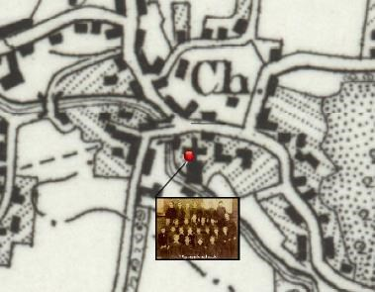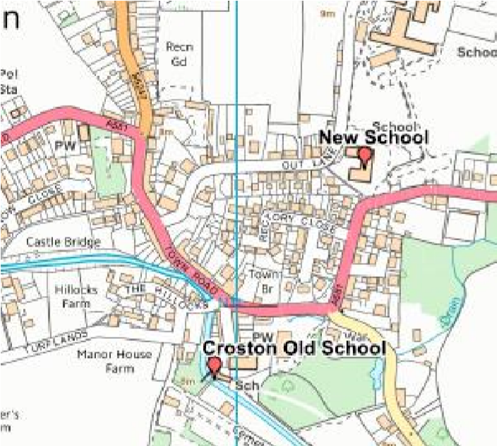

Contents

Contents 2
Digimap for Schools Geography Resources 3
Introduction 3
Our historical maps 3
How to view historic maps 3
Activities 5
1 Old School 5
2 Picture the Past 7
3 Your Street 9
4 The Dock and the Bay 10
5 Spot the Difference 12
6 All Change! 13
7 Coastal Erosion 15
8 Cathedral City 17
9 Victorian Gardens 19
10 Mining the Past 21
11 Over the Sea to Skye 22
Copyright 24
Acknowledgements 24

Digimap for Schools Geography Resources
These resources are a guide for teachers to demonstrate to the whole class or direct individual students as appropriate. Each activity has several ideas within it that you can tailor to suit your class and pupils. Some resources contain worksheets for direct distribution to pupils.
https://digimapforschools.edina.ac.uk/

Introduction
Here are some quick and adaptable ideas for using the modern and historic 1890s and 1950s maps in Digimap for Schools to look at change over time. These can either be used on a whiteboard, or using printed maps as hand-outs, perhaps as a homework exercise.

Our historical maps
The 1890s maps are old black and white Ordnance Survey one-inch maps, which have been scanned by the National Library of Scotland. They were published between 1895 and 1899. The 1950s maps are in colour and also at one inch and were published between 1952 and 1961. They were originally known as the ‘Seventh Series’ which was the last series to be published at one inch. The closest modern map scale is the 1:50 000 scale, but Digimap for Schools allows you to zoom in and out of the historic map to enlarge the detail.

How to view historic maps
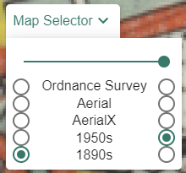
Check the Map Selector tool on the map window to see what maps are available at any given scale.

- To view any map, just select the button to the right of its name, e.g. 1890s.
- To compare 2 maps, select the button to the right of the first map’s name. Then select the button to the left of the other map’s name. Now use the slider bar at the top of the Map Selector to fade between them.
Whichever maps you choose you may find that the fit between them is not exact and this will be exaggerated as you zoom in. This will particularly be the case with the 1890s maps as the national grid was not used then and it is not possible to completely correlate the 1890s and modern mapping frameworks within a seamless GB dataset. So, if you see a difference in, for example, the course of a road, it does not mean the old maps were very inaccurate, or that a feature has since completely moved.
There may also sometimes be a noticeable difference between details or colours on the old map at what would have been the edges of the paper map sheets. This can be caused by sheets being of a different date, and sometimes due to a difference in the meridians used between the old maps.
If you come across example like these, you can point them out to your pupils so that they can understand the limitations of using old and new resources together.

Activities

1 Old School
How old is your school? Do you know what the present site was used for in the 1950s or the 1890s?
- Ask pupils to first locate their school.
- Then compare the area using the Point Buffer tool, found in the Drawing Tools.
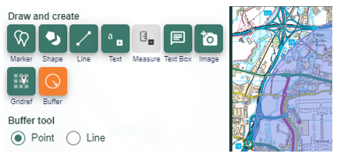

- Set the buffer to 1km and a bold colour for the outline.
- What is still the same and what has changed?
- What are the biggest changes you can find?
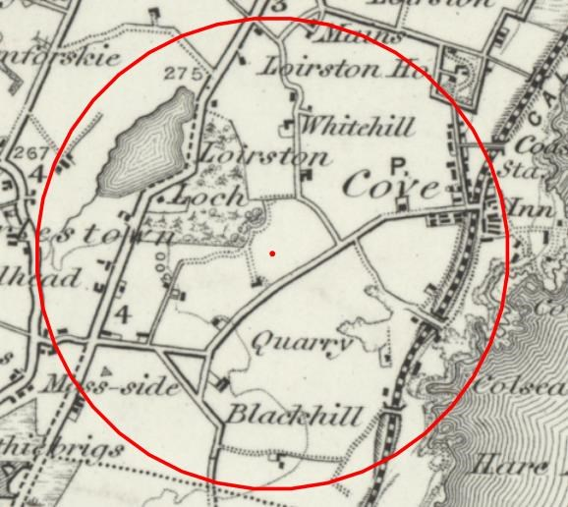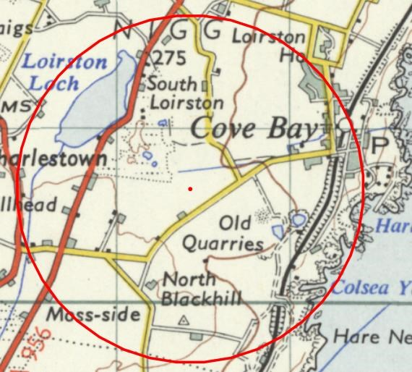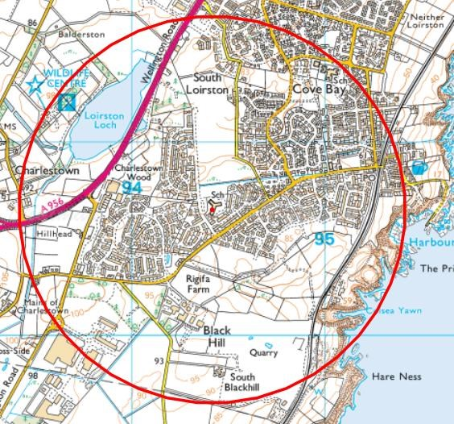

1950s - the quarry has gone out of use and some housing has appeared South of Loirston House.
In the 1890s, there was no school and very little settlement.
Present day - now there is a lot more housing between Cove Bay and Charlestown and several schools serve this area south of Aberdeen.

Ask pupils why there is so much more housing today in Aberdeen or why people might have moved there. When investigating changes in your school’s area, why not add some old photographs to the new map to show what is still the same?
However, sometimes your school may not be shown on the old map for other reasons – see 2. Picture the Past.

2 Picture the Past
If you have found your school on the 1890s map add some images from that time of the building or of some of its pupils. It's worth double checking by doing some historical research if you think your school is old enough to have been there about that time, but find it's not shown on the map. Your school may have even moved since the 1890s to a new building.
For example, there are images of pupils from the 1890s at Croston School in Lancashire, but the map does not show a school there (usually marked on the 1890s map as 'Sch'). Schools may not have been recorded for a variety of reasons and this in itself could be a useful teaching enquiry to find out why this might have been.
A quick check online for 'Croston School' reveals this: http://croston-old-school.org/history.htm
'The Old School is a Grade 2 listed building which originates from 1660 and was rebuilt by subscription in 1827. It is in the centre of the village at the end of Church Street within an Article 4 conservation area, next to the 900-year-old church and next to the River Yarrow. Until 1999 the buildings were used by Lancashire County Council as a school for up to 60 children, in March 1999 the children were re-located to new school buildings and the Old School was left vacant.'
With these precise details, the present-day map can be opened up to reveal the details of Croston.
- Find the Church at the heart of this settlement and zoom in as far as you can go to topographical level of detail. It is easy to find Church Street, the River Yarrow and to deduce through logical reasoning where the school was. The image showing pupils from the school can then be pinned to the correct location.
- Then zoom out one level at a time until the Map Selector on the map window is green (meaning there are maps available).
- Select the 1890s map and view the old village layout.
Croston, Lancashire showing the location of the old school in 1890 and the old and new schools on the present-day map.
Image http://www.victorianschool.co.uk/free.html#school1897

You could easily add a range of other images to the old and new maps. For example, why not add one of present-day pupils to a map showing the current school or images showing the old and new school buildings to the old and new maps respectively?
See the video clips at this link for more information about Victorian schools https://www.bbc.co.uk/programmes/b0078b97/clips

3 Your Street
How long has your street or road been around? What about where your friends live?
- Ask pupils to put in their own postcode, zoom in to find their house.
- Then use the Draw Polygon tool outline it.
- Ask pupils to zoom out.
- Then use the Map Selector to view 1890s and 1950s maps and find out if their house was there then.
- How many in the class have a road or street that can be found on the old maps?
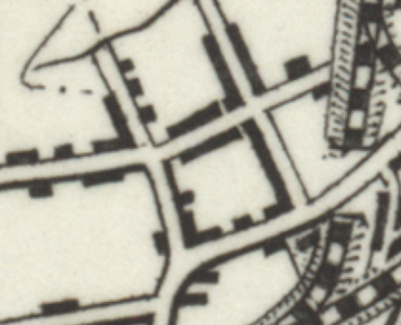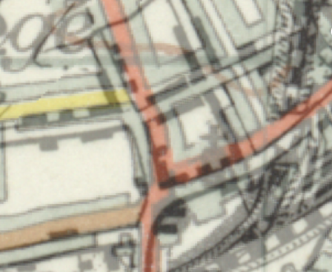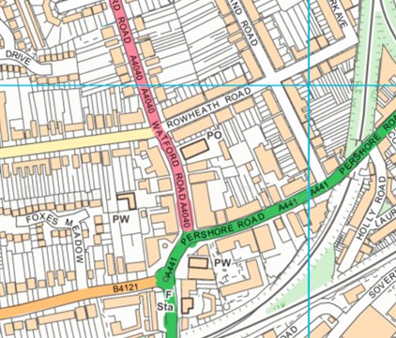
Here, near Cotteridge, on the outskirts of Birmingham, the housing is more developed in 2015, but the transition of development can be clearly seen in the 1950’s. The original roads can be found on the present-day map as can this terraced house.

4 The Dock and the Bay
Cities change over time and reflect key ways that people make a living. From the 1850s, coal replaced iron as the industrial foundation of South Wales and was exported around the world from Cardiff Docks.
Cardiff became one of Britain's three major ports, along with London and Liverpool thanks mainly to the large amount of coal shipped through there from the local valleys. The East Bute dock opened in 1859 to meet this increasing demand. However, the coal industry declined and many of the docks shut down.
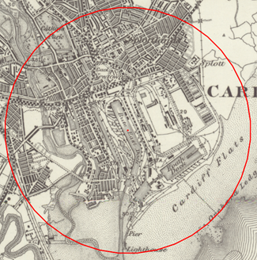
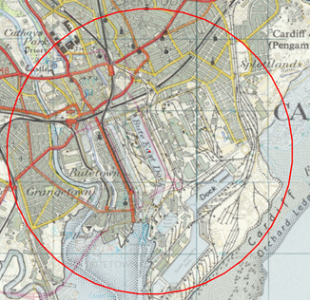
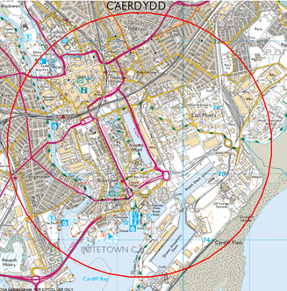
The Cardiff Bay Development Corporation was set up in April 1987, to regenerate the area. East Bute dock was renamed Atlantic Wharf as the area was redeveloped to meet current day needs.

At the height of the coal industry, the Norwegian merchant navy were regular traders in Cardiff docks and even had their own church. Today it mainly functions as an Arts and Community centre.
- Ask pupils to use the Search Box to find 'Atlantic Wharf'.
- Open the Drawing Tools, select the Buffer tool.
- Add a point buffer with a 2km radius.
- Save this map.
- Now use the Map Selector to view the 1890s version and save this too.
- How has land use changed around the original East Bute Dock?
- What other changes can be spotted?
- Ask pupils to research old and new photographs of the area and find out about enduring features. For example: the Norwegian Church (where Roald Dahl was baptised) is still there but has a different use today.
There is scope here for major enquiry based around the Cardiff Bay Development. See weblinks below:
Cardiff Bay history: https://cardiffharbour.com/history/

5 Spot the Difference
If you have no computer access or want to set homework to introduce the concept of landscape change over time, simply give each pupil an A4 colour modern map and the 1890s version of the same area.

Prints
When making your prints make sure you:
- Tick ‘National grid lines’
- Ensure that your printer is set to 100% scale (some printers default to ‘fit to paper’, which will distort the scale).

Activity
- First ask the pupils to identify a number of landmarks that appear on each map to ensure they can orientate themselves.
- Now ask them to comment on their impressions of the place they are looking at using appropriate geographical language and terms.
- How have things changed over the period?
Next time they have access to a computer they could use Digimap for Schools to annotate some of the changes.

6 All Change!
From the mid-1960s, 2,128 railway stations across Britain were closed and 67,700 jobs were lost following a review by the then chairman of the British Transport Commission, Dr Richard Beeching, who said that rail travel was not good value for money.
One of the worst cuts was said to be the 98 mile Waverley Route from Edinburgh to Carlisle as it left the Scottish Borders the only region of Britain without a train service and Hawick, 56 miles from Edinburgh and 42 miles from Carlisle, the largest town farthest from a railway station. Dr Beeching said he wanted everyone to drive cars but today our roads are congested, and trains are generally viewed as a greener and faster option.
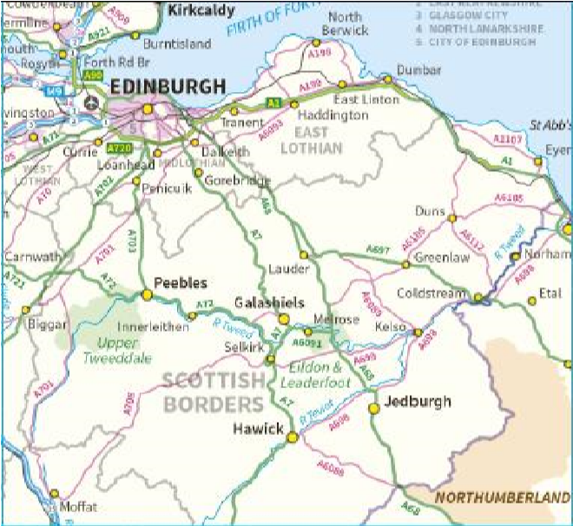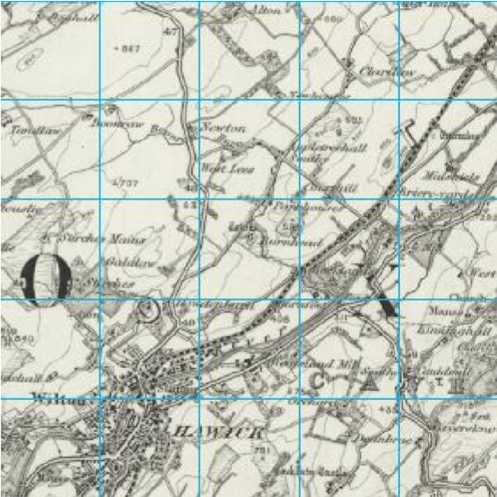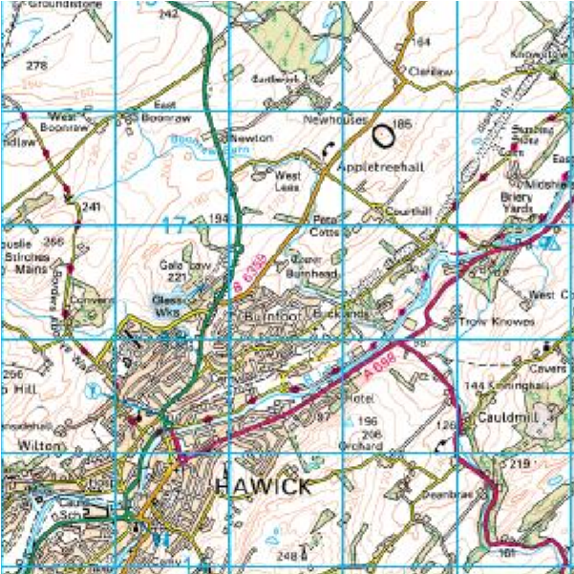
Hawick is a town situated between Carlisle and Edinburgh in the Scottish Borders. It was well connected by rail in the 1890s, but now is only accessible by road.
- Use the Search Bar to find 'Hawick' and then zoom out until its location can be appreciated with regard to either Edinburgh and/or Carlisle.
- Then zoom in until you can select an 1890s map from the Map Selector.
- Look at the network of roads around the town.
- Then look at the 1890s map that shows the old railway.
- Ask pupils to reflect on how they would have felt to have lost their rail link back at that time. How might it have affected people's lives?
- Where else can they find rail lines which have disappeared thanks to Beeching's cuts and what was the impact of this on remote communities?
- How far is it to the nearest station now to get on the rail network from Hawick? Ask pupils to look at today's map and zoom out until they find the nearest rail station.
- They can measure the distance between Hawick and its nearest station its distance using the Measurement Tools in the sidebar.
More than 40 years after the closure, some of the Waverley Route is to be revived in the form of the new £300m Borders Railway, which, after years of wrangling, was completed in the summer of 2015. Can you measure how far the nearest station was before the revival?
See: http://www.bordersrailway.co.uk/

7 Coastal Erosion
Changes can take place so slowly that we only realise what has happened by looking back over a long period. On the Isle of Sheppey, soft London clay is easily eroded through a mixture of landslip and undercutting thanks to the combined effect of weather, sea and tide on the NE coastline.
- Ask pupils to find Warden Point in Kent using the Search Box.
- Open the Map Selector.
- Select the button to the left of 1890s.
- Then use the slider bar to slowly fade the present-day map out until the 1890s map starts to appear. You will be able to see both the old and new coastline.
- Using the Line Tool from the Drawing Tools, draw a line between the old and new coastline.
- Then select the Measurement label to show of how much coastline has been lost (here, the amount of erosion in just over 100 years is more than 300 metres). You could also highlight any buildings that have disappeared since the 1890s.
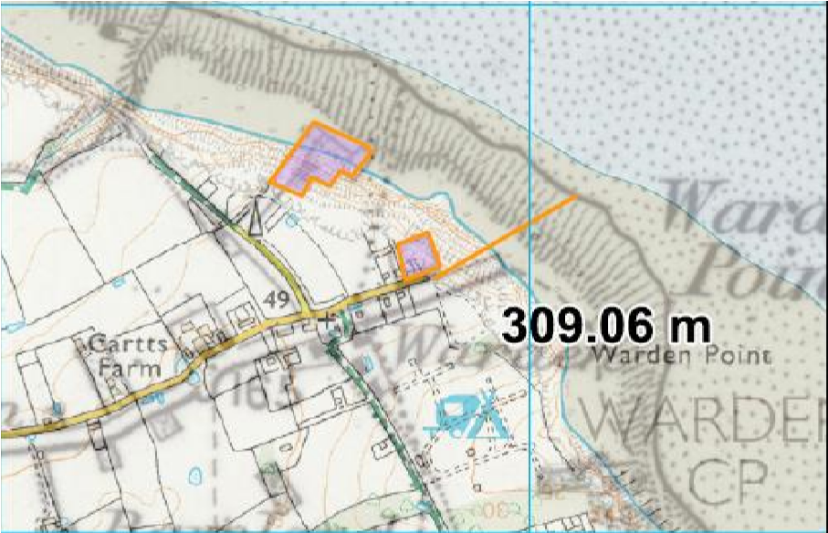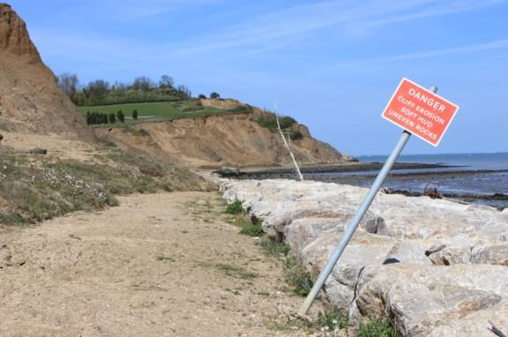Looking North you can see a 'Rip Rap' system of large rocks in place to try and reduce cliff erosion around Warden Point on the Isle of Sheppey.
Photograph: Paula Owens
This part of the Sheppey coastline was home to many concrete Observation Posts and Gun Batteries in WW2. Ask pupils if they can offer explanations as to why they were useful here by zooming out to look at the location of this part of the coastline. These structures now lie in pieces along the foreshore thanks to coastal erosion.
Look out posts at Warden Isle of Sheppey: http://www.sheppeywebsite.co.uk/index.php?id=68
Old images of Warden Point: http://www.pbase.com/luckytrev/warden
Investigate other parts of the GB coastline where erosion is happening and measure how much the coastline has been eroded there since the 1890s using this technique.

8 Cathedral City
Coventry's St Michael's Cathedral was built around the late 14th and early 15th century, but then bombed to near destruction in 1940 during WW2 in a raid that became known as the 'Coventry Blitz' because of the wider damage done to the city.
- Ask pupils to locate the present-day Cathedral in Coventry by using the map symbols and zooming in to topographical scale to read the annotation on the buildings.
- Using the Drawing Tools, select a marker to show the new cathedral.
- Then use the Add Polygon Tool to highlight the ruin and former site of the old cathedral.
See the weblinks below for more information:
http://www.bbc.co.uk/history/ww2peopleswar/stories/23/a4799523.shtml
http://www.coventrycathedral.org.uk/wpsite/
- Add British National Grid lines to enable better comparison: Select Overlays then check the British National Grid box.
- Then zoom out until You can select 1890's in the Map Selector.
- How has the heart of Coventry changed since the 1890s and how many of the buildings standing at that time remain?
- Ask pupils to zoom out further and look at the growth of housing around the city centre since 1890 too.
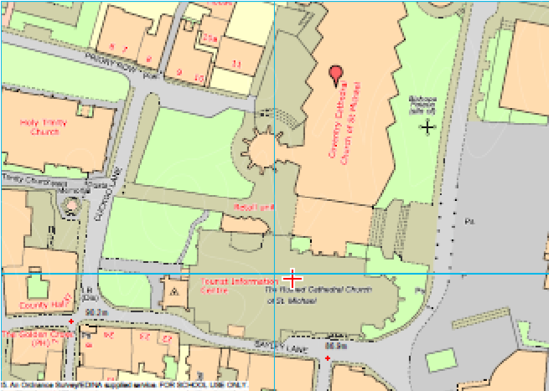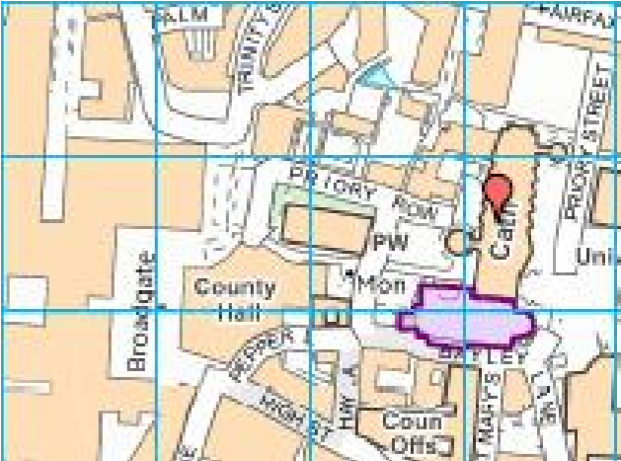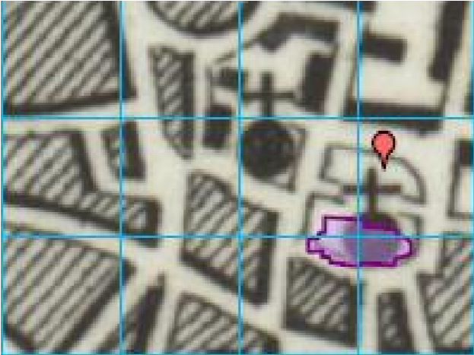

The new St Michaels, built to replace the cathedral bombed in WW2, is located next to its ruin in Coventry and was completed in 1962. Its address is 1 Hill Top, Coventry CV1 5AB.
You could investigate cathedral settings within other city centres and compare changes since the 1890s.
- Ask pupils to find out which cathedral areas within cities have changed the most and which appear to have changed very little?
- Pupils could compare the 1890s and modern-day map and then research further by zooming in on the modern map as far as possible (1:1250 scale) to find out more about buildings and land use.
- Why do you think so many old buildings are preserved at the heart of cities?
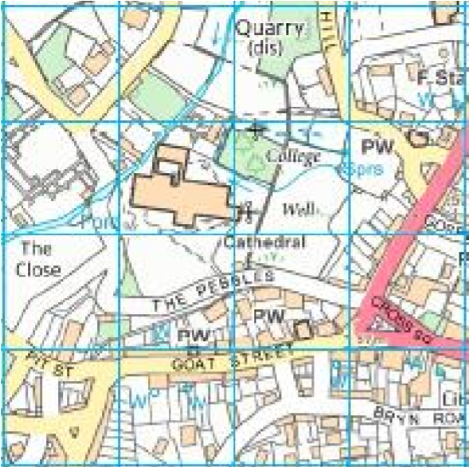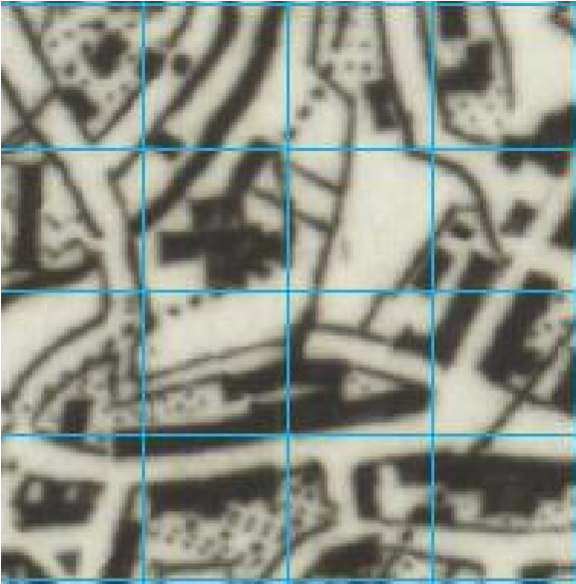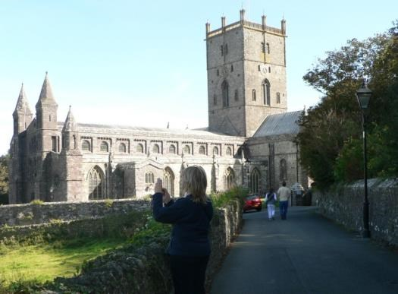
Photograph Paula Owens

St David's in Pembrokeshire, Wales is one of the smallest cities in the U.K. The cathedral sits at the centre of this tiny city that remains relatively unchanged in layout.
See the following links for more information:
http://www.stdavidscathedral.org.uk/
http://www.coventrycathedral.org.uk/wpsite/visits-hospitality/

9 Victorian Gardens
Gardening became a popular pastime and practice during the Victorian era and many explorers brought back exotic plants from other countries around the world that were then used in garden designs. James Bateman was a famous garden designer and grower during this period; he created a large and impressive garden at Biddulph Grange, in Staffordshire filled with rare specimens from Victorian plant hunters.
The garden re-created different scenes using plants from Egypt to China in a series of smaller gardens connected by underground tunnels. Between then and now the garden fell into disrepair but was saved by The National Trust® and now operates as a visitor centre.
The National Trust website has a list of their gardens and addresses. The post code for this garden is ST8 7SD.
- Ask pupils to locate this National Trust property either using the search term 'Biddulph' or by entering the postcode.
- Then, use the Draw Polygon tool to carefully select around the edges of the country park.
- Then, ask pupils to select the 1890s map with the Map Selector and compare the current shaded garden area with what was there before.
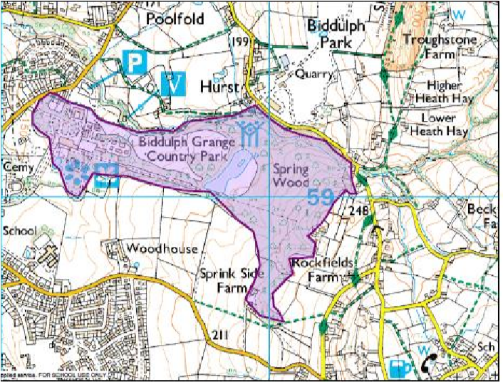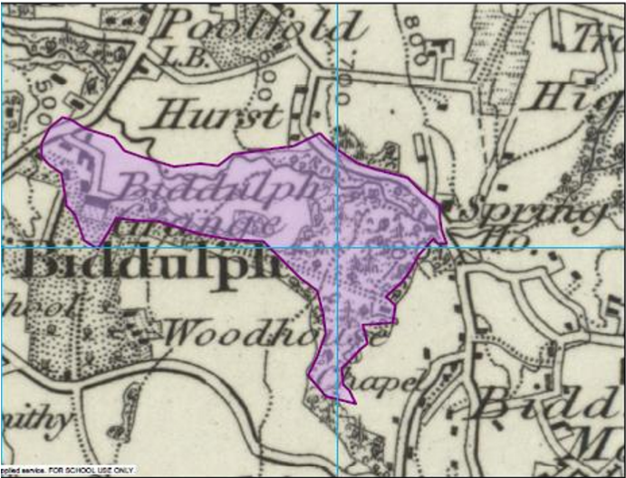
The area of the current day gardens and park shown on the 1890s map of Biddulph Grange.
See the web link for more information:
A look around Biddulph Grange: https://www.bbc.co.uk/programmes/p01xcyjn
National Trust Biddulph Grange Gardens: https://www.nationaltrust.org.uk/biddulph-grange-garden

You could ask pupils what else they notice in the old and new maps. If they zoom out a little they will see the clearly marked railway running through the Biddulph valley in the 1890s map, whereas in the present day map the railway is gone and replaced by a walking route-bridle path and part National Trail.
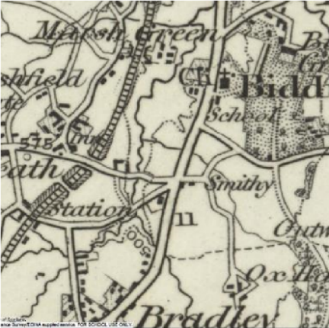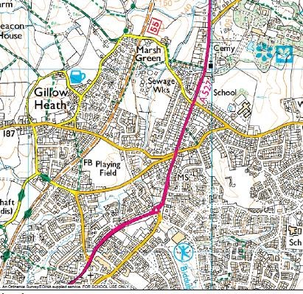
The Biddulph Valley Railway Line running in 1890 as a freight and passenger service is only evident as a Bridle Way in 2015.
The old railway line was used for freight (mainly coal), but also ran a passenger service for 60 years until the 1920s. Was this line the victim of Dr Beeching cuts too (see: 6. All Change!) or just declining fortune?

10 Mining the Past
In 1870 Cornwall was the foremost tin mining field in the world and at one time had around 2,000 mines. Other minerals were mined too in Cornwall and which brought prosperity before competition from other mines around the world caused the mines to close in the late 19th and early 20th century. One of the most enduring and successful mines was Dolcoath, near Camborne. It started as a copper mine, but also supplied tin, silver, and other minerals. When it closed in 1921 it was the deepest mine in Cornwall and one of the longest surviving. Between 1853 and 1920 it produced more black tin than any other Cornish mine, over 100,000 tons!
- Ask pupils to find the location of the mine using the 1890s map. They could do this using the search term 'Camborne' and then scan the map to look for 'Dolcoath Mine' or they could use the grid reference SW661401 supplied on one of the research websites.
- Note the nearby church and the railway line.
- Then ask pupils to use the Map Selector to return to the present-day map and see what is there now. What do they notice? What still remains?
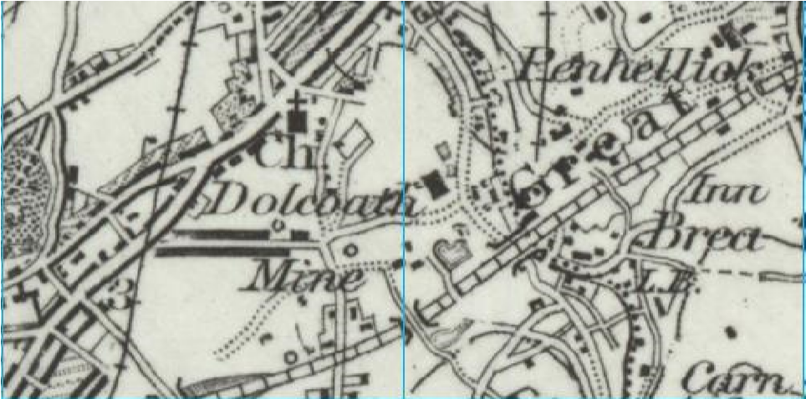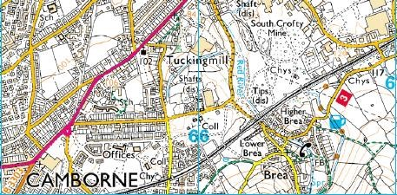
Dolcoath Mine, Cornwall. Today the shafts are disused and some of the spoil tips remain, but the site now has a school and offices where once the mine thrived. The Great Western Railway line has remained unchanged.
- What other evidence of mines in Cornwall can you find using the 1890s maps?
- How did the industry collapse and why did so many people from Cornwall choose to emigrate?
- Do you think that the remains of mines should be preserved for our heritage?
For more information follow the weblink below:
Timeline Dolcoath Mine Cornwall: A history of Dolcoath Mine: http://www.cornwall-calling.co.uk/mines/camborne/dolcoath.htm

11 Over the Sea to Skye
The Kyle Rhea Straits spans the narrow divide between Kylerhea on the east coast of the Isle of Skye and Glenelg on the mainland. This narrow crossing point has been used for hundreds of years. Today, the last manually operated turntable ferry in Scotland the 'Glenachulish' still works back and forth. There has been a car ferry service here since 1934. Before that, you had to swim, use a rowing boat or the early ferry service!
Black cattle being taken to market in the south would swim across the few hundred metres of the channel in small groups tied nose to tail and trailed behind a rowing boat. The slipway at Glenelg was built for cattle and designed by Thomas Telford.
How would you feel crossing this stretch of water with its fast-flowing currents?
The 1878 Edition of the Royal Tourist Handbook to the Highlands and Islands warned that in Kyle Rhea
"the tides race at 7 and 8 miles an hour, and with a head gale might baffle the steamers to force a passage. In southerly storms the wind against the tide creates an extraordinary uproar".
- How far is it? Ask pupils to open the map and enter 'Kylerhea' as a search term.
- Then locate the ferry route, which is clearly marked.
- Open the Drawing Tools and use the Draw Line tool to mark the distance across the Strait.
- Then select the Add Measurement label to find out the distance. It's nearly 500 metres! The old map shows an Inn and the Pier clearly.
- Why do you think this ferry route was of such importance then?
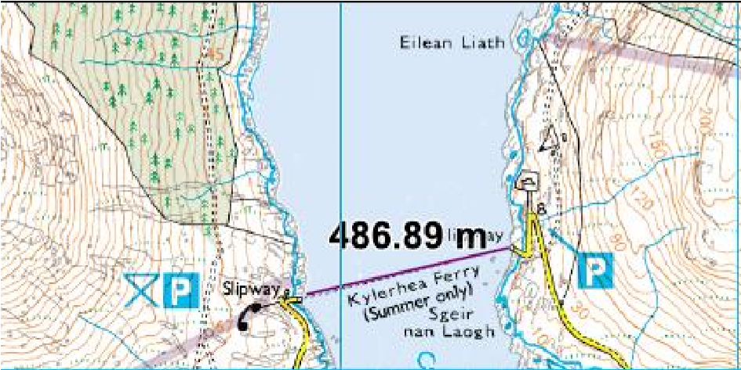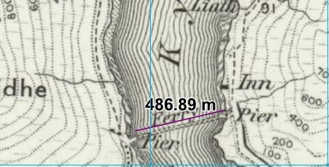
The crossing route between Skye and the Mainland where a ferry route has been in operation for hundreds of years.
How do people get to Skye nowadays? They probably use the new Skye Bridge.
- Ask pupils to find Mallaig and Oban and look for ferry crossings-how many routes can they find?
- Then compare this with maps showing the same areas in the 1890s.
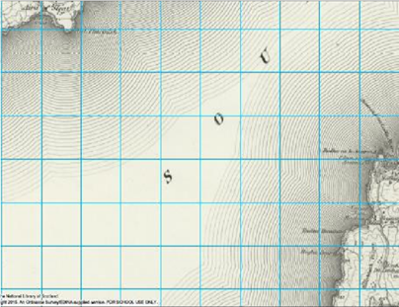
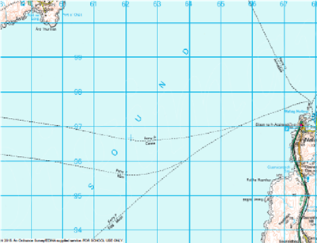
- What does this tell them about travel between the islands, then and now? What is the relationship between modern day ferry services and tourism?

There is a gradual increase in the number of ferry routes with the 1890’s map displaying none, 1950’s map showcasing one route and the 2015 map showing some of the many ferry routes to the islands.
For more information follow the weblinks below:
The slipway at Glenelg: http://www.britishlistedbuildings.co.uk/sc-51306-glenelg-slipway-kylerheaferry-glenelg#.VcNVEDjbLIU
The Ferry house: http://www.ferryhouse.co.uk/ferry.html
Undiscovered Scotland: http://www.undiscoveredscotland.co.uk/skye/glenelgferry/

Copyright
©EDINA at the University of Edinburgh 2016
This work is licensed under a Creative Commons Attribution-Non-Commercial Licence

Acknowledgements
© CollinsBartholomew Ltd (2019) FOR SCHOOLS USE ONLY
© Crown copyright and database rights 2020 Ordnance Survey (100025252). FOR SCHOOLS USE ONLY.
Aerial photography © Getmapping plc. Contains OS data. FOR SCHOOLS USE ONLY.
Historic mapping courtesy of the National Library of Scotland. FOR SCHOOLS USE ONLY.

