Teifi Travels

Social and environmental features along a river

Paula Owens

Geography Teaching Resource

Primary
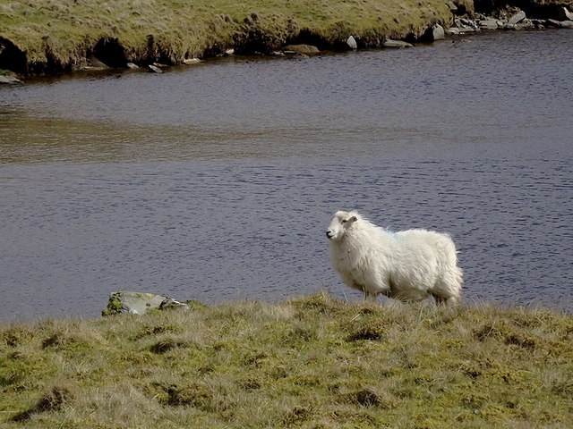
Lone ewe by Llyn Teifi, Ceredigion

Contents
Digimap for Schools Geography Resources 3
Content and Curriculum Links 3
Activity 3
Introduction 4
Main activity 4
Places along the River Teifi – worksheet 5
River travel guide worksheet 6
Taking it further 8
Web links 8
Copyright 9
Acknowledgements 9

Digimap for Schools Geography Resources
These resources are a guide for teachers to demonstrate to the whole class or direct individual students as appropriate. Each activity has several ideas within it that you can tailor to suit your class and pupils. Some resources contain worksheets for direct distribution to pupils.

Content and Curriculum Links

Level | Context | Location
Primary | Social and environmental features along a river | River Teifi, Wales. Idea can be applied to other rivers in GB.

Knowledge | Using the search box. Adding markers. Adding labels. Reading maps. Using a key.
Curriculum links (England) | Describe and understand key aspects of:  physical geography, including rivers, and human geography, including settlements and land use. Use digital mapping to locate and describe features.
Curriculum links (Wales) | Identify and locate places and environments using globes, atlases and maps. Identify and describe the spatial patterns (distributions) of places and environments and how they are connected.
Scottish Curriculum for Excellence | Social Studies Outcomes: People, Place and Environment:2-09a, 2-12a, 2-14a.

Activity
Pupils see a presentation of a journey along the River Teifi, but you will notice that the slides are muddled and are not in the right order. Ask pupils to use their map skills to help you put it right.
NOTE: the slides in the PowerPoint are provided in the correct order so you will need to move the slides around before you start. The images showing the source and mouth are clearly marked so these will be straightforward to identify – unless you hide the captions.

Introduction
The River Teifi (Welsh: Afon Teifi) forms the boundary between the counties of Ceredigion and Carmarthenshire in south-west Wales for most of its length and flows into the sea below the town of Cardigan at Poppit Sands. The source of the Teifi is Llyn Teifi, one of several lakes known collectively as the Teifi Pools, in the Cambrian Mountains.

Main activity
Show the PowerPoint presentation of a journey along the River Teifi from source to mouth. As you look at the images, you will decide they are not in the right order.
Can the pupils use their maps skills to help you put it right?
Discuss what the river and the surrounding areas looks like in each of the images.
Open Digimap for Schools and give pupils a copy of the worksheet Teifi Places. Once they have completed this, show them the presentation again and let them help you reorder the slides. Some questions you might ask are:

- What was your favourite place along the river and why?
- What was the class favourite?
How did the landscape, and in particular the river, change along its journey to the sea?

Places along the River Teifi – worksheet
Name:
- Use the Search Box to find these place names on a map.
  - Cardigan
  - Llandysul
  - Llyn Teifi
  - Newcastle
  - Emlyn
  - Poppit Sands
  - Cenarth
- Open the Drawing Tools.
- Add a marker to each place.
- Select the Add standalone label tool and choose the font, text colour and size you want. Type the name of your place in the label box and select the right spot on the map to add it.
- When you have marked and labelled them on a map, put the names in the right order on the table below, from source to mouth.
- Zoom in at each place on your map and use the key to help you describe some of the human and physical features there. Add this information to the table too.

Place | What is this place like?
Source:
Mouth:

River travel guide worksheet
Name:
Name of river:
Source: Grid reference:
Mouth: Grid reference:
Name of river:
Source: Grid reference:
Mouth: Grid reference:

Description of landscape at river source

Description of landscape at river mouth

Places of interest to visit and what you might do there

Taking it further
- Save the images in the PowerPoint and involve pupils in adding some to these to a map to create an illustrated map of the river for classroom display.
- Look at the river in more detail using aerial photography.
- Compile a ‘River Guide’ for another river using the second worksheet.
- With Image Search in Digimap for Schools you can search for and display Geograph images on your map. You can save them locally if you wish to create a new PowerPoint presentation.
- Research some more information about your favourite place along the river.
- Design a tourism flyer advertising the River Teifi as a place to go for an activity weekend.
- Describe the job of someone who has to work on or with the river every day.

Web links
- West Wales Rivers Trust: http://afonyddcymru.org/the-west-wales-rivers-trust/

Copyright
©EDINA at the University of Edinburgh 2016
This work is licensed under a Creative Commons Attribution-Non Commercial Licence

Acknowledgements
© CollinsBartholomew Ltd (2019) FOR SCHOOLS USE ONLY
© Crown copyright and database rights 2020 Ordnance Survey (100025252). FOR SCHOOLS USE ONLY.
Aerial photography © Getmapping plc. Contains OS data. FOR SCHOOLS USE ONLY.
Historic mapping courtesy of the National Library of Scotland. FOR SCHOOLS USE ONLY.

